Challenging the knowledge resources complementarity hypothesis: A counterexample

Luis M. Molina
University of Granada, Spain
Ferran Vendrell-Herrero
University of Birmingham, UK
Oscar F. Bustinza
University of Granada, Spain

Abstract
Drawing on the resource-based view of the firm, and counter to the mainstream literature, we propose and test whether firm resources can substitute for each other. Our test focuses on the interplay between managers’ and workers’ capabilities. We hypothesise a mutually exclusive effect of managerial experience and labour skills on product innovation. More-experienced managers work more effectively and achieve higher innovation outcomes when they work with less-qualified workers, who focus on the tasks assigned. Conversely, skilled workers have more freedom to develop their own product development projects and apply their expertise when working with less-experienced managers. Drawing on the most recent waves of the World Bank Enterprise Survey (WBES) in Latin America, we construct a cross-sectional sample of 2,725 manufacturing firms from 12 countries. We used binary choice models to test the proposed effects. The results show negative interaction between labour skills and managers’ experience in determining product innovation likelihood. This result is significant to various specifications, including graphical analysis, and has valuable theoretical and managerial implications for the underexplored analysis of resource substitutability.
Keywords: resources; capabilities; innovation; interaction effects

Acknowledgments
This work was supported by the FEDER/Ministerio de Ciencia, Innovacion y Universidades– Agencia Estatal de Investigacion, Spain [PGC2018-101022-A-100].

Introduction
Product innovation is a central element to firm differentiation and the achievement of supra-normal returns (Utterback and Abernathy, 1975). Since the dynamics of product innovation are linked to different business capabilities (Daneels, 2002), product firms seek to develop organizational capabilities that facilitate positive innovative outcomes (Lages et al., 2009). One theory that has enabled extensive understanding of strategic organizational resources and capabilities is the Resource-Based View (RBV) of the firm (Wernerfelt, 1984). This theory explains that organizational resources and capabilities are responsible for enhancing and extracting greater business benefits from product innovation (Lai et al., 2010; Yu et al., 2019). The general framework of the RBV identifies four fundamental attributes of strategic resources: (1) value, (2) rarity, (3) imperfect imitability and (4) non-substitutability (Barney, 1991). Although extensive documentation shows that these attributes are explained to a great extent by the firm’s internal knowledge and the leadership team’s capabilities (Drucker, 1985; Lombardi et al., 2019), fuller understanding is needed to determine which resources are valuable, rare, inimitable and non-substitutable (VRIN), and how these resources should be combined to achieve greater competitive advantage (Ainuddin et al., 2007).
A growing number of studies based on the RBV disagree with approaches that study the relationship between a specific individual resource and performance (Sirmon et al., 2007). This line of research questions whether the direct relationship among better resources always brings better results (Baker and Nelson, 2005; Chau, 2019) and argues the need to analyse the relationships among these resources. The relationship among resources can be either synergistic—among complementary resources (Paradkar et al., 2015)—substitutive (Clarysse et al., 2011), or neutral (Lavie, 2006). To date, quite a few studies analyse complementarity. Although Peteraf and Bergen (2003) asserted the importance of considering substitution of resources as early as 2003, very few studies have analysed this relationship, and those performed focus primarily on the different internal and external resources available to entrepreneurs and the possibility of these resources’ substitutability (Xiao and Ramsden, 2016).
Among the resources and capabilities available to drive innovation, previous studies stress the great importance of resources and capabilities that focus on knowledge (Arias-Aranda and Molina, 2002; Elliot et al., 2019). The study of available knowledge sources and their relationship to innovation is a topic of great interest, with predominant focus on the relationship between and relative importance of internal and external knowledge (Che et al., 2019). The alternative of investigating possible substitutability among the different knowledge sources on innovation has received insufficient analysis, despite the theoretical and practical importance of determining whether more knowledge is always better or whether it is possible to substitute one form of knowledge for another to drive innovation. Following Conner and Prahalad (1996) on substitution of forms of knowledge and their application by workers and managers, we argue and empirically demonstrate that there is a mutually exclusive effect of workforce skills and managerial experience in determining innovation outcomes. Skilled workers have more freedom to develop their own projects and apply their expertise when working with less-experienced managers. Furthermore, more-experienced managers work more effectively when they work with less-qualified workers, who focus on the assigned tasks.
From an empirical standpoint, a strength of our study is the exploitation of the most recent waves of the World Bank Enterprise Survey (WBES), an underrepresented data source in management and innovation studies that provides extensive information on firm strategies (Luo and Bu, 2016) and innovation outcomes in emerging economies (Goedhuys and Veugelers, 2012). Our study’s large sample of 2,725 Latin American manufacturing firms enables us to test the consistency and significance of the relationships explained above through logistic regression models and graphical analyses. Choice of context is important for a couple of reasons. First, it responds to recent calls for studies to contextualize and develop theory suitable for less-developed countries (Buckley et al., 2017). Second, emerging markets provide a better business environment to test resource substitutability, as they have more variations in firm resources and innovation outcomes (King et al., 2003).
This article is organized as follows. First, we perform the literature review from which to propose the hypotheses. Next, we present the methodology and explain the sample chosen. Analysis and discussion of the results follow. The article ends with a section on conclusions, as well as the study’s limitations and future lines of research.

Literature review and hypothesis development
Knowledge and innovation
Knowledge is a key resource in the strategic management literature (Grant, 1996). The theory of resources and capabilities emerged to provide an economic explanation of the differences in organizations’ performance (Barney, 1991). The knowledge-based view of the firm has been crucial in explaining differences in performance between organizations. According to this view, firms differ in both the knowledge resources they have available (knowledge stock) and their capability to manage these resources. In this context, knowledge management has emerged as a central research field that studies the best focuses, strategies and practices for improving knowledge as a key resource.
A rich literature has emerged on the relationship between innovation and the knowledge-based view of the firm (Arias-Aranda and Molina, 2002; du Plessis, 2007). For Andreeva and Kianto (2011, pp. 1017), “a key premise in the literature on new product innovation is that the rate of new product introduction is a function of a firm’s ability to manage, maintain, and create knowledge”. The relationship of different knowledge stocks to innovation has thus been analysed (Sun and Hou, 2017), as have the importance of internal (Tortoriello et al., 2012) and external (Bustinza et al., 2019) flows, the interaction between internal and external flows (Caner and Tyler, 2015), and the interaction between flows and stocks of knowledge (Roper and Hewitt-Dundas, 2015). Research has also studied how the organization’s knowledge management capabilities (Ruiz-Jimenez et al., 2016) affect its innovation performance.
These studies always assume, however, that more knowledge resources and capabilities are better. Although (as indicated in the introduction) the theoretical framework for the firm’s resources and capabilities stresses that one of the four main attributes a resource must have is non-substitutability (Barney, 1991), these studies do not investigate the possibility of substitution effects among them. Research has recently begun to study both the importance of the relationship of complementarity or substitutability among resources (Clarysse et al., 2011; Peteraf and Bergen, 2003) and the importance of configuring resources for optimal performance (Youndt et al., 2004). The following sections present a series of theoretical arguments by way of a counterexample that suggest a substitution effect between employees’ training and the manager’s experience.

Workforce skills, managerial experience and product innovation
Having qualified workers is central to product innovation. Ryan et al. (2018) stress that individuals are one of the microfoundations of innovation. Capability evolution in innovative firms is a consequence of the mindful behaviour and interactions of individuals (Salvato and Rerup, 2011). The knowledge stock accumulated by workers is the foundation from which organizations innovate. Innovations emerge based on the knowledge stock accumulated and through recombination of this knowledge stock (Galunic and Rodan, 1998). Knowledge stock is thus a central enabler of innovation, implying that “the innovative efforts are the right consequence of the investment in knowledge and knowledge workers” (Carneiro, 2000, pp. 92)
Prior studies that analyse the relationship between skilled workers and product innovation in different ways find a direct relationship between the two constructs (Zhang et al., 2018). Engelman et al. (2017) analyse how absorption capacity mediates the relation between the two constructs. Xie et al. (2016), in contrast, analyse how workers’ potential relative to their skills moderates the relationship between knowledge inertia and product innovation. The product innovation literature has previously used labour skills as a fundamental variable to determine the organization’s innovative potential.
The importance of the CEO in determining the firm’s performance has continued to grow over time (Quigley and Hambrick, 2015). Upper Echelons Theory (Hambrick, 2007) is the fundamental theoretical framework, under the premise of bounded rationality, for analysing whether seniors managers’ characteristics are the factors that condition the firm’s decisions (Hambrick and Mason, 1984). Managers’ importance in determining the firm’s level of innovation has also been theorized in this context (Yadav et al., 2007). The CEO’s experience in the sector is considered as essential for product innovation (Matzler et al., 2008). The firm’s top management must also possess expertise in the sector and have sufficient experience. These qualifications ensure that efforts are made in the right direction and that the firm’s structure and organization are adapted to the needs of an innovative organization (Ruiz-Jimenez et al., 2016). Along these lines, Custodio et al. (2019) confirm that the CEO’s experience spurs innovation due to the knowledge the CEO acquires and the skill he/she develops. Based on the foregoing discussion, we can formulate the following hypotheses:
H1. The greater the qualification of a firm’s workers, the greater the firm’s innovation performance.
H2. The greater the experience of a CEO, the greater the firm’s innovation performance.

Interaction between workforce qualification and managerial experience
The theory of resources and capabilities argues that the firm’s resources and capabilities can interact in two directions. Some of the firm’s resources may be complementary and, when combined, generate synergy amongst themselves (Bloodgood, 2018). Other resources, in contrast, may replace each other. The latter possibility has received much less attention, as contradicts initial RBV postulates suggesting that a resource must be not only valuable, rare, and non-imitable, but also non-substitutable (Barney, 1991).
The interaction that occurs between resources depends on the different use the resources have. If these two resources are ultimately used for the same end in the firm, their relationship will be one of substitutability (Peteraf and Bergen, 2003). An example would be the relationship between mental capability to perform large mathematical operations and any electronic computer system. These two resources may be substituted for each other to obtain the same service. If the resources are used such that they coordinate and cooperate in synergy to perform a service together, the resources would be complementary. For example, it is usually said that having high potential absorptive capacity does not improve a firm’s performance if this capacity is not complemented by realized absorptive capacity (e.g., Jimenez-Barrionuevo et al., 2019).
The ideas of Conner and Prahalad (1996) can be applied in the case of the firm’s workers and manager when their knowledge is applied to innovation. According to these authors, a knowledge substitution effect occurs that is ultimately applied at work. Conner and Phahalad (1996) thus believe that organizations exist because workers see their knowledge as replaced by superior knowledge (the knowledge available in the organization), signifying a competitive advantage for organizations over markets, in which this effect does not occur.
According to knowledge-based theory, a firm that seeks to innovate has various options. If managers lack sufficient experience, they can hire qualified workers, who bring knowledge with them and can apply it in innovation processes (Falk and Biagi, 2017). To some extent, these managers are buying the knowledge that the workers have absorbed in markets with productive factors and will apply in innovation processes. When, in contrast, managers know the lines of innovation that their organization should follow, the manager’s knowledge might be able to replace the knowledge applied by the workers, such that the manager’s vision guides the innovation processes.
To confirm this view of the interaction between the manager’s experience and the workers’ knowledge, the theoretical view adopted in this paper predicts that the importance of the workers’ skills in innovation decreases as the manager’s experience increases. Based on the substitution of resources proposed by the knowledge-based theory of the firm developed by Conner and Prahalad (1996), we can formulate the following hypothesis:
H3: Managerial experience and labour skills are mutually exclusive determinants of product innovation.
In sum, we hypothesize that both managerial experience and workers skills have an independent, direct and positive relationship to product innovation, but their joint effect reduces the likelihood to innovate. That is, let us define P as the firm’s probability to achieve a product innovation, M the manager experience, W the workers skills, and super indexes H and L denote the high and low level of the resource respectively. Then Hypotheses 1 and 2 would imply that P(W^{H}, M^{L}) > P(W^{L}, M^{L}) and P(W^{L}, M^{H}) > P(W^{L}, M^{L}) respectively, whereas Hypothesis 3 would suggest that the following inequalities hold: P(W^{H}, M^{L}) > P(W^{H}, M^{H}) and P(W^{L}, M^{H}) > P(W^{H}, M^{H}).

Data and method
Context and database
This study uses the context of Latin America, including the Caribbean, to test the hypotheses. According to the 2019 World Bank indicators (World Bank, 2019), the region had an approximate GDP of US$6 trillion in 2017. This GDP accounts for 7.4% of global production, a considerably higher contribution than the region made in 2007 (6.8%). The regional economic growth translates into development of strong metropolitan areas (Rodríguez-Vignoli and Rowe, 2018), the rise of the middle class (Martinez and Kalliny, 2012), and an increase in the number of Latin American firms that are world leaders in their sectors (Aguilera et al., 2017). All of these factors not only retain skilled labour but attract qualified workers from other regions (Newburry et al., 2014). The region is thus a good context in which to analyse the links between hiring strategies and innovation.
This study requires survey data that capture operational, strategic and knowledge nuances better than many secondary financial databases (Montabon et al., 2018). We use the World Bank Enterprise Survey (WBES), a survey specifically conducted to gather information on the business climate in less-developed regions. The WBES has been used extensively in previous studies that analyse strategies of firm innovation (Fritsch and Görg, 2015; Vendrell-Herrero et al., 2019) and internationalization (Gomes et al., 2018; Luo and Bu, 2016) in various developing regions/countries. The survey uses a stratified sampling technique based on firm size, location and sector. It collects detailed information on various firm characteristics, outcomes and strategic choices. Our study uses the most recent survey rounds conducted in the region, which cover the period 2016-18.
By restricting our sample to the most recent WBES in Latin America, we focus on a diverse but limited number of countries. We analyse firms located in 12 different countries, 11 on the continent and 1 in the Caribbean (Dominican Republic). Figure A1 in the Appendix maps the 11 continental Latin American countries, 4 located in Central America (El Salvador, Guatemala, Honduras and Nicaragua) and 7 in South America (Argentina, Bolivia, Colombia, Ecuador, Paraguay, Peru and Uruguay). Figure A1 also indicates the number of observations available in each country.
For purposes of homogeneity, we restrict the sample to firms in the manufacturing sector. The sample available is of 3,073 manufacturing firms. After cleaning for missing data, the sample consists of 2,725 manufacturing firms. We did not detect any significant non-response bias, as the firms with missing information did not differ significantly in size or sector from the firms used in the analysis.

Key variables
Construction of the dependent variable, product innovation, follows previous research using the WBES (Fritsch and Görg, 2015). We construct a binary variable based on the question, “During the last three years, did your establishment introduce any new or significantly improved products in the market?” The variable takes the value “1” for a positive answer (“Yes”) and “0” otherwise. Given the nature of our context (emerging markets in Latin America), the types of innovation captured by these measures are likely to be “new to the market” or “new to the firm”, rather than “new to the world” as is usually the case for European countries (Altomonte et al., 2013). Of the firms sampled, 42.9% claim that they obtained product innovation in the last three years. This figure is quite similar to that obtained in other studies that analyse product innovation in developed countries (Cassiman et al., 2010; Martínez-Ros, 2019).
The survey also provides information about other innovation activities that the firm performs. As innovation activities seem to correlate closely, the analysis includes dichotomous variables for process innovation and R&D. Figure 1 provides an innovation profile for the different countries (Panel A) and manufacturing industries (Panel B) in the sample. We can draw various conclusions from this analysis. First, R&D is less frequent than process and product innovation in all countries and sectors analysed. Second, while countries in the northern part of South America (especially Bolivia, Colombia, Peru and Ecuador) seem to have more innovation inputs (R&D) and technological outputs (product and process innovation) than other countries in the sample, countries in Central America have the worst innovation profile (especially Honduras and El Salvador). Third, in examining industrial heterogeneity, we observe as expected that industries with more technological resources (i.e., electronics, precision instrument or chemicals) have more firms investing in R&D, which translates into higher rates of product and process innovation. At the other extreme, traditional industries (i.e., tobacco, wood and furniture) show lower propensity to invest in R&D and therefore obtain lower innovation rates.
[Insert Figure 1 here]
The first independent variable is percentage of Skilled Workers. Construction of this variable follows previous research that analyses the mix of workers’ capabilities, dividing workers into more and less educated (Falk and Biagi, 2017). Here, we consider production workers and calculate what percentage are highly skilled. For example, in a regular firm in the sample with 100 workers, approximately 70 will work in the production division, while the remaining 30 fill other positions, including finance, legal, human resources and sales functions. Our variable focuses on the skill distribution of the 70 production workers. Among the firms sampled, the average firm has 26 highly skilled workers, 21 semi-skilled and 23 unskilled. The percentage of highly skilled labour in our sample is thus on average approximately 37% (=26/70). The second independent variable is Manager’s experience. Following previous studies (Javalgi and Todd, 2011; Narteh and Acheampong, 2018), we operationalize this variable with the question: “How many years of experience working in this sector does the top manager have?” In the WBES, top manager (or CEO) refers to the individual with the highest managerial role in the company, which may be the owner if he/she works as firm manager. In our sample, the average CEO has 25 years of managerial experience. Figure 2 presents country (Panel A) and industry (Panel B) heterogeneities for top manager experience and percentage of skilled workers. Manager’s experience seems to be close to the sample mean in all countries and industries, but significant differences emerge for percentage of skilled labour. For instance, Central America and the Caribbean countries seem to have a higher rate of skilled workers than does South America.
[Insert Figure 2 here]
To visualize descriptively the interplay among our three key variables, we group individual observations into cohorts of workers skills and managerial experience. Figure 3 presents the mean value of product innovation for each cohort. We then divide the samples into firms with low (Panels A and C) and high (Panels B and D) presence of the resource considered. The descriptive evidence in Panel A [Panel C] is consistent with Hypothesis 1 [Hypothesis 2] as it shows that there is a direct and positive relationship between workers skills [managerial experience] and product innovation under low managerial skills [workers skills] conditions, therefore the inequality P(W^{H}, M^{L}) > P(W^{L}, M^{L}) [P(W^{L}, M^{H}) > P(W^{L}, M^{L})] holds. Moreover, consistently with our predictions for resource substitutability (Hypothesis 3), in Panel B [Panel A] our descriptive results show a negative relationship between workers skills [manager’s experience] and product innovation whilst having above-average managerial skills [workers skills], thus the inequality P(W^{H}, M^{L}) > P(W^{H}, M^{H}) [P(W^{L}, M^{H}) > P(W^{H}, M^{H})] holds.
[Insert Figure 3 and here]
We add a number of firm and business environment characteristics that serve as control variables in our model. We controlled for number of workers because previous research on firm innovation considers firm size as an important factor that may affect firms’ innovation outcomes (Goedhuys and Veugelers, 2012). Since smaller firms tend to have more limited resources, these firms tend to use different approaches to innovation than larger firms (Vaona and Pianta, 2008). The average firm size in our sample is 126.1 employees. Firm age has been included in previous management studies as an important control variable because it seems to correlate with firm growth (Mata and Portugal, 1994). The average firm age in the sample is 27.9 years. For convenience in interpreting parameters, our tables divide number of employees and firm age by 100.
Innovation and internationalization seem to be closely connected constructs (see Pla-Barber and Alegre, 2007). To control for this correlation, we introduce export intensity, computed as foreign sales over total sales. On average, foreign sales account for 12.6% of sales in the firms sampled. Geographical proximity to external knowledge in firms with intensive business services (KIBS) is another variable that influences product firms’ innovation outcomes (Lafuente et al., 2019). We therefore control for the percentage of knowledge-based service firms in the city where the manufacturer is located, operationalizing a city-level measure of KIBS co-location with the measure presented in Vendrell-Herrero et al. (2019). We then take the total number of service firms in communications and business services (COMMS) as a share of the total number of service firms (TOTSERVICES) in the city (c). Our measure of KIBS co-location thus takes the form KIBS_{c} = COMMS_{c} /TOTSERVICES_{c} and produces an average of 0.128 for this sample. Finally, production firms usually have slack resources that enable them to increase production if demand rises but that increase fixed costs (George, 2005). We operationalize slack resources using the WBES measure for capacity utilization: “the output or production level compared to the full-production capacity that is the maximum level of production that could reasonably be expected under normal conditions fully utilizing the machinery, equipment and employees in place”. Firms in the sample use 71.04% of their capacity. Table 1 displays the variables’ means, standard deviations and correlations.
[Insert Table 1 here]

Statistical method
The aim of this research is to understand how hiring strategies and managerial experience influence a firm’s innovation outcome. Since we use a dummy variable to measure our dependent variable, binary choice regression (Logit) is the appropriate method to estimate a firm’s likelihood of innovating. More precisely, a given firm has a propensity to innovate y_{i}*, linearly related to a vector of observable variables, x_{i}, and non-observable factors collected in the error term, ε_{i}:
y_{i}*= βx_{i} + ε_{i} (1)
When y_{i}* is greater than 0, the firm i is a product innovator. The firm’s propensity to innovate cannot be observed; we see only the actual outcome, which is defined as y_{i} and has a value of “1” when the firm innovates and “0” otherwise. The probability that y_{i}=1 is given by Equation 2, where β is the vector of coefficients to be estimated.
$P\left(y_{i}=1 | x_{i}\right)=\frac{exp\left(x_{i}^{'}β\right)}{1+exp\left(x_{i}^{'}β\right)}$ (2)
Although the coefficients (β) in Equation 2 are the basis for supporting or rejecting hypotheses, their size is not economically relevant. We must estimate the marginal effect in order to quantify the economic effect of a particular explanatory variable (Greene, 2012). To do so, we report both the coefficient and the marginal effect for each model.
We must also test the joint effect of hiring skilled workers (W) and manager’s experience (M) on the firm’s likelihood to innovate (P). Estimation of interactive effects is quite complex in non-linear models, since coefficients have systematic inconsistencies (Ai and Norton, 2003). For example, the interaction effect is conditioned by the independent variables and may have different signs for different values of covariates. To correct for this limitation, previous research strongly encourages interpreting the magnitudes of marginal effects through graphical examination (Greene, 2010). The following procedure shows that graphical analysis supplements the main logistic regression analysis. Equation 3 describes our empirical model, where subindex i refers to the firm; $Ω_{i}$ is the vector of control variables; $ϑ_{s},ϑ_{c},ϑ_{t}$indicate sector, country and year dummies; and $ε_{i}$ is the error term. According to Hypothesis 1, higher rates of skilled workers lead to higher innovation propensity, meaning that we expect $β_{1}$ to be positive. Similarly, since we hypothesized (H2) that managerial experience is conducive to product innovation, we expect $β_{2}$ to be positive. Finally, to confirm the resource substitutability hypothesis (H3), $β_{3}$ must be negative. The analyses in all tables report p-values that follow current trends in the management literature (Meyer et al., 2017).
$P_{i}=α+β_{1}W_{i}+β_{2}M_{i}+β_{3}W*M_{i}+Ω_{i}+ϑ_{s}+ϑ_{c}+ϑ_{t}+ε_{i}$ (3)

Results
Table 2 presents main results for the specification in Equation 3. Table 2 reports the percentage of correctly predicted cases, where the cut-off level for the ex-post predictive analysis follows the assumption that the predicted probability to innovate equals the sample mean (43.9%). For example, Models 2 and 3 have good fit, correctly predicting approximately 67% of the cases.
[Insert Table 2 here]
Hypothesis 1 proposes that firms with a higher percentage of skilled production workers have a greater likelihood of being product innovators. The skilled workers coefficient is positive in all estimations. Although this coefficient is non-significant in the absence of control variables (Model 1), it becomes statistically significant when some or all control variables are present in the analyses (Models 2 and 3). According to Model 3, when the other variables remain constant (et ceteris paribus), an increase of 1% in percentage of skilled workers leads to an increase of 0.102 percentage points in likelihood to innovate. This result is significant at 5% (P-value < 0.05). Most of the results in Table 2 support Hypothesis 1 ($β_{1}$>0). We also analyse the direct relationship between manager’s experience and likelihood of being a product innovator. While the parameter is consistently positive in all estimations, it is not statistically significant ($β_{2}$=0). We therefore reject Hypothesis 2.
Hypothesis 3 proposes a substitution effect between skilled workers and manager experience in explaining probability to innovate. This effect is analysed through the interaction term, $β_{3}$. As hypothesized, the parameter is negative and statistically significant in all models. According to the third model, if the other variables remain constant (et ceteris paribus), an increase of 1% in the value of the interaction term leads to a decrease of 0.0034 percentage points in likelihood to innovate. This result is significant at 1% (P-value < 0.01).
As explained in the methodology, the results of the interaction terms in non-linear models are only averages and are thus better interpreted through graphical representation (Ai and Norton, 2003; Greene, 2010). Figure 4 shows this analysis for the estimation in Model 3. The figure is composed of three panels with a common X-axis, the predicted probability that the firm actually is a product innovator. Panel A on the top shows the correct marginal effects. Panel B in the middle shows the statistical significance of this marginal effect. Panel C provides the histogram, showing the fraction of firms with a specific predicted probability to innovate. According to Figure 4 Panel A, the skilled workers – manager’s experience interaction effect is especially negative for the firms with a predicted probability to innovate of 0.4-0.6. According to Panel C, 28% of the firms in the sample are in the 0.4-0.6 range (770 firms). For these firms, the marginal effect of the interaction term is on average -0.0040, with a minimum of -0.0042. The negative effect of the interaction term is less severe for firms at the extremes. Predicted probability to innovate is higher than 0.8 for 46 firms and lower than 0.2 for 365. For these firms, the interaction can be as low (in absolute terms) as -0.0015. According to Panel B for all observations, the statistical significance is just below the 5% threshold.
[Insert Figure 4 here]
To help with practical interpretation of the results, we plot the interaction terms between skilled workers and manager’s experience, assuming that the control variables are set at their sample means. We create two types of plots based on the estimations obtained in Table 2 Model 3. At first, Figure 5 restricts manager’s experience to a selection of values: managers without previous experience or apprentices in their first year in the role when surveyed, junior managers with 10 years of experience, senior managers with 30 years of experience and veterans with 50 years of managerial experience. While percentage of skilled workers is still a continuous variable, manager’s experience becomes a categorical variable. As per Figure 5, a higher percentage of skilled labour is conducive to product innovation for unexperienced and junior managers. The slope of the curve flattens for senior managers and quite negative for veteran managers.
[Insert Figure 5]
Secondly, Figure 6 displays the contour plot (Press et al., 2007), which enables the explanatory variables—skilled workers and manager experience—to be continuous. Consistent with previous graphical analysis, firms with relatively inexperienced managers (less than 20 years of managerial experience) increase the likelihood of obtaining product innovation by increasing their percentage of skilled workers. Firms with experienced managers, in contrast, maximize the probability of innovating by recruiting a lower number of skilled workers. At the extreme, firms whose managers have more than 45 years of experience maximize predicted likelihood of product innovation when skilled workers constitute less than 5% of the production workforce.
[Insert Figure 6]
To conclude on the results, analysis of the coefficients for the control variables obtained (see Table 2) shows only R&D and process innovation to be statistically significant. According to Model 3, if the other variables remain constant (et ceteris paribus), firms investing in R&D (with process innovation) have a likelihood of obtaining product innovation that is 0.1488 (0.1869) percentage points higher than the other firms sampled. Significant at 1% (p-value <0.01), this result is consistent with existing research that stresses that involvement with R&D activities and process innovation increases the odds of attaining higher levels of product innovation (Martínez-Ros, 2019).

Discussion, limitations and future Research avenues
The results confirm the main hypotheses formulated in this study, providing information relevant to various fields of knowledge and lines of research. As explained in Hypothesis 1, a positive relationship exists between having qualified workers and achieving product innovation. This result provides evidence that the knowledge-based view is valid for analysing innovation, especially product innovation. The analyses performed confirm prior results on this issue (Gonzalez et al., 2016) in finding a direct and positive relationship between percentage of skilled workers and level of product innovation.
The analysis did not, however, find a positive relationship between the CEO’s experience and product innovation. Although this result aligns with those of previous studies (Phung Minh Thu et al., 2018), evidence exists that the CEO’s experience does affect innovation positively (Custodio et al., 2019). Since the evidence is contradictory, more in-depth study of this relationship is needed. Our results indicate that there is not a direct relationship between the two variables, making it of great interest to study the variables that mediate the relationship between CEO experience and product innovation. The CEO usually guides and sets the direction of the innovation, while also creating the organizational context that facilitates innovation (Llorens et al., 2003). The results obtained here lead us to propose a future line of research that studies the mechanisms by which the CEO’s experience affects product innovation.
The main result of this study is the interaction between percentage of skilled labour and CEO’s experience. The results indicate that product innovation increases in firms with a higher percentage of skilled labour but that this positive relationship decreases as the CEO’s experience increases. This negative moderating effect occurs even in the case of senior or veteran managers (over 30 years of experience) and determines whether or not skilled labour has a negative effect on product innovation. As Figure 4 shows, this result is especially significant in firms with medium-level innovation and less severe in highly innovative firms.
This result is very important. Most prior studies in the literature on resources and capabilities assume that two resources or capabilities have positive individual effects on performance, and that the more we invest in developing and acquiring both, the better the end result will be for the organization, even producing an effect of synergy (Gonzalet et al., 2016). According to our study results, however, since both percentage of skilled workers and positive CEO experience are positive for improving product innovation, investing in or developing both resources to the maximum cannot be a good strategy, as the substitution effect between the two does not improve the firm’s final performance due to this investment. It is a matter of different costs for the firm. Whereas skilled workers are a sunk cost associated with standardization processes that firms attempt to recover (Lai et al., 2010), senior managers both cost less and are easier to replace. These results show why it is advisable for firms to adjust the capabilities of senior managers and skilled workers to avoid a substitution effect between them.
This result has important implications for RBV. Although the very origins of this theory postulate the importance of possible substitution effects among the resources and capabilities to determine their potential to generate competitive advantages (Barney, 1991; Peteraf and Bergen, 2003), further studies of possible interaction among firms’ resources and capabilities have been neglected almost systematically. Our findings open a very extensive field of research on the real effects of accumulation of resources and capabilities on business performance by considering the effects of the interactions among them on performance.
The results are also important for the knowledge-based view of the firm. First, these results support the theory of the knowledge-based firm developed by Conner and Prahalad (1996). Despite its theoretical importance, this view has not received sufficient empirical analysis. On the other hand, the maxim that more knowledge is always better should be reviewed, since the interaction and substitution effects between different stocks of knowledge can lead to unexpected results. In the previous literature, only the fact of the acquisition costs are greater than their value for the company has been previously considered (Bloodgood, 2018), but our result not only considers that the final financial performance may be diminished by the difference between costs and benefits, but even the overall performance can be diminished without considering the associated costs.
This finding opens a new line of research that analyses complementary and substitutive effects among the different knowledge stocks and flows together to obtain the desired yield. The results of this study also open a number of lines of inquiry. First, it seems necessary to analyse which variables affect the interaction among the different knowledge stocks and whether contingency theory can modulate or change the relationship among them from substitutive to complementary or the reverse based on these variables. Second, analysing how the different knowledge flows and stocks relate to variables other than innovation or how the firm’s strategic orientation affects them would enable us to deepen knowledge in this line of research, whose results are very significant to both academia and practice.
This study also makes important contributions to product innovation literature. On the one hand, the study sheds light on the need to analyse in greater depth the effect of complementary resources on innovation, since the interaction among resources plays a determining role in appropriation of profits from innovation (Stieglitz and Heine, 2007). Moreover, the results underscore the need to deepen knowledge of the substitution effect among resources, since complementarity of resources is one of the crucial mechanisms that firms possess to establish barriers to imitation (Dierickx and Cool, 1989). Finally, the results generate significant consequences for establishing synergistic effects among resources as the basis for innovation. As Stieglitz and Heine (2007) indicate, the substitutive effect of one specific resource reduces the marginal benefit of another that should hypothetically increase benefit. The same occurs in our study.
We also note the importance of the context in which the study is performed. The region of Latin American is composed of a number of developing countries. Technological progress in these environments is complex, as the firms do not have the same resources that are available in other, more developed environments (Aguilera et al., 2017; Goedhuys and Veugelers, 2012). Despite these complexities, the region has certain dynamic conditioners that enable it to have a higher percentage of innovative firms than do economically similar environments (World Bank, 2019)—or, as this article shows, that are similar to more developed environments. The results not only enable us to improve understanding of innovative processes in developing countries but also to contrast a fundamental hypothesis of the RBV, that of resource substitutability, in an environment in which resources are more limited and heterogeneous and thus have more relevance in the pursuit of differentiated products. Future studies should be performed in these environments since, as Buckley et al. (2017) argue, they are a storehouse of evidence for established theories that have been developed and tested in more stable contexts.
Finally, we must consider the study’s methodological limitations, due in large part to the nature of the WBES database. For example, the cross-sectional nature of the database permits neither determining the dynamic change in resources nor timing the cause-effect relationship between resources and innovation. Similarly, by construction, the sample used in this study includes only product firms, not service firms, whose skills and experience may (or may not) be complementary. Finally, this study presents only a single case of resource substitutability, but this case may apply to other types of resources and outcome variables. Future research should consider longitudinal approaches in a wider spectrum of industries and resources.

Concluding remarks
The results of this study shed light on the interplay between labour skills, CEO experience and product innovation. The main conclusion is that it is necessary to analyse the interaction that occurs between workers skills and managerial experience. Although these two factors have a positive effect on product innovation, the interaction between them produces a substitution effect. Their influence thus cannot simply be added, and they do not strengthen each other but instead reduce the significance of the factors’ effect on the level of product innovation.
This conclusion is very important for both scholars and practitioners. The results of this study provide evidence for the theory of resources and capabilities and for the importance of studying the substitution effects among resources and capabilities, on which scholarly evidence to date is very limited. These results are also important for the field of knowledge management, where they provide evidence on the relationship among the different knowledge stocks and the importance of considering the firm’s knowledge stock in its totality—with the interactions that occur among these forms of knowledge—when analysing their relevance to the firm’s innovation performance. From this perspective, the results are also relevant to the theory of the firm, since they support the knowledge-based view developed by Conner and Prahalad.
The managerial focus on the need for boards of directors to analyse investments in improving the firms’ knowledge stock. Greater investment in improving the percentage of skilled workers or in hiring managers with more experience does not necessarily result in greater product innovation, due to the substitution effect between these two resources. More, therefore, is not always better. One must analyse how the firm’s current resources mesh with each other, since there is some trade-off between increasing the percentage of skilled workers and having a CEO with more experience when improving product innovation. Understanding the final result of a business decision is even more complicated, as its result depends on the firm’s resource configuration at the moment.

References
Aguilera, R. V., Ciravegna, L., Cuervo-Cazurra, A. and M. A. Gonzalez-Perez, 2017, “Multilatinas and the internationalization of Latin American firms”, Multilatinas and the Internationalization of Latin American Firms, 52: 447–460.
Ai, C. and E. C. Norton, 2003, “Interaction terms in logit and probit models”, Economics Letters, 80: 123–129.
Ainuddin, R. A., Beamish, P. W., Hulland, J. S. and M. J. Rouse, 2007, “Resource attributes and firm performance in international joint ventures”, Journal of World Business, 42: 47–60.
Andreeva, T. and A. Kianto, 2011, “Knowledge processes, knowledge‐intensity and innovation: A moderated mediation analysis”, Journal of Knowledge Management, 15: 1016–1034.
Arias-Aranda, D. and L. M. Molina, 2002, “Determinants of innovation through a knowledge‐based theory lens”, Industrial Management & Data Systems, 102: 289–296.
Baker, T. and R. E. Nelson, 2005, “Creating something from nothing: Resource construction through entrepreneurial bricolage”, Administrative Science Quarterly, 50: 329–366.
Barney, J., 1991, “Firm resources and sustained competitive advantage”, Journal of Management, 17: 99–120.
Bloodgood, J. M., 2018, “Knowledge acquisition and firm competitiveness: The role of complements and knowledge source”, Journal of Knowledge Management, 23: 46–66.
Buckley, P. J., Doh, J. P. and M. H. Benischke, 2017, “Towards a renaissance in international business research? Big questions, grand challenges, and the future of IB scholarship”, Journal of International Business Studies, 48: 1045–1064.
Bustinza, O. F., Gomes, E., Vendrell‐Herrero, F. and T. Baines, 2019, “Product–service innovation and performance: The role of collaborative partnerships and R&D intensity”, R&D Management, 49: 33–45.
Caner, T. and B. B. Tyler, 2015, “The effects of knowledge depth and scope on the relationship between R&D alliances and new product development”, Journal of Product Innovation Management, 32: 808–824.
Carneiro, A., 2000, “How does knowledge management influence innovation and competitiveness?”, Journal of Knowledge Management, 4: 87–98.
Cassiman, B., Golovko, E. and E. Martinez-Ros, 2010, “Innovation, exports and productivity”, International Journal of Industrial Organization, 28.4: 372-376.
Chau, V. S. 2019. Performance Management: State-of-the-art and Implications for Europe and Beyond. European Management Review, 16(4).
Che, T., Wu, Z., Wang, Y. and R. Yang, 2019, “Impacts of knowledge sourcing on employee innovation: The moderating effect of information transparency”, Journal of Knowledge Management, 23: 221–239.
Clarysse, B., Bruneel, J. and M. Wright, 2011, “Explaining growth paths of young technology-based firms: Structuring resource portfolios in different competitive environments”, Strategic Entrepreneurship Journal, 5: 137–157.
Conner, K. R. and C. K. Prahalad, 1996, “A resource-based theory of the firm: knowledge versus opportunism”, Organization Science, 7: 477–501.
Custodio, C., Ferreira, M. A. and P. Matos, 2019, “Do general managerial skills spur innovation?”, Management Science, 65: 459–476.
Dierickx, I. and K. Cool, 1989, “Asset stock accumulation and sustainability of competitive advantage”, Management Science, 35: 1504–1511.
Drucker, P. F., 1985, “The discipline of innovation”, Harvard Business Review, 80: 67–72.
Elliott, K., Patacconi, A., Swierzbinski, J. and J. Williams, 2019, “Knowledge protection in firms: A conceptual framework and evidence from HP Labs” European Management Review, 16: 179–193.
Engelman, R. M., Fracasso, E. M., Schmidt, S. and A. C. Zen, 2017, “Intellectual capital, absorptive capacity and product innovation”, Management Decision, 55: 474–490.
Falk, M. and F. Biagi, 2017, “Relative demand for highly skilled workers and use of different ICT technologies”, Applied Economics, 49: 903–914.
Fritsch, U. and H. Görg, 2015, “Outsourcing, importing and innovation: evidence from firm-level data for emerging economies”, Review of International Economics, 23: 687–714.
Galunic, D. C. and S. Rodan, 1998, “Resource recombinations in the firm: Knowledge structures and the potential for schumpeterian innovation”, Strategic Management Journal, 19: 1193–1201.
George, G., 2005, “Slack resources and the performance of privately held firms”, Academy of Management Journal, 48: 661–676.
Goedhuys, M. and R. Veugelers, 2012, “Innovation strategies, process and product innovations and growth: Firm-level evidence from Brazil”, SI: Firm Dynamics and SI: Globelics Conference, 23: 516–529.
Gomes, E., Vendrell-Herrero, F., Mellahi, K., Angwin, D. and C. M. P. Sousa, 2018, “Testing the self-selection theory in high corruption environments: Evidence from African SMEs”, International Marketing Review, 35: 733–759.
Gonzalez, X., Miles-Touya, D. and C. Pazo, 2016, “R&D, worker training and innovation: Firm-level evidence”, Industry and Innovation, 23: 694–712.
Grant, R. M., 1996, “Prospering in dynamically-competitive environments: Organizational capability as knowledge integration”, Organization Science, 7: 375–387.
Greene, W. H., 2010, “Testing hypotheses about interaction terms in nonlinear models”, Economics Letters, 107: 291–296.
Greene, W. H., 2012, Econometric Analysis. London: Pearson.
Hambrick, D. C., 2007, “Upper echelons theory: An update”, Academy of Management Review, 32: 334–343.
Hambrick, D. C. and P. A. Mason, 1984, “Upper echelons: The organization as a reflection of its top managers”, Academy of Management Review, 9: 193–206.
Javalgi, R. G. and P. R. Todd, 2011, “Entrepreneurial orientation, management commitment, and human capital: The internationalization of SMEs in India”, Globalization, Culture, and Marketing Strategy, 64: 1004–1010.
Jimenez-Barrionuevo, M. M., Molina, L.M. and V. J. García-Morales, 2019, “Combined influence of absorptive capacity and corporate entrepreneurship on performance”, Sustainability, 11: 3034.
King, D. R., Covin, J. G. and W. H. Hegarty, 2003, “Complementary resources and the exploitation of technological innovations”, Journal of Management, 29: 589–606.
Lafuente, E., Vaillant, Y. and F. Vendrell-Herrero, 2019, “Territorial servitization and the manufacturing renaissance in knowledge-based economies”, Regional Studies, 53: 313–319.
Lages, L. F., Silva, G. and C. Styles, 2009, “Relationship capabilities, quality, and innovation as determinants of export performance”, Journal of International Marketing, 17: 47–70.
Lai, H. C., Chiu, Y. C., Liaw, Y. C. and T. Y. Lee, 2010, “Technological diversification and organizational divisionalization: The moderating role of complementary assets”, British Journal of Management, 21: 983–995.
Lavie, D., 2006, “The competitive advantage of interconnected firms: An extension of the resource-based view”. Academy of Management Review, 31: 638–658.
Llorens, F. J., Verdu, A. and L. M. Molina, 2003, “Factors affecting the relationship between total quality management and organizational performance”, International Journal of Quality & Reliability Management, 20: 189–209.
Lombardi, S., Cavaliere, V., Giustiniano, L. and F. Cipollini, 2019, “What money cannot buy: The detrimental effect of rewards on knowledge sharing”, European Management Review, available at: https://doi.org/10.1111/emre.12346
Luo, Y. and J. Bu, 2016, “How valuable is information and communication technology? A study of emerging economy enterprises”, Journal of World Business, 51: 200–211.
Martinez, C. A. and M. Kalliny, 2012, “Academic research in the Latin American context: A review of the empirical literature 1990‐2010”, Multinational Business Review, 20: 231–247.
Martinez-Ros, E., 2019, “Revisiting product and process innovations”, International Journal of Business Environment, 10: 270–280.
Matzler, K., Schwarz, E., Deutinger, N. and R. Harms, 2008, “The relationship between transformational leadership, product innovation and performance in SMEs”, Journal of Small Business & Entrepreneurship, 21: 139–151.
Meyer, K. E., van Witteloostuijn, A. and S. Beugelsdijk, 2017, “What’s in a p? Reassessing best practices for conducting and reporting hypothesis-testing research”, Journal of International Business Studies, 48: 535–551.
Montabon, F., Daugherty, P. J. and H. Chen, 2018, “Setting standards for single respondent survey design”, Journal of Supply Chain Management, 54: 35–41.
Narteh, B. and G. Acheampong, 2018, “Foreign participation and internationalization intensity of African enterprises”, International Marketing Review, 35: 560–579.
Newburry, W., Gardberg, N. A. and J. I. Sanchez, 2014, “Employer attractiveness in Latin America: The association among foreignness, internationalization and talent recruitment”, Journal of International Management, 20: 327–344.
Paradkar, A., Knight, J. and P. Hansen, 2015, “Innovation in start-ups: Ideas filling the void or ideas devoid of resources and capabilities?”, Technovation, 41–42: 1–10.
Peteraf, M. A. and M. E. Bergen, 2003, “Scanning dynamic competitive landscapes: A market-based and resource-based framework”, Strategic Management Journal, 24: 1027–1041.
Phung Minh Thu, T., Knoben, J., Vermeulen, P. and D. T. Tran, 2018, Made in Vietnam: Internal, collaborative, and regional knowledge sources and product innovation in Vietnamese firms”, European Journal of Innovation Management, 21: 581–600.
Pla-Barber, J. and J. Alegre, 2007, “Analysing the link between export intensity, innovation and firm size in a science-based industry”, International Business Review, 16: 275–293.
(du) Plessis, M., 2007, “The role of knowledge management in innovation”, Journal of Knowledge Management, 11: 20–29.
Press, W. H., Teukolsky, S. A., Vetterling, W. T. and B. P. Flannery, 2007, Numerical Recipes 3rd Edition: The Art of Scientific Computing. Cambridge, UK: Cambridge University Press.
Quigley, T. J. and D. C. Hambrick, 2015, “Has the ‘CEO effect’ increased in recent decades? A new explanation for the great rise in America’s attention to corporate leaders”, Strategic Management Journal, 36: 821–830.
Rodriguez-Vignoli, J. and F. Rowe, 2018, “How is internal migration reshaping metropolitan populations in Latin America? A new method and new evidence”, Population Studies, 72: 253–273.
Roper, S. and N. Hewitt-Dundas, 2015, “Knowledge stocks, knowledge flows and innovation: Evidence from matched patents and innovation panel data”, Research Policy, 44: 1327–1340.
Ruiz-Jimenez, J. M., Fuentes-Fuentes, M. M. and M. Ruiz-Arroyo, 2016, “Knowledge combination capability and innovation: The effects of gender diversity on top management teams in technology-based firms”, Journal of Business Ethics, 135: 503–515.
Ryan, P., Geoghegan, W. and R. Hilliard, 2018, “The microfoundations of firms’ explorative innovation capabilities within the triple helix framework”, Technovation, 76–77: 15–27.
Salvato, C. and C. Rerup, 2011, “Beyond collective entities: Multilevel research on organizational routines and capabilities”, Journal of Management, 37: 468–490.
Sirmon, D. G., Hitt, M. A. and R. D. Ireland, 2007, “Managing firm resources in dynamic environments to create value: Looking inside the black box”, Academy of Management Review, 32: 273–292.
Stieglitz, N. and K. Heine, 2007, “Innovations and the role of complementarities in a strategic theory of the firm”, Strategic Management Journal, 28: 1–15.
Sun, Q. and R. Hou, 2017, “Knowledge forms and enterprise innovation performance: An evidence from the dimensions of stock and flow”, International Journal of Knowledge Management, 13: 55–70.
Tortoriello, M., Reagans, R. and B. McEvily, 2012, “Bridging the knowledge gap: The influence of strong ties, network cohesion, and network range on the transfer of knowledge between organizational units”, Organization Science, 23: 1024–1039.
Utterback, J. M. and W. J. Abernathy, 1975, “A dynamic model of process and product innovation”, Omega, 3: 639–656.
Vaona, A. and M. Pianta, 2008, “Firm size and innovation in European manufacturing”, Small Business Economics, 30: 283–299.
Vendrell-Herrero, F., Darko, C. K. and P. Ghauri, 2019, “Knowledge management competences, exporting and productivity: Uncovering African paradoxes”, Journal of Knowledge Management, available at: https://doi.org/10.1108/JKM-07-2018-0433.
Wernerfelt, B., 1984, “A resource-based view of the firm”, Strategic Management Journal, 5: 171–180.
World Bank, 2019, World Development Indicators Database. Washington, D.C.
Xiao, L. and M. Ramsden, 2016, “Founder expertise, strategic choices, formation, and survival of high-tech SMEs in China: A resource-substitution approach”, Journal of Small Business Management, 54: 892–911.
Xie, X., Fang, L., Zeng, S. and J. Huo, 2016, “How does knowledge inertia affect firms product innovation?”, Designing Implementable Innovative Realities, 69: 1615–1620.
Yadav, M. S., Prabhu, J. C. and R. K. Chandy, 2007, “Managing the future: CEO attention and innovation outcomes”, Journal of Marketing, 71: 84–101.
Youndt, M. A., Subramaniam, M. and S. A. Snell, 2004, “Intellectual capital profiles: An examination of investments and returns”, Journal of Management Studies, 41: 335–361.
Yu, W., Jacobs, M. A., Chavez, R. and M. Feng, 2019, “Data‐driven supply chain orientation and financial performance: The moderating effect of innovation‐focused complementary assets”, British Journal of Management, 30: 299–314.
Zhang, M., Qi, Y., Wang, Z., Pawar, K. S. and X. Zhao, 2018, “How does intellectual capital affect product innovation performance? Evidence from China and India”, International Journal of Operations & Production Management, 38: 895–914.

LIST OF FIGURES
Figure 1: Innovation Profile
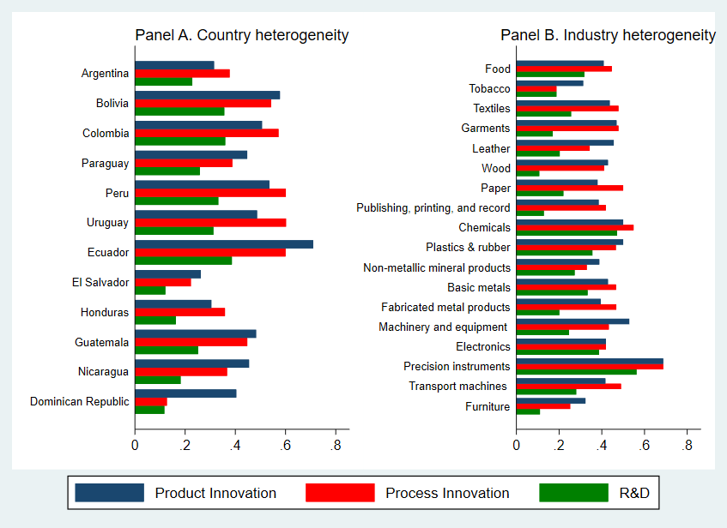

Figure 2: Mean Values of CEO Experience and Skilled Labour by Country and Sector
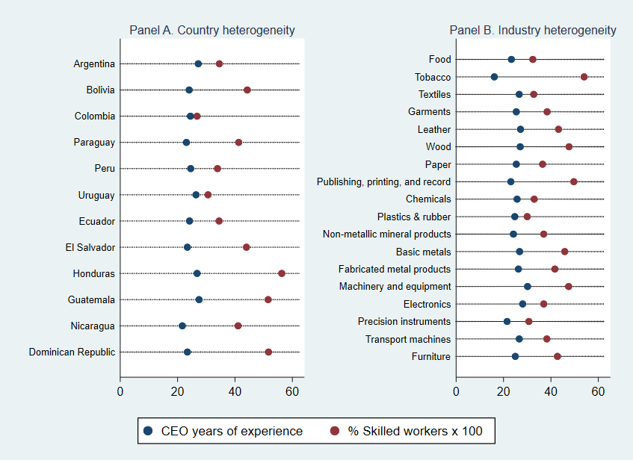

Figure 3: Cohort Analysis: Product Innovation Differences among various cohorts and subsamples
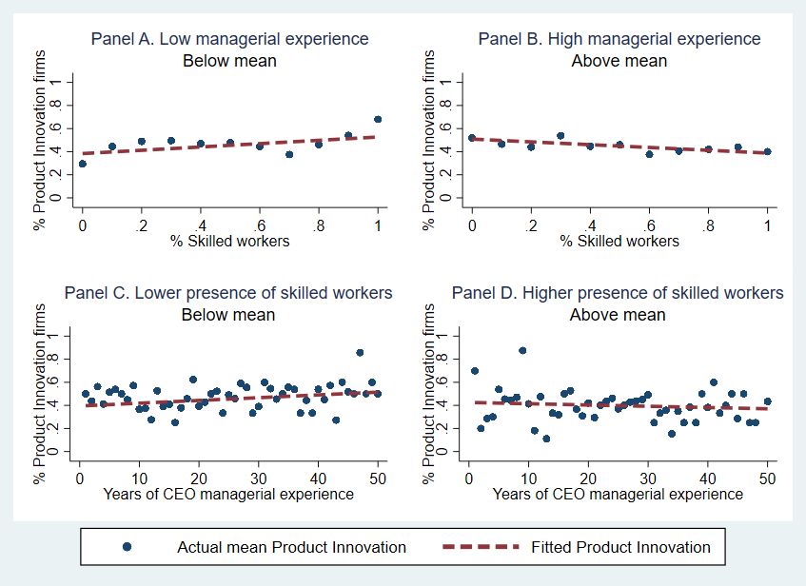

Figure 4: Graphical Interpretation of Interaction Effect of CEO’s Experience and % Skilled Workers on Product Innovation
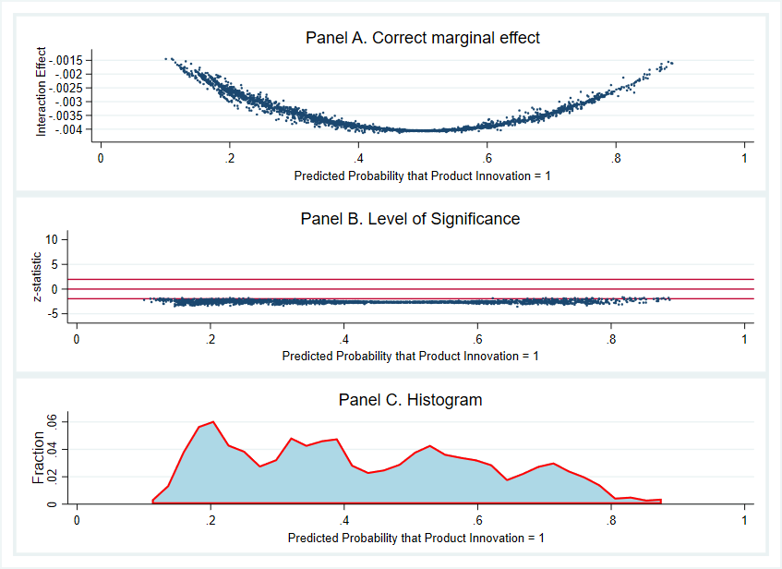
*Estimation based on Model 3 Table 2

Figure 5: Moderating Role of Manager’s Experience
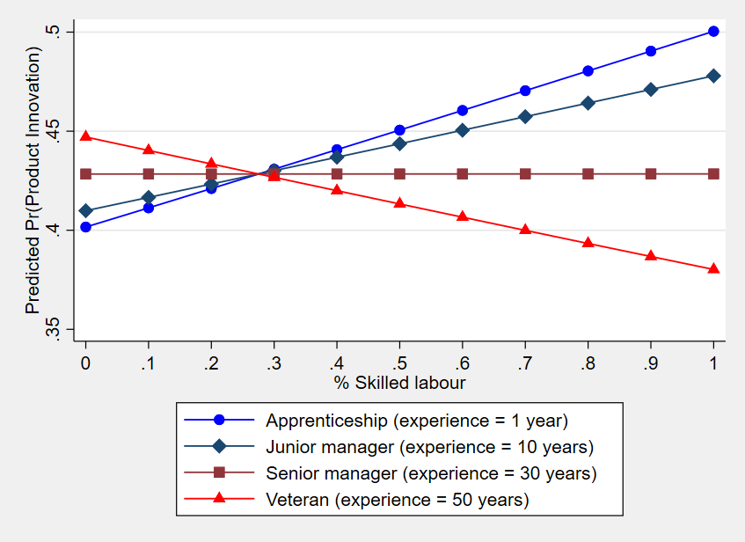

Figure 6: Contour Analysis
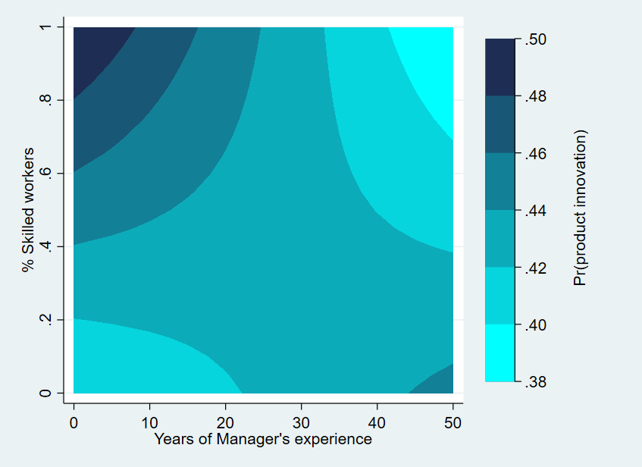

List of Tables
Table 1: Correlation Matrix

Table 2: Binary Choice Model

APPENDIX
A1: Map of Latin American Countries Introduced in the Analysis

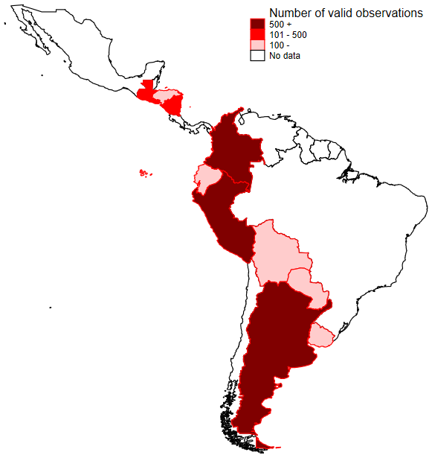

NOTE: Map includes only Latin American region, not the Caribbean. This means that the Dominican Republic (a Caribbean country with 58 observations in the sample) is not highlighted on the map.

According to the World Bank questionnaire manual, “highly skilled production workers are those workers involved in the production process whose main tasks and duties involve complex problem solving, decision making and creativity, technical and practical tasks requiring extensive body of theoretical, technical, procedural, and factual knowledge in a specialized field. A highly skilled worker usually has attended a higher educational institution for at least one year or more after completing secondary school. Skill is defined based on the occupation or tasks the individual performs rather than his/her qualifications. This type of skills corresponds to skill level 3 and 4 in the ILO classification”. Production workers with skill levels of 1 and 2 in the ILO classification are considered unskilled or semi-skilled, respectively.

