Molecular Functionalization and Emergence of Long-range Spin-dependent Phenomena in Two-dimensional (2D) Carbon Nanotube Networks

Md. Wazedur Rahman¹, Mari C. Mañas-Torres², Seyedamin Firouzeh¹, Juan Manuel Cuerva², Luis Álvarez de Cienfuegos^{2,†} and Sandipan Pramanik^{1,}*

¹ Department of Electrical and Computer Engineering, University of Alberta, Canada
² Universidad de Granada, Departamento de Química Orgánica, Facultad de Ciencias, Unidad de Excelencia de Química Aplicada a Biomedicina y Medioambiente (UEQ), 18071 Granada, Spain

† Corresponding author (lac@ugr.es)
* Corresponding author (spramani@ualberta.ca)

Abstract

Molecular functionalization of carbon nanotubes (CNTs) is a routine procedure in the field of nanotechnology. However, whether and how these molecules affect the spin polarization of the charge carriers are largely unknown. In this work we first demonstrate that spin polarization can indeed be induced in two-dimensional (2D) carbon nanotube networks by “certain” molecules and the spin signal routinely survives length scales significantly exceeding 1µm. This result effectively connects the area of molecular spintronics with that of carbon-based 2D nanoelectronics. By using the versatility of peptide chemistry, we further demonstrate how spin polarization depends on molecular structural features such as chirality as well as molecule-nanotube interactions. A new type of chirality-independent effect was detected in addition to the more common chirality-dependent effect, and the overall spin signal was found to be a combination of both. Finally, magnetic field dependence of the spin signals has been explored and the “chirality dependent” signal has been found to exist only in certain field angles.

- Introduction

Intersections of the apparently disparate areas of organic chemistry, carbon nanotubes and spintronics have intrigued the scientific community for several decades. Organic molecular functionalization of carbon nanotubes is a common technique for various nanotechnology applications.^{[1–6]} Spin transport in carbon nanotubes has been explored extensively due to its potential application in future information technology.^{[7,8]} The area of “organic spintronics” (or, “molecular spintronics”) explores spin transport in organic molecular systems and has found surprisingly long spin lifetimes which could be useful for quantum information processing and other applications.^{[9]} Recent developments in this area have unraveled an intriguing connection between organic molecular chirality and carrier spin polarization, often dubbed as “chirality-induced spin selectivity” or CISS.^{[10–12]} The key observation is that the transmission of spin unpolarized electrons through chiral molecules can polarize the carrier spins via a spin filtering effect, and that the spin orientation is determined by molecular chirality (left or right handed).^{[12]} CISS effect has been extensively studied using single molecule or self-assembled monolayers of DNA strands,^{[13]} oligopeptides,^{[14]} helicenes,^{[15]} polymers,^{[16]} metal-organic frameworks^{[17]} and crystals^{[18]}, supramolecular nanofibers^{[19]} etc.

While organic molecules offer virtually limitless chemical tunability, they behave as insulators in terms of their bulk (long-range) electronic properties, which inhibits their direct integration with mainstream electronics or emerging two-dimensional (2D) nanoelectronics.^{[20,21]} This can potentially be remedied by CNT-based CISS systems, which are more conductive than their organic molecular counterparts, and could provide a useful platform for practical spintronics devices. Initial studies have reported CISS effect in one or few carbon nanotubes which are functionalized with helical single-stranded DNA.^{[22–28]} Whether this effect persists in a two-dimensional nanotube network remains unknown. Ability to induce spin polarization in 2D CNT network would allow imparting spintronic functionalities to myriads of devices developed on this platform over the past few decades.^{[2]}

Despite significant experimental evidence in support of the CISS effect, its microscopic origin and a comprehensive and quantitative theoretical understanding remain elusive. Most theoretical models invoke molecular spin-orbit interaction to explain this effect, although the theoretically predicted effect is orders of magnitude smaller than the experimentally observed ones. In ref.^{[29]} an “orbital polarization model” was proposed, which does not require spin-orbit interaction in the molecule. Instead, in this model, electrons become orbital polarized during their transport through chiral molecules and this orbital polarization is converted to spin polarization by the spin-orbit coupling at the electrodes, resulting in CISS signals. Although most experimental and theoretical studies employ molecules with helical or chiral geometries, it is inversion asymmetry which is a necessary ingredient for the CISS effect.^{[29,30]} In principle, achiral inversion-asymmetric systems can also exhibit similar spin-selective phenomena.^{[29,31]} Given that a wide range of organic molecules form efficient non-covalent binding with CNTs in water via hydrophobic interactions,^{[1,32,33]} it remains unknown what role, if any, they play in inducing spin polarization in carbon nanotubes.

To shed light on some of these unknowns, in this study we consider two-dimensional single walled (SW) CNT networks as our conductive medium of choice. Such 2D SWCNT networks offer a high degree of electrical conductivity, which is tunable with CNT concentration, doping etc. These networks are easy to fabricate using commercially available SWCNTs, their transport properties are well understood,^{[34–36]} and they find a multitude of applications in electronics, optoelectronics and thermoelectrics.^{[2]} As functionalization entities we choose dipeptides linked to Fmoc (N-Fluorenylmethoxycarbonyl) molecules (Figure 1(a)). Fmoc has a planar, aromatic achiral structure, which efficiently binds with CNTs^{[33,37,38]} (as well as other Fmoc molecules^{[39–42]}) in water, mainly via π-stacking interactions and form a three-dimensional network. Chirality can be introduced by appropriately choosing the side chains R₁ and R₂ (Figure 1a) in the amino acids that constitute the dipeptide. For example, Fmoc-diglycine (Fmoc-GG; R₁ = R₂ = H) is achiral whereas Fmoc-dialanine (Fmoc-AA; R₁ = R₂ = -CH₃) or Fmoc-diphenylalanine (Fmoc-FF; R₁ = R₂ = -CH₂Ph) are chiral and therefore the spin filtering effect can be studied in both enantiomers using L and D amino acids. In addition, among the various side chains, the ones with aromatic rings (such as FF) are expected to bind with CNTs more efficiently than the ones without (such as AA and GG). In this work amino acids having identical side chains and chirality were chosen (i.e. R₁ = R₂, LL or DD) for ease of comparison between different data sets.

We note that the average diameter of the nanotubes is ~ 0.84 nm, with a nominal circumference of ~ 2.64 nm, whereas the Fmoc-dipeptide molecules are approximately ~2 nm in length.^{[39]} Thus, the nanotube wall can accommodate both the Fmoc and its side chain. This is supported by the Raman data discussed later in the paper. The choice of Fmoc-dipeptides as functionalization entities thus allows us to investigate the spin-dependent effects in a systematic way. We also note that Fmoc is a widely used protecting group in peptide chemistry and Fmoc-dipeptides are commonly used as supramolecular hydrogels and scaffolds for complex three-dimensional nanostructures.^{[38,43–45]}

The key findings of this work are as follows:
(a) We show for the first time that the CISS effect can be induced in two-dimensional conductive SWCNT networks using appropriate chiral functionalizations. This effect is immune to nanotube disorder and does not require helical functionalization of individual nanotubes. The spin signal is “long-range” and routinely survives length scales significantly exceeding 1 µm. This observation effectively bridges the gap between molecular spintronics and carbon-based two-dimensional (2D) nanoelectronics.

(b) Presence of aromatic ring in the chiral side chain is necessary to observe the CISS effect, presumably due to their more efficient binding with CNTs.

(c) Surprisingly, a non-zero spin signal has been observed in the case of a non-aromatic chiral group side chain. This effect, hitherto unreported, is independent of molecular chirality and hence cannot be ascribed to “chirality-induced” spin selective effect.

(d) Finally, angle-dependent measurements show that the CISS signal not only depends on the chirality of the molecule but also on the applied magnetic field direction. To our knowledge this has not been reported before and we show that our results are qualitatively consistent with a recently proposed theoretical model.

- Results and Discussion.

Fabrication of CNT hydrogel networks functionalized with Fmoc-FF, Fmoc-AA and Fmoc-GG has been described in the Supplementary Section using a modified protocol previously described by us.^{[38]} Briefly, a suspension of SWCNTs was prepared in an aqueous basic solution of Fmoc-dipeptide, followed by sonication and centrifugation. Gelification in this case was triggered using Na₂CO₃ instead of using δ-gluconolactone to avoid additional chiral molecules in the media.^{[46–48]} A slice of the gel is placed on Ni-Au electrode pairs (~ 100 nm thick, nominal electrode gap ~ 1‒2 µm) fabricated on SiO₂/Si, dried at room temperature and subsequently annealed. Helium ion microscopic image of the final device structure is shown in Figure 1(b). Two-dimensional nanotube network, functionalized with Fmoc-dipeptides, is connected between the contacts. The SWCNTs used in this work are achiral.

Raman characterization (Figure 1(c)) performed on the xerogels shows that the Fmoc-dipeptide molecules are indeed interacting with the CNTs. Intensity of the G⁻ peak (~ 1540 cm⁻¹), which arises due to the transverse vibration of the carbon atoms, gets suppressed as a result of functionalization. The FF molecules (both L and D) are most effective in suppressing this peak, whereas the effect is weakest for GG and AA has an intermediate effect (GG < AA < FF). This trend is summarized in Figure 1(d), which shows the G⁻/G⁺ intensity ratio for each functionalization, measured on multiple samples. Apart from the intensity ratio, locations of all the signature peaks such as RBM (radial breathing mode, ~250-300 cm⁻¹), G⁻ (discussed above) and G⁺ (~ 1590 cm⁻¹, which arises due to the longitudinal vibrations of the carbon atoms) are shifted as a result of functionalization (Figure 1(c)), indicating fractional charge transfer between the molecules and nanotubes.^{[38,49]} This data is summarized in the Supplementary Section (Figure S2).

As expected, the observed trend of GG < AA < FF in reducing the intensity of the G⁻ band shows that Fmoc-FF is interacting more strongly with CNTs than Fmoc-AA and Fmoc-GG. As previously shown in ref.^{[33]}, among the hydrophobic interactions that bind together Fmoc-amino acids and CNTs, π-stacking interactions between the aromatic groups of the amino acids with the CNT show higher values of interaction energy. Additional hydrophobic interactions come from amino acid backbones, and the more hydrophobic Fmoc-AA backbone shows stronger interactions compared to that of Fmoc-GG.

Figures 2(a), (c) show typical current-voltage (I-V) characteristics of the Fmoc-FF samples (both L and D, Ni-Au contacts) as a function of temperature (T) at zero magnetic field. Typical semiconducting behaviour is observed at low temperatures which in some cases changes to weak metallic behaviour at high temperatures (insets of Figures 2 (a), (c)). This is a common occurrence in two-dimensional SWCNT networks and has been reported by various groups in the past.^{[22,25,34–36,50]} This has been explained using a “heterogenous model” in which transport is viewed as metallic conduction in the tubes, interrupted by hopping or tunneling through small electrical barriers that arise from molecular functionalization, tangled regions, inter-tube junctions or tube defects.^{[34]} In the low temperature range, conduction is therefore thermally activated, whereas at higher temperatures metallic conduction manifests. Figures 2 (b) and (d) show fitting of temperature-dependent resistance R(T) with the two dimensional variable range hopping model: R(T) ∝ exp (T₀/T)^{1/3}, where T₀ is a parameter often referred to as the “characteristic temperature”.^{[51]} A linear dependence is observed over a wide temperature range. Small deviations are observed at the low and high temperature limits, the latter due to the metallic conduction as described above. Deviations at low temperatures are consistent with the CISS phenomenon, as reported before.^{[22]}

Figure S3 (Supplementary information) shows R(9K)/R(300K) at zero magnetic field for various functionalizations. For Fmoc-GG samples, the ratio is small (~2; also Figure S5), whereas for the Fmoc-FF samples the ratio is large (~10; also Figures 2 (a), (c) insets) and Fmoc-AA samples (Figure S4) fall in between. This is consistent with the GG < AA < FF trend observed from the Raman data earlier. Due to strong interaction with the CNTs, Fmoc-FF functionalized samples appear to suppress metallic conduction in the tubes and contribute additional potential barriers, which makes the conduction strongly thermally activated.

Electrical detection of the CISS effect typically involves a two-terminal geometry in which the chiral layer is contacted between a magnetic (such as Ni) and a non-magnetic (such as Au) electrode.^{[10]} Device resistances (R) are measured for two opposite magnetizations (± $\hat{m}$) of Ni and due to the CISS effect, unequal resistances are observed. Defining the CISS signal as [R($-\hat{m}$) $-$ R ($+\hat{m}$)] / min [R (± $\hat{m}$)] = Δ, the sign of Δ reverses as the chirality is reversed. Physically, carrier propagation in chiral systems generates chirality-dependent spin polarization, which either get transmitted or blocked depending on the direction of $\hat{m}$, giving rise to non-zero Δ. Another property of CISS systems is that for a given chirality, I ($+V$, ±$\hat{m}$) = I ($-V$, ±$\hat{m}$),^{[10]} i.e. for a given $\hat{m}$, reversal of applied bias does not alter the conductance state of the device.

Origin of two-terminal magnetoresistance (MR) Δ in CISS systems has been discussed extensively in recent literature.^{[52–54]} Based on Onsager reciprocity argument, it has been pointed out that the above two-terminal geometry cannot result in a non-zero Δ in the linear response regime i.e. when the I-V characteristics is linear, which typically happens in the low bias range.^{[52,53]} However, no such restriction applies in the non-linear regime, where most of the experimental observations are made.^{[10,52,53]} Recent experiments have shown non-zero two-terminal MR in both linear and non-linear regimes.^{[55]} These results have been explained using a model proposed in ref.^{[54]}, which suggests that in a two-terminal geometry true equilibrium is reached with local spin accumulation on the non-magnetic electrode, which depends on $\hat{m}$ as well as molecular chirality. Reversing $\hat{m}$ changes the local magnetization, which results in different conductances for ±$\hat{m}$.

Figures 3 (a)-(d) show two-terminal MR measurements on Fmoc-FF (L and D) samples. Direction of the magnetic field is perpendicular to the sample plane (θ = 90º), i.e. Ni magnetization is out-of-plane. A background negative MR is observed, which is a common occurrence in CNT networks^{[22,28,35,36,50]}, and originates from the magnetic field dependence of hopping conductivities in these samples.^{[28,35,36,56,57]} Most importantly, we observe a non-zero Δ (= R(-12 kG) $-$ R (+12 kG) / min [R (±12 kG)]) for each functionalization. For the L samples Δ is negative, whereas for the D samples Δ is positive. Figures 3 (e), (f) show bias dependence of resistance (computed by numerical differentiation of the I-V data), which shows the symmetric nature of device conduction for ±V. This data unequivocally demonstrates that CISS effect is induced in two-dimensional CNT networks by Fmoc-FF functionalization. We note that this effect is “long-range” i.e. it survives long channel length of ~ 2 µm, even in the presence of significant nanotube disorder. The experimentally accessible signal Δ is an “ensemble average”, and surprisingly the MR signal is still approximately in the same range of those obtained from ordered chiral molecules under comparable conditions.^{[10]} In addition, due to the planar geometry, these devices do not suffer from the reliability issues encountered in the vertically stacked geometry.^{[58]}

Figures 4(a), (b) show the temperature dependences of background MR (defined as (R(0) - min[R(±12 kG)])/ min [R(±12 kG)]) and Δ respectively, as observed in Figure 3. The MR responses of both L and D follow a similar non-monotonic trend and gradually decrease with temperature. MR nonmonotonicity in CNT based chiral systems has been reported before^{[22–24]}, which arises due to an interplay between the quantum interference effect between the forward and reverse hopping paths and simultaneous suppression of carrier backscattering due to the CISS effect at low temperatures. The magnitude of the MR asymmetry signal Δ decays monotonically with temperature. This is presumably due to enhanced spin scattering at higher temperatures in CNTs, which has been reported before.^{[7]} An interesting observation from Figure 4(b) is that the CISS signal Δ from the D molecules is stronger than that of L. Origin of this will be discussed later in the paper.

The role of temperature and resulting lattice distortion on the CISS effect has received considerable attention recently. Ref.^{[59]} investigates transport of polarons, formed as a result of strong electron-lattice coupling in chiral molecules, in presence of spin orbit coupling. A spin-momentum locking feature was observed which gives rise to significant spin polarization. The value of spin polarization increases with the number of atomic sites and finally saturates. Ref.^{[60]} explored the role of interaction of electrons with lattice vibration in double-stranded DNA molecules, and it has been found to favor the CISS effect. Ref.^{[61]} proposed spin-dependent electron-phonon coupling as a possible mechanism for the CISS effect. Lattice vibrations or phonons result in a variation of the crystal potential, which couples with spin via spin-orbit interaction. This has been shown to result in exchange splitting between the spin channels, which will result in spin-dependent transmission between a nonmagnetic and a magnetic electrode, similar to the CISS effect. Spin polarization has been found to increase with the molecular chain length, which is qualitatively consistent with ref.^{[59]} and also agrees with prior CISS experiments as well as our observation of long-distance survival of the spin signal. With increasing temperature, spin polarization has been found to increase and then saturate. While this is consistent with the purely molecular CISS systems where room temperature signal was observed, our present study shows a different behavior. In the CNT based systems spin signal actually decays with temperature, which could be due to temperature dependent spin randomization mechanisms being active between the spin split channels.

Figure 4(c) shows angle (θ) dependence of normalized Δ as observed from multiple samples (both L and D). In each case normalization has been done relative to the corresponding maximum value of Δ (say Δ_{max}) for ease of comparison. The MR responses shown earlier in Figure 3 are for θ = 90º, which corresponds to out-of-plane magnetic field (and hence out-of-plane Ni magnetization $\hat{m}$); similarly, θ = 0º corresponds to in-plane magnetic field and in-plane $\hat{m}$). The measurement geometry is shown in Figure 4(c) inset, as well as in Figure 1(b). Interestingly, we notice that for some angle ranges Δ has the same sign for both chiralities. Thus, the chirality-dependent response exists only in a few narrow ranges of θ (in the vicinity of 90º and 270º). Overall, Δ has a periodicity of ~360º. This is consistent with the general CISS behaviour in which Ni magnetization and chirality jointly select one direction along which current flow is favoured.

Dependence of Δ on both $\hat{m}$ and chirality is consistent with recent theoretical models. According to the model proposed in ref.^{[54]} the nonmagnetic contact (Au) is locally magnetized under equilibrium. This occurs as a result of transient spin transfer from the magnetic lead (Ni) through the chiral medium to Au, which ensures zero current under equilibrium. The induced local magnetization of the Au contact (say $\hat{m'}$) depends on $\hat{m}$ as well as molecular chirality. The induced magnetization $\hat{m'}$ can be decomposed into two components that are perpendicular and parallel to Ni magnetization $\hat{m}$. The perpendicular component changes sign as $\hat{m}$ is reversed, but the parallel component remains unchanged. Thus, as $\hat{m}$ is changed $\hat{m'}$ changes as well in a non-trivial way. Under small applied bias this setup generates non-zero Δ, which will clearly be dependent on $\hat{m}$ as well as molecular chirality.

To explore the existence of the CISS effect for other types of chiral molecular functionalization, we chose Fmoc-AA. Although Fmoc-AA is chiral, unlike Fmoc-FF its side chain is non-aromatic and hence it is expected to have weaker interaction with the CNTs. The Raman and transport data presented earlier confirms that this is indeed the case. Figure 5 shows MR responses of Fmoc-AA functionalized CNTs for θ = 90º. Background negative MR is present as before. Asymmetric MR (i.e. non-zero Δ) is present as well, which indicates spin-dependent transmission through the Ni spin detector. However, unlike Fmoc-FF the sign of Δ is independent of molecular chirality, and it is positive for both L and D samples. Chirality independence of Δ can be rationalized by invoking weak interaction of the chiral side chain with CNTs as discussed above. However it remains unclear why the MR asymmetry Δ manifested in the first place, since the chiral interaction is weak.

Figure 6 summarizes the salient features of the MR responses observed in Figure 5 such as (i) non-monotonic temperature dependence of the background MR (Figure 6(a)) and (ii) gradual decay of Δ with temperature. Unlike Fmoc-FF, in the case of Fmoc-AA Δ has the same sign (positive) for both L and D functionalizations. Figure 6(c) shows Δ as a function of Ni magnetization orientation θ. Unlike Fmoc-FF, the sign of Δ is virtually the same for L and D molecules at all measurement angles θ, which precludes detection of any “chirality-dependent” behaviour at any angle.

Since side chain interaction with CNTs appears to have an influence on Δ, next we chose Fmoc-GG as the functionalization agent. Fmoc-GG is achiral and has the weakest interaction with SWCNTs compared to Fmoc-AA and Fmoc-FF as discussed earlier. Figure 7 shows the MR responses of Fmoc-GG functionalized SWCNTs. The background negative MR is present, but MR asymmetry Δ could barely be detected above the noise level (for θ = 90º and other angles). Combined with the Fmoc-FF and Fmoc-AA data presented above, this shows that the side chain interaction with SWCNT plays a central role in determining Δ, which is related to the spin polarization of the carriers.

There are two primary sources of interaction between Fmoc-dipeptides and CNTs: (a) interaction of the aromatic rings belonging to the Fmoc group with CNTs and (b) interaction of the dipeptide side chains with CNTs. The former is common for all the molecules discussed above, and the latter is variable with a trend GG < AA < FF as discussed before. In case of Fmoc-GG, side chain interaction is negligible, and hence absence of Δ in this case indicates that the interaction of the Fmoc group aromatic rings with CNT does not result in any spin-polarization of the charge carriers.

The MR asymmetry Δ (implying carrier spin polarization) in case of Fmoc-AA must therefore be attributed to the peptide side chain interaction with the CNTs. However, this induced spin polarization is not dependent on molecular chirality, as demonstrated in Figures 5 and 6, and hence doesn’t fall under the category of “chirality-induced” spin selectivity (CISS). As discussed earlier, this could be related to the inherent inversion asymmetry of the chiral molecules considered.^{[29,31]} Chirality independence of Δ could be attributed to the weak interaction of the chiral side chain with CNTs.

If the above hypothesis is correct then this inversion-asymmetry related Δ should also be present in case of Fmoc-FF, although in this case strong side chain interaction dominates the MR response and gives rise to CISS effect. This underlying inversion asymmetry effect could explain why the Δ signals have different magnitudes for Fmoc-FF (L) and Fmoc-FF (D) as shown in Figure 4(b). As seen from Figure 5, this inversion asymmetry effect results in positive Δ, which will oppose the CISS signal for Fmoc-FF (L) and aid the CISS signal for Fmoc-FF (D). Therefore, the D signal (positive Δ) in Figure 4(b) is stronger than the L signal (negative Δ), because it is a combined effect of the molecular chirality as well as inherent inversion asymmetry.

To summarize, in this study we have tested the role of molecular functionalization on inducing spin polarization in two-dimensional carbon nanotube networks. Achiral, aromatic interactions (such as the Fmoc group with CNT in the case of Fmoc-GG) did not result in any detectable spin signal. “Weak” chirality was then introduced in the system by replacing the side group with a non-aromatic but chiral entity (the case of Fmoc-AA, which interacts weakly with CNT). This resulted in a chirality-independent spin signal, presumably due to the inversion asymmetry of the system. Next, “strong” chirality was introduced by replacing the side chain with an aromatic chiral entity (the case of Fmoc-FF, which interacts strongly with CNT). This resulted in a spin signal which is a combination of the chirality dependent part as well as the inversion asymmetric part. Effect of inversion asymmetry on spin signals is a virtually unexplored area, especially compared to their CISS counterpart. Further studies in this area are needed to generate a coherent understanding of these phenomena.

Looking at the bigger picture, this study indicates that long-range (~ 1‒2 µm) spin dependent effects can be induced in a wide variety of two-dimensional carbon-based materials functionalized with appropriate chiral entities. We offer preliminary “rules of thumb” regarding what molecular structural features could be most appropriate for this purpose. Since the CISS effect is enhanced with the spatial extent of the chiral scattering path, the proposed scheme can result in even longer-range (presumably tens of microns or more) spin information transmission. Some of these studies are currently in progress.

- Acknowledgements.

This study was supported by project FEDER/Junta de Andalucía- Consejería de Transformación Económica, Industria, Conocimiento y Universidades (Spain) project P18-FR-3533. MCMT acknowledge grant PRE2018-083773 funded by MCIN/AEI/10.13039/501100011033 and FSE “El FSE invierte en tu futuro”, Spain. S. P. acknowledges the support from NFRFE (New Frontiers in Research Fund - Exploration) and NSERC (Natural Sciences and Engineering Research Council) Canada.

[1] C. Gao, Z. Guo, J.-H. Liu, X.-J. Huang, Nanoscale 2012, 4, 1948.
[2] Y. Wu, X. Zhao, Y. Shang, S. Chang, L. Dai, A. Cao, ACS Nano 2021, 15, 7946.
[3] S. Marchesan, M. Melchionna, M. Prato, ACS Nano 2015, 9, 9441.
[4] D. Iglesias, M. Melle-Franco, M. Kurbasic, M. Melchionna, M. Abrami, M. Grassi, M. Prato, S. Marchesan, ACS Nano 2018, 12, 5530.
[5] S. Adorinni, P. Rozhin, S. Marchesan, Biomedicines 2021, 9, 570.
[6] P. Rozhin, C. Charitidis, S. Marchesan, Molecules 2021, 26, 4084.
[7] A. Cottet, T. Kontos, S. Sahoo, H. T. Man, M.-S. Choi, W. Belzig, C. Bruder, A. F. Morpurgo, C. Schönenberger, Semicond. Sci. Technol. 2006, 21, S78.
[8] L. E. Hueso, J. M. Pruneda, V. Ferrari, G. Burnell, J. P. Valdés-Herrera, B. D. Simons, P. B. Littlewood, E. Artacho, A. Fert, N. D. Mathur, Nature 2007, 445, 410.
[9] Y. Zhang, L. Guo, X. Zhu, X. Sun, Front. Chem. 2020, 8.
[10] D. H. Waldeck, R. Naaman, Y. Paltiel, APL Mater. 2021, 9, 040902.
[11] C. D. Aiello, M. Abbas, J. Abendroth, A. S. Banerjee, D. Beratan, J. Belling, B. Berche, A. Botana, J. R. Caram, L. Celardo, G. Cuniberti, A. Dianat, Y. Guo, R. Gutierrez, C. Herrmann, J. Hihath, S. Kale, P. Kurian, Y.-C. Lai, E. Medina, V. Mujica, R. Naaman, M. Noormandipour, J. Palma, Y. Paltiel, W. Petuskey, J. C. Ribeiro-Silva, D. Stemer, A. Valdes-Curiel, S. Varela, D. Waldeck, P. S. Weiss, H. Zacharias, Q. H. Wang, ArXiv200900136 Cond-Mat Physicsquant-Ph 2020.
[12] R. Naaman, Y. Paltiel, D. H. Waldeck, Nat. Rev. Chem. 2019, 3, 250.
[13] Z. Xie, T. Z. Markus, S. R. Cohen, Z. Vager, R. Gutierrez, R. Naaman, Nano Lett. 2011, 11, 4652.
[14] M. Kettner, B. Göhler, H. Zacharias, D. Mishra, V. Kiran, R. Naaman, D. H. Waldeck, S. Sęk, J. Pawłowski, J. Juhaniewicz, J. Phys. Chem. C 2015, 119, 14542.
[15] V. Kiran, S. P. Mathew, S. R. Cohen, I. H. Delgado, J. Lacour, R. Naaman, Adv. Mater. 2016, 28, 1957.
[16] S. Mishra, A. K. Mondal, E. Z. B. Smolinsky, R. Naaman, K. Maeda, T. Nishimura, T. Taniguchi, T. Yoshida, K. Takayama, E. Yashima, Angew. Chem. 2020, 132, 14779.
[17] U. Huizi-Rayo, J. Gutierrez, J. M. Seco, V. Mujica, I. Diez-Perez, J. M. Ugalde, A. Tercjak, J. Cepeda, E. San Sebastian, Nano Lett. 2020, 20, 8476.
[18] A. K. Mondal, N. Brown, S. Mishra, P. Makam, D. Wing, S. Gilead, Y. Wiesenfeld, G. Leitus, L. J. W. Shimon, R. Carmieli, D. Ehre, G. Kamieniarz, J. Fransson, O. Hod, L. Kronik, E. Gazit, R. Naaman, ACS Nano 2020, 14, 16624.
[19] C. Kulkarni, A. K. Mondal, T. K. Das, G. Grinbom, F. Tassinari, M. F. J. Mabesoone, E. W. Meijer, R. Naaman, Adv. Mater. 2020, 32, 1904965.
[20] G. Fiori, F. Bonaccorso, G. Iannaccone, T. Palacios, D. Neumaier, A. Seabaugh, S. K. Banerjee, L. Colombo, Nat. Nanotechnol. 2014, 9, 768.
[21] A. C. Ferrari, F. Bonaccorso, V. Fal’ko, K. S. Novoselov, S. Roche, P. Bøggild, S. Borini, F. H. L. Koppens, V. Palermo, N. Pugno, J. A. Garrido, R. Sordan, A. Bianco, L. Ballerini, M. Prato, E. Lidorikis, J. Kivioja, C. Marinelli, T. Ryhänen, A. Morpurgo, J. N. Coleman, V. Nicolosi, L. Colombo, A. Fert, M. Garcia-Hernandez, A. Bachtold, G. F. Schneider, F. Guinea, C. Dekker, M. Barbone, Z. Sun, C. Galiotis, A. N. Grigorenko, G. Konstantatos, A. Kis, M. Katsnelson, L. Vandersypen, A. Loiseau, V. Morandi, D. Neumaier, E. Treossi, V. Pellegrini, M. Polini, A. Tredicucci, G. M. Williams, B. H. Hong, J.-H. Ahn, J. M. Kim, H. Zirath, B. J. van Wees, H. van der Zant, L. Occhipinti, A. D. Matteo, I. A. Kinloch, T. Seyller, E. Quesnel, X. Feng, K. Teo, N. Rupesinghe, P. Hakonen, S. R. T. Neil, Q. Tannock, T. Löfwander, J. Kinaret, Nanoscale 2015.
[22] Md. W. Rahman, S. Firouzeh, V. Mujica, S. Pramanik, ACS Nano 2020, 14, 3389.
[23] K. M. Alam, S. Pramanik, Adv. Funct. Mater. 2015, 25, 3210.
[24] K. M. Alam, S. Pramanik, Nanoscale 2017, 9, 5155.
[25] Md. W. Rahman, K. M. Alam, S. Pramanik, ACS Omega 2018, 3, 17108.
[26] G. S. Diniz, A. Latgé, S. E. Ulloa, Phys. Rev. Lett. 2012, 108, 126601.
[27] Y. Perlitz, K. Michaeli, Phys. Rev. B 2018, 98, 195405.
[28] M. W. Rahman, S. Firouzeh, S. Pramanik, Nanotechnology 2021, 32, 455001.
[29] Y. Liu, J. Xiao, J. Koo, B. Yan, Nat. Mater. 2021, 20, 638.
[30] A. Ghazaryan, Y. Paltiel, M. Lemeshko, J. Phys. Chem. C 2020, 124, 11716.
[31] A.-M. Guo, T.-R. Pan, T.-F. Fang, X. C. Xie, Q.-F. Sun, Phys. Rev. B 2016, 94, 165409.
[32] F. Tournus, S. Latil, M. I. Heggie, J.-C. Charlier, Phys. Rev. B 2005, 72, 075431.
[33] B. G. Cousins, A. K. Das, R. Sharma, Y. Li, J. P. McNamara, I. H. Hillier, I. A. Kinloch, R. V. Ulijn, Small 2009, 5, 587.
[34] A. B. Kaiser, G. Düsberg, S. Roth, Phys. Rev. B 1998, 57, 1418.
[35] G. T. Kim, E. S. Choi, D. C. Kim, D. S. Suh, Y. W. Park, K. Liu, G. Duesberg, S. Roth, Phys. Rev. B 1998, 58, 16064.
[36] M. Jaiswal, W. Wang, K. A. S. Fernando, Y.-P. Sun, R. Menon, Phys. Rev. B 2007, 76, 113401.
[37] S. Roy, A. Banerjee, RSC Adv. 2012, 2, 2105.
[38] R. Contreras‐Montoya, G. Escolano, S. Roy, M. T. Lopez‐Lopez, J. M. Delgado‐López, J. M. Cuerva, J. J. Díaz‐Mochón, N. Ashkenasy, J. A. Gavira, L. Á. de Cienfuegos, Adv. Funct. Mater. 2019, 29, 1807351.
[39] V. Jayawarna, M. Ali, T. A. Jowitt, A. F. Miller, A. Saiani, J. E. Gough, R. V. Ulijn, Adv. Mater. 2006, 18, 611.
[40] A. Mahler, M. Reches, M. Rechter, S. Cohen, E. Gazit, Adv. Mater. 2006, 18, 1365.
[41] K. Tao, A. Levin, L. Adler-Abramovich, E. Gazit, Chem. Soc. Rev. 2016, 45, 3935.
[42] S. Fleming, R. V. Ulijn, Chem. Soc. Rev. 2014, 43, 8150.
[43] G. Wei, Z. Su, N. P. Reynolds, P. Arosio, I. W. Hamley, E. Gazit, R. Mezzenga, Chem. Soc. Rev. 2017, 46, 4661.
[44] A. Levin, T. A. Hakala, L. Schnaider, G. J. L. Bernardes, E. Gazit, T. P. J. Knowles, Nat. Rev. Chem. 2020, 4, 615.
[45] R. Contreras-Montoya, M. Arredondo-Amador, G. Escolano-Casado, M. C. Mañas-Torres, M. González, M. Conejero-Muriel, V. Bhatia, J. J. Díaz-Mochón, O. Martínez-Augustin, F. S. de Medina, M. T. Lopez-Lopez, F. Conejero-Lara, J. A. Gavira, L. Á. de Cienfuegos, ACS Appl. Mater. Interfaces 2021, 13, 11672.
[46] L. Chen, G. Pont, K. Morris, G. Lotze, A. Squires, L. C. Serpell, D. J. Adams, Chem. Commun. 2011, 47, 12071.
[47] L. Chen, T. O. McDonald, D. J. Adams, RSC Adv. 2013, 3, 8714.
[48] M. C. Mañas-Torres, C. Gila-Vilchez, J. A. González-Vera, F. Conejero-Lara, V. Blanco, J. Manuel Cuerva, M. T. Lopez-Lopez, A. Orte, L. Á. de Cienfuegos, Mater. Chem. Front. 2021, 5, 5452.
[49] M. S. Dresselhaus, G. Dresselhaus, R. Saito, A. Jorio, Phys. Rep. 2005, 409, 47.
[50] K. Yanagi, H. Udoguchi, S. Sagitani, Y. Oshima, T. Takenobu, H. Kataura, T. Ishida, K. Matsuda, Y. Maniwa, ACS Nano 2010, 4, 4027.
[51] L. B. Ioffe, B. Z. Spivak, J. Exp. Theor. Phys. 2013, 117, 551.
[52] X. Yang, C. H. van der Wal, B. J. van Wees, Phys. Rev. B 2019, 99, 024418.
[53] X. Yang, C. H. van der Wal, B. J. van Wees, Nano Lett. 2020, 20, 6148.
[54] S. Dalum, P. Hedegård, Nano Lett. 2019, 19, 5253.
[55] T. Liu, X. Wang, H. Wang, G. Shi, F. Gao, H. Feng, H. Deng, L. Hu, E. Lochner, P. Schlottmann, S. von Molnár, Y. Li, J. Zhao, P. Xiong, ACS Nano 2020, 14, 15983.
[56] M. E. Raikh, G. F. Wessels, Phys. Rev. B 1993, 47, 15609.
[57] V. L. Nguen, B. Z. Spivak, B. I. Shklovskii, J. Exp. Theor. Phys. 1985, 62, 1021.
[58] K. Michaeli, V. Varade, R. Naaman, D. H. Waldeck, J. Phys. Condens. Matter 2017, 29, 103002.
[59] L. Zhang, Y. Hao, W. Qin, S. Xie, F. Qu, Phys. Rev. B 2020, 102, 214303.
[60] G.-F. Du, H.-H. Fu, R. Wu, Phys. Rev. B 2020, 102, 035431.
[61] J. Fransson, Phys. Rev. B 2020, 102, 235416.

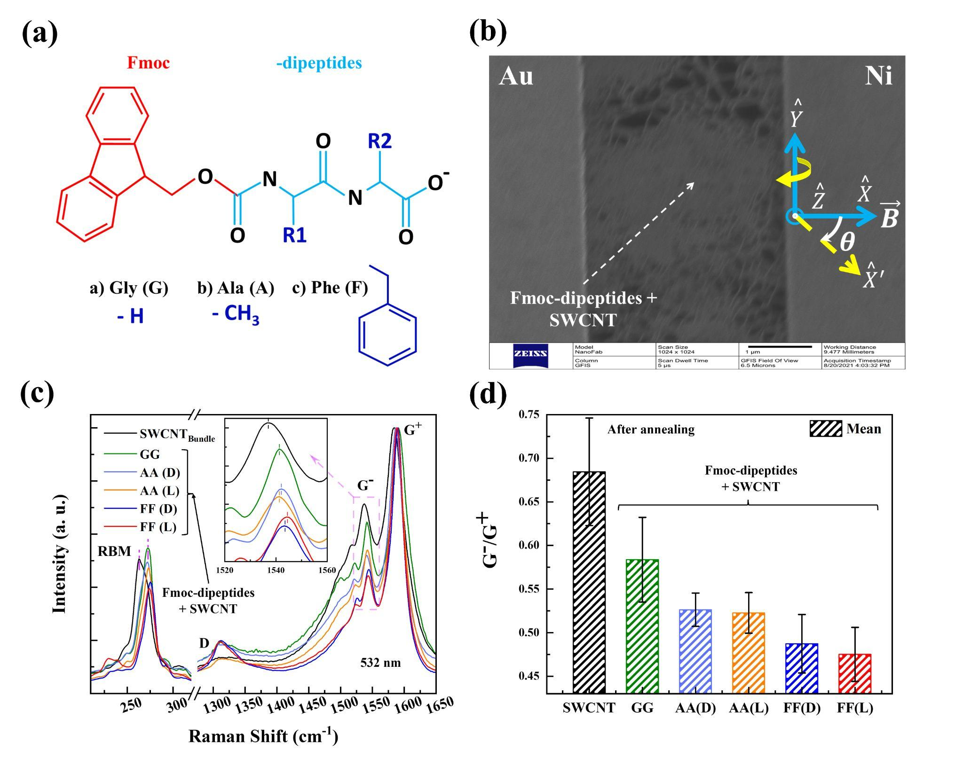

Figure 1. (a) Molecular structure of Fmoc–dipeptides and the chosen side groups (R₁, R₂): (a) Gly (G), (b) Ala (A), and (c) Phe (F). (b) Helium ion microscope (HiM) image of a typical device. Two-dimensional functionalized carbon nanotube networks are connected between Au and Ni electrodes. Channel length ~ 2 µm. Sample plane is X-Y, with the X axis coinciding with the magnetic field B at θ = 0º. For angle (θ)-dependent measurements, the sample plane is rotated clockwise relative to the Y axis as shown, with the magnetic field direction remaining fixed. This changes the Ni magnetization direction as well as the angle between magnetic field and the two-terminal current. At 0º Ni magnetization is in-plane, whereas at 90º it is out of plane. In this study magnetic field is applied by an electromagnet and I-V and MR measurements are performed using Keithley Dual Channel Source Meter and a Picotest Multimeter. (c), (d) Raman characterization of the functionalized nanotubes.

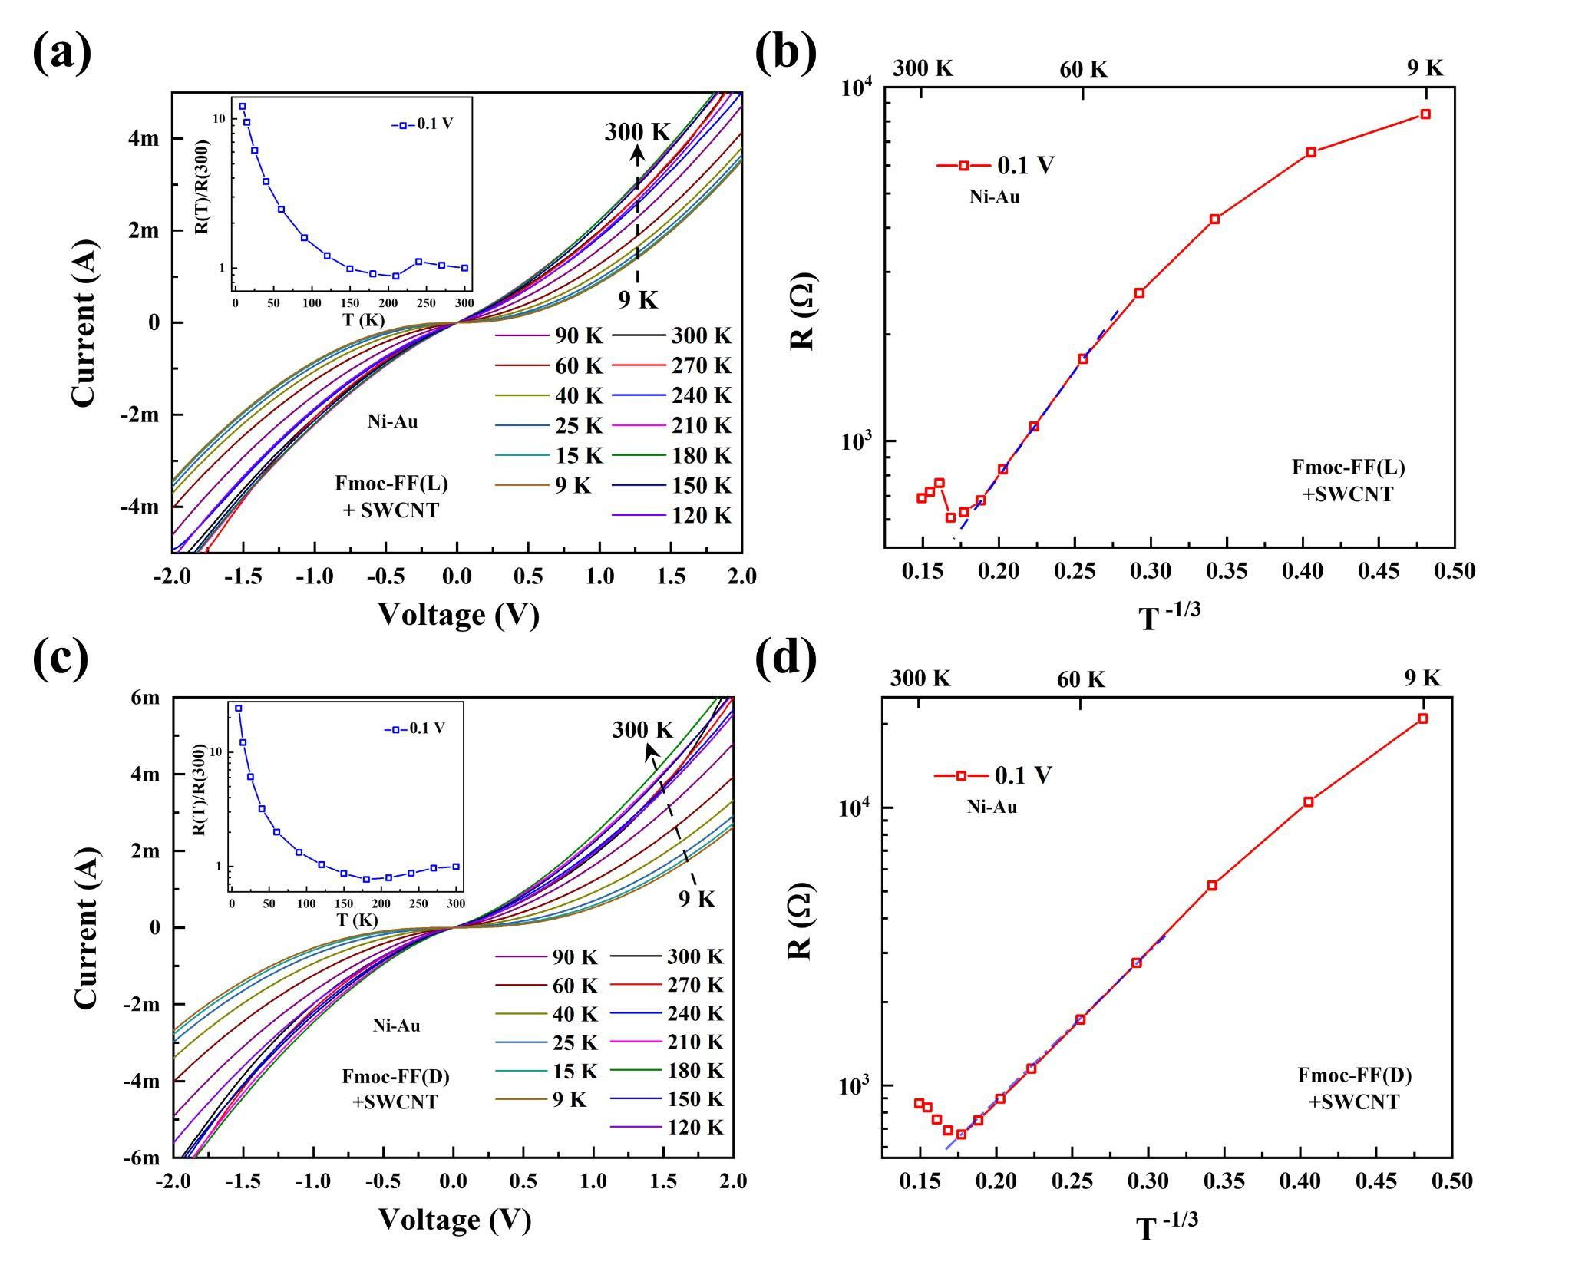
Figure 2. Current-voltage (I-V) characteristics (at zero magnetic field) of (a) Fmoc-FF (L) and (c) Fmoc-FF (D) functionalized SWCNTs with Ni-Au contacts. (b), (d) Fitting of device resistance R (= dV/dI) with the variable range hopping model for d = 2.

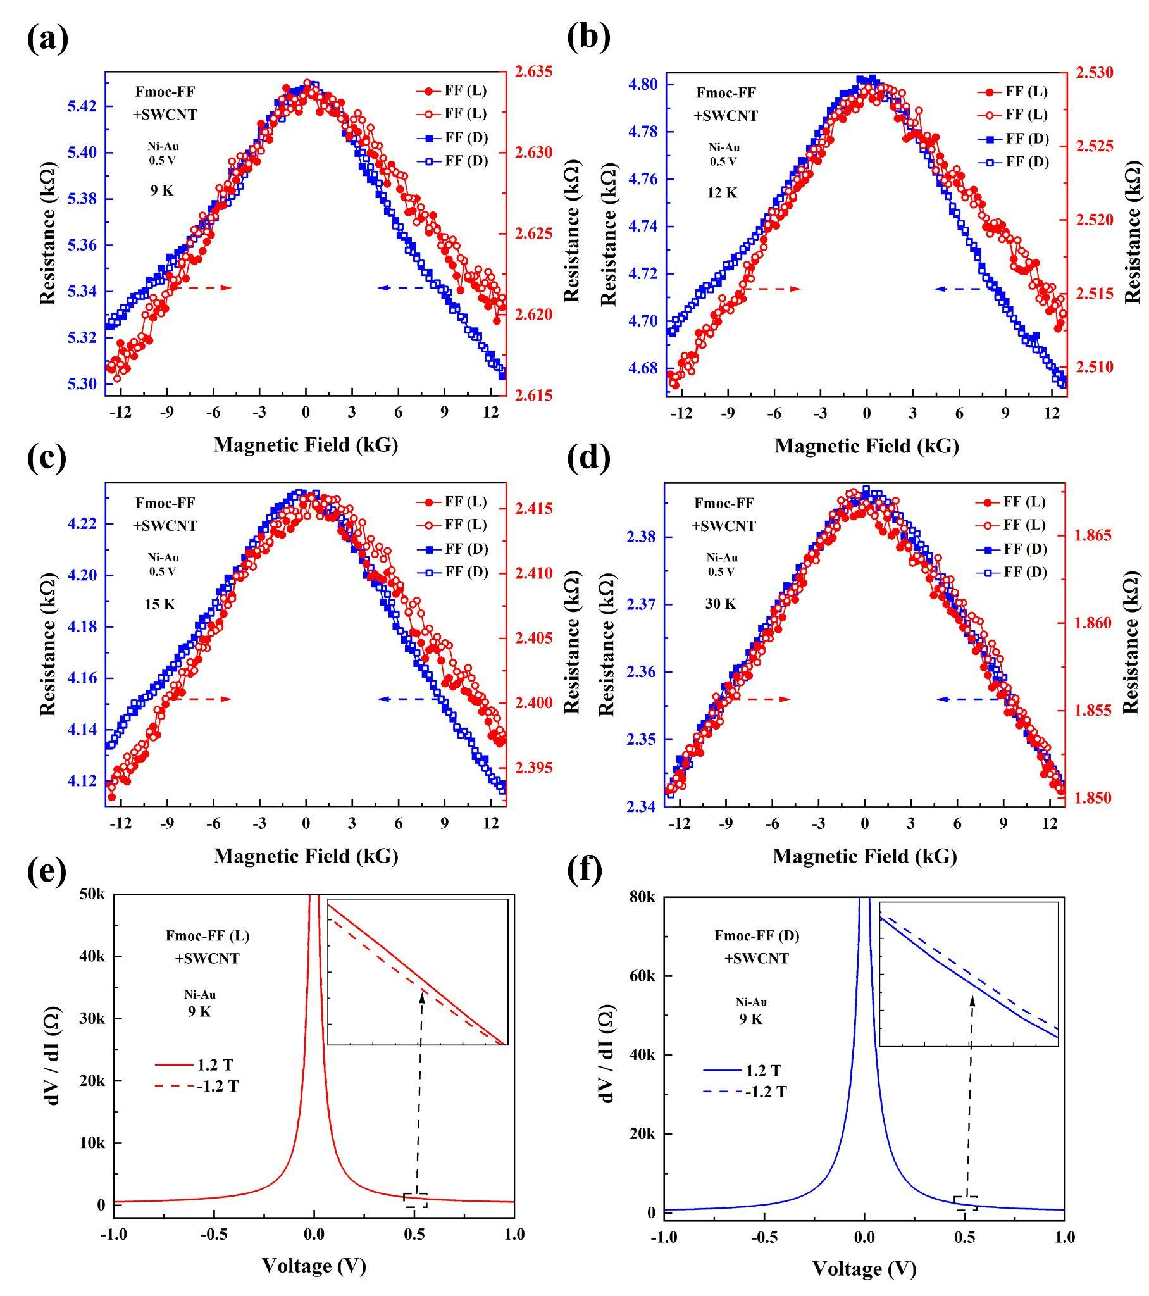

Figure 3. (a)-(d) Asymmetric MR (θ = 90º) of achiral SWCNTs functionalized with Fmoc-FF (L or D) at various temperatures. Applied bias is 0.5 V in all cases. Solid (open) symbols indicate magnetic field scan from negative (positive) to positive (negative) fields. MR asymmetry has been found to be chirality-dependent. (e), (f) Differential resistance (dV/dI) vs bias (V).
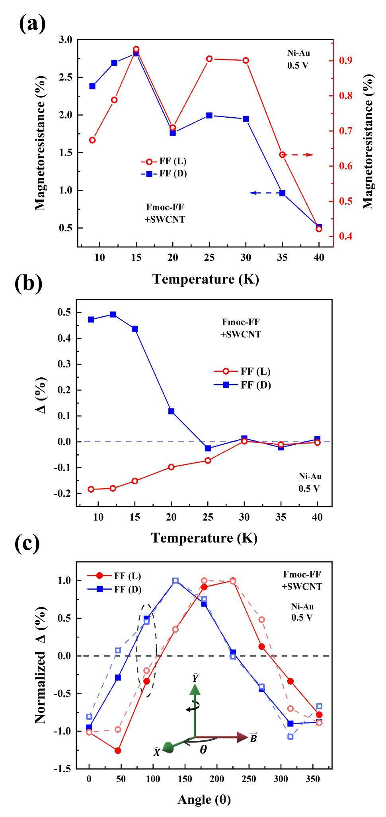
Figure 4. (a) Temperature dependence of background MR (at θ = 90º) for Fmoc-FF (L or D) functionalized SWCNTs. (b) MR asymmetry Δ (%) as a function of temperature (at θ = 90º). (c) Normalized Δ (%) at different orientations of Ni magnetization. Sample is in the X-Y plane. For each sample, normalization is done relative to the corresponding maximum value of Δ. Responses from two different samples are shown for each functionalization. Applied bias is 0.5 V in all cases.

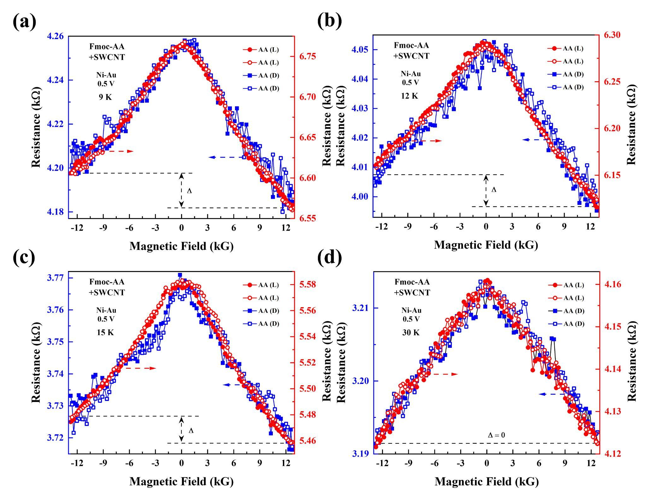
Figure 5. (a)-(d) Asymmetric MR of Fmoc-AA (L or D) functionalized SWCNTs using Ni-Au contacts at various temperatures (θ = 90º). Applied bias is 0.5 V in all cases. Solid (open) symbols indicate magnetic field scan from negative (positive) to positive (negative) fields. MR asymmetry is independent of molecular chirality.

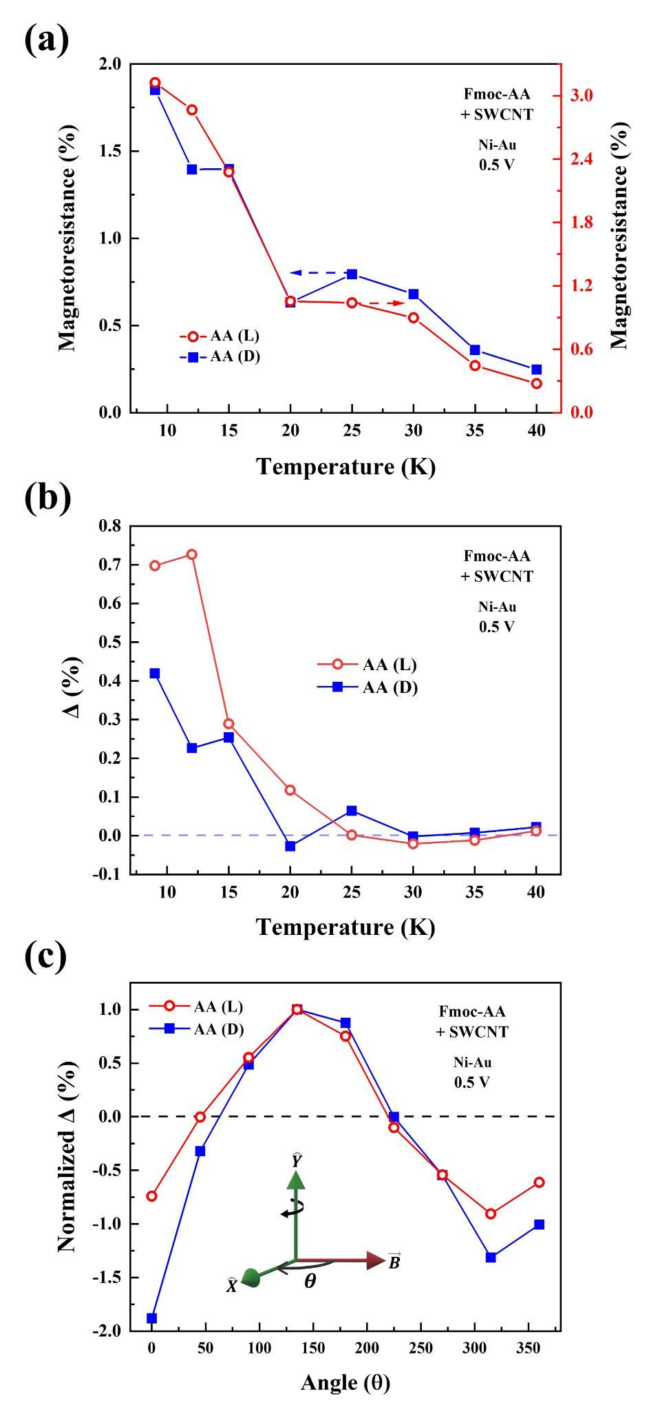
Figure 6. (a) Temperature dependence of background MR (θ = 90º) for Fmoc-AA (L or D) functionalized SWCNTs. (b) Δ (%) as a function of temperature. (c) Normalized Δ (%) at different magnetization orientations of Ni. Sample is in the X-Y plane. For each type of sample, normalization is done relative to the corresponding maximum value of Δ. Applied bias is 0.5 V in all cases.
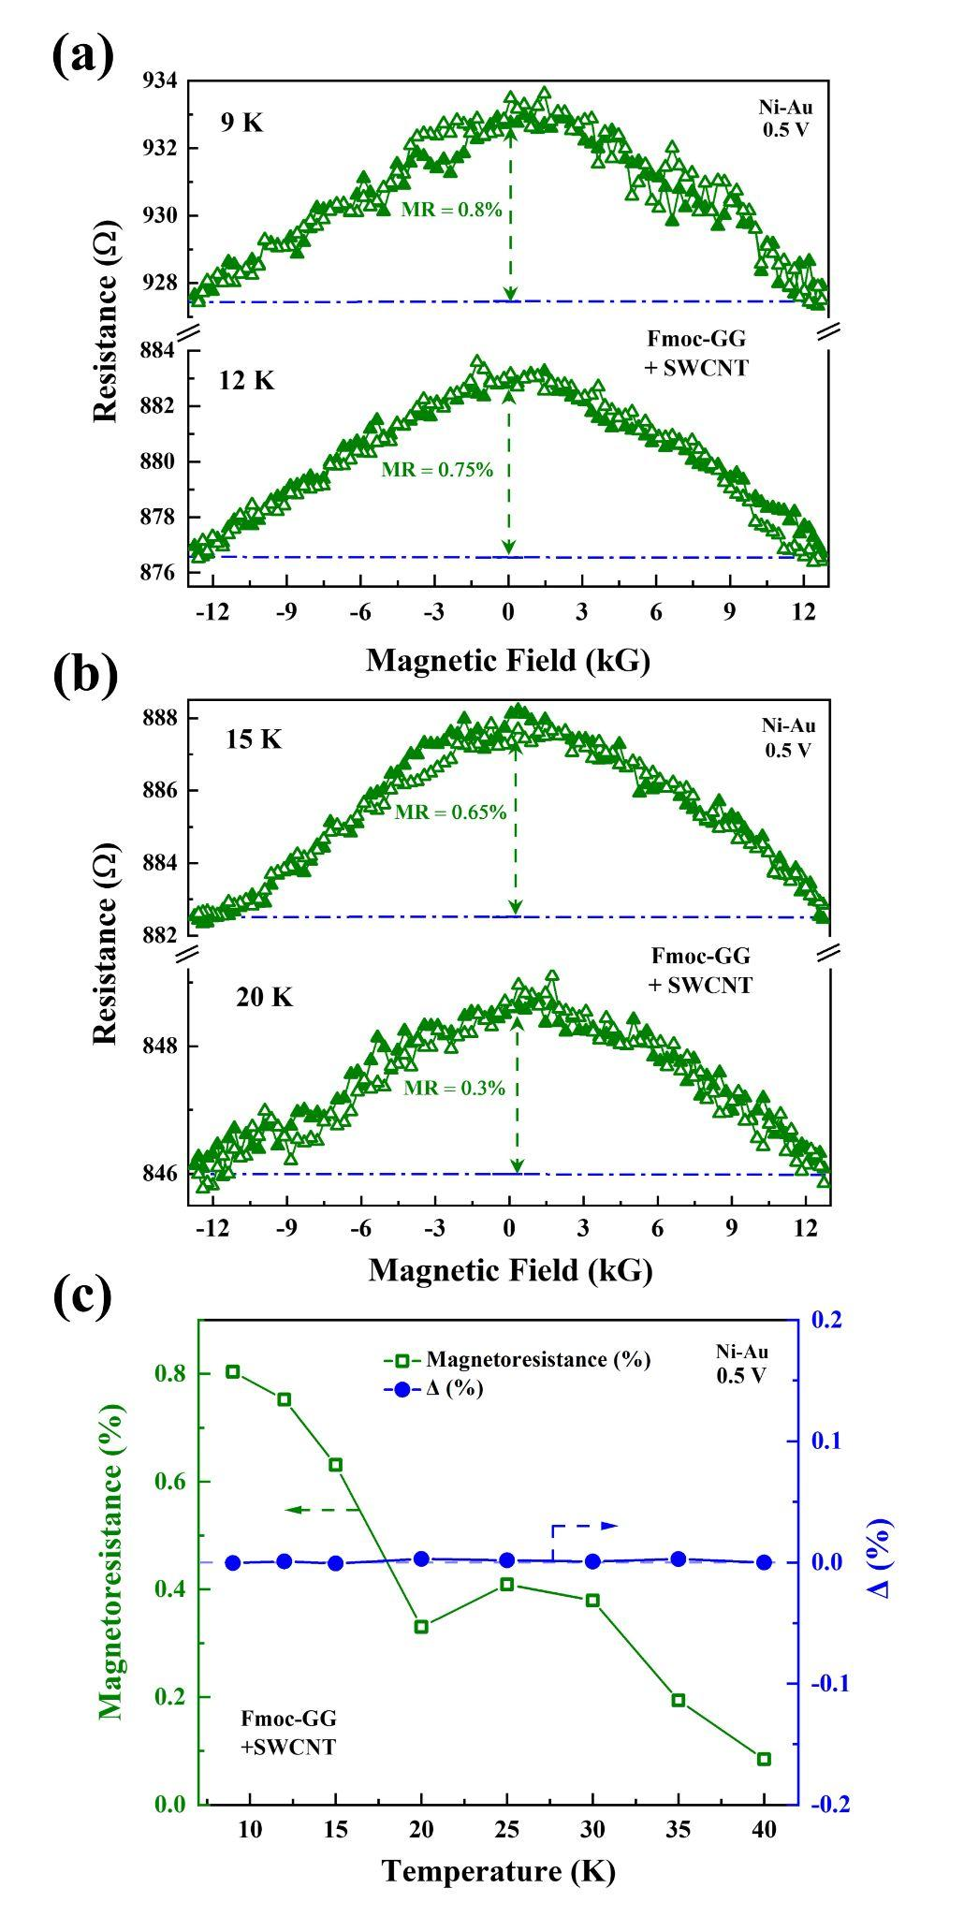

Figure 7. (a), (b) Symmetric MR of Fmoc-GG functionalized SWCNTs using Ni-Au contacts at various temperatures (θ = 90º). (c) Temperature dependence of background MR. MR asymmetry signal Δ is zero (below the noise margin of the measurements) for Fmoc-GG functionalization.

