Article title: Water vapor adsorption by dry soils: a potential link between the water and carbon cycles
Journal name: Science of the Total Environment
Authors: Clément Lopez-Canfin ª, Roberto Lázaro ª, Enrique P. Sánchez-Cañete ^{b, c}
Affiliation: ª Department of Desertification and Geo-Ecology, Experimental Station of Arid Zones (EEZA-CSIC), Almería, Spain. ^{b} Department of Applied Physics, University of Granada (UGR), Granada, Spain. ^{c} Inter-University Institute for Earth System Research (IISTA-CEAMA), Granada, Spain
Corresponding author: Clément Lopez-Canfin. E-mail: lopezcle@gmail.com

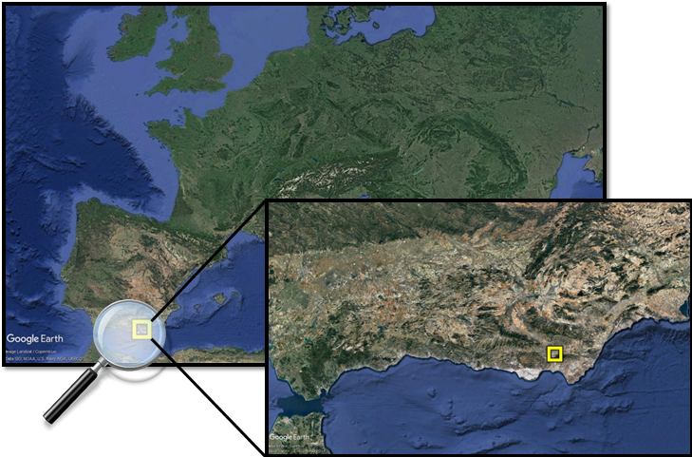
Figure S1 Location of the experimental site.

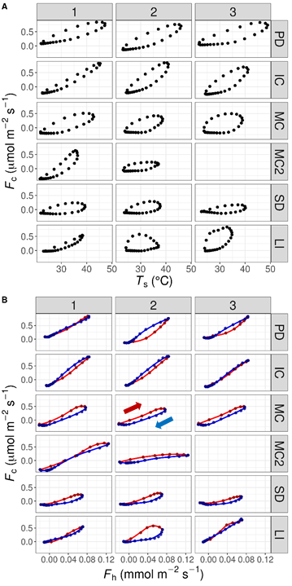
Figure S2 Diel hysteresis between the soil-atmosphere CO₂ flux (F_{c}) and (A) soil temperature (T_{s}), and (B) the soil-atmosphere water vapor flux (F_{h}). The blue line represents the decrease from F_{h} maximum (during daytime) to minimum (during nighttime) and vice-versa for the red line. Stages of the biocrusts succession are labeled as: physical depositional crust (PD), incipient Cyanobateria (IC), mature Cyanobacteria (MC), lichen community dominated by Squamarina lentigera and Diploschistes diacapsis (SD), lichen community characterized by Lepraria isidiata (LI), and Cyanobacteria patches within the SD microsite (MC2).
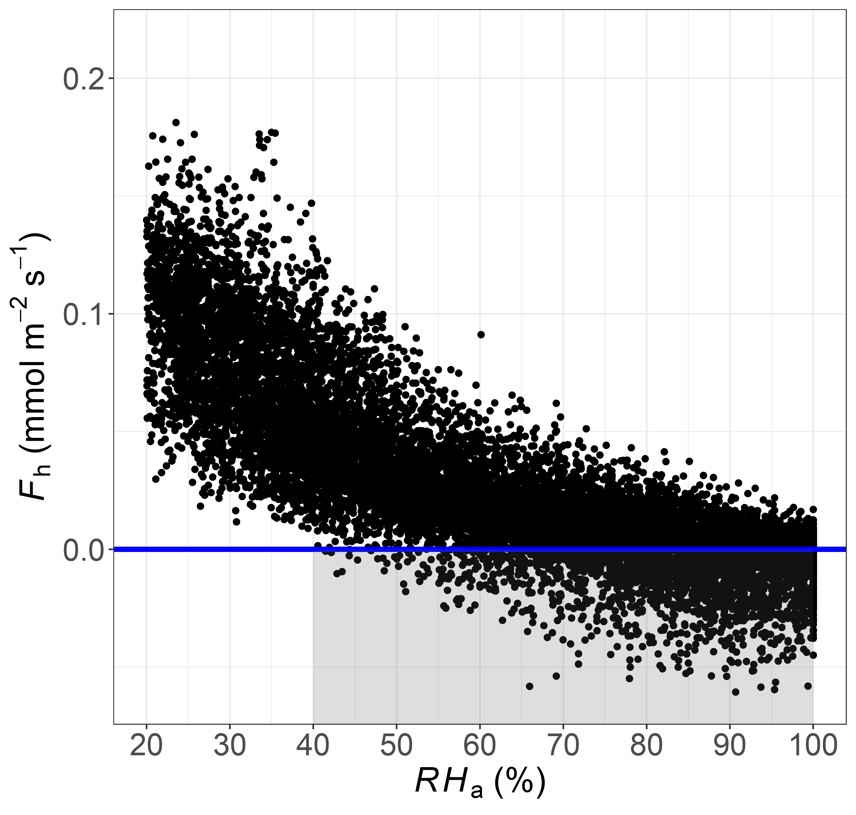
Figure S3 Relationship between the soil-atmosphere water vapor flux and the relative humidity in atmosphere (RH_{a}) within the mature Cyanobacteria site (MC2).

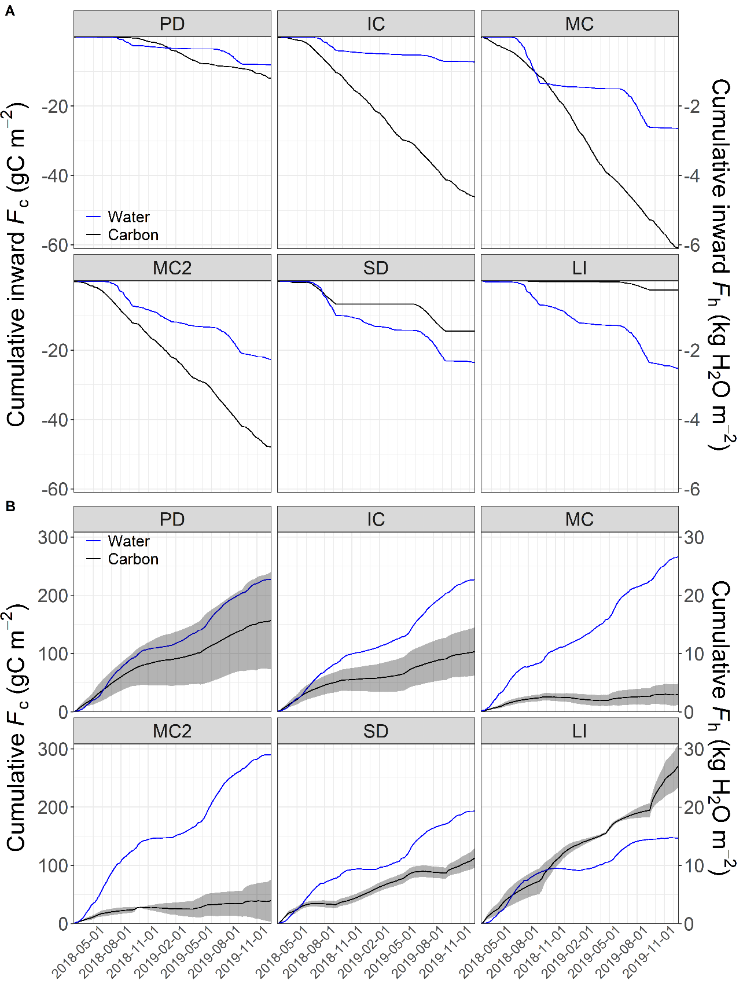
Figure S4 Cumulative (A) inward and (B) total fluxes of water vapor (F_{h}) and carbon (F_{c}). The shaded areas delimit the spatial standard variation. Represented water vapor fluxes were estimated with the diffusion model of Bittelli et al. (2015) while carbon fluxes were calibrated empirically. Stages of the biocrusts succession are labeled as: physical depositional crust (PD), incipient Cyanobateria (IC), mature Cyanobacteria (MC), lichen community dominated by Squamarina lentigera and Diploschistes diacapsis (SD), lichen community characterized by Lepraria isidiata (LI), and Cyanobacteria patches within the SD microsite (MC2).

Table S1 Continuous environmental measurements and associated instruments
Measurement | Height/depth (m) | Variable | Instrument(s) | Manufacturer
Atmosphere CO₂ molar fraction | 0.02 | χ_{c} | GMP252 | Vaisala
Soil CO₂ molar fraction | -0.05 | χ_{c} | GMP252
 |  |  | GMM222
Soil water content | -0.05 | ϑ_{w} | EC-5 | Meter Group
 |  |  | 5TM
Soil temperature | -0.05 | T_{s} | 5TM
 |  |  | Thermistors 108 | Campbell Scientific
Soil relative humidity | -0.05 | RH_{s} | iButton® DS1923 logger | Maxim Integrated
Atmosphere relative humidity | 0 | RH_{a} | iButton® DS1923 logger
 | 0.3 | RH_{a} | S-THB-M00x Smart Sensor | Onset Computer Corporation
Atmosphere temperature | 0.3 | T_{a} | S-THB-M00x Smart Sensor
Surface temperature | 0 | T_{surf} | S-TMB-M0xx Smart Sensor
Photosynthetically active radiation | 0 | PAR | S-LIA-M003 Smart Sensor
Precipitation | 1.5 | - | Rain-O-Matic-Pro tipping-bucket rain gauge | Pronamic
All variables were measured every 30 seconds and stored as 20-minute averages by data-loggers CR1000 (Campbell Scientific) and H21 (Onset), except the rain gauge which was connected to an on–off Hobo Event data logger (Onset).

Table S2A Summary of fixed effects of non-linear models of the diel hysteresis between CO₂ and water vapor fluxes
 |  | Diel decrease model |  |  | Diel increase model
Parameter | Crust | Value | SE | p-value | Value | SE | p-value
φ₁ | PD | 0.892 | 0.056 | <0.001 | 1.284 | 0.099 | <0.001
 | IC | 0.749 | 0.078 | 0.07 | 0.817 | 0.125 | <0.001
 | MC | 0.546 | 0.080 | <0.001 | 0.611 | 0.126 | <0.001
 | MC2 | 0.395 | 0.087 | <0.001 | 0.488 | 0.136 | <0.001
 | SD | 0.451 | 0.131 | <0.001 | 0.283 | 0.126 | <0.001
 | LI | 1.182 | 0.125 | <0.05 | 0.736 | 0.126 | <0.001
φ₂ | PD | -0.077 | 0.045 | 0.09 | 0.068 | 0.039 | 0.08
 | IC | -0.216 | 0.063 | <0.05 | -0.189 | 0.054 | <0.001
 | MC | -0.195 | 0.063 | 0.06 | -0.191 | 0.055 | <0.001
 | MC2 | -0.240 | 0.070 | <0.05 | -0.248 | 0.062 | <0.001
 | SD | -0.079 | 0.062 | 0.98 | -0.059 | 0.054 | <0.05
 | LI | 0.054 | 0.063 | <0.05 | 0.073 | 0.054 | 0.94
φ₃ | PD | 0.041 | 0.009 | <0.001 | 0.084 | 0.007 | <0.001
 | IC | 0.032 | 0.013 | 0.53 | 0.040 | 0.010 | <0.001
 | MC | 0.047 | 0.014 | 0.68 | 0.032 | 0.010 | <0.001
 | MC2 | 0.051 | 0.015 | 0.51 | 0.030 | 0.011 | <0.001
 | SD | 0.095 | 0.017 | <0.01 | 0.049 | 0.010 | <0.001
 | LI | 0.113 | 0.015 | <0.001 | 0.045 | 0.010 | <0.001
φ₄ | PD | 0.028 | 0.002 | <0.001 | 0.032 | 0.002 | <0.001
 | IC | 0.019 | 0.002 | <0.001 | 0.021 | 0.003 | <0.001
 | MC | 0.033 | 0.003 | 0.06 | 0.031 | 0.003 | 0.88
 | MC2 | 0.034 | 0.003 | <0.05 | 0.033 | 0.003 | 0.79
 | SD | 0.030 | 0.004 | 0.61 | 0.020 | 0.003 | <0.001
 | LI | 0.043 | 0.004 | <0.001 | 0.020 | 0.003 | <0.001
Table S2B Summary of the non-linear relationship between CCE and SOC contents
Parameter | Value | SE | p-value
φ₁ | 0.318 | 0.005 | <0.001
φ₂ | 0.183 | 0.005 | <0.001
φ₃ | 0.646 | 0.004 | <0.001
φ₄ | 0.028 | 0.005 | <0.01
SE, standard error, φ_{n} are the fitted parameters of the four-parameter logistic model (y = φ₁ + (φ₂ - φ₁)/ (1 + exp[(φ₃ − x)/φ₄)], with ϕ₁ the horizontal asymptote as x ∞, ϕ₂ the horizontal asymptote as x -∞, ϕ₃ the x value at the inflection point of the sigmoid (the value of x for which the response variable y = ϕ₁/2), and ϕ₄ a scale parameter on the x-axis. SE is the standard error.

