**The spread of news deserts in Chile**

**The case of the Aysén region**

Rodríguez-Urra, Carlos *

Trillo-Domínguez, Magdalena**

Herrero-Solana, Víctor **

* Social Sciences PhD Program, University of Granada, Granada, Spain

** Unit for Computational Humanities and Social Sciences (U-CHASS), University of

Granada, Granada, Spain

**Abstract**: News deserts are geographical contexts with an absence of media in the context of the global crisis of the press. This crisis weakens local citizenship by affecting democracy, social cohesion, and identity. The Aysén region is analysed as a pilot experience using a triangular quantitative and qualitative methodology. First, the research constructs a media map that identifies 20% of the territory at high risk of becoming a news desert, while another 40% is already one. The triggers are the lack of information plurality and digital infrastructure, and the economic difficulties of small media. Second, we combine a non-participant observation experience developed between January and February 2023 with case studies and semi-structured interviews that address the causes of the problem and point to constructive proposals, such as the creation of collaborative networks and the strengthening of mobile journalism and local identity. The work is focused on the Chilean region of Aysén as a case study but can be extended to other Latin American realities and countries with similar media weaknesses.

**Keywords**: Chile, news deserts, local journalism, hyperlocal journalism, regional journalism

## Introduction: Objectives and Research Context

The study of news deserts is emerging globally as a necessary endeavor from both academia and the journalistic industry to understand the repercussions of the retreat and absence of media in regional, local, and hyperlocal areas. An increasing number of researchers are addressing the issue with geographic, temporal, or media content approaches (Abernathy, 2016; Gulyas, 2022; Negreira‐Rey et al., 2023; Lins da Silva & Pimenta, 2020; Napoli et al., 2019).

In the context of these new challenges, it is essential to remember that local journalism itself is highly exposed to continuous changes due to the influence of the economy and local politics (Nielsen, 2015), and territorial dynamics, such as population shifts from rural to urban areas (Negreira-Rey et al., 2023). Technological advancements have also impacted the traditional economic model of the industry (Ferrucci & Alaimo, 2020), driven by adjustments in advertising strategies to maximize digital news revenue (Harte et al., 2019) and accelerating the crisis of newspapers in terms of staff and infrastructure availability (Abernathy, 2020).

Gulyas et al., (2023) argues that the definition of new deserts varies according to setting and context, but 'is a powerful concept that can speak to academic and non-academic audiences' (p.287). So there are different approaches to studying news deserts. Abernathy (2016) has been a pioneer in the studies of news deserts by focusing on the identification of areas without local newspapers in the United States and warning of the consequences for the country's democratic quality. For Smethers (2021), newspapers are also essential to the local economies of communities, and thus affect social practices. The lack of pluralism is another critical issue, as revealed by Nielsen (2015) following Friedland (2012) highlighting how local information is devalued when constructed solely from sources from political parties, local governments, or businesses. News deserts thus affect civic coexistence, considering that democracy "begins at the local level" (Hess & Waller, 2017, p.8) and opens spaces for manipulation, populisms, and polarization (Trillo-Domínguez, 2023). Here, the media plays an important role in the development of thecivic participation, which is vital in proximity areas to build and protect public spheres (Nah & Chung, 2020). Other authors also stress the need for information pluralism to combat news deserts (Abernathy, 2020; Karlsson & Rowe, 2019).

These deserts affect "different types of communities to varying degrees" (Napoli et al., 2019, p.1028) with groups composed of historically marginalized minorities and those lacking digital skills (Abernathy, 2020) being the most vulnerable. It is crucial to remember that the relationship between local media and residents is inseparable, as it strengthens local identity and interprets national and global realities within these scales of proximity (Hess & Waller, 2017).

The emergence of COVID-19 has revalued local journalism (Abernathy, 2020) and demonstrated the vital role of community cohesion, a situation fostered by journalistic innovation in practice and closer engagement with audiences (Amigo, 2023; Wahl-Jorgensen et al., 2022). This is reinforced when journalistic practice is linked to place, taking into account the construction of identity that operates in local affairs (Hess & Waller, 2017) and those that can be supported by citizen collaborations at hyperlocal levels (Harte et al., 2019). Therefore, audience knowledge is key to generating quality content to build trust (Adornato, 2022, p. 63) from the reciprocity with communities, an aspect that is very much present in hyperlocal producers (Harte et al., 2019, p.125).

The importance of journalism at regional, local and hyperlocal levels has recently been underpinned by a number of financial support initiatives to ensure its sustainability as in the case in some countries of Europe as United Kingdom (Heawood, 2022; Cheverton 2022) or Sweden (Newman et al., 2023). Publicly funded support can help strengthen it in the case of even smaller media operating at a hyperlocal level, which are often difficult to sustain (Tenor, 2018). Analyzing the tension between old and new media (conventional and digital), we note how technology has impacted journalistic work (Adornato, 2022) with “the impact of internet on journalists’ ability to find new and different sources” (Hess & Waller, 2017, p.96) in a context where digital media have experienced a "meteoric rise" (Abernathy, 2020, p.28) due to the rise of small news outlets in the face of the decline of conventional media (Cheverton, 2022). In addition, proximity media seek to be authentic in order to differentiate themselves with a range of motivations (Harte et al., 2019). However, although digital media are pointed out as part of the solution to news deserts (Nygren, 2019; Smethers et al., 2021) due to their low operational costs (Nielsen, 2015, p.7) and even digital media associations such as LION in the United States have been formed to help digital media achieve long-term financial sustainability (Abernathy, 2020, p.46) but it is true that they find their survival hard and challenging in "regions with economic difficulties" (Abernathy, 2020, p.8). Therefore, digital formats have not yet managed to fully strengthen, corresponding to "a type of ephemeral journalism, it is being verified that the lifespan of these media is quite short (Salaverría et al., 2022, p.10) at least in Latin America, a territory also marked by restructuring and the closure of offices press (Suenzo et al., 2020).

In this geographic context, local journalism faces challenges due to the “hegemony of large commercial media conglomerates” (Giovani-Vieira, 2021, p.175), while ‘hyperlocal’ remains underrecognized (De Mendonça & Brito-Batista, 2021: 379; Rodríguez-Urra et al., 2023b).

Despite these challenges, digital natives have been considered in studies of news deserts (Kizilkaya, 2021; Lins da Silva & Pimenta, 2020). These virtual spaces, along with social platforms, were previously mentioned by Ferrier (2016) in her proposal regarding media deserts and their layered media infrastructure.

Online spaces are increasingly central to proximity journalism, with “young journalists skilled in mobile and social media” (Adornato, 2022, p.59) reflecting a new youth-oriented, digital layer focused on internet access. This trend has led to a “suburbanization of the sphere” (Midões, 2021, p.9), where easier and faster access to media is demanded and achieved.

Concrete precedents in the analysis of news deserts include the work of Lins da Silva and Pimenta (2020) in Latin American academia and studies driven by private initiatives (FOPEA, 2021; IPYS, 2023), reflecting the growing concern in this emerging field. Additionally, studies warn that one-third of newspapers functioning in the United States in 2005 will have disappeared by 2024 (Abernathy, 2023). In Spain, there already exists an initial map of news deserts (Negreira-Rey et al., 2023) from the perspective of depopulation (“España vaciada”). However, the Anglo-Saxon sphere currently leads global research in this area.

In this case, we focus on the Aysén region, a Chilean territory perceived as remote (Núñez-González & Aliste-Almuna, 2014). The territory has been the scene of strong social protests related to "historical deficiencies in infrastructure and social services" (Contreras, 2022, p.4) which fostered a strong union in a context of administrative centralism of the State intensified by territorial isolation. On the other hand, the region also holds interest for social researchers insofar as "horizontal networks that reinforced community collective actions" have been built (Durston et al., 2016, p.245) with Madipro’s radios (Madre de la Divina Providencia of Vicariate Apostolic of Aysén) founded in the last century with a sense of catholic evangelization for community cohesion (Osorio, 2020), and sharing traits with the Argentine Patagonian culture due to historic migratory phenomena (Carrasco-Urrutia, 2021).

While Chile has historically excelled in Latin America in terms of digital connectivity and innovation (Rodríguez-Urra et al., 2023a), the Aysén region lags behind other territories, as evidenced by Nperf[1] data exploration across the country. It should be noted, however, that a government project called "Fibra Optica Austral"[2] is currently underway to improve Internet coverage and access in the area.

Furthermore, in Chile there is a context of "press duopoly" by the groups El Mercurio and La Tercera (Newman et al., 2023; Dodds, 2017; Greene et al., 2022) which also have various regional titles wih the “90% of the newspapers (…) both are situated on the right end of the political spectrum” (Mellado & Scherman, 2020, p.5). This is a reality that has overshadowed the study of other media, such as regional, local and hyperlocal media in this country (Rodríguez-Urra et al., 2023b). In particular, Chile “has one of the most concentrated media systems in Latin America, characterised by the dominance of private shareholders and commercially oriented content” (Mellado & Cruz, 2024, p.5) where there is a need to "generate a proactive construction to reconnect citizens with professional journalism" (Labrín, 2023, p.121) in the Chilean context. Aysén deserves a closer look, a unique case in Chile, along with the Magallanes region, in the absence of the national press duopoly.

Given the region’s particularities and the growing concern about news deserts, we find it pertinent to develop a pilot research project in the area that can be replicated at other geographical and social scales.

As a starting point, we formulated the following research questions:

1. Is it feasible to construct a regional media map using open data?
2. What economic, technological, and sociocultural situations can we identify as triggering factors for news deserts in the region?
3. Can media outlets mitigate the expansion of news deserts?

These questions serve as the foundation for our investigation into the Aysén region, allowing us to explore the dynamics of information accessibility and the role of media in addressing this critical issue.

Our main objective is to construct a media map of the Aysén region reflecting the advancement of news deserts. Derived from this, our secondary objectives include:

1. Establishing a methodology for identifying news deserts that can be extrapolated

to other Latin American and global contexts.

1. Analyzing the specific economic, technological, and sociocultural factors that contribute to media abandonment in the Aysén region.
2. Understanding the routines, singularities, motivations, and constraints of journalistic activity through contributions from professionals working in this unique Chilean region
3. Proposing a constructive roadmap of possible actions and measures to help curb and reverse the situation.

# Materials and methods

We propose a triangular methodological approach that begins with an initial quantitative phase based on constructing a dataset[3] (Rodríguez-Urra, 2024) of media organizations in the territory, considering their impact on social networks. Additionally, we construct a media map to identify news deserts, in agreement with Gulyas (2022), as a way of approaching the representation of the situation of a territory.

To achieve this, we conducted an extensive search for Chilean media organizations, aggregating them in different formats:

1. Regional Association of Open Signal Television Channels in Chile (ARCATEL): Comprising 22 regional television channels, ARCATEL represents them at the central and national political level.
2. National Press Association (ANP): An organization that brings together major Chilean print media, both nationally and regionally.

During the process, we encountered some inconsistencies. We were unable to obtain a list of radio stations affiliated with the Association of Chilean Broadcasters (ARCHI), nor could we communicate with the institution. Regarding digital media, there were limitations due to the absence of an entity that aggregates them or provides open reports on digital audiences, a scenario previously highlighted by Rodríguez-Urra (2023b).

Due to these limitations, we expanded our search to other data sources belonging to the State, including regulatory bodies and archives:

1. National Library (Biblioteca Nacional, BN) and Transparency Portal (Portal de Transparencia): Both institutions use the same registry of regional media. The BN receives voluntary registration requests, which are then forwarded to the Transparency Portal and consolidated in the Registry of Regional Media.
2. Subsecretariat of Telecommunications (SUBTEL): This entity contains records of registered and approved media for operating sound broadcasting services, community radios, and open television services.
3. Ministry General Secretariat of the Presidency (SECOM): Administers the ‘Fondo de Medios de Comunicación Social’ with calls for journalistic projects from regional media. It falls under the Budget Law, Article No. 20, which requires Ministries and Services to allocate at least 40% of the item to media that are not part of conglomerates, holdings, or media chains.
4. National Cultural Heritage Service (Servicio Nacional de Patrimonio Cultural): The "Bajo la Lupa" project repository contains research conducted to study cultural collections and local identities.
5. Electoral Service (SERVEL): This institution monitors, supervises, and manages electoral processes. From its reports, it is possible to know the media outlets that are authorized to broadcast electoral propaganda.

To expand our search, we turned to Google to identify local and hyperlocal news spaces with periodic publication. Here, we used a systematic search proposed by Negreira-Rey (2020), a method replicated by Rodríguez-Urra (2023a) for creating a Hispanic-American media map, considering scientific production hosted in major global reference databases. In this case, we adapted and executed the following equations: "news OR media AND (locality); newspaper OR digital newspaper AND (locality); diario AND (locality); radio AND (locality); television OR TV AND (locality); Canal AND (locality)"[4]. While Negreira-Rey (2020) only considered territories with over 20,000 inhabitants for the Spanish context, we did not set population limits due to the low population density of the territory. We excluded media whose addresses or radio/television transmission stations were located in regions outside Aysén. For social media spaces, we considered those with digital presence and a website. We excluded media with non-journalistic focuses, such as exclusively religious, sports, educational, tourist, or environmental media.

The dataset is openly available for download on Zenodo[5], and includes a total of 63 identified media distributed across the ten municipalities that make up the Aysén region.

The media on the final map were subjected to the social impact criterion, which corresponds to September 2022. This indicator of Rodríguez-Urra (2023b) is composed of data from Twitter (now X), due to its widespread informative use in its early years (Herrero-Solana & Trillo-Domínguez, 2014), whose followers were counted, and Facebook from its fan pages. In particular, this social network has a "more consolidated and broader presence in age groups and with greater transversality in all countries" (Rodríguez-Urra et al., 2023b).

The data are visualised using the open-source software Scimago Graphica, a tool that allows us to create graphs that combine information "with a high level of expressiveness and a user-friendly interface" (Hassan-Montero et al., 2022: 2). This exercise allows us to identify the news spaces that receive the most attention from their audiences on social platforms.

This data is also useful in the qualitative methodology, as we know which media are better positioned in the region. We assume that these are relevant institutions in terms of information, so it is a priority to approach them to understand their views and actions in order to understand the factors that cause the emergence of deserts and the possible fight against them.

To conclude the quantitative aspect, we have constructed figures that show the distribution of media formats in cities and formats, as well as the map of the situation of deserts. In doing so, we rely on the *media ecology focused* proposed by Gulyas (2022), approach that examines the availability of media supply in a sub-national territory. This is added to the population projected according to the Library of the National Congress of Chile (BCN).

Table 1. Data for the Aysén Region

|  |  |  |
| --- | --- | --- |
| Commune | Projected population 2023 (BCN) | Media outlets |
| Cisnes | 5865 | 8 |
| Guaitecas  Aysén  Cochrane  O’Higgins  Tortel  Coyhaique  Lago Verde  Chile Chico  Río Ibáñez | 1608  25180  3731  672  582  61885  915  5157  2711 | 4  13  3  2  1  19  3  6  4 |

Source: Own elaboration

This table provides data on the projected population for 2023 and the total number of identified media outlets in various communes of the Aysén Region in Chile. It highlights the variation in population size and media presence across different areas.

We also consider as news deserts those territories where only media outlets dependent on local municipalities operate (Nielsen, 2015; Abernathy, 2020; Karlsson & Rowe, 2019). In such cases, institutional dependence prevails, and a minimum level of informational plurality is not guaranteed. Considering the Aysén reality, we examine the media landscape, taking into account the absence of newspapers (Abernathy, 2016), as well as radios, television stations, and digital media, following the frameworks proposed by Ferrier (2016), Lins da Silva and Pimenta (2020) and Kizilkaya (2021).

The number of identified media outlets correlates with the population, with a predominance of traditional formats. These outlets are part of a complex and unique scenario shaped by geographical characteristics. Consequently, we propose a new framework for categorizing news deserts:

* **Low Risk**: Assured pluralism, diverse formats, and a medium to high number of media outlets.
* **Moderate Risk**: Assured pluralism, but lacking format diversity, with a medium to high number of media outlets.
* **High Risk**: Unassured pluralism and minimal media diversity.
* **Desert**: Non-existent pluralism and/or an extremely low number of media outlets.

Subsequently, we incorporated qualitative research, including non-participant observation in the region and conducting semi-structured interviews and case studies. We selected a series of media outlets from Puerto Aysén and Coyhaique, including those with high social impact (over 25,000 followers combined on Facebook and Twitter) across print, radio, television, and digital platforms, as well as medium-sized outlets (between 5,000 and 25,000 followers). Based on these parameters, we contacted and collaborated with willing media outlets for the research.

After analyzing metrics and assessing their interest in participating, eleven media outlets ultimately took part in the investigation:

Table 2. List of Media Outlets in the Region and Metrics

|  |  |  |  |  |  |
| --- | --- | --- | --- | --- | --- |
| **Media outlet** | **Type** | **Face**  **book** | **Twitter(X)** | **Social impact** | **Commune** |
| Santa María | Radio | 49000 | 28000 | High | Coyhaique |
| Ventisqueros  Santa María  El Divisadero  Vía Austral  Tehuelche Noticias  Milenaria  Las Nieves  Aysén TV  Panorámica Informativa  ComunicAysén | Radio  TV  Printed  Digital native Digital native Radio  Radio  TV  Digital native Digital native | 2998  34000  34662  114775  10341  8900  20804  6763  10000  4283 | 6765  6588  13700  5483  2554  550  7324  128  70  60 | Medium  High  High  High  Medium  Medium  Medium  Medium  Medium  Medium | Coyhaique  Coyhaique  Coyhaique  Coyhaique  Coyhaique  Coyhaique  P.Aysén  P.Aysén  P.Aysén  P.Aysén |

Source: Own elaboration

Radio and Television *Santa María*, *El Divisadero*, and *Vía Austral,* identified as media outlets with high social impact, were approached through non-participant observation and semi-structured interviews. For other media outlets, only interviews were conducted[6].

Fieldwork was carried out with the flexibility inherent to such initiatives (Jensen, 2014; Taylor & Bogdan, 2009), adjusting timelines to the dynamics and characteristics of each newsroom.

# Results

* 1. *Characteristics of the media in the Aysén Region*

As an initial approach to the phenomenon of news deserts, we present the following graph depicting the distribution of audiences based on media types and geographical zones.

Figure 1: Typology of media in different communes of the Aysén Region

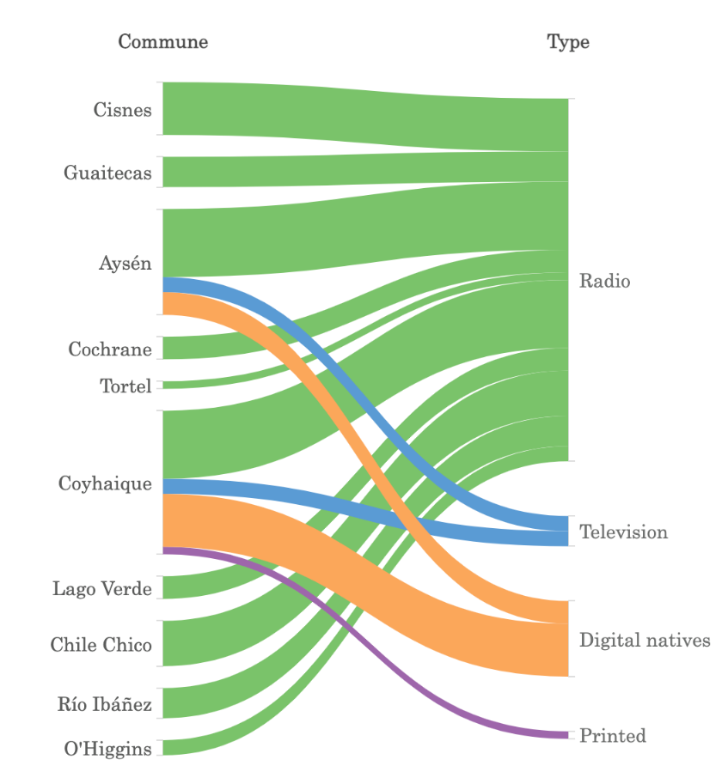

Source: Own elaboration

The 63 cataloged media outlets are primarily concentrated in the cities of Coyhaique (the regional capital) and Puerto Aysén. Radio dominates the region (48 outlets) and is present in all communes, including remote areas with low population density. Radios constitute 76% of the total, followed by digital natives (10 outlets, 16%), four television channels (6%), and one print outlet (2%).

Figure 2: Map of news deserts detected in the Aysén Region

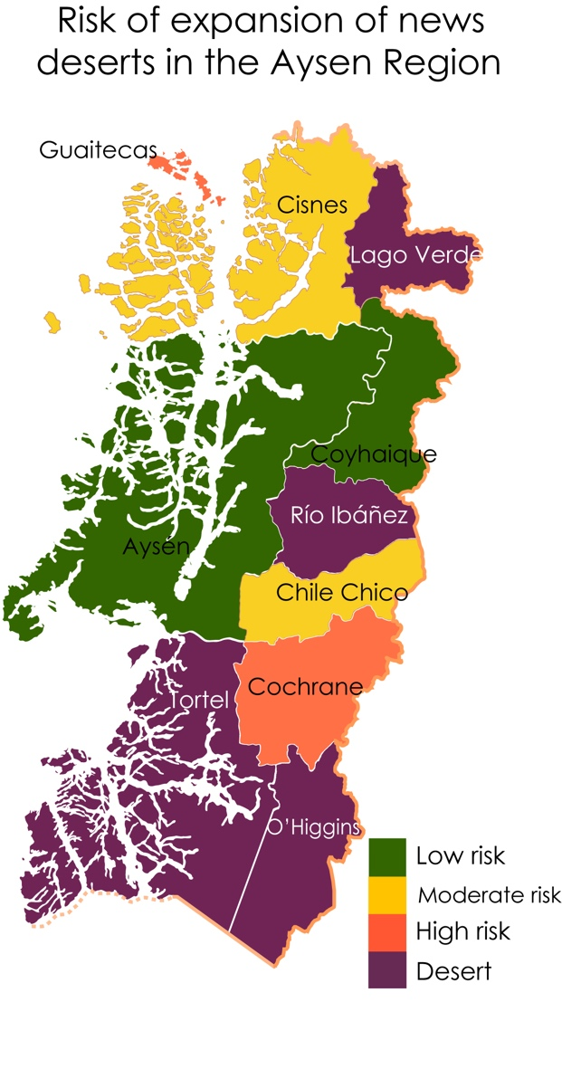

Source: Own elaboration

Upon analyzing the presence of media in the Aysén Region from Figure 2, we observe that only two out of ten communes (20%) are at low risk of being declared news deserts, and these are located in the main cities. Additionally, 20% of the territory is at moderate risk, another 20% at high risk, and 40% can be identified as a news desert.

Lago Verde, Río Ibáñez, Tortel, and O’Higgins are classified as news deserts[7] due to the presence of municipally administered radios. In cases of high risk, there is a slight increase in media outlets lacking diversity (Cochrane), and while there is some balance with municipal radios (Guaitecas), other media outlets are quite limited.

Figure 3: Metrics analysis between Facebook and Twitter

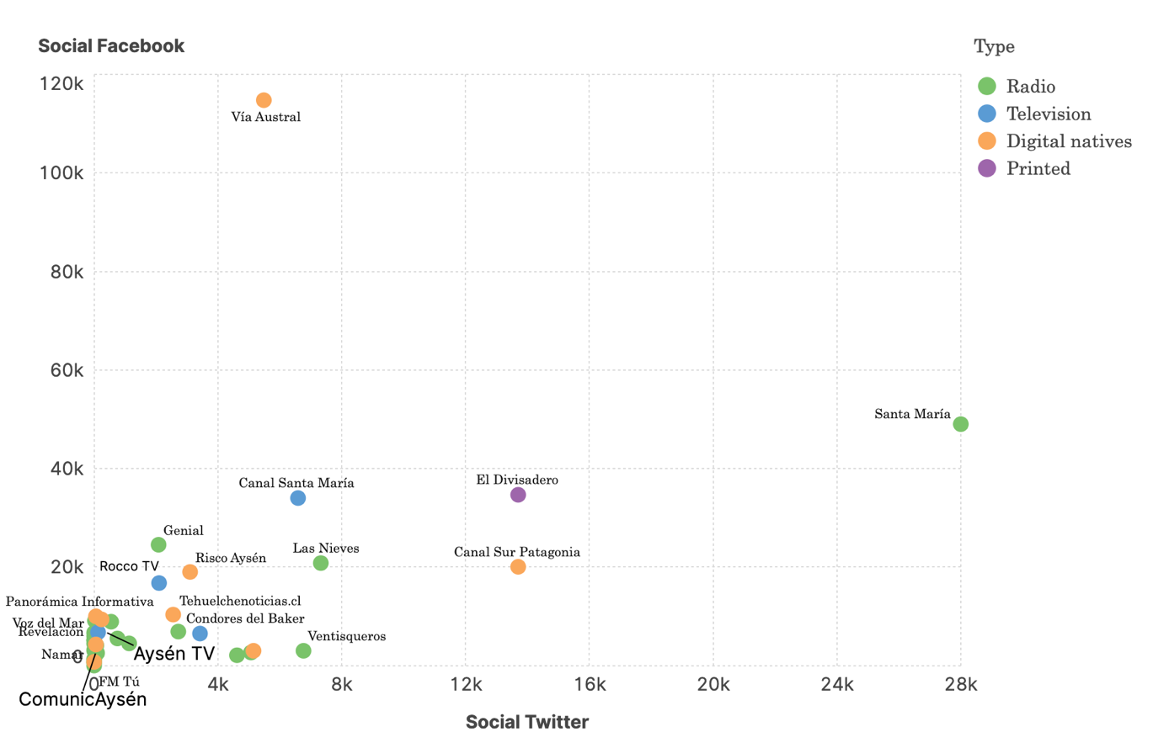

Source: Own elaboration

In Figure 3, we present a graph that illustrates the metrics comparison between Facebook and Twitter (X). Key observations are that he best-positioned medium in the region is the digital outlet *Vía Austral*, which stands out in terms of followers on Facebook. Another well-situated medium is Radio *Santa María*, with outstanding activity on Twitter. Following closely is the newspaper *El Divisadero*, which exhibits notable metrics on both social networks. The television channel *Santa María*, an affiliate of the aforementioned radio station, also holds a prominent position. We attribute Vía Austral’s leadership on Facebook to its consistent activity on the platform since its foundation in 2015, during the widespread adoption of Facebook. Meanwhile, *Santa María*has strengthened its presence on Twitter, positioning itself as the primary conventional medium in the region. This boost is also due to a network of stations under agreement within the Madipro radio transmitters. These leading media outlets originate from Coyhaique, the capital city with the highest population in the region.

* 1. *Reference media profiles from non-participant observation*

Non-participant observation was conducted between January and February 2023. During this period, our research focused on the media outlets *El Divisadero*, Radio *Santa María*, Televisión *Santa María*, and *Vía Austral*—representatives of each typology due to their high social impact indices and availability for observation.

The non-participant observation aimed to explore media profiles based on the following topics:

* Team sizes and profiles
* Professional routines and journalistic innovation
* Business models
* Relationship with audiences on social networks and geolocation

Conventional media have small teams (5-6 people), while native digital media typically operate with a single member (in the case of this analysis, its own founder, a young communicator who previously worked for a local media outlet). Professional journalists and career reporters are present in traditional media, with specific functions and a hierarchical operating structure. In television, journalists are supported by professional audiovisual communicators. In contrast, the digital medium lacks dedicated personnel and relies on occasional collaborators. This results in non-constant, amateur journalistic activity, with irregular participation in the city's press points.

Routines vary based on the type of media. Radio and television follow a traditional dynamic, responding to the immediacy of information for producing three daily news broadcasts. However, investigative journalism is limited, and there are no editorial meetings to decide topics throughout the day.

Newspapers, on the other hand, engage in long-form journalism and multimedia content. Without audiovisual communicators, journalists explore possibilities for storytelling. For example, during a virtual press briefing, the team discussed mobile apps and recording for social networks.

Mobile journalism is widely adopted. At *Santa María*, journalists replace traditional TV camera live links with the Zoom app using their mobile phones. An observed example was the inauguration of the Coyhaique bus station, where the section chief personally attended to record a series of support videos with her mobile phone. Nevertheless, conventional cameras are used on specific occasions, such as obtaining cleaner shots for Zoom links with the journalist's mobile phone. This practice eliminates the need for cumbersome transmission equipment and facilitates mobility. Zoom is also used to follow the development of the Court's cases from the newsroom, saving time and resources.

*El Divisadero*, in contrast to *Santa María*, does not maintain a physical office presence. It operates with a telematic organizational culture, emphasizing multimedia content. The platform features photographic reports, Facebook livestreams of press briefings from Coyhaique, and additional news extras. Another innovation is the audiovisual recording of editorial columns and interview programs with multiple episodes as ‘Café Diario’.

For its part, *Vía Austral* responds to the logic of social networks and viral content, which is why social media metrics are essential. Its viral content, based on Patagonian culture and life, as well as livestreams with a dynamic vlogger about the city of Coyhaique and its surroundings, have earned it a large number of followers. Its communicator has imitated television formats with live broadcasts in a studio, with interviews and livestreaming outdoors on foot to discuss issues with the public while reading comments from Facebook Lives. These have had sporadic production and rely on software for scheduling livestreams and editing templates in Canva.

As a business model, advertising prevails—a traditional formula seen across Chilean media. Conventional outlets assert their viability without the need for alternative funding. In the case of *Vía Austral*, achieving advertising revenue has intensified the inclusion and promotion of small and civil organizations, as well as sponsorship of cultural and sports organizations' dissemination projects. Commercial logic takes precedence as the primary activity.

Audience engagement can be examined from two angles: their integration into social networks and the production of geolocated news content, viewed through the lens of news deserts.

*Santa María* has its own sources of information but has not incorporated user comments into its dynamic. At the end of the day, the director also in a journalistic role, minimally updates social networks using Canva designs. El Divisadero, on the other hand, relies on user comments to reinforce its news coverage. For example, during an attempted jailbreak in Coyhaique, netizens shared preliminary information on social networks, which journalists then reported. In addition, the press director analyses livestreaming statistics to identify popular topics for further investigation. It is noticeable that the youngest journalist in the newspaper is the only one who usually publishes using emoticons to be closer to the public, while in Vía Austral colloquial, youthful language is often used.

The centralization of information in Coyhaique is a complex issue, challenging to avoid. From Santa María’s perspective, during a typical day, only two out of ten news stories concern territories at risk or in an news desert condition. A similar situation occurs with *El Divisadero*, which concentrates its activity in Coyhaique, primarily due to the extensive presence of public and private organizations during press briefings.

Based on these analytical criteria, non-participant observation has allowed us to identify the following local realities. These insights are crucial for understanding the challenges faced by territories experiencing the growing phenomenon of news deserts. The teams are small, and conventional media differ from digital native in terms of regularity of news production and solid organisational structures. *Santa María* differs from *El Divisadero* in their preference for in-house sources. Meanwhile, print media have innovated in multimedia and have attracted the attention of cybernauts. The hybridisation and use of technologies is also used in radio and television, but focuses on traditional journalistic products, while the digital media base their activity on social networks with topics that are not part of the news. Journalistic activity is very latent in Coyhaique and news from other communities is scarce, a fact that can accentuate news deserts.

* 1. *The problem of news deserts viewed from the main cities*

As a complement to non-participant observation, our investigation into news deserts is enriched by 16 semi-structured interviews conducted with professionals and communicators from Coyhaique and Puerto Aysén. These cases allow us to delve into the routines and dynamics of journalism from regional, local, and hyperlocal perspectives.

The interviews address the following key topics, aiming to comprehend the factors contributing to the news desert phenomenon in the Aysén region:

* Limited news production in remote areas
* Criteria of information relevance Business models
* Influence of audience and regional media concentration
* Financial weakness of media enterprises
* Tensions between the media and local authorities

A shared reflection from the interviewees highlights the challenge of providing news coverage in areas where current events are extremely limited. The director of *El Divisadero* acknowledges that the news reaching the editorial team does not meet minimum standards of periodicity: “Of course, you can’t ask for news every day because not every day significant events occur in a small commune”. Similarly, the head of *Santa María* notes that despite their agreements with various community radios, the news reaching the editorial office remains scarce.

Geographical distance significantly impacts journalistic production and media consumption. The editor of *El Divisadero* admits that obtaining news from remote communes is complex due to unstable communications and long geographical distances, yet they always strive to access information. Additionally, the lack of media outlets in remote areas, according to the director of *ComunicAysén*, leads citizens in neighboring sectors to listen to Argentinean radio stations.

Regarding journalistic criteria, *Milenaria* in Puerto Aysén often broadcasts news from surrounding areas when an event disrupts productivity, industry, or terrestrial connectivity. Aysén TV’s founder emphasizes that they cover worthwhile information, such as the inauguration of a gas station as a connectivity milestone in the news desert zone of Villa Cerro Castillo. The director of *El Divisadero* observes that in distant areas, political topics related to elections, tourism, and culture are more frequent and generate interest.

The audience primarily comes from Coyhaique, influencing proximity-based coverage. El Divisadero’s web administrator explains that readers from other communes lag behind in interaction and viewing news. Founders of *Aysén TV* and *Panorámica Informativa* criticize the fact that while their commune, Puerto Aysén, drives the region’s economy, administrative headquarters are located in the regional capital, resulting in a concentration of informational activity. *Panorámica Informativa* (whose owner had previously worked as a audiovisual correspondent for a major television station in Chile as *TVN*) reveals that Coyhaique dominates people’s perception, leading to confusion in news coverage.

Economic weakness poses another challenge, limiting staff incorporation, geographical coverage expansion, and investigative journalism development. The former director of *Tehuelche Noticias* pointed out the structural problem for hiperlocal and local independent media to produce quality journalism as there are not enough sponsors to make the media self-sustainable, suggesting the need for new media laws to ensure small outlets access to State funds, as is the case where the press duopoly has access. Meanwhile, the lack of funding for *Panorámica Informativa* prevents the establishment of correspondents in other municipalities. This issue aligns with ComunicAysén’s struggle to deliver its monthly printed magazine to all communities in the region.

Conventional media outlets like *Santa María* and *Milenaria* reduced their journalistic staff by 50% due to COVID-19. *Ventisqueros* experienced an even more pronounced reduction (from three journalists down to one). However, *Las Nieves* maintained a stable staff, and the collaborators and journalistic team at *El Divisadero* even grew. In this case, the manager explains that discontinuing the print version was due to high production costs.

Another factor contributing to news deserts is the tension between media outlets and local authorities. The director of *Aysén TV* reflects that many conventional media outlets were initially founded by political figures. Additionally, it points out that political or corporate sponsors often induce passivity in local media when it comes to scrutinizing those in power, out of fear of losing financial support. The director of *El Divisadero* suggests that antagonizing local institutions can have repercussions, potentially leading to missed opportunities and assistance.

A specific case exemplifies this dynamic: the closure of Radio *Madipro* in Villa O’Higgins, where it used to broadcast Santa María’s content. According to the director of *El Divisadero*, ideological motivations prompted the closure due to pressure from a former mayor, who exploited the lack of emission rights regulation. Unfortunately, this situation remained unresolved. Consequently, the signal transformed into “yet another arm of the municipality” during that authority’s tenure.

Reflecting on municipal radio stations, the former director of *Tehuelche Noticias* notes their limited diversity of perspectives and reliance on the same news sources. This is in line with El Divisadero's webmaster, who stresses that information from remote areas lacks impartiality, which is why the newspaper itself prefers contacts close to the media.

From the findings of non-participant observation and interview analysis, we can identify several causes of weaknesses in the media landscape as news deserts advance:

* Information trickle from remote areas and challenges in journalistic coverage due to geographical and connectivity limitations
* Concentration of informational activity resulting from the dominance of institutions and corporations in populated areas
* Inability to develop comprehensive geographical coverage and diversify formats and audience connections due to economic weaknesses of media companies in the region
* Influence and pressure from institutions restricting informational activity in local media ecosystems
  1. *Constructive proposals as a roadmap to avoid news deserts*

Combining non-participant observation and semi-structured interviews conducted in the region, we can propose a roadmap to combat news deserts that we believe is fully applicable to other territories, both in the Latin American context and on a global scale.

As a counterbalance, we identify a practice historically not inherent to journalistic enterprises: collaboration. Establishing a network of alliances and synergies allows for content dynamism and complementarity.

Even among competing media outlets, there are bonds—a characteristic observed in Puerto Aysén. For instance, *Aysén TV* collaborates with *Panorámica Informativa* due to their limited journalistic staff. They share content when one outlet cannot attend a press event. Similarly, *ComunicAysén*, a digital native media, has found value in its alliance with conventional *Canal 11*. This partnership has facilitated content creation and supported the publication of their monthly print version. Milenaria’s presenter and director also maintains partnerships with *Auténtica* and *Voz del Mar*, radio stations in Cisnes and *La Voz del Ciprés* in Guaitecas, allowing for content exchange and audience reach. Another example is the collaborative reporting by the author of the fan page *ViveElDeporte* for *Las Nieves* in Puerto Aysén.

Meanwhile, in Coyhaique the collaborators play distinct roles at *El Divisadero* and *Santa María*. At *El Divisadero*, they serve as informants working in communication offices, bridging the gap between remote sources and the media outlet. *Santa María*, on the other hand, connects with community radios distributed throughout the region. As previously mentioned, Santa María’s extensive presence traces back to infrastructure established decades ago by Catholic missionary Father Ronchi, aimed at evangelization. This system persists through Madipro and municipal radio stations. *Ventisqueros* also operates a network of stations, with local coordinators providing information to the journalist based in Coyhaique. In addition, this radio also collaborates with *Radio Fenomenal*.

The occasional contributions and citizen reports received by *Vía Austral* are a testimony to its reputation. The founder effectively collects information from citizens located in different locations in the Aysén region using audiovisual material, photographs and audio messages received via WhatsApp. Depending on the significance, the communicator travels to different comunes to cover events. This approach is feasible for a self-managed outlet, where mobile journalism occasionally enables livestreaming from the field—whether covering connectivity issues, infrastructure problems or traditional fairs.

For its owner, the main motivation and reason for the high metrics was to show the region, both its possitive news and its weaknesses, being a dynamic that differentiates itself from national media representations of the region. In this line, El Divisadero’sdirector, referring to Chile's concentrated press industry, calls for purely local journalism without national content: "The content of El Mercurio's regional newspapers is sent to Santiago, where they decide what is published and what is not (...) the conditioning is brutal". This is in line with what a journalist from the same newspaper also said, that "the region is often skipped over by the national media (...) which leads to a lack of knowledge about the territory" among Chileans.

Mobile journalism is a constructive practice for professionals, amateur communicators, and citizens. Its significance grew during the Covid pandemic, making it an indispensable element in journalistic routines enabling the creation of content and spaces for local and hiperlocal community engagement. At *Milenaria*, the director frequently reports using mobile applications, a practice also adopted by *Las Nieves* for remote interviews via Zoom. These practices allow connections to distant news sources and save time for media outlets, as observed in *Santa María*. Additionally, new formats emerged during the pandemic, exemplified by El Divisadero’s transition from print to digital, resulting in more human-interest news and deeper engagement on social media to navigate the challenges posed by Covid.

The pandemic strengthened digital natives in terms of audience reach, innovation, and local engagement. Following the discontinuation of El Divisadero’s print edition, *ComunicAysén*, a digital media outlet, aimed to position itself as the sole informative space with a printed publication as motivator. Panorámica Informativa’s director notes that during the Covid-19 lockdown, their news segment and morning show in Puerto Aysén gained followers through Facebook livestreaming. The creator attributes this surge in interest to people seeking ways to occupy their time. In response, *Panorámica Informativa* incorporated regional music and interviewed local community members to reinforce its local identity, along with receiving attention from other sites such as the Argentinean Patagonia, due to family connections between the inhabitants of Aysén region.

*Vía Austral* intensified its activity due to audience demand for information. The pandemic prompted a proliferation of livestreams and real-time updates on Covid from *Tehuelche Noticias*, covering infection rates and measures to combat the emergency. This heightened journalistic activity had already been evident during the coverage of Chile’s 2019 social protests. The former director of *Tehuelche Noticias* emphasizes that their left-leaning and counter-hegemonic press positioning has cultivated a niche viewership, promoting pluralism and diverse perspectives within their community.

Conventional media outlets also deepened their connection with local audiences during the pandemic. The director of *Las Nieves* highlights how the radio served as a bridge, channeling the community’s sense of unity during the emergency. By conveying public concerns to local authorities, the radio became an authentic utility for the community.

In summary, we propose focusing on the following practices from these media outlets as models to implement in other contexts threatened by news deserts:

* Collaboration networks among media outlets: Collaborative practices are widespread, as seen in Puerto Aysén due to the small size of media teams.
* Reliable collaborators in remote areas: Some media outlets have trusted collaborators in distant regions, facilitating access to contacts and necessary information. Additionally, partnerships with community radios, as exemplified by *Santa María*, enhance coverage.
* Vital role of mobile journalism: Mobile journalism is now integral to journalistic work, allowing hybridization of professional profiles and improved audience connections.
* Impact of the covid pandemic on media: The pandemic prompted digital media outlets to strengthen audience relationships and grow through Facebook livestreaming. *El Divisadero*, a prominent print medium, shifted its agenda to focus on more human-interest stories and new formats.

# Discussion and conclusions

This research highlights the current state of the Aysén region’s media system and related journalistic practices, in the context of the news deserts problem, as a pioneering approach to understanding and combating this new media crisis, taking advantage of the experiences analysed in this Chilean reality. From our experience in the region, we propose to reconcile the weaknesses of the local media reality with the opportunities identified through the analysis of the work dynamics and the experiences of professionals working in the field.

From this perspective, the value of audiences and their collaboration are relevant points for the media, as practised by *Vía Austral* and citizen content (Harte et al., 2019), or the search for and deepening of news content in the digital sphere (Hess & Waller (2017), as practised by El Divisadero.

In this field, collaborative alliances between media are a finding registered in this area, corresponding to an extension of the state of the art in terms of the study of subnational media systems. This interrelationship takes place between intercommunal media to obtain news content, in a context of small journalistic teams and limited resources. In order to reverse news deserts, it is proposed to expand alliances between traditional media and indigenous digital media, considering that these digital spaces can help by reaching places where traditional media do not (Abernathy, 2020). The creation of new information spaces that allow diversification of information sources and act as a counterweight to municipal media to ensure information plurality (Nielsen, 2015; Abernathy, 2020; Karlsson & Rowe, 2019), with a focus on areas at risk or declared news deserts in our study, or the concentration of actions to create more information spaces outside the most populated areas, as was the case with the Puerto Aysén-Coyhaique axis. Audiences are at the heart of most media.

As addressed by a number of researchers on the central factor that complements the audience (Adornato, 2022; Hess & Waller, 2017; Nielsen 2015) in order to build a mutual and trusting relationship (Harte et al., 2019), this is also replicated in this Chilean region. Whether the territory already had such a precedent, due to the particular characteristics of community cohesion (Carrasco-Urrutia, 2021; Durston et al., 2016, Contreras, 2022), and in line with research in other contexts (Amigo, 2023; Wahl-Jorgensen et al., 2022), the media's approach to citizens experienced an increase as a result of COVID-19. This demonstrates the importance of these geographically focused media, with examples such as reinvention of the concept of news to focus on human stories from a perspective of proximity rooted in the territory (Hess & Waller, 2017), and the consolidation of information spaces on social platforms such as Facebook due to its massiveness among young communicators and journalists (Adornato, 2022). Furthermore, digital media *Tehuelche Noticias* is an example of alternative press, which helps to add pluralism from the digital sphere (Dodds, 2017) at a local scale. We also see what Suenzo (2020) comments on the journalistic ventures of people who previously worked in conventional media: here we can highlight the cases of *Vía Austral* and *Panorámica Informativa*.

The communicators and journalists have motivations in their practices (Harte et al., 2019) to distance themselves from the national media, in a context of a national duopoly of the press (Mellado & Scherman, 2020; Mellado & Cruz, 2024; Dodds, 2017; Rodríguez-Urra et al., 2023b) perceiving them as invisibilising the region and with great economic advantages.

This is in line with the economic difficulties in developing independent journalism and to hiring more journalists in the region. The State must also take a much more active stance by increasing funding, in line to other experiences (Heawood, 2022; Cheverton, 2022; Newman et al., 2023), or allowing more media access to State advertising if it really wants to combat news deserts. This is in line with Labrín (2023), who proposes in the case of Chile the need to "propose public policies in the field of media that favour the reduction of barriers for the generation of new media that are at the service of the most diverse communities" (p.121). Such State support is plausible and necessary to strengthen media in the local and hyperlocal sphere (Tenor, 2018). This is in addition to the fact that digital media have little survival in Latin America (Salaverría et al., 2022), a relevant issue in a context where there are media in Aysén, especially the conventional ones, that continue to resent the emergence of COVID-19.

The creation of meeting spaces between the media, professionals and local communicators is beneficial, a strong aspect in other latitudes such as the United States, which has led to training and union activities in digital media (Abernathy, 2020). Due we observe that the journalistic activity of the main local media is concentrated in the most densely populated areas, the institutional activities or press points can be diversified in other communes. It is plausible that professional organisations, such as the Chilean Journalists' Association (Colegio de Periodistas de Chile), could join this effort to lead these proposals.

We believe that these actions will lead to greater civic participation and representation in the media, promoting democratic values and the control of power based on the relevance of the local sphere in the lives of individuals (Hess and Waller, 2017; Nah & Chung, 2020).

From a methodological point of view, focusing on one of the central questions and issues of the research, we believe we have been able to establish the possibility of constructing a regional media map from open data, thanks to the combination of several complementary sources of information and a systematic search.

Our map shows that large cities concentrate the largest number of media with a diverse typology. There is a certain plurality of information in them, encouraged by the new digital media.

In the specific case of the region studied, a very interesting peculiarity stands out, the strong presence of radio stations, due to their effectiveness in a territory so fragmented in terms of physical relief and the large geographical distances that allow inhabitants to meet. Although it is a limitation that many of them are municipally owned, which means that plurality of information cannot be guaranteed, their proliferation and support by citizens in this type of context should be seen as an opportunity in the fight against news deserts, as well as new research opportunities for understanding local and hyperlocal media in regional contexts (Rodríguez-Urra et al., 2023b).

In line with possible future lines of work, we believe that this research opens an important front for the elaboration of regional media maps that allow us to understand the reality of local and hyperlocal media, both companies and professionals, working in very complex circumstances, and to propose constructive actions to combat the threat of news deserts, a growing research front at the global level, and to guarantee the presence of professional journalism as a fundamental pillar of our democracies.

# References

Abernathy, P. M. (2016): *The rise of a new media baron and the emerging threat of news deserts*. University of North Carolina Press. <https://bit.ly/49bUzVK>

Abernathy, P. M. (2020): *News Deserts and Ghost Newspapers: Will Local News Survive?* University of North Carolina Press. <https://bit.ly/3SCRCYH>

Abernathy, P. M. (2023): *The State of Local News: the 2023 Report*. Northwestern University. <https://bit.ly/3HFjHZm>

Adornato, A. (2022): *Mobile and social media journalism: a practical guide for multimedia journalism* (Second ed.). Routledge.

Amigo, L. (2023): «Apart but together». Proximity to Audiences in Times of Pandemic: The Case of the Italian daily L’Eco di Bergamo. *Journalism Studies*. <https://doi.org/10.1080/1461670X.2023.2193657>

Carrasco-Urrutia, P. (2021): Paisajes narrados de la Patagonia Aysén, Memorias ensambladas de un espacio en movimiento. *Diálogo Andino*, *66*, 83–93. <https://doi.org/10.4067/s0719-26812021000300083>

Cheverton, S. (2022): Supporting hyperlocal reporting: global funding, local voices. In D. Harte & R. Matthews (Eds.), *Reappraising local and community news in the UK: Media, Practice, and Policy* (pp. 55–67). Routledge. <https://doi.org/10.4324/9781003173144-5>

Contreras, M. (2022): Las barricadas como lugares efímeros: el caso de las movilizaciones sociales de Aysén (2012) y Chiloé (2016). *Geograficando*, *18*(2), e118. <https://doi.org/10.24215/2346898xe118>

De Mendonça, T., & Brito-Batista, P. C. (2021): Local radio without borders: the experiment of a small Portuguese broadcaster on the internet. *Brazilian Journalism Research*, *17*(2), 376–401. <https://doi.org/10.25200/BJR.v17n2.2021.1324>

Dodds, T. (2017): Emergence of rebellious digital press in Chile: Divergence, engagement and impact. *Media watch*, 8(2), 143–156. <https://doi.org/10.15655/mw/2017/v8i1/49016>

Durston, J. W., Gaete, J. M., & Pérez, M. (2016): Comunidad, conectividad y movimiento regional en la Patagonia: Evolución del capital social en la Región de Aysén, Chile. *Cepal Review*, *118*, 221–234. <https://doi.org/10.18356/CDCF3B02-EN>

Ferrier, M., Sinha, G., & Outrich, M. (2016): Media Deserts: Monitoring the Changing Media Ecosystem. In M. I. Lloyd & L. A. Friedland (Eds.), *The Communication Crisis in America, And How to Fix It* (pp. 215–232). Palgrave Macmillan.<https://doi.org/10.1057/978-1-349-94925-0>

Ferrucci, P., & Alaimo, K. I. (2020): Escaping the news desert: Nonprofit news and open-system journalism organizations. *Journalism*, *21*(4), 489–506. <https://doi.org/10.1177/1464884919886437>

FOPEA. (2021): *Desiertos informativos en Argentina*. <https://bit.ly/4bfpWk1>

Friedland, L., Napoli, P., Ognyanova, K., Weil, C., & Wilson, E. (2012): *Review of the Literature Regarding Critical Information Needs of the American Public*. <https://bit.ly/3udTZI6>

Giovani-Vieira, M. (2021): *Desafiando a desertificação da mídia: o jornalismo hiperlocal como instrumento de aproximação informativa em contraste aos desertos de notícia na Região Administrativa de Bauru, interior de São Paulo* [Universidade Estadual Paulista]. <https://bit.ly/3u6iyXE>

Greene, M. F., Lecaros, M. J., & Cerda-Diez, M. F. (2022): Medios de prensa digitales en Chile: Influencia del editor y de la audiencia en la reunión de pauta. *Cuadernos.Info*, (51), 93–113. <http://dx.doi.org/10.7764/cdi.51.29645>

Gulyas, A. (2022): Local news deserts. In R. Matthews & D. Harte (Eds.), *Reappraising Local and Community News in the UK: Media, Practice, and Policy* (First edit, pp. 16–28). Routledge. <https://doi.org/10.4324/9781003173144-2>

Gulyas, A., Jenkins, J., & Bergstrom, A. (2023): Places and Spaces Without News: The Contested Phenomenon of News Deserts. *Media and Communication* 11(3): 285–289. <https://doi.org/10.17645/mac.v11i3.7612>

Harte, D., Howells, R., & Williams, A. (2019): *Hyperlocal Journalism: The Decline of Local Newspapers and the Rise of Online Community News*. Routledge<https://doi.org/10.4324/9781315561240>

Hassan-Montero, Y., De-Moya-Anegón, F., & Guerrero-Bote, V. P. (2022): SCImago Graphica: a new tool for exploring and visually communicating data. *Profesional de La Información*, 31(5). <https://doi.org/10.3145/epi.2022.sep.02>

Heawood, J. (2022): All in, All together? Government subsidy for news. In D. Harte & R. Matthews (Eds.), *Reappraising local and community news in the UK: Media, Practice, and Policy* (pp. 29–41). Routledge. <https://doi.org/10.4324/9781003173144-3>

Herrero-Solana, V., & Trillo-Domínguez, M. (2014): Twitter Brand-Directors: el efecto marca en las redes sociales de los directores de medios españoles. *Estudios Sobre El Mensaje Periodístico*, *20*(1), 131–146. <https://doi.org/10.5209/rev_esmp.2014.v20.n1.45223>

Hess, K., & Waller, L. (2017): *Local Journalism in a digital world* (1st ed.). Palgrave Macmillan.

IPYS. (2023): *Atlas del Silencio*. Instituto Prensa y Sociedad. <https://bit.ly/47UKc7F>

Jensen, K. B. (2014): El proceso de investigación cualitativa. In K. B. Jensen (Ed.), *La comunicación y los medios: metodologías de investigación cualitativa y cuantitativa* (pp. 425–454). Fondo de Cultura Económica.

Karlsson, M., & Rowe, E. H. (2019): Local Journalism when the Journalists Leave Town: Probing the news gap that hyperlocal media are supposed to fill. *Nordicom Review*, 40(S2): 15–29

Kizilkaya, E. (2021): *News Deserts Spread in Turkey’s Inner Aegean, Central Anatolian and Eastern Regions*. Journo. <https://bit.ly/3SiIc3o>

Labrín, J. M. (2023): Por un periodismo que retorne a sus comunidades. *Comunicación y Medios,* 32(48): 120-122. <http://dx.doi.org/10.5354/0719-1529.2023.73010>

Lins da Silva, CE., & Pimenta, A. (2020): Local news deserts in Brazil: Historical and contemporary perspectives. In Gulyas, A. and Baines, D. (eds) *The Routledge Companion to Local Media and Journalism*. Taylor and Francis, pp. 44–53. <https://doi.org/10.4324/9781351239943-5>

Mellado, C., & Scherman, A. (2020): Mapping source diversity across chilean news platforms and mediums. *Journalism Practice*, 15(7): 974–993. <https://doi.org/10.1080/17512786.2020.1759125>

Mellado, C,. & Cruz, A. (2024)*: Consumo de noticias y evaluación del periodismo en Chile: informe 2024*. Pontificia Universidad Católica de Valparaíso <https://bit.ly/43Grkc2>

Midões, M. (2021): Community radios in Portugal: Mapping an overlooked alternative media. *Online Journal of Communication and Media Technologies*, *11*(3), 1–12. <https://doi.org/10.30935/ojcmt/11086>

Nah, S,. and Chung, D. S. (2020): *Understanding citizen journalism as civic participation*. Routledge.

Napoli, P. M., Stonbely, S., McCollough, K., & Renninger, B. (2019): Local Journalism and the Information Needs of Local Communities: Toward a Scalable Assessment Approach. *Journalism Practice*, *13*(8), 1024–1028. <https://doi.org/10.1080/17512786.2019.1647110>

Negreira-Rey, M. C., López-García, X., & Vázquez-Herrero, J. (2020): Mapa y características de los cibermedios locales e hiperlocales en España. *Revista de Comunicación*, *19*(2), 193–214. <https://doi.org/10.26441/rc19.2-2020-a11>

Negreira‐Rey, M. C., Vázquez‐Herrero, J., & López‐García, X. (2023): No People, No News: News Deserts and Areas at Risk in Spain. *Media and Communication*, *11*(3), 293–303. <https://doi.org/10.17645/MAC.V11I3.6727>

Newman, N., Fletcher, R., Eddy, K., Robertson, C. & Nielsen, R. K. (2023): Reuters Institute Digital News Report 2023. <https://bit.ly/3xdjlXK>

Nielsen, R. K. (2015): Introduction: The uncertain future of local journalism. In R. K.Nielsen (Ed.), *Local journalism: The decline of newspapers and the rise of digital media* (pp. 1–25). I.B Tauris.

Núñez-González, A., & Aliste-Almuna, E. (2014): Patagonia-Aysén en la construcción del imaginario geográfico de la nación. *Iztapalapa. Revista de Ciencias Sociales y Humanidades*, *76*, 165–188. <https://doi.org/10.28928/ri/762014/aot2/nunezgonzaleza/alistealumnae/bellomaldonadoa>

Nygren, G. (2019): Local Media Ecologies: Social media taking the lead. *Nordicom Review*, *40*(S2), 51–67. <https://doi.org/10.2478/nor-2019-0026>

Osorio, M. (2020): El padre Antonio Ronchi Berra, "misionero relacionador de comunidades". Servicio Nacional del Patrimonio Cultural. <https://bit.ly/3PL5lec>

Rodríguez-Urra, C. (2024): *Dataset Región de Aysén medios (septiembre 2022)*. Zenodo.<https://zenodo.org/records/13766069>

Rodríguez-Urra, C., Trillo-Domínguez, M., & Herrero-Solana, V. (2023a): Mapa mediático hispanoamericano: una aproximación desde la academia = Hispano-American Media Map: An approach from the academy. *Revista de Comunicación*, *22*, 435–452. <https://doi.org/10.26441/RC22.2-2023-3105>

Rodríguez-Urra, C., Trillo-Domínguez, M., & Herrero-Solana, V. (2023b): The irruption of digital natives on the chilean media landscape: analysis of the academic impact in front of web and social networks (2004-2022). *Brazilian Journalism Research*, *19*(1). <https://doi.org/10.25200/BJR.v19n1.2023.1572>

Salaverría, R., Harlow, S., & Felipe-de-Lima, M. (2022): *Medios Nativos Digitales de Latinoamérica: Un panel de expertos*. In K. Alexis-García (ed.). Universitat Pompeu Fabra. <https://bit.ly/484HL2E>

Smethers, J. S., Mwangi, S. C., & Bressers, B. (2021): Signal interruption in Baldwin City: Filling a communication vacuum in a small town «news desert.» *Newspaper Research Journal*, *42*(3), 379–396. <https://doi.org/10.1177/07395329211030687>

Suenzo, F., Boczkowski, P., & Mitchelstein, E. (2020): La crisis de la prensa escrita: una revisión bibliográfica para repensarla desde Latinoamérica. *Cuadernos.Info*, *47*, 1–25. <https://doi.org/10.7764/cdi.47.1867>

Taylor, S. J., & Bogdan, R. J. (2009): *Introducción a los métodos cualitativos de investigación: la búsqueda de significados*. Paidós.

Tenor, C. (2018): Hyperlocal News And Media Accountability. *Digital Journalism*, *6*(8), 1064–1077. <https://doi.org/10.1080/21670811.2018.1503059>

Trillo-Domínguez, M. (2023, November 29): Desiertos Informativos. *Granadahoy.Com*. <https://bit.ly/3vWtZ4y>

Wahl-Jorgensen, K., Garcia-Blanco, I., & Boelle, J. (2022): British community journalism’s response to the COVID-19 pandemic. In Harte, D & Matthews, R. *Reappraising Local and Community News in the UK: Media, Practice, and Policy* (pp. 42–54). Taylor and Francis. <https://doi.org/10.4324/9781003173144-4>

1. <https://bit.ly/3ufx6nE>
2. <http://bit.ly/3TVDQBb>
3. <https://zenodo.org/records/13766069>
4. For each space (locality), the toponym of the commune of the Aysén Region was entered
5. <https://zenodo.org/records/13766069>
6. <https://zenodo.org/records/13843427>
7. In the southern municipalities, there has been a history of high volatility in ownership, subject to changes in local government, as well as informal and autonomous administrations, resulting in the intermittent functioning of local media.