Business Models Innovation Patterns in Servitization
Francisco J. Luque-Hernandez
University of Granada
Oscar F. Bustinza
University of Granada
Ferran Vendrell-Herrero
University of Edinburgh
Manuel Rios de Haro
University of Granada

Abstract
New business models expand the current innovation portfolio and support advancements in both product and process innovation. When such business model innovations incorporate service innovation within manufacturing contexts, they are commonly recognized as servitization business model changes. This research endeavors to elucidate the principal business model patterns linked with servitization. By scrutinizing nearly sixty business model patterns delineated in the business model navigator framework, this study delineates the primary business models embraced and the prevalent interconnections among them within servitization contexts. The novelty of this investigation lies in enriching the existing categorization of business models associated with servitization, broadening the conventional servitization business model continuum to encompass the product business model, service-agreement business model, process-oriented business model, and performance-oriented business model. Contributions manifest in elucidating the complementary nature of business models, identifying comparative patterns across different sectors that elucidate variations in servitization performance, exploring the transferability of these models among sectors, and offering tailored business model recommendations aligned with the firm's objectives.
Keywords: Servitization, business models navigator, innovation.

Predominant Business Models in Servitized firms

Business models are built around understanding the customer served, the value proposition offered, the resources, capabilities, value chain involved, and the related revenue model (Gassmann & Frankenberger, 2020). Business model innovation complements other forms of innovation, such as product and process innovations. Considering that servitization includes changing from a product-centered to a service-centered business model, the current research analyzes the specific business models used in servitization contexts, exploring the interconnections between them and shedding light on the heterogeneities inherent to servitization (Bustinza et al., 2019a; 2020; Vendrell-Herrero et al., 2023).
Gassmann & Frankenberger (2020) propose sixty business model innovation patterns that describe how a firm creates and captures value. Any further business model can be conceptualized as a reconfiguration and creative adaptation of these patterns. These non-technological business model innovations complement other types of technological innovation, such as product, service, or process innovation (Coreynen et al., 2024). In Table 1 below, we display, as an example, 21 of the business model innovation patterns followed by manufacturers that implement servitization strategies (Bustinza et al., 2024).
Table 1. Main Business Model Innovation patterns in servitization contexts
#G&F | ID | BUSINESS MODEL INNOVATION PATTERN | EXAMPLES | SERVITIZATION TYPE
1 | BM1 | ADD-ON | Bosch, Mercedes, Tesla | After sales (Baines et al., 2017)
6 | BM2 | CASH-MACHINE | Dell | Pre-sales + 48. SUBSCRIPTION
11 | BM3 | DIGITIZATION | CDs and mp3 | Products and services as substitutes/complements (Parry et al., 2013)
14 | BM4 | EXPERIENCE SELLING | Harley Davidson, NIO | Service membership
15 | BM5 | FLAT RATE | Porsche | Service membership
20 | BM6 | GUARANTED AVAILABILITY | IBM, HILTI, OTIS, MITSHUBISHI, SCHINDLER | Advanced services + 15. FLAT RATE (Baines et al., 2017)
23 | BM7 | INTEGRATOR | Würth | Servitization going downstream (Wise and Baumgartner, 1999)
25 | BM8 | LEVERAGE CUSTOMER DATA | Tesla | Servitization through Smart Products (Porter and Heppelmann, 2014)
26 | BM9 | LICENSING | Basf, Bosch | Servitization through outsourcing (Bustinza et al., 2015)
27 | BM10 | LOCK-IN | Hewlett-Packard | Servitization through lock-in customers (Bustinza et al., 2015)
29 | BM11 | MAKE MORE OF IT | Porsche, Bosch | Servitization by offering consulting, training… (Brax and Visintin, 2017)
30 | BM12 | MASS CUSTOMIZATION | Levi’s, Adidas | Servitization paradox standardization-customization. Modular solutions (Jovanovic et al., 2024)
32 | BM13 | OPEN BUSINESS | IBM | Servitization-Productization
35 | BM14 | PAY PER USE | Daimler | Servitization by pay per use products (Parry et al., 2013)
38 | BM15 | PERFORMANCE-BASED CONTRACTING | Xerox, Basf | Servitization by advanced services offerings (Baines et al., 2017)
40 | BM16 | RENT INSTEAD OF BUY | Porsche | Leasing (Brax and Visintin, 2017)
41 | BM17 | REVENUE SHARING | Apple | Servitization by advanced services offerings (Baines et al. 2017)
47 | BM18 | SOLUTION PROVIDER | Heidelberg Printing Machines, Tetra Pack, 3M | Servitization through Total Solutions (Brax and Visintin, 2017)
48 | BM19 | SUBSCRIPTION | HILTI, DELL | Payment model (Brax and Visintin, 2017)
54 | BM20 | USER DESIGN | Cisco | Payment model (Brax and Visintin, 2017)
56 | BM21 | SENSOR AS A SERVICE | Panasonic | Servitization through Smart Products (Porter and Heppelmann, 2014)
57 | BM22 | VIRTUALIZATION | NVIDIA | Servitization and digital twins (West et al., 2020)
58-59 | BM23 | OBJECT SELF-SERVICE AND POINT OF SALE | Würth, GOOGLE glasses | Servitization through Smart Products (Porter and Heppelmann, 2014)
Note: #G&F refer to the number each business model has in Gassmann & Frankenberger (2020). ID is allocated by authors and is used in the correlation heatmap.

The Business Model Navigator (BMI) interactive database provides various examples of manufacturers that have adopted servitization, utilizing either a single or a combination of business model innovations. From the BMI database we have linked 47 firms to their different business model pattern Figure 1.
Figure 1. Heatmap of Business Models by company
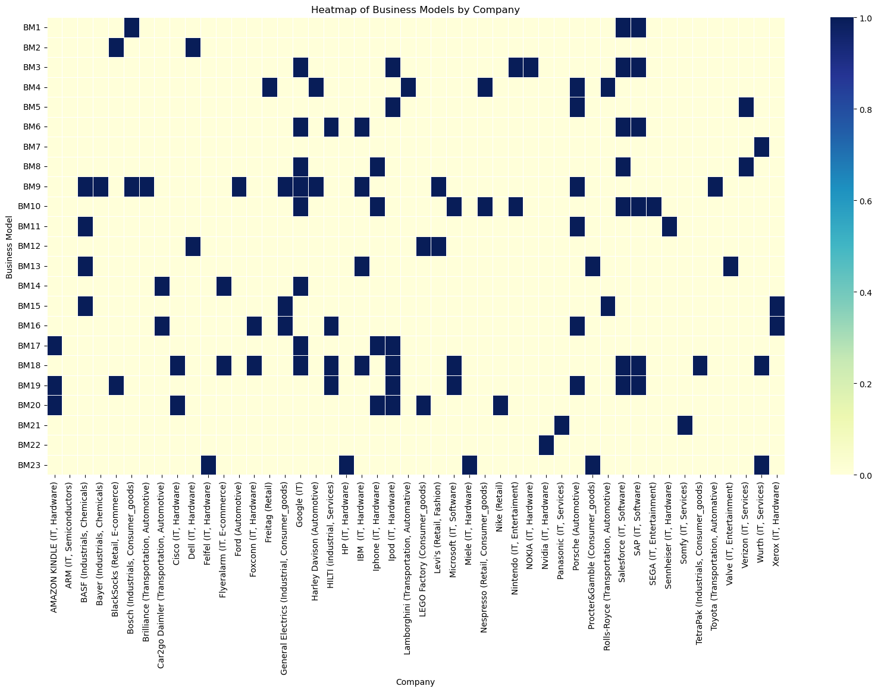

By generating a correlation heatmap of the main business model innovation patterns implemented in servitization contexts (Figure 2), we can identify, for instance, the predominant business models adopted by computers and electronic goods manufacturers. The most prevalent business models in the technology industry seem to be "Digitization," "Solution provider," "Open business," "User design," and "Performance-based contracting." Based on the observed correlations, these business models appear to be interconnected, suggesting that they could complement each other within a comprehensive business strategy.
Figure 2. Correlation heatmap between Business Model Innovation patterns in servitization
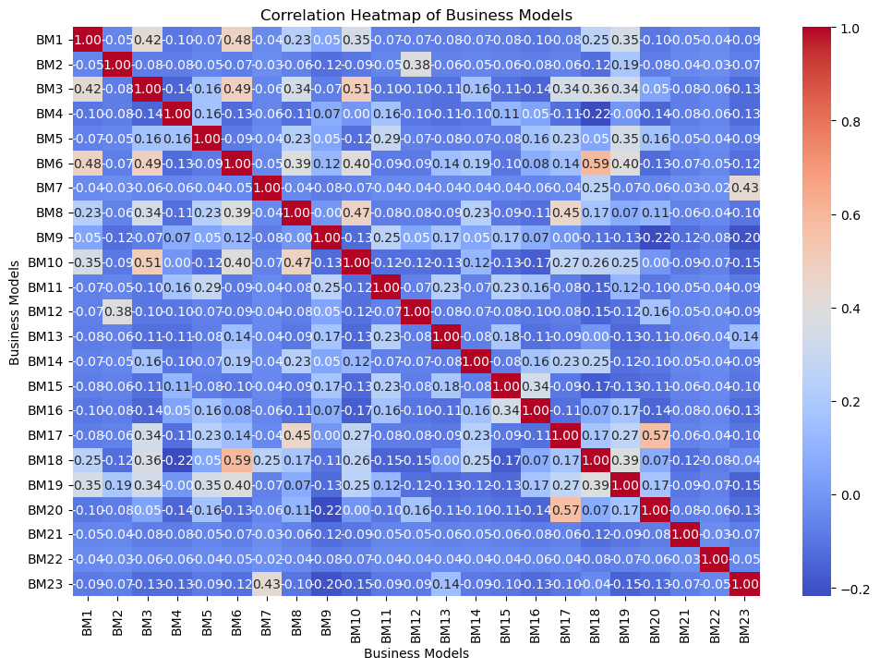

Conceptual Servitization Business Models Map
Considering the various manufacturing sectors, we can distinguish, for instance, the predominant business models followed by hardware and software manufacturers. Following this analysis, we can illustrate the interdependencies between business models, the firms implementing them, and the sectors in which these firms operate (Figure 3).

Figure 3. Network Graph of Business Model Innovation patterns in servitized manufacturers
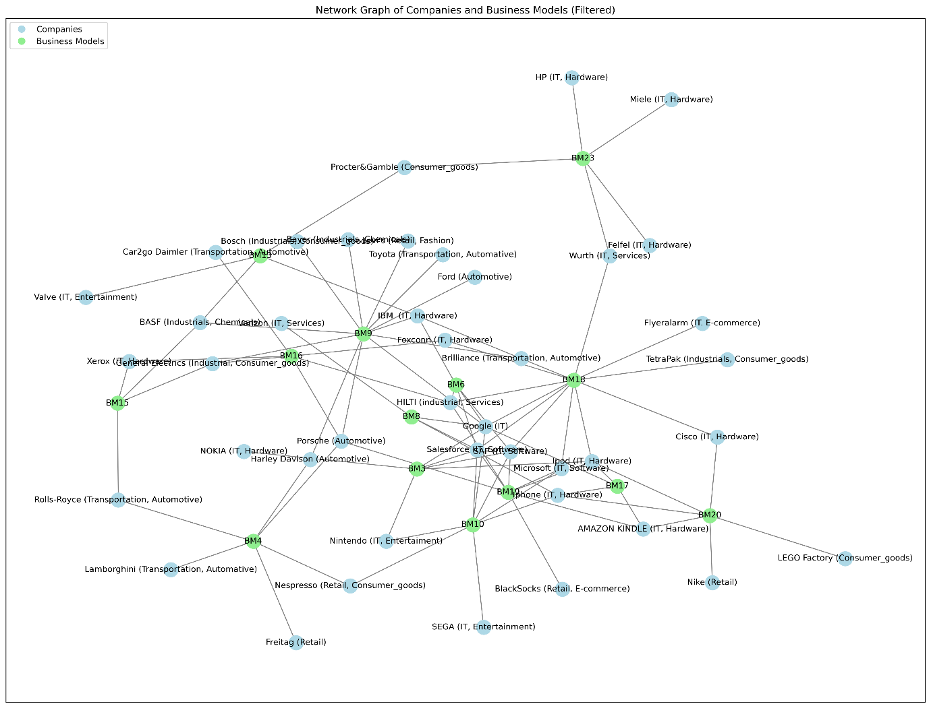

With this data, we can conduct a thorough analysis of how different servitized manufacturing companies are involved in various business model innovations. Here are some observations that arise from the analysis:
- Identification of focus areas: It can be observed which companies are more focused on certain business models. For example, companies like Amazon Kindle and Nespresso are closely associated with the "Cash-Machine" concept, suggesting a focus on business models that generate revenue continuously. These firms prioritize servitization strategies as a stable revenue stream (Baines et al., 2017).
- Identification of opportunities and threats: By examining term associations, we can identify areas where one company is heavily involved while others are not. For instance, if a company is highly associated with the concept of "Mass Customization," it could indicate a competitive advantage in the ability to customize products or services on a large scale. These servitized manufacturers could be facing the industrializer trajectory (Kowalkowski et al., 2015). However, if a company lacks association with terms like "Digitization" or "User Design," it could indicate a gap in technology adoption approaches or servitization-digitalization paradox (Kohtamäki et al., 2020).
- Comparative within-industry analysis: Comparing how different companies in the same industry are involved in specific terms can reveal sector trends (Busitnza et al., 2019a). For example, looking at automotive companies like Ford, Lamborghini, and Porsche, we can identify which terms are more prevalent in these companies and how they differ in their business models approaches.
- Evaluation of innovation and adaptability: Associations with terms like "Flat Rate," "Subscription," and "Rent Instead of Buy" may indicate a tendency toward customer-oriented flexible business models (Parry et al., 2013). Conversely, associations with terms like "Lock-In" could indicate a more traditional customer retention strategy (Bustinza et al., 2015).
From here, an analysis of the effect of business model implementation in servitized manufacturers will help quantify the impact of these models on those firms compared to their sector counterparts. We believe that this approach can be instrumental in selecting service-related revenue models for manufacturers and redefining servitization business models for academic researchers.
References
Alghisi, A., & Saccani, N. (2015). Internal and external alignment in the servitization journey–overcoming the challenges. Production Planning & Control, 26(14-15), 1219-1232.
Baines, T., Ziaee Bigdeli, A., Bustinza, O. F., Shi, V. G., Baldwin, J., & Ridgway, K. (2017). Servitization: revisiting the state-of-the-art and research priorities. International Journal of Operations & Production Management, 37(2), 256-278.
Brax, S. A., & Visintin, F. (2017). Meta-model of servitization: The integrative profiling approach. Industrial Marketing Management, 60, 17-32.
Bustinza, O. F., Bigdeli, A. Z., Baines, T., & Elliot, C. (2015). Servitization and competitive advantage: the importance of organizational structure and value chain position. Research-Technology Management, 58(5), 53-60.
Bustinza, O. F., Lafuente, E., Rabetino, R., Vaillant, Y., & Vendrell-Herrero, F. (2019a). Make-or-buy configurational approaches in product-service ecosystems and performance. Journal of Business Research, 104, 393-401.
Bustinza, O. F., Gomes, E., Vendrell‐Herrero, F., & Baines, T. (2019b). Product–service innovation and performance: the role of collaborative partnerships and R&D intensity. R&D Management, 49(1), 33-45.
Bustinza, O. F., Vendrell-Herrero, F., & Gomes, E. (2020). Unpacking the effect of strategic ambidexterity on performance: A cross-country comparison of MMNEs developing product-service innovation. International Business Review, 29(6), 101569.
Bustinza, O. F., Vendrell-Herrero, F., Davies, P., & Parry, G. (2024). Testing service infusion in manufacturing through machine learning techniques: looking back and forward. International Journal of Operations & Production Management, 44(13), 127-156.
Coreynen, W., Matthyssens, P., Struyf, B., & Vanhaverbeke, W. (2024). Spiraling between learning and alignment toward digital service innovation. Journal of Service Management, 35(2), 306-331.
Gassmann, O., & Frankenberger, K. (2014). The Business Model Navigator: 55 Models That Will Revolutionise Your Business. Pearson UK.
Jovanovic, M., Bustinza, O. F., Davies, P., & Parry, G. (2024). The interplay of product modularity, service types, and servitization depth on firm performance: a moderated mediation model. Production Planning & Control, 1-14.
Kohtamäki, M., Einola, S., & Rabetino, R. (2020). Exploring servitization through the paradox lens: Coping practices in servitization. International Journal of Production Economics, 226, 107619.
Kowalkowski, C., Windahl, C., Kindström, D., & Gebauer, H. (2015). What service transition? Rethinking established assumptions about manufacturers' service-led growth strategies. Industrial Marketing Management, 45, 59-69.
Parry, G., Bustinza, O. F., & Vendrell-Herrero, F. (2012). Servitisation and value co-production in the UK music industry: an empirical study of consumer attitudes. International Journal of Production Economics, 135(1), 320-332.
Porter, M. E., & Heppelmann, J. E. (2014). How smart, connected products are transforming competition. Harvard Business Review, 92(11), 64-88.
Vendrell-Herrero, F., Bustinza, O. F., Opazo-Basaez, M., & Gomes, E. (2023). Treble innovation firms: antecedents, outcomes, and enhancing factors. International Journal of Production Economics, 255, 108682.
West, S., Gaiardelli, P., & Rapaccini, M. (2018). Exploring technology-driven service innovation in manufacturing firms through the lens of Service dominant logic. IFAC-PapersOnLine, 51, 1317–1322.
Wise, R., & Baumgartner, P. (1999). Go downstream. Harvard Business Review, 77(5), 133-133.Bustinza, O. F., Lafuente, E., Rabetino, R., Vaillant, Y., & Vendrell-Herrero, F. (2019). Make-or-buy configurational approaches in product-service ecosystems and performance. Journal of Business Research, 104, 393-401.

Acknowledgements
Grant C-SEJ-020-UGR23 funded by Consejería de Universidad, Investigación e Innovación and by ERDF Andalusia Program 2021–2027.

