**Elucidating the role of organic loading rate on the performance and microbial dynamics of a novel continuous-flow aerobic granular sludge reactor**

Aurora Rosa-Masegosaa,b*, Barbara Muñoz-Palazonc, Jesus Gonzalez-Lopeza,b, Alejandro Gonzalez-Martineza,b

aInstitute of Water Research, University of Granada, C/Ramón y Cajal, 4, 18071 Granada, Spain.

bDepartment of Microbiology, Faculty of Pharmacy, University of Granada, Campus de Cartuja, s/n, 18071 Granada, Spain; [jgl@ugr.es](mailto:jgl@ugr.es) (J. G.-L.); [agon@ugr.es](mailto:agon@ugr.es) (A. G.-M.).

cDepartment of Ecological and Biological Sciences (DEB), University of Tuscia, Largo dell’Università snc, 01100 Viterbo, Italy; [barbara.munoz@unitus.it](mailto:barbara.munoz@unitus.it) (B. M.-P.).

*Corresponding author: Institute of Water Research, University of Granada, C/Ramón y Cajal, 4, 18071 Granada, Spain. E-mail address: [aurorarm@ugr.es](mailto:aurorarm@ugr.es) (A. R.-M.) Tel. 958 24 83 21.

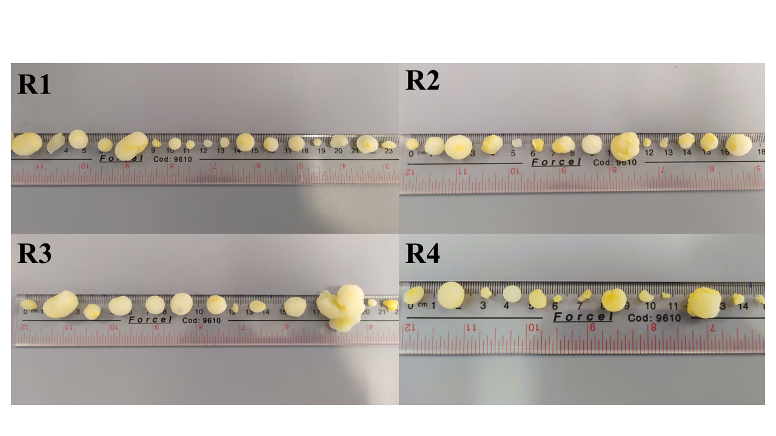

Figure S1. Digital images of granular sludge of bioreactors R1, R2, R3 and R4.

Figure S2. Digital images of granules cultivated in R2 and R3 bioreactor during the adaptation.

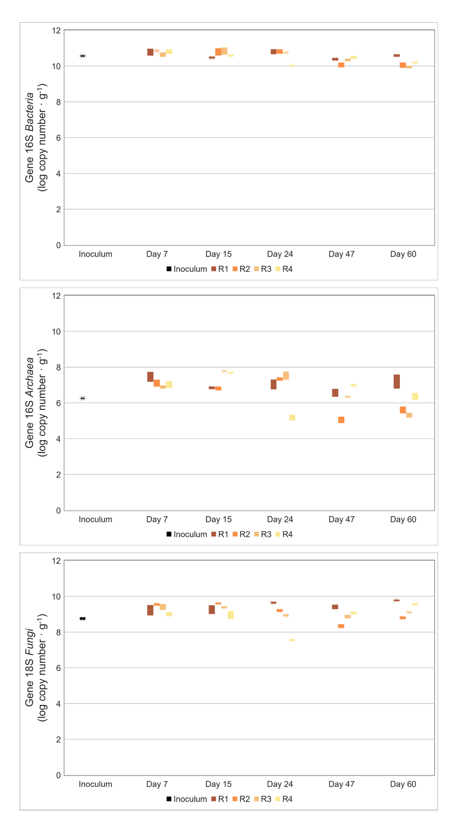

Figure S3. Gene copy numbers (log No. copies • g of granule-1) for total *Bacteria*, total *Archaea* and total *Fungi*.

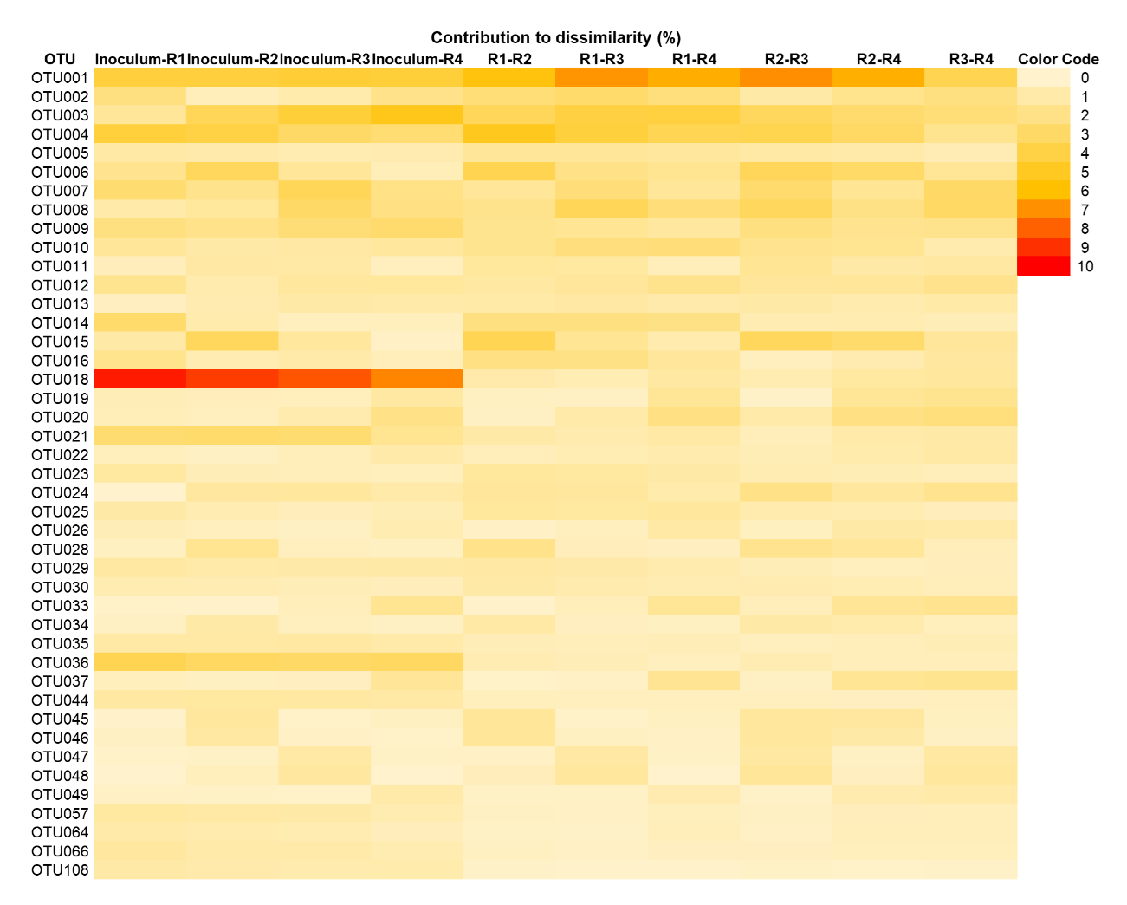

Figure S4. Similarity percentage analysis for prokaryotic community.

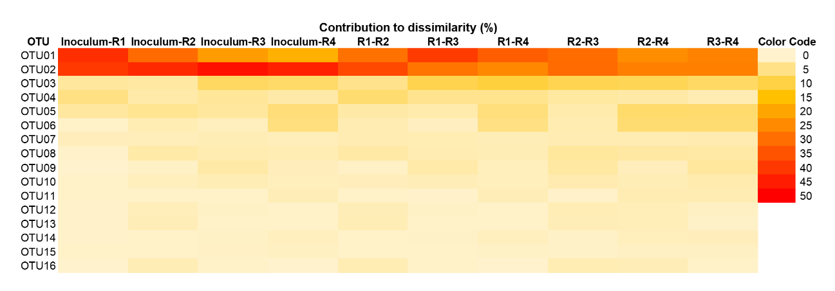

Figure S5. Similarity percentage analysis for eukaryotic community.

Table S1. Synthetic wastewater composition.

|  |  |  |  |  |  |  |
| --- | --- | --- | --- | --- | --- | --- |
|  | **CH3COONa**•**3H2O (g**•**L-1)** | **NH4Cl (g**•**L-1)** | **MgSO4**•**7H2O (g**•**L-1)** | **K2HPO4 (g**•**L-1)** | **KCl (g**•**L-1)** | **KH2PO4 (g**•**L-1)** |
| R1 | 1.050 | 0.250 | 0.100 | 0.085 | 0.040 | 0.030 |
| R2 | 0.787 | 0.250 | 0.100 | 0.085 | 0.040 | 0.030 |
| R3 | 0.525 | 0.250 | 0.100 | 0.085 | 0.040 | 0.030 |
| R4 | 0.262 | 0.250 | 0.100 | 0.085 | 0.040 | 0.030 |

Table S2. α-diversity for prokaryotic and eukaryotic communities.

|  |  |  |  |  |  |  |
| --- | --- | --- | --- | --- | --- | --- |
|  | **Reactor** | **Operational days** | **Shannon** | **Pielou's Evenness** | **Simpson** | **Chao-1** |
| **Prokaryotic community** | Inoculum |  | 4,442 | 0,06075 | 0,9718 | 2407 |
| R1 | 7 | 4,504 | 0,06725 | 0,972 | 2607 |
| 15 | 4,419 | 0,06555 | 0,9685 | 2404 |
| 24 | 4,313 | 0,05354 | 0,9671 | 2472 |
| 47 | 3,981 | 0,04182 | 0,9506 | 2276 |
| 60 | 3,809 | 0,03513 | 0,9375 | 2374 |
| R2 | 7 | 4,322 | 0,05004 | 0,9622 | 2620 |
| 15 | 4,294 | 0,05677 | 0,9654 | 2438 |
| 24 | 3,982 | 0,04503 | 0,9554 | 2088 |
| 47 | 4,364 | 0,06334 | 0,9692 | 2202 |
| 60 | 4,318 | 0,05589 | 0,965 | 2162 |
| R3 | 7 | 4,466 | 0,06069 | 0,9706 | 2732 |
| 15 | 4,332 | 0,06422 | 0,9703 | 2085 |
| 24 | 4,33 | 0,0612 | 0,9665 | 2359 |
| 47 | 4,471 | 0,07669 | 0,972 | 1896 |
| 60 | 4,447 | 0,07471 | 0,9753 | 1776 |
| R4 | 7 | 4,542 | 0,06349 | 0,9759 | 2950 |
| 15 | 4,606 | 0,07762 | 0,9783 | 2377 |
| 24 | 4,673 | 0,08412 | 0,9795 | 2130 |
| 47 | 4,582 | 0,07752 | 0,9801 | 1935 |
| 60 | 4,52 | 0,07369 | 0,9773 | 1817 |
| **Eukaryotic community** | Inoculum |  | 2,59 | 0,07088 | 0,8489 | 242,1 |
| R1 | 7 | 2,784 | 0,0767 | 0,9047 | 286,6 |
| 15 | 2,487 | 0,06013 | 0,8527 | 281,4 |
| 24 | 2,126 | 0,04873 | 0,7596 | 231,9 |
| 47 | 2,355 | 0,06126 | 0,8278 | 223,8 |
| 60 | 2,001 | 0,04228 | 0,7315 | 273,3 |
| R2 | 7 | 2,524 | 0,07214 | 0,84 | 242,2 |
| 15 | 2,478 | 0,06273 | 0,848 | 255,4 |
| 24 | 2,036 | 0,05394 | 0,7387 | 197,7 |
| 47 | 3,426 | 0,1379 | 0,9357 | 290,5 |
| 60 | 2,905 | 0,0777 | 0,885 | 306,3 |
| R3 | 7 | 2,589 | 0,0736 | 0,8595 | 287,9 |
| 15 | 2,462 | 0,07065 | 0,7991 | 238,1 |
| 24 | 2,882 | 0,1026 | 0,8673 | 216 |
| 47 | 3,517 | 0,1573 | 0,9446 | 243,6 |
| 60 | 3,092 | 0,08839 | 0,8935 | 304,1 |
| R4 | 7 | 2,872 | 0,08796 | 0,8941 | 315,4 |
| 15 | 3,53 | 0,1459 | 0,9514 | 385,9 |
| 24 | 3,572 | 0,1625 | 0,9475 | 279,1 |
| 47 | 3,439 | 0,1534 | 0,9446 | 238,7 |
| 60 | 3,086 | 0,1028 | 0,9076 | 280,5 |