Treatment of hospital wastewater using aerobic granular sludge technology: removal performance and microbial dynamics.

Lizandra Pérez-Boua,b, Aurora Rosa-Masegosab,*, Ramiro Vilchez-Vargasc,d, Alexander Linke, Alejandro Gonzalez-Martinezb, Jesus Gonzalez-Lopezb, Barbara Muñoz-Palazonf,**

aEnvironmental Microbiology Group, Department of Microbiology and Virology, University of Havana, 10400, Havana, Cuba

bInstitute of Water Research, University of Granada, C/Ramón y Cajal, 4, 18071 Granada, Spain

cMedical Department II, University Hospital, Ludwig-Maximillians-Universität, 81377, Munich, Germany

dGerman Center for Infection Research (DZIF), Partner Site Munich, 81377, Munich, Germany

eDepartment of Gastroenterology, Hepatology, and Infectious Diseases, Otto Von Guericke University Hospital Magdeburg, 39120, Magdeburg, Germany

fDepartment of Ecological and Biological Sciences (DEB), University of Tuscia, 01100 Viterbo, Italy

⁎Corresponding author at: A. Rosa-Masegosa, Institute of Water Research, University of Granada, C/Ramón y Cajal, 4, 18071 Granada, Spain. E-mail: aurorarm@ugr.es

⁎⁎Correspondence to: B. Muñoz-Palazon, Department of Ecological and Biological Sciences (DEB), University of Tuscia, 01100 Viterbo, Italy. E-mail: barbara.munoz@unitus.it

Figure S1. Removal efficiency ratio of COD (%), BOD5(%) and nutrients removal (%).

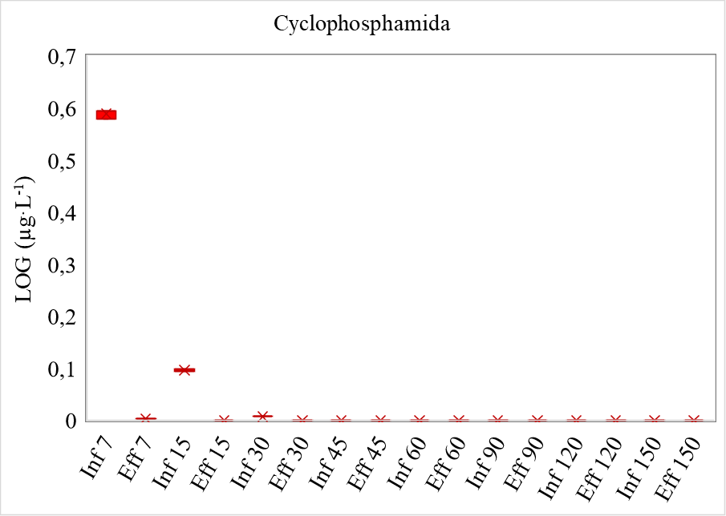

Figure S2. Cyclophosphamide analysis measured by UHPLC detected only in three influent samples at Day 7, Day 15, and Day 30.

Figure S3. Heat of map of bacterial dynamics expressed as a taxonomic operational unit (OTU) with phylogenetic similarity of 97% with more than 1.50% of relative abundance.

Figure S4. The heat of map of fungal dynamics expressed as a taxonomic operational unit (OTU) with phylogenetic similarity of 95% with more than 1.50% of relative abundance.

Figure S5. β-diversity measured by Whittaker index between pairs of samples for *Archaea*, *Bacteria* and *Fungi* communities.

Figure S6. Principal Component Analysis (PCA) calculated with compositional statistical of duplicate samples from next-generation sequencing for *Archaea* (a), *Bacteria* (b) and *Fungi* (c).

Figure S7. Similarity percent analysis (SIMPER) calculated to elucidate the contribution of genera (<1.5%) to dissimilarities between start-up and steady-state phases for *Archaea*, *Bacteria* and *Fungi.*

Figure S8- RDA analysis of archaeal (a), bacterial (b), and fungal (c) dominant OTUs with the performance of the reactor (PhACs, COD, BOD5, Nitrogen, ammonium, and phosphate removal), and granular properties.

Table S1. PERMANOVA analysis for the evaluation of startup (day 0 to day 38) and steady-stable period (Day 39 to day 150)

|  |  |  |  |  |  |  |
| --- | --- | --- | --- | --- | --- | --- |
| PERMANOVA | Nitrogen | Phosphate | BOD rem | COD rem | Settle | Size |
|  |  |  |  |  |  |  |
| Permutation N: | 9999 | 9999 | 9999 | 9999 | 9999 | 9999 |
| Total sum of squares: | 0.2988 | 1.837 | 0.2542 | 3.15E+04 | 0.3686 | 0.8804 |
| Within-group sum of squares: | 0.1446 | 0.9366 | 0.1982 | 2.16E+04 | 0.1417 | 0.8107 |
| F: | 8.53 | 7.69 | 9.614 | 32.92 | 40.04 | 2.149 |
| *p* (same): | 0.0226 | 0.0063 | 0.0051 | 0.0001 | 0.0001 | 0.1488 |

|  |  |  |  |  |  |  |  |  |  |  |  |  |  |  |  |  |  |  |  |  |  |
| --- | --- | --- | --- | --- | --- | --- | --- | --- | --- | --- | --- | --- | --- | --- | --- | --- | --- | --- | --- | --- | --- |
|  |  | Day 0 | D.S | Day 3 | D.S | Day 7 | D.S | Day 15 | D.S | Day 30 | D.S | Day 60 | D.S | Day 90 | D.S | Day 120 | D.S | Day 140 | D.S | Day 150 | D.S |
| Archaea | Simpson | 0.9 | 0.0 | 0.8 | 0.0 | 0.9 | 0.0 | 0.5 | 0.0 | 0.9 | 0.0 | 0.8 | 0.0 | 0.8 | 0.0 | 0.8 | 0.0 | 0.8 | 0.0 | 0.7 | 0.2 |
| Shannon | 3.0 | 0.0 | 2.4 | 0.1 | 2.8 | 0.1 | 1.5 | 0.1 | 2.8 | 0.0 | 2.6 | 0.0 | 2.2 | 0.0 | 2.3 | 0.0 | 2.6 | 0.1 | 2.4 | 0.8 |
| Evenness | 0.4 | 0.1 | 0.2 | 0.0 | 0.3 | 0.0 | 0.1 | 0.0 | 0.2 | 0.0 | 0.1 | 0.0 | 0.1 | 0.0 | 0.1 | 0.0 | 0.1 | 0.0 | 0.1 | 0.1 |
| B-Parker | 0.1 | 0.0 | 0.4 | 0.0 | 0.2 | 0.0 | 0.7 | 0.0 | 0.3 | 0.0 | 0.5 | 0.0 | 0.5 | 0.0 | 0.3 | 0.0 | 0.4 | 0.0 | 0.5 | 0.3 |
| Chao | 60.6 | 14.1 | 116.5 | 34.7 | 114.8 | 26.5 | 161.6 | 21.2 | 167.6 | 12.6 | 157.5 | 6.9 | 92.0 | 4.2 | 151.9 | 9.1 | 190.5 | 10.8 | 173.7 | 3.2 |
| Bacteria | Simpson | 0.9 | 0.0 | 1.0 | 0.0 | 1.0 | 0.0 | 0.9 | 0.0 | 1.0 | 0.0 | 1.0 | 0.0 | 1.0 | 0.0 | 1.0 | 0.0 | 1.0 | 0.0 | 0.9 | 0.0 |
| Shannon | 3.6 | 0.1 | 4.4 | 0.0 | 4.5 | 0.2 | 3.4 | 0.0 | 4.5 | 0.1 | 5.0 | 0.0 | 5.0 | 0.2 | 5.0 | 0.1 | 4.8 | 0.1 | 4.4 | 0.0 |
| Evenness | 0.0 | 0.0 | 0.0 | 0.0 | 0.0 | 0.0 | 0.0 | 0.0 | 0.0 | 0.0 | 0.1 | 0.0 | 0.3 | 0.1 | 0.1 | 0.0 | 0.2 | 0.1 | 0.1 | 0.0 |
| B-Parker | 0.2 | 0.0 | 0.1 | 0.0 | 0.2 | 0.0 | 0.2 | 0.0 | 0.1 | 0.0 | 0.1 | 0.0 | 0.0 | 0.0 | 0.1 | 0.0 | 0.1 | 0.0 | 0.2 | 0.0 |
| Chao | 2014.0 | 107.5 | 3643.0 | 135.8 | 4195.5 | 734.7 | 3526.5 | 265.2 | 4163.5 | 71.4 | 4036.5 | 416.5 | 1010.8 | 346.8 | 2208.5 | 135.1 | 1713.2 | 1087.3 | 2258.5 | 75.7 |
| Fungi | Simpson | 0.6 | 0.1 | 0.3 | 0.0 | 0.6 | 0.0 | 0.3 | 0.0 | 0.1 | 0.0 | 0.7 | 0.0 | 0.9 | 0.0 | 0.8 | 0.0 | 0.8 | 0.0 | 0.8 | 0.0 |
| Shannon | 1.6 | 0.3 | 0.8 | 0.0 | 1.4 | 0.0 | 0.8 | 0.0 | 0.3 | 0.0 | 1.4 | 0.0 | 2.5 | 0.2 | 2.2 | 0.1 | 1.9 | 0.2 | 2.2 | 0.2 |
| Evenness | 0.1 | 0.0 | 0.0 | 0.0 | 0.0 | 0.0 | 0.0 | 0.0 | 0.0 | 0.0 | 0.0 | 0.0 | 0.2 | 0.0 | 0.1 | 0.0 | 0.1 | 0.0 | 0.1 | 0.0 |
| B-Parker | 0.5 | 0.1 | 0.8 | 0.0 | 0.5 | 0.0 | 0.8 | 0.0 | 1.0 | 0.0 | 0.5 | 0.0 | 0.2 | 0.0 | 0.3 | 0.0 | 0.3 | 0.0 | 0.3 | 0.0 |
| Chao | 291.8 | 38.5 | 666.5 | 67.9 | 625.1 | 78.1 | 526.2 | 85.5 | 476.8 | 147.9 | 278.9 | 159.5 | 153.4 | 10.4 | 228.8 | 18.0 | 137.7 | 57.1 | 367.4 | 19.6 |

Table S2. Alpha diversity of archaeal. bacterial and fungal communities over operational days

*D.S: Deviation standard; B-Parker: Berger-Parker; Evenness : Pielou’s evenness.