**Efecto de la fertilización con nanopartículas, sulfato y quelato de zinc en la biomasa, producción y asimilación de nitrógeno en frijol ejotero en un suelo alcalino.**

**Proving the effectiveness of three different Zn fertilizers on *Phaseolus vulgaris* grown in an alkaline soil**

Linda Citlalli Noperi-Mosqueda1, Esteban Sánchez3, Cástor Omar Ponce-García 2, Juan Manuel Soto Parra1, Eloy Navarro-León4

1 Facultad de Ciencias Agrotecnológicas, Universidad Autónoma de Chihuahua, Ciudad Universitaria s/n, C.P. 31310, Chihuahua, México; e-mail@e-mail.com

2 Centro de Investigación en Alimentación y Desarrollo A.C. Coordinación Delicias, Av. Cuarta Sur 3820, Fraccionamiento Vencedores del Desierto, C.P. 33089, Delicias, México. [esteban@ciad.mx](mailto:esteban@ciad.mx)

3 Instituto Nacional de Investigaciones Forestales, Agrícolas y Pecuarias. Ave. Hidalgo No 1213, Col. Centro. CP. 31500, Cd. Cuauhtémoc, México.

4Universidad de Granada, Facultad de Ciencias, Departamento de fisiología Vegetal, Granada España; enleon@ugr.es

**Abstract**

The common bean (*Phaseolus vulgaris* L.) is one of the most important grain legumes for human diets worldwide due to its nutritional attributes. The application of large amounts of fertilizers is a current problem in agriculture because it could be harmful to the soil and reduce micronutrient availability including zinc (Zn). Zn is an essential element for crop production and quality and also in human diets. Zn deficiency in plants causes biomass reduction, interveinal chlorosis, necrotic spots, browning, small leaves, and growth retardation, and in humans increases the incidence of several diseases. Zn deficiency is common in alkaline soils. Therefore, this study aims to assess the efficiency of ZnSO4, a Zn chelate (DTPA-Zn), and Zn nanoparticles (NfsOZn) as fertilizers in *P. vulgaris* plants grown in an alkaline soil. To that end, *P. vulgaris* plants were supplied with the three fertilizers and grown in an experimental greenhouse. Parameters related biomass, NR activity, photosynthetic pigments, and Zn accumulation were analyzed. The three Zn fertilizers, especially DTPA-Zn and NfsOZn, were effective to increase the analyzed parameters. DTPA-Zn was the Zn source that most improved the bean yield and the ZnUpE, whereas NfsOZn produced a greater increase in NR activity, photosynthetic pigments, and ZnUtE. Besides, DTPA-Zn and NfsOZn considerably increased the Zn content in beans. Overall, the application of 50 ppm NfsOZn is the optimum Zn fertilizer to ensure a good yield, quality, and Zn content in *P. vulgaris* grown in an alkaline soil.

Keywords: Chelate; Common bean; Nanoparticles; Photosynthetic pigments; Yield; Zn use efficiency

**Introduction**

The common bean (*Phaseolus vulgaris* L.) is one of the most important grain legumes for human diets worldwide (Ponce-García et al., 2019). It belongs to the Fabaceae family, also called Leguminosae, which includes more than 20,000 species and over 700 genera. However, not all the Fabaceae species are within the legume food group. In this group are included species of the genera *Cicer*, *Cajanus*, *Lens*, or *Phaseolus* (FAO, 2018). The FAO in 2018 reported a global production of 31,771,830 tons of beans. Currently, bean cultivation is carried out mainly by small farmers in Latin America, the Caribbean, Africa, and Asia, which account for 77% of the world production (FAO, 2018). Mexico is the fourth largest bean producer in the world, contributing to 5.5% of the global production (SAGARPA, 2017). Beans are important in diets worldwide because they are rich in proteins, carbohydrates, dietary fiber, and are low in fat. They are also considered a good source of vitamins such as vitamin B6, niacin, thiamine, riboflavin, and folic acid, and a source of minerals such as phosphorus, potassium, calcium, magnesium, iron, and zinc (Zn). Therefore, bean consumption contributes to the prevention and treatment of chronic degenerative diseases, such as diabetes, obesity, cancer, and cardiovascular disease (Campos-Vega et al., 2018).

The application of large amounts of fertilizers in the form of salts is a current problem in agriculture because it could be harmful to the soil and reduce the availability of micronutrients such as Zn (Alloway, 2008; Ghormade et al., 2011). Zn is an essential element for crop production and quality because it is necessary for different enzymatic activities such as dehydrogenases, isomerases, transphosphorylases, DNA and RNA polymerases. In addition, Zn is involved in tryptophan synthesis, cell division, photosynthesis, and acts as a cofactor in protein synthesis (Davarpanah et al., 2016). Zn deficiency in plants causes biomass reduction, interveinal chlorosis, necrotic spots, browning, small leaves, and growth retardation. Besides, it causes negative effects in several physiological processes such as photosynthesis, glycolysis, starch synthesis, protein synthesis, flowering, and seed production. Another important process that is affected by Zn deficiency is nitrogen (N) metabolism, and N concentration in the plant (Navarro-León et al., 2016). On the other hand, Zn is also an essential nutrient in human diets. Zn deficiency is widespread throughout the world and increases the incidence of several diseases. Therefore, biofortification is a technique that can address this problem to increase the amount of Zn in the edible parts of food (White and Broadley, 2011).

Soil pH is a central factor that affects Zn bioavailability. Thus, Zn is less bioavailable in soils with a pH above 7 (alkaline soils). In these soils, Zn deficiency is frequent in crops and it is necessary to apply higher amounts of fertilizers (Alloway, 2008). Zn deficiency could limit crop production in many Latin American regions. Indeed, more than half of the soils in Mexico have a pH above 7 and could present Zn deficiency problems, especially in the northern zone (Omuto et al. 2013). Zn deficiency is common in bean cultivation and considerably reduces yields. Ponce-García et al. (2019) observed lower yield and quality in the bean variety used in the present study (Strike) in comparison with other cultivars under Zn-deficiency conditions. Thus, the application of fertilizers is crucial in Strike cultivar to increase its quality and production. Hence, the objective of this research is to measure the effect of three different sources of Zn fertilization, such as sulfate (ZnSO4), chelate (DTPA-Zn), and Zn nanoparticles (NfsOZn). These fertilizers were effective in bean plants grown under acid soil (Ponce-García et al., 2019), but its efficacy in alkaline soils is unknown. Therefore, in the present study, we assess the efficiency of these fertilizers in *P. vulgaris* plants grown in an alkaline soil.

**2. Materials and methods**

**2.1. Crop management**

The bean plants (*Phaseolus vulgaris* L. cv. Strike) were germinated and grown in polyethylene bags with 3 kg of alkaline soil (pH 7.8) in an experimental greenhouse located in Chihuahua City, Mexico at an average temperature of 30 ± 5°C. The plants received a nutrient solution composed of 6 mM NH4NO3, 1.6 mM K2HPO4, 2.4 mM K2SO4, 4 mM CaCl2•2H2O, 1.4 mM MgSO4, 2 µM MnSO4•H2O, 1 µM ZnSO4•7H2O, 0.25 µM CuSO4•5H2O, 0.3 µM (NH4)6Mo7O24•4H2O, and 0.5 µM H3BO3 prepared with distilled water (Sanchez et al., 2004). The pH of the solution was between 5.5 and 6.0. The Zn fertilizers were applied 15 days after germination and each plant received 200 mL, once a week during the next 60 days.

2.2. Experimental design

The experimental design consisted of a completely randomized design with ten treatments and five replicates. Table 1 shows the sources and doses of each Zn fertilizer.

Table 1. Description of treatments (Zn sources and doses)

|  |  |
| --- | --- |
| Zn source | Dose (mg kg-1) |
| Control | 0 |
| Sulfate  (ZnSO4) | 25 |
| 50 |
| 100 |
| DTPA chelate  (DTPA-Zn) | 25 |
| 50 |
| 100 |
| Zn O nanoparticles  (NfsOZn) | 25 |
| 50 |
| 100 |

2.3. Plant sampling

The complete plants were sampled 60 days after germination and the beans were harvested. The plants were in the phenological stage of full development and fruit maturity. The fresh material was used for the quantification of biomass, yield, photosynthetic pigments, and nitrate reductase (NR) activity. The dry material was used for the determination of Zn concentration and Zn assimilation efficiency. Four replicates were used per treatment for each analyzed parameter.

2.4. Plant Analysis

2.4.1. Biomass and yield

The fresh weight of each part of the plant (root, stem, leaves, and pods) was obtained separately to measure the production in biomass and the total biomass was obtained as the sum of the weights of each part. Plant yield was expressed as the mean bean fresh weight per plant.

2.4.2. Assay and determination of the in vivo enzymatic activity of NR.

The in vivo NR activity (EC 1.6.6.1) was determined by the method described by Salinas et al. (2012). Leaves were cut into 5-mm sections (100 mg) and placed in 10 ml of incubation buffer (100 mM K-phosphate buffer, pH 7.5, and 1% (v/v) propanol). The samples were infiltrated and the intracellular spaces of the tissues were flushed with buffer, using vacuum (0.08 MPa). After 5 min, the vacuum was released and the samples were re-evacuated, incubated at 30°C in darkness for 1 h, and finally placed in a boiling water bath to stop the NR activity. The resulting nitrite concentration was determined spectrophotometrically at 540 nm in a reaction mixture containing 2 ml of extract, 2 ml of 1% (m/v) sulfanilamide in 1.5 M HCl and 2 ml 0.02% (m/v) N-(1-naphthyl)-ethylenediamine dihydrochloride in 0.2 M HCl. (NR+NO3-) was determined following the same method but using a modified incubation buffer, containing 50 mM KNO3. The NR induced by NO3- and Mo (NR+NO3- +Mo), and the NR induced by NO3- and Mo (NR+NO3- +Mo), were also determined using a modification of the incubation buffer containing 20 mM NaMoO4 and 50 mM KNO3 plus 20 mM NaMoO4, respectively. The resulting nitrate concentration was also determined spectrophotometrically.

2.4.3. Photosynthetic Pigments

The method described by Castillo et al. (2017) was used for the extraction and quantification of the leaf pigments. 0.2-0.3 g of fresh photosynthetic plant material (leaves) was weighed in disks. The diameter of the disks was 7 mm. 10 ml of pure methanol (CH3OH) was added. Subsequently, the samples were incubated at room temperature in darkness for 24 hours. Then, the absorbance was measured at 470 nm (carotenoids), 653 nm (chlorophyll b, chl b), and 666 nm (chlorophyll a, chl a). Total Chls was obtained through the sum of Chl a and Chl b. Pigment concentrations were obtained using the following formulas (Castillo et al., 2017):

1. Chl a: [15.65·(A666) – 7.34·(A653)]
2. Chl b: [27.05·(A653) – 11.21·(A666)]
3. Carotenoids = (1000 X A470 nm - 2.86 X Chl a - 129.2 X Chl b) / 221

V1: Volume of extraction; p1: weight (g) per disk; p2: total weight (g); n: number of disks; r2: disk diameter.

2.4.4. Determination of Zn concentration and Zn efficiency parameters (ZnUE)

Zn concentration was determined using an Inductive Couple Plasma Optical Emission Spectrometer (Agilent Technologies 700 Series ICP-OES, California, USA), and according to the method described by Wellburn (1994). Zn concentration was expressed as mg kg-1 of dry weight.

ZnUE parameters were calculated as follow:

Total Zn accumulation (TZnA) was calculated as Zn concentration multiplied by total plant biomass (Elliott and Læuchli, 1985).

Zn uptake efficiency (ZnUpE) was calculated as TZnA divided by root DW (mg Zn g-1 RDW) (Elliott and Læuchli, 1985).

Zn utilization efficiency (ZnUtE) was calculated as leaf tissue DW divided by Zn concentration (g2 LDW mg-1 Zn) (Siddiqi and Glass, 2008).

2.5. Statistical analysis

All data were subjected to analysis of variance. The 95% LSD test was used for the difference between the treatment means. The significance levels of both analyses were expressed as *P<0.05; **P<0.01; ***P<0.001 and NS (not significant).

3. Results and discussion

3.1. Biomass and yield

One of the main symptoms of Zn deficiency is a biomass reduction due to Zn is an essential microelement for plant development (Alloway, 2008, Navarro-León et al., 2016). Figure 1a shows that both DTPA-Zn and NfsOZn were the sources of Zn with the greatest impact on the bean pod weight. Regarding the plant biomass (stem and leaves), it was higher in the plants supplied with the three fertilization sources compared to the control plants. However, there were no significant differences between the doses of each fertilizer (Figure 1b). Similarly, in terms of root weight, all Zn sources contributed to increasing root growth, although the highest doses of ZnSO4 and DTPA-Zn did not show significant differences compared to control (Figure 1c). This increase in root biomass is favorable because increases the absorption area and the uptake of nutrients from the soil (Roy et al. 2010). Besides, the increment in leaf and stem biomass probably leads to a higher photosynthetic capacity impacting positively on yield. Overall, the doses that produced the highest increase in total biomass compared to control plants were: 50 ppm NfsOZn (**59%REVISAR %**), 25 ppm DTPA-Zn (47%), and 25 ppm ZnSO4 (41%) (Figure 1d). Therefore, DTPA-Zn, and specially NfsOZn, were more effective than ZnSO4 to increase plant biomass. These results agree with those obtained by other authors that proved that NfsOZn application to bean plants considerably increased biomass of plants (Liu and Lal, 2015; Mahdieh et al., 2018). On the other hand, although the highest value in total biomass was reached in plants supplied with 50 ppm NfsOZn, there were no significant differences in the different NfsOZn doses. Therefore, the application of the lowest NfsOZn dose (25 ppm) is enough to increase biomass. Indeed, a moderate application of NfsOZn is better because high NfsOZn doses can cause toxicity in crops (Liu and Lal, 2015; Alvarez et al., 2017).

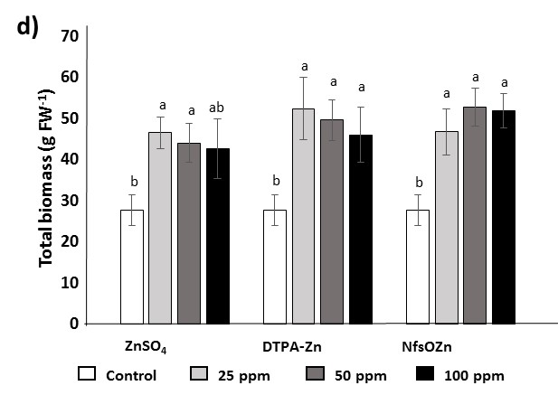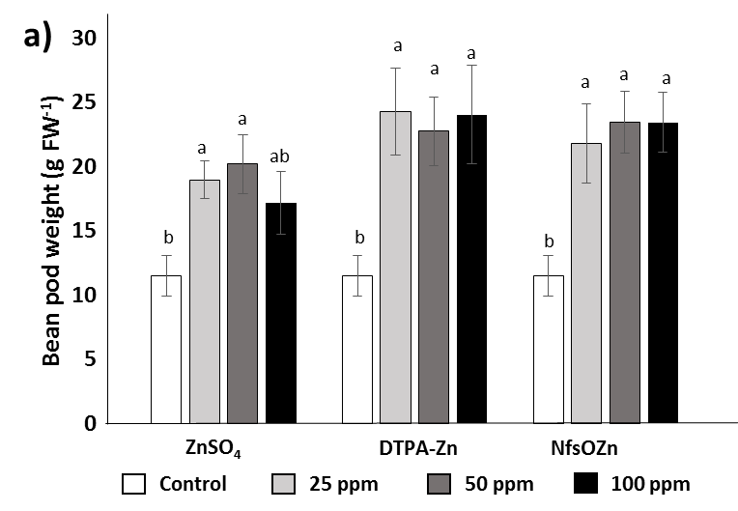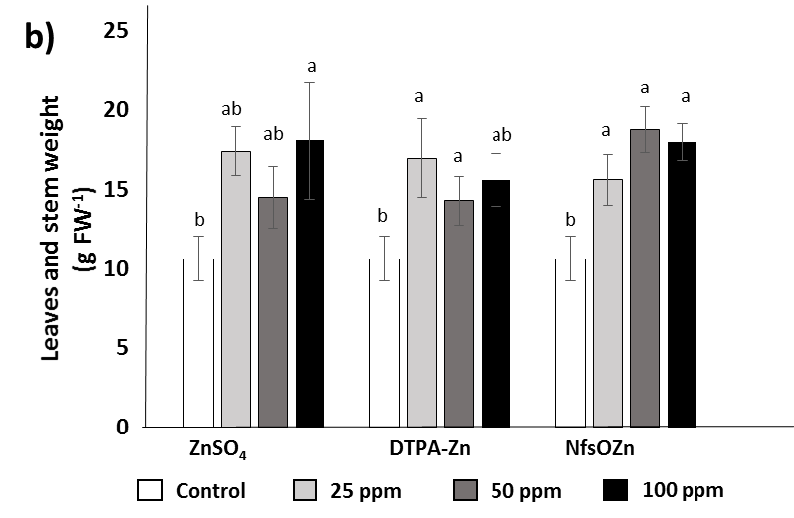

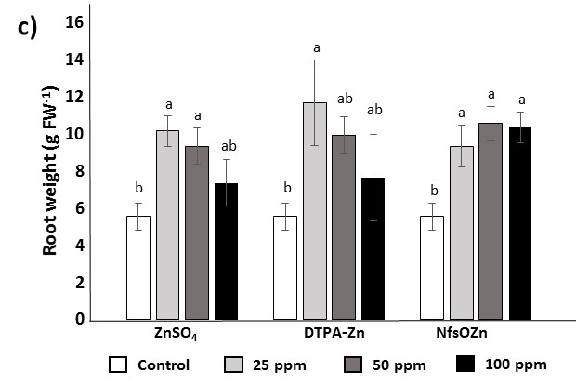

Figure 1. Effect of the application of ZnSO4, DTPA-Zn, and NfsOZn on the fresh weight of the bean pod (a), the plant (b), and the root (c). **QUITAR -1 despues de FW**

Several studies reported that the application of Zn to crops such as beans, tomatoes, and corn increased crop yield (Alvarez et al., 2017; Sturikova et al., 2018). In the present experiment, the best doses of each fertilizer that incremented yield were: 50 ppm ZnSO4 (43%), 100 ppm DTPA-Zn (70%), and 50 ppm NfsOZn (51%) in comparison to control plants (Figure 2). These results agree with those obtained by Ponce-García et al. (2019) that found increases in yield by application of different Zn sources to beans plants grown in an acidic soil. The Zn source that showed the greatest impact on yield was 100 ppm DTPA-Zn, which could be due to Zn chelates increase the availability of this micronutrient especially in alkaline soils, and thereby contributing to the increase in crop yield (Alloway 2008).

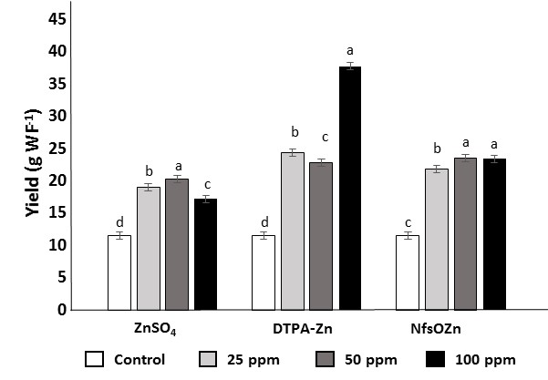

Figure 2. Effect of the application of ZnSO4, DTPA-Zn, and NfsOZn on the yield of the Strike bean. **CAMBIAR WF EN GRAFICA y quitar -1**

3.2. "In vivo" NR activity

NR activity is crucial to reduce nitrate to ammonium and is highly related to plant growth regulation (Taghavi and Babalar, 2007; Yang et al., 2010). Zn deficiency usually causes a reduction in N metabolism activity and specifically in NR activity (Navarro-León et al., 2016). In the present study, the doses that increased NR activity were 25 ppm ZnSO4, 25 ppm DTPA-Zn, and 50 ppm NfsOZn (Figure 3). The most effective Zn fertilization was 50 ppm NfsOZn that increased NR activity by 26%. Hence, NfsOZn, applied at the proper dose, could enhance NR and thereby the assimilation of N. This could contribute to the higher biomass of the plants that were fertilized with 50 ppm NfsOZn (Figure 1). Faizan et al. (2018) also reported a positive effect of NfsOZn on plant metabolism because its application to tomato plant increased enzymatic activity. The metabolic functions of Zn are based on its strong tendency to form complexes with N, oxygen, and particularly sulfur, which gives it the ability to perform catalytic and structural functions in enzymatic reactions (Alloway, 2008). Thus, the application of Zn as nanoparticles might favor the formation of those complexes.

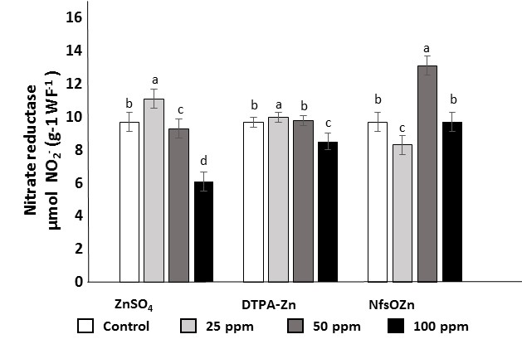

Figure 3. Effect of the application of ZnSO4, DTPA-Zn, and NfsOZn on NR activity of beans cv. Strike. **PONER el -1 como superindice. PONER en ZnSO4 b a b c; una a al 50 ppm de DTPA-Zn**

3.3. Photosynthetic pigments concentration

Photosynthetic pigments such as Chls and carotenoids convert solar radiation into chemical energy needed for photosynthesis (Wang et al., 2020). Indeed, Chls concentration is very important because it is positively correlated with net photosynthesis, leaf N, and thereby with plant biomass (De Castro, et al., 2014). Carotenoids play an important role as accessory light-harvesting pigments that dissipates the energy excess and also have antioxidant characteristics (Sun et al., 2018). In addition, the concentration of photosynthetic pigments, especially Chls, can be reduced by environmental factors such as mineral deficiencies (De Castro, et al., 2014). Figures 4a and 4b show that there is not a correlation between higher doses of Zn fertilizers and higher photosynthetic pigments. This agrees with the results of Rossi et al. (2019), that applied ZnSO4 and NfsOZn to coffee plants without any effect on pigment concentration. Nevertheless, in the present experiment, 100 ppm ZnSO4, 25 ppm DTPA-Zn, and 50 ppm NfsOZn increased photosynthetic pigments (Figures 4a and 4b). The most effective Zn source was NfsOZn that incremented Chls by 17% and carotenoids by 30%. This agrees with Faizan et al. (2018) and Pullagurala et al. (2018) studies that reported higher photosynthetic efficiency in plants supplied with metallic element nanoparticles such as NfsOZn. Besides, the higher carotenoids concentration in plants supplied with NfsOZn could contribute to the bean quality because carotenoids enhance the antioxidant properties of human diets (Kan et al., 2018).

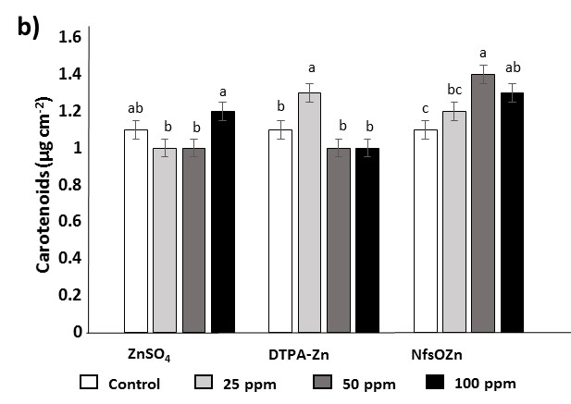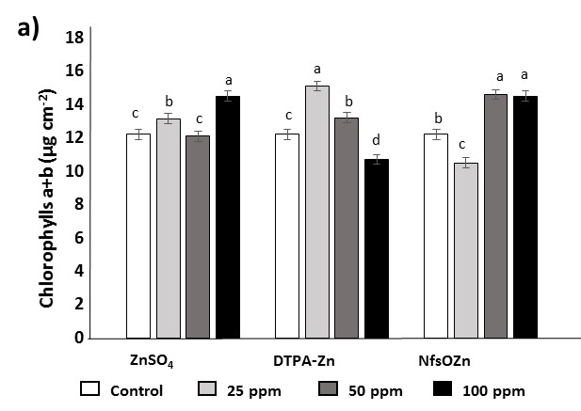

Figure 4. Effect of the application of ZnSO4, DTPA-Zn, and NfsOZn on Chls (a) and carotenoids (b) concentrations in leaves of bean cv. Strike.

3.4. Zn concentration

Zn is an essential micronutrient that is necessary for normal crop growth and reproduction (Alloway, 2008). Several studies proved that the application of different fertilization sources increases Zn concentration in all plant parts (Ponce-García et al., 2019; Rossi et al., 2019). This effect was also observed in the present study because Zn concentration increased regardless of the Zn source applied, although it was different in each plant part. In roots, Zn concentration increased by 17% in plants treated with 100 ppm ZnSO4, by 30% in plants treated with 100 ppm DTPA-Zn, whereas plants treated with 25 ppm NfsOZn reached a 22% (Figure 4a). In the stem, the doses that promoted the greatest increases in Zn concentration were 25 ppm ZnSO4 (52%), 100 ppm DTPA-Zn (55%), and 100 ppm NfsOZn (3%) (Figure 4b). These results indicate that bean plants, despite growing in an alkaline soil, were able to uptake the extra Zn supplied by fertilizers.

Conversely, Zn fertilizers were not so effective to increase Zn concentration in leaves. Thus, 100 ppm of ZnSO4 only increased Zn by 4%, and 100 ppm of DTPA-Zn by 2%. However, the application of 25 ppm NfsOZn incremented Zn concentration by 31% in leaves (Figure 4c). In addition, plants fertilized with DTPA-Zn and NfsOZn reached great increments in bean Zn content (roughly 130%) in comparison to control plants and regardless of the dose (Figure 4d). Other authors also proved that DTPA-Zn and NfsOZn are effective to increase Zn content in fruits such as beans (Mahdieh et al, 2018; Du et al., 2019; Kheyri et al., 2019; Ponce-García et al., 2019). The increase in Zn concentration in the beans is encouraging because it is the edible part of this crop. Besides, Zn is not only important for plant growth, but also for human nutrition because it is present in 925 proteins and more than 300 enzymes involved in metabolic processes (Alloway 2008). Therefore, the use of DTPA-Zn and especially the most efficient NfsOZn is a potential strategy for Zn biofortification to increase Zn content in the edible part of beans.

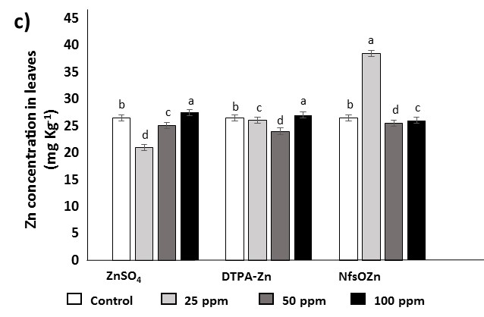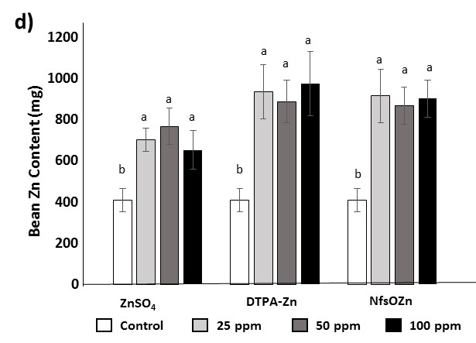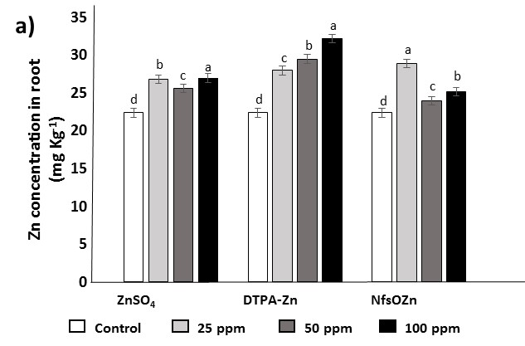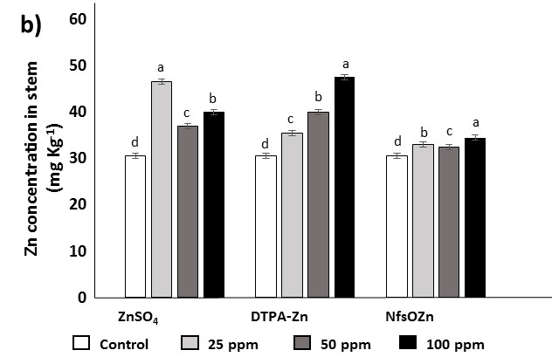

**CAMBIAR LETRAS EN HOJAS (c) en DTPA-Zn poner b b c a y en NfsOZn poner b a c c**

Figure 4. Zn concentration in (a) root, (b) stem, (c) leaves and (d) beans in cv.Strike in response to the application of ZnSO4, DTPA-Zn, and NfsOZn.

3.5 Zn efficiency parameters

To better understand the efficacy of fertilizers is useful not only to know the nutrient concentration in the plant but its efficiencies of uptake and use by the plant (Elliott and Læuchli, 1985; Siddiqi and Glass, 2008). In this study, all the applied fertilizers increased TZnA regardless of the dose. Thus, plants supplied with fertilizers reached similar TZnA levels, except plants supplied with 50 ppm ZnSO4, that reached lower values in comparison to the other ZnSO4 doses (Table 2). The higher Zn accumulation could be favored by the higher ZnUpE in fertilized plants than in control plants. Therefore, Zn fertilizers were effective in enhance Zn uptake in *P. vulgaris* plants. The highest increment in ZnUpE was observed in plants supplied with 100 ppm ZnSO4, whereas 100 ppm of NfsOZn did not affect this parameter. Regarding NfsOZn, plants supplied with the 25 ppm dose showed the highest ZnUpE and TZnA values (Table 2). These results agree with the results observed by Ponce-García et al. (2019) that showed that 25 ppm was the optimum dose in an acid soil. Furthermore, the three Zn fertilizers considerably enhanced ZnUtE, except 100 ppm DTPA-Zn. The highest increments were found in plants that received 50 ppm NfsOZn (Table 2). These results suggest that Zn supplied as nanoparticles is more bioavailable, and is more easily incorporated for plant tissues than the other Zn fertilizers.

Tabla 2. Zn efficiency parameters in common bean plants supplied with ZnSO4, DTPA-Zn, and NfsOZn

|  |  |  |  |
| --- | --- | --- | --- |
|  | TZnA  (mg) | ZnUpE  (mg Zn g−1 RDW) | ZnUtE  (g2 LDW mg−1 Zn) |
| ZnSO4 |  |  |  |
| Control | 1.24 ± 0.23c | 232.72 ± 6.71c | 0.17 ± 0.02b |
| 25 ppm | 2.65 ± 0.37a | 266.05 ± 8.03b | 0.30 ± 0.04a |
| 50 ppm | 1.97 ± 0.28b | 213.99 ± 23.69c | 0.27 ± 0.02a |
| 100 ppm | 2.51 ± 0.27a | 329.51 ± 37.38a | 0.28 ± 0.03a |
| *p-valor* | *** | *** | *** |
| LSD0.05 | 0.39 | 30.49 | 0.04 |
|  |  |  |  |
| DTPA-Zn |  |  |  |
| Control | 1.24 ± 0.23b | 232.72 ± 6.71b | 0.17 ± 0.02b |
| 25 ppm | 2.67 ± 0.22a | 288.49 ± 22.08a | 0.33 ± 0.03a |
| 50 ppm | 2.48 ± 0.41a | 264.39 ± 17.63a | 0.30 ± 0.04a |
| 100 ppm | 2.32 ± 0.28a | 278.82 ± 30.74a | 0.20 ± 0.02b |
| *p-valor* | *** | ** | *** |
| LSD0.05 | 0.39 | 28.35 | 0.04 |
|  |  |  |  |
| NfsOZn |  |  |  |
| Control | 1.24 ± 0.23b | 232.72 ± 6.71c | 0.17 ± 0.02c |
| 25 ppm | 2.79 ± 0.30a | 271.41 ± 18.25a | 0.28 ± 0.03b |
| 50 ppm | 2.53 ± 0.32a | 252.28 ± 8.08b | 0.38 ± 0.05a |
| 100 ppm | 2.43 ± 0.37a | 235.67± 11.19c | 0.33 ± 0.05a |
| *p-valor* | *** | *** | *** |
| LSD0.05 | 0.42 | 15.99 | 0.05 |

Values are means and differences between means were compared by Fisher’s least-significance test (LSD; P=0.05). Values with different letters indicate significant differences. The levels of significance were represented by p<0.01 (**) and p<0.001 (***)

5. Conclusions

According to the results, the three Zn fertilizers are effective to increase the parameters analyzed in *P. vulgaris* grown in an alkaline soil. However, The Zn sources that showed the best results were DTPA-Zn and NfsOZn. DTPA-Zn was the Zn source that most improved the bean yield and the ZnUpE, whereas NfsOZn was more effective to increase NR activity, photosynthetic pigments, and ZnUtE. Specifically, the optimum NfsOZn dose to enhance the analyzed parameters was 50 ppm. Regarding Zn biofortification, plants supplied with both DTPA-Zn and NfsOZn registered great increments in bean Zn content regardless of the dose. Briefly, the application of 50 ppm NfsOZn is the optimum Zn fertilizer to ensure a good yield, quality, and Zn content in *P. vulgaris* grown in an alkaline soil. However, further research is required to understand the mechanism by which NfsOZn is assimilated by the plants to achieve the most efficient use of them.

**6. References**

Agroalimentario, P. Frijol 2016 [Internet]. México: Fideicomisos instituidos en relación con la agricultura. 2016.

Alloway, B. J. (2008). Zinc in soils and crop nutrition. 3th ed. International Zinc Association Brussels, Belgium.

Álvarez, S. P., Sida-Arrerola, J. P., Chávez, E. S., & Ardisana, E. F. H. (2017). Expression analysis and biochemical characterization of beans plants biofortificated with zinc. Saudi journal of biological sciences, 24(6), 1322-1326.

Castillo, F.S.D.; Durán Paredes, M.; Pérez, M.; del Carmen, E.; Magdaleno Villar, J.J. (2017) Variedades y densidades de población de frijol ejotero cultivado bajo invernadero e hidroponía. Revista Mexicana de Ciencias Agrícolas, 8, 1187–1193.

Campos-Vega, R., Bassinello, P. Z., Santiago, R. de A. C., & Oomah, B. D. (2018). Dry Beans: Processing and Nutritional Effects. Therapeutic, Probiotic, and Unconventional Foods, 367–386. doi:10.1016/b978-0-12-814625-5.00019-4

Cakmak, I., Pfeiffer, W. H., & McClafferty, B. (2010). Biofortification of durum wheat with zinc and iron. Cereal Chemistry, 87(1), 10-20.

De Castro, F. A., Campostrini, E., Netto, A. T., Gomes, M. D. M. D. A., Ferraz, T. M., & Glenn, D. M. (2014). Portable chlorophyll meter (PCM-502) values are related to total chlorophyll concentration and photosynthetic capacity in papaya (Carica papaya L.). Theoretical and Experimental Plant Physiology, 26(3-4), 201-210.

Du, W., Yang, J., Peng, Q., Liang, X., & Mao, H. (2019). Comparison study of zinc nanoparticles and zinc sulphate on wheat growth: From toxicity and zinc biofortification. Chemosphere, 227, 109-116.

Elliott, G.C., Læuchli, A., 1985. Phosphorus efficiency and phosphate-iron interaction in maize. Agron. J. 77, 399. <https://doi.org/10.2134/agronj1985.00021962007700030011x>

Faizan, M., Faraz, A., Yusuf, M., Khan, S. T., & Hayat, S. (2018). Zinc oxide nanoparticle-mediated changes in photosynthetic efficiency and antioxidant system of tomato plants. Photosynthetica, 56(2), 678-686.

FAO. 2018. Legumbres. Pequeñas semillas, grandes soluciones. Ciudad de Panamá. 292 páginas. ISBN 978-92-5-131129-5

Ghormade, V., Deshpande, M. V., & Paknikar, K. M. Perspectives for nano-biotechnology enabled protection and nutrition of plants. Biotechnology advances 2011, 29(6), 792-803. doi:10.1016/j.biotechadv.2011.06.007

Kan, L., Nie, S., Hu, J., Wang, S., Bai, Z., Wang, J., ... & Song, K. (2018). Comparative study on the chemical composition, anthocyanins, tocopherols and carotenoids of selected legumes. Food chemistry, 260, 317-326.

Kheyri, N., Norouzi, H. A., Mobasser, H. R., & Torabi, B. (2019). Effects of Silicon and Zinc Nanoparticles on Growth, Yield, and Biochemical Characteristics of Rice. Agronomy Journal, 111(6), 3084-3090.

Mahdieh, M., Sangi, M. R., Bamdad, F., & Ghanem, A. (2018). Effect of seed and foliar application of nano-zinc oxide, zinc chelate, and zinc sulphate rates on yield and growth of pinto bean (Phaseolus vulgaris) cultivars. Journal of plant nutrition, 41(18), 2401-2412.

Liu, R., & Lal, R.. Potentials of engineered nanoparticles as fertilizers for increasing agronomic productions. Science of the total environment 2015, 514, 131-139. http://dx.doi.org/10.1016/j.scitotenv.2015.01.104

Navarro-León, E., Barrameda-Medina, Y., Lentini, M., Esposito, S., Ruiz, J. M., & Blasco, B. (2016). Comparative study of Zn deficiency in L. sativa and B. oleracea plants: NH4+ assimilation and nitrogen derived protective compounds. Plant Science, 248, 8-16.

Navarro-León, E., Albacete, A., de la Torre-González, A., Ruiz, J. M., & Blasco, B. (2016). Phytohormone profile in Lactuca sativa and Brassica oleracea plants grown under Zn deficiency. Phytochemistry, 130, 85-89.

Pullagurala, V. L. R., Adisa, I. O., Rawat, S., Kalagara, S., Hernandez-Viezcas, J. A., Peralta-Videa, J. R., & Gardea-Torresdey, J. L. (2018). ZnO nanoparticles increase photosynthetic pigments and decrease lipid peroxidation in soil grown cilantro (Coriandrum sativum). Plant Physiology and Biochemistry, 132, 120-127.

Omuto, C., Nachtergaele, F., & Rojas, R. V. (2013). State of the Art Report on Global and regional Soil Information: Where are we? Where to go? (p. 81). Rome: Food and Agriculture Organization of the United Nations.

Ponce-García, C. O., Soto-Parra, J. M., Sánchez, E., Muñoz-Márquez, E., Piña-Ramírez, F. J., Flores-Córdova, M. A., ... & Yáñez Muñoz, R. M. (2019). Efficiency of nanoparticle, sulfate, and zinc-chelate use on biomass, yield, and nitrogen assimilation in green beans. Agronomy, 9(3), 128.

Rossi, L., Fedenia, L. N., Sharifan, H., Ma, X., & Lombardini, L. (2019). Effects of foliar application of zinc sulfate and zinc nanoparticles in coffee (Coffea arabica L.) plants. Plant physiology and biochemistry, 135, 160-166.

Roy, S., Arunachalam, K., Dutta, B. K., & Arunachalam, A. (2010). Effect of organic amendments of soil on growth and productivity of three common crops viz. Zea mays, Phaseolus vulgaris and Abelmoschus esculentus. Applied Soil Ecology, 45(2), 78-84.

Salinas Ramírez, N.; Escalante Estrada, J.A.; Rodríguez González, M.; Sosa Montes, E. (2012). Rendimiento y calidad nutrimental de frijol ejotero en dos ambientes. Rev. Fitotec. Mex. 35, 317–323.

Secretaría de Agricultura, Ganadería, Desarrollo Rural, Pesca y Alimentación (SAGARPA). 2017 Planeación Agrícola Nacional 2017-2030. México

Schweizer, S. A., Seitz, B., Van Der Heijden, M. G., Schulin, R., & Tandy, S. (2018). Impact of organic and conventional farming systems on wheat grain uptake and soil bioavailability of zinc and cadmium. Science of the Total Environment, 639, 608-616.

Siddiqi, M.Y., Glass, A.D.M., 2008. Utilization index: A modified approach to the estimation and comparison of nutrient utilization efficiency in plants. J. Plant Nutr. 4, 289–302. <https://doi.org/10.1080/01904168109362919>

Sun, T., Yuan, H., Cao, H., Yazdani, M., Tadmor, Y., & Li, L. (2018). Carotenoid metabolism in plants: the role of plastids. Molecular plant, 11(1), 58-74.

Sturikova, H., Krystofova, O., Huska, D., & Adam, V. (2018). Zinc, zinc nanoparticles and plants. Journal of hazardous materials, 349, 101-110.

Taghavi, T. S., & Babalar, M. (2007). The effect of nitrate and plant size on nitrate uptake and in vitro nitrate reductase activity in strawberry (Fragaria× ananassa cv. Selva). Scientia horticulturae, 112(4), 393-398.

Wang, Z., Chen, J., Fan, Y., Cheng, Y., Wu, X., Zhang, J., ... & Liu, J. (2020). Evaluating photosynthetic pigment contents of maize using UVE-PLS based on continuous wavelet transform. Computers and Electronics in Agriculture, 169, 105160.

Wellburn, A.R. (1994). The spectral determination of chlorophylls a and b, as well as total carotenoids, using various solvents with spectrophotometers of different resolution. J. Plant Physiol. 144, 307–313.

White, P. J., & Broadley, M. R. (2011). Physiological limits to zinc biofortification of edible crops. Frontiers in plant science, 2, 80.

Yang, X. Y., Wang, X. F., Min, W. E. I., Yang, F. J., & Shi, Q. H. (2010). Changes of nitrate reductase activity in cucumber seedlings in response to nitrate stress. Agricultural sciences in China, 9(2), 216-222.