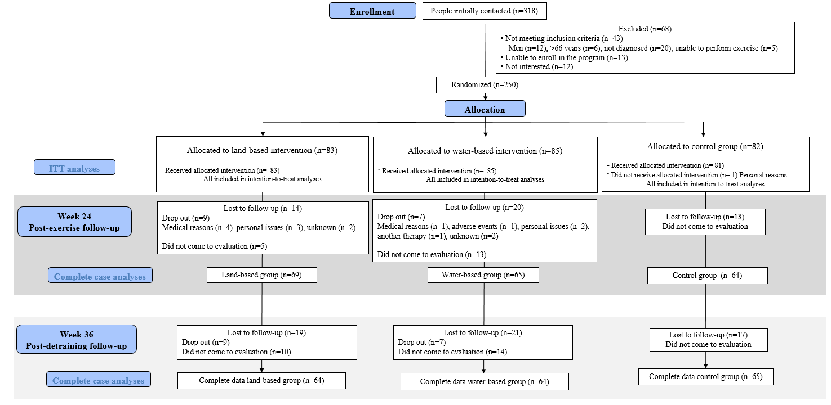
Figure 1. Flow chart of the study participants throughout the al-Ándalus trial. ITT: Intention-to-treat
Table 1. Baseline descriptive characteristics of the study participants in the al-Ándalus trial

 | All |  |  | Land-based |  |  | Water-based |  |  | Control
 | (n=250) |  |  | (n=83) |  |  | (n=85) |  |  | (n=82)
 | mean | (SD) |  | mean | (SD) |  | mean | (SD) |  | mean | (SD) | P-value
Age (years) | 50.8 | 7.6 |  | 49.8 | 7.2 |  | 52.3 | 8.2 |  | 50.4 | 7.2 | 0.069
Body Mass Indez (kg/m²) | 28.6 | 5.6 |  | 27.7 | 5.2 |  | 29.5 | 5.6 |  | 28.6 | 5.9 | 0.115
Disease Impact (FIQR, 0-100)† | 65.5 | 15.9 |  | 66.4 | 15.9 |  | 63.7 | 15.5 |  | 66.5 | 16.3 | 0.446
Dimensions of fatigue
General Fatigue (MFI, 4 - 20)† | 18.3 | 2.2 |  | 18.4 | 2.3 |  | 18.1 | 2.3 |  | 18.5 | 2.1 | 0.549
Physical Fatigue (MFI, 4 - 20)† | 17.0 | 2.8 |  | 17.1 | 2.9 |  | 17.2 | 2.5 |  | 16.7 | 2.9 | 0.383
Reduced Activity (MFI, 4 - 20)† | 13.2 | 4.8 |  | 13.5 | 4.7 |  | 13.0 | 4.8 |  | 13.1 | 4.8 | 0.802
Reduced Motivation (MFI, 4 - 20)† | 13.3 | 3.8 |  | 13.5 | 3.7 |  | 13.1 | 3.5 |  | 13.1 | 4.2 | 0.690
Mental Fatigue (MFI, 4 - 20)† | 14.4 | 2.2 |  | 14.4 | 2.2 |  | 14.1 | 2.3 |  | 14.7 | 2.1 | 0.295
Dimensions of sleep quality
Subjective sleep quality (PSQI, 0 -3)† | 2.1 | 0.7 |  | 2.2 | 0.7 |  | 2.0 | 0.7 |  | 2.1 | 0.7 | 0.167
Sleep latency (PSQI, 0 -3)† | 2.0 | 0.9 |  | 2.2 ª | 0.9 |  | 1.8 ª | 0.9 |  | 2.0 | 0.8 | 0.035
Sleep duration (PSQI, 0 -3)† | 1.8 | 0.9 |  | 1.9 | 0.8 |  | 1.8 | 0.9 |  | 1.7 | 0.9 | 0.437
Sleep efficiency (PSQI, 0 -3)† | 1.7 | 1.2 |  | 1.8 | 1.1 |  | 1.7 | 1.2 |  | 1.7 | 1.2 | 0.887
Sleep disturbances (PSQI, 0 -3)† | 2.2 | 0.6 |  | 2.2 | 0.6 |  | 2.1 | 0.7 |  | 2.2 | 0.6 | 0.849
Sleep medication (PSQI, 0 -3)† | 2.1 | 1.2 |  | 1.9 ª | 1.3 |  | 2.0 | 1.3 |  | 2.4 ª | 1.0 | 0.020
Daytime dysfunction (PSQI, 0 -3)† | 1.6 | 0.7 |  | 1.6 | 0.8 |  | 1.6 | 0.7 |  | 1.7 | 0.8 | 0.439
Sleep quality global score (PSQI, 0 -21)† | 13.6 | 3.8 |  | 13.7 | 3.9 |  | 13.1 | 3.7 |  | 13.9 | 3.7 | 0.314
Time since diagnosis
Less than 1 year | 20 | 8.2 |  | 6 | 7.5 |  | 6 | 7.2 |  | 8 | 9.9 | 0.772
Between 1 and 5 years | 95 | 38.9 |  | 34 | 42.5 |  | 34 | 41 |  | 27 | 33.3
More than 5 years | 120 | 52.9 |  | 40 | 50 |  | 43 | 51.8 |  | 46 | 56.8
 | n | % |  | n | % |  | n | % |  | n | % | P-value
Marital status
Married | 184 | 73.9 |  | 63 | 75.9 |  | 63 | 75 |  | 58 | 70.7 | 0.722
Not married | 65 | 26.1 |  | 20 | 24.1 |  | 21 | 25 |  | 24 | 29.3
Educational level
Non-universitary | 218 | 87.6 |  | 67 ª | 80.7 |  | 81 ^{a,b} | 96.4 |  | 70 ^{b} | 85.4 | 0.007
Universitary | 31 | 12.4 |  | 16 | 19.3 |  | 3 | 3.6 |  | 12 | 14.6
Occupational status
Working full/part time | 63 | 25.3 |  | 22 | 26.5 |  | 18 | 21.4 |  | 23 | 28 | 0.589
Unemployed/Retired/Housekeeper | 186 | 74.7 |  | 61 | 73.5 |  | 66 | 78.6 |  | 59 | 72
Regular menstruation
Yes | 78 | 31.3 |  | 27 | 32.5 |  | 21 | 25 |  | 30 | 36.6 | 0.263
No | 171 | 68.7 |  | 56 | 67.5 |  | 63 | 75 |  | 52 | 63.4
Analgesics consumption
Yes | 225 | 90.4 |  | 74 | 89.2 |  | 75 | 89.3 |  | 76 | 92.7 | 0.685
No | 24 | 9.6 |  | 9 | 10.8 |  | 9 | 10.7 |  | 6 | 7.3
Antidepressants consumption
Yes | 149 | 59.8 |  | 49 | 59 |  | 52 | 61.9 |  | 48 | 58.5 | 0.892
No | 100 | 40.2 |  | 34 | 41 |  | 32 | 38.1 |  | 34 | 41.5
BMI: Body Mass Index, FIQR: Fibromyalgia Impact Questionnaire, MFI: Multidimensional Fatigue Inventory, PSQI: Pittsburg Sleep Quality Index.
Common superscripts indicate significant differences between groups with the same letter
† Greater scores indicate worse health status

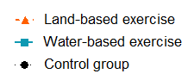

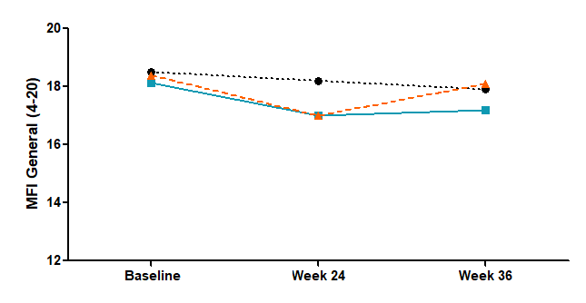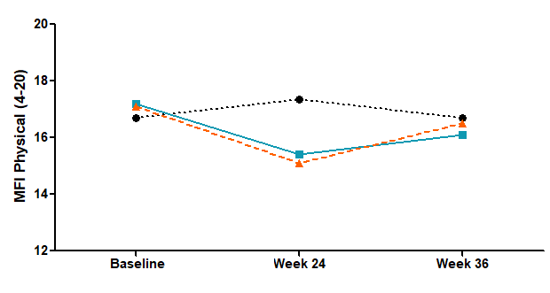
*
╪

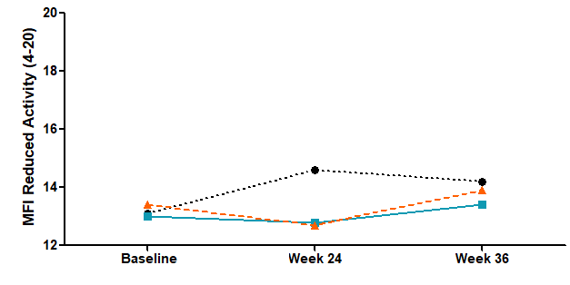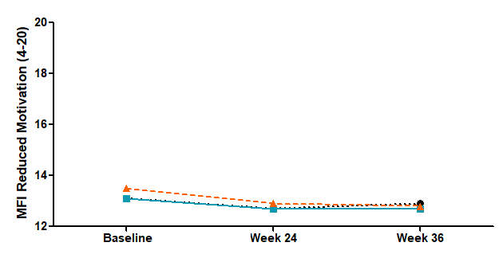

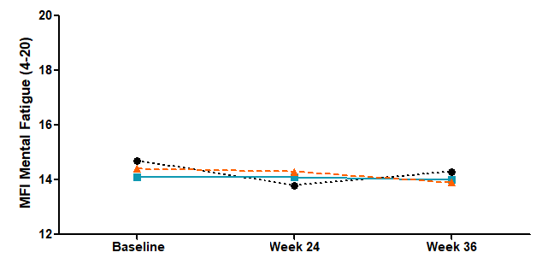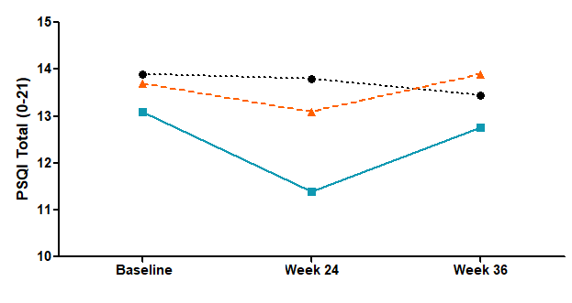
╪ ┼

Figure 2. Means of fatigue and sleep quality variables at baseline, at week 24 (after exercise intervention program) and at week 36 (12 weeks after exercise cessation) for each intervention group in intention-to-treat analyses. Greater scores indicate worse health status
MFI: Multidimensional Fatigue Inventory, PSQI: Pittsburgh Sleep Quality Index
*Significant differences between mean change of land vs. control group
╪ Significant differences between mean change of water vs. control group
┼ Significant differences between mean change of land vs. water group

Table 2. Differences in fatigue and sleep quality between groups after 24 weeks of water or land-based exercise: intention to treat analyses
 | Water vs Control |  |  |  |  |  | Land vs Control |  |  |  |  |  | Water vs Land
 | Mean difference | SE | (95% CI) |  | P | d | Mean difference | SE | (95% CI) |  | P | d | Mean difference | SE | (95% CI) |  | P | d
MFI General Fatigue | -0.8 | 0.3 | -1.4 | -0.1 | 0.012 | 0.4 | -0.6 | 0.3 | -1.3 | 0.0 | 0.060 |  | -0.1 | 0.3 | -0.8 | 0.5 | 0.999
MFI Physical Fatigue | -0.7 | 0.3 | -1.5 | 0.1 | 0.100 |  | -0.9 | 0.3 | -1.7 | -0.1 | 0.020 | 0.4 | 0.2 | 0.3 | -0.6 | 1.0 | 0.999
MFI Reduced Activity | -1.0 | 0.5 | -2.2 | 0.3 | 0.189 |  | -0.8 | 0.5 | -2.0 | 0.4 | 0.381 |  | -0.2 | 0.5 | -1.4 | 1.1 | 0.999
MFI Reduced Motivation | 0.0 | 0.4 | -1.0 | 1.0 | 0.999 |  | 0.3 | 0.4 | -0.7 | 1.4 | 0.999 |  | -0.3 | 0.4 | -1.4 | 0.7 | 0.999
MFI Mental Fatigue | -0.1 | 0.3 | -0.8 | 0.5 | 0.999 |  | 0.1 | 0.3 | -0.5 | 0.7 | 0.999 |  | -0.2 | 0.3 | -0.9 | 0.4 | 0.978
PSQI Subjective sleep quality | -0.2 | 0.1 | -0.4 | 0.0 | 0.030 | 0.4 | 0.1 | 0.1 | -0.1 | 0.3 | 0.867 |  | -0.3 | 0.1 | -0.5 | -0.1 | 0.001 | 0.5
PSQI Sleep latency | -0.2 | 0.1 | -0.5 | 0.0 | 0.147 |  | 0.0 | 0.1 | -0.2 | 0.3 | 0.999 |  | -0.3 | 0.1 | -0.5 | 0.0 | 0.046 | 0.3
PSQI Sleep duration | 0.0 | 0.1 | -0.3 | 0.2 | 0.999 |  | 0.2 | 0.1 | -0.1 | 0.4 | 0.236 |  | -0.2 | 0.1 | -0.4 | 0.0 | 0.144
PSQI Sleep efficiency | -0.2 | 0.1 | -0.5 | 0.1 | 0.545 |  | 0.0 | 0.1 | -0.3 | 0.3 | 0.999 |  | -0.2 | 0.1 | -0.5 | 0.1 | 0.602
PSQI Sleep disturbances | -0.1 | 0.1 | -0.3 | 0.0 | 0.115 |  | -0.1 | 0.1 | -0.2 | 0.1 | 0.999 |  | -0.1 | 0.1 | -0.3 | 0.1 | 0.792
PSQI Sleep medication | -0.5 | 0.1 | -0.9 | -0.2 | <0.001 | 0.7 | -0.4 | 0.1 | -0.8 | -0.1 | 0.005 | 0.4 | -0.1 | 0.1 | -0.4 | 0.2 | 0.999
PSQI Daytime dysfunction | -0.3 | 0.1 | -0.5 | -0.1 | 0.004 | 0.5 | -0.1 | 0.1 | -0.4 | 0.1 | 0.291 |  | -0.1 | 0.1 | -0.3 | 0.1 | 0.358
PSQI Sleep quality global score | -1.6 | 0.4 | -2.7 | -0.6 | 0.001 | 0.6 | -0.5 | 0.4 | -1.5 | 0.6 | 0.920 |  | -1.2 | 0.4 | -2.2 | -0.1 | 0.023 | 0.4
Data is presented as estimated mean difference between groups, standard error (SE) and 95% confidence interval (CI). P values obtained from post-hoc Bonferroni corrections from the linear mixed repeated measures analyses. Missing values were imputed using multiple imputation by chained equations. CI: Confidence Interval; MFI: Multidimensional Fatigue Inventory. PSQI: Pittsburg Sleep Quality Index.
Table 3. Differences in fatigue and sleep quality between groups 12 weeks after water or land-based exercise cessation: intention to treat analyses
 | Water vs Control |  |  |  |  |  | Land vs Control |  |  |  |  |  | Water vs Land
 | Mean difference | SE | (95% CI) |  | P | d | Mean difference | SE | (95% CI) |  | P | d | Mean difference | SE | (95% CI) |  | P | d
MFI General Fatigue | -0.4 | 0.3 | -1.0 | 0.3 | 0.575 |  | 0.1 | 0.3 | -0.6 | 0.7 | 0.999 |  | -0.4 | 0.3 | -1.1 | 0.2 | 0.387
MFI Physical Fatigue | -0.3 | 0.3 | -1.1 | 0.5 | 0.999 |  | -0.4 | 0.3 | -1.1 | 0.4 | 0.822 |  | 0.0 | 0.3 | -0.8 | 0.7 | 0.999
MFI Reduced Activity | -0.5 | 0.5 | -1.7 | 0.8 | 0.999 |  | 0.2 | 0.5 | -1.1 | 1.4 | 0.999 |  | -0.6 | 0.5 | -1.9 | 0.6 | 0.687
MFI Reduced Motivation | 0.2 | 0.4 | -0.8 | 1.3 | 0.999 |  | 0.1 | 0.4 | -0.9 | 1.2 | 0.999 |  | 0.1 | 0.4 | -0.9 | 1.1 | 0.999
MFI Mental Fatigue | -0.3 | 0.2 | -0.9 | 0.3 | 0.794 |  | -0.2 | 0.2 | -0.8 | 0.4 | 0.999 |  | -0.1 | 0.2 | -0.7 | 0.5 | 0.999
PSQI Subjective sleep quality | -0.1 | 0.1 | -0.3 | 0.1 | 0.703 |  | 0.0 | 0.1 | -0.2 | 0.2 | 0.999 |  | -0.1 | 0.1 | -0.3 | 0.1 | 0.309
PSQI Sleep latency | -0.2 | 0.1 | -0.5 | 0.0 | 0.097 |  | 0.0 | 0.1 | -0.2 | 0.3 | 0.999 |  | -0.2 | 0.1 | -0.5 | 0.0 | 0.052
PSQI Sleep duration | 0.1 | 0.1 | -0.1 | 0.3 | 0.714 |  | 0.3 | 0.1 | 0.0 | 0.5 | 0.022 | 0.4 | -0.1 | 0.1 | -0.4 | 0.1 | 0.381
PSQI Sleep efficiency | 0.0 | 0.1 | -0.3 | 0.3 | 0.999 |  | 0.1 | 0.1 | -0.2 | 0.4 | 0.999 |  | -0.1 | 0.1 | -0.4 | 0.2 | 0.999
PSQI Sleep disturbances | -0.1 | 0.1 | -0.3 | 0.1 | 0.530 |  | 0.0 | 0.1 | -0.2 | 0.1 | 0.999 |  | -0.1 | 0.1 | -0.2 | 0.1 | 0.981
PSQI Sleep medication | 0.4 | 0.1 | -0.7 | 0.0 | 0.023 | 0.4 | 0.3 | 0.1 | -0.7 | 0.0 | 0.035 | 0.4 | 0.0 | 0.1 | -0.3 | 0.3 | 0.999
PSQI Daytime dysfunction | -0.1 | 0.1 | -0.3 | 0.1 | 0.999 |  | 0.0 | 0.1 | -0.2 | 0.2 | 0.999 |  | -0.1 | 0.1 | -0.3 | 0.1 | 0.999
PSQI Sleep quality global score | -0.8 | 0.4 | -1.8 | 0.2 | 0.194 |  | 0.2 | 0.4 | -0.9 | 1.2 | 0.999 |  | -1.0 | 0.4 | -2.0 | 0.1 | 0.070
Data is presented as estimated mean difference between groups, standard error (SE) and 95% confidence interval (CI). P values obtained from post-hoc Bonferroni corrections from the linear mixed repeated measures analyses. Missing values were imputed using multiple imputation by chained equations. CI: Confidence Interval; MFI: Multidimensional Fatigue Inventory. PSQI: Pittsburg Sleep Quality Index.

