**Magnetic particles as new adsorbents for the reduction of phosphate inputs from a wastewater treatment plant to a Mediterranean Ramsar wetland (Southern Spain)**

# Inmaculada Álvarez-Manzaneda1,2, Francisco Guerrero3,4, Luis Cruz-Pizarro1,2, Manuel Rendón5 and Inmaculada de Vicente1,2*

(1) Departamento de Ecología, Universidad de Granada, 18071 Granada, Spain

(2) Instituto del Agua, Universidad de Granada, 18071 Granada, Spain

[miams@ugr.es](mailto:miams@ugr.es); [lcruz@ugr.es](mailto:lcruz@ugr.es); [ivicente@ugr.es](mailto:ivicente@ugr.es)

(3) Departamento de Biología Animal, Biología Vegetal y Ecología, Universidad de Jaén, 23071 Jaén, Spain

(4) Centro de Estudios Avanzados en Ciencias de la Tierra, Universidad de Jaén, 23071 Jaén, Spain

[fguerre@ujaen.es](mailto:fguerre@ujaen.es)

(5) Reserva Natural Laguna Fuente de Piedra, Consejería de Agricultura, Ganadería, Pesca y Desarrollo Sostenible,29520 Fuente de Piedra, Málaga, Spain

[manuel.rendon@juntadeandalucia.es](mailto:manuel.rendon@juntadeandalucia.es)

**Full address for correspondence**:

*Corresponding author:

Departamento de Ecología, Universidad de Granada, 18071 Granada, Spain

Instituto del Agua, Universidad de Granada, 18071 Granada, Spain

Phone: (+34) 958 249768; Fax: (+34) 958 243093; email: [ivicente@ugr.es](mailto:ivicente@ugr.es)

**Abstract**

This study assessed the convenience of using magnetic particles (MPs) to reduce phosphorus (P) concentration in treated wastewater. The working hypothesis is that MP addition increases P removal in artificial wastewater treatment ponds. Water samples were collected at the inlet and outlet of a semi-natural pond receiving secondary municipal effluent that is discharged in a Ramsar site (Fuente de Piedra, Málaga, Spain). Then, laboratory batch experiments were run to (i) assess the effect of adding MPs on the chemical composition of treated wastewater, (ii) identify the number of adsorption cycles (by reusing MPs) which are able to trap a high percentage of P (> 50%) and (iii) select the optimum ratio between MP mass and initial dissolved inorganic P (DIP) concentration. The results show the suitability of using MPs to remove P in treated wastewater due to both their high equilibrium adsorption capacity (q) and P removal efficiency. Lastly, considering its practical and economical relevance, based on the advantages (P removal efficiency) and disadvantages (economic price), the optimum dose of MPs (0.16 g MPs mg-1 P) to achieve a high P removal efficiency (> 50%) was identified.

***Keywords:*** magnetic particles, phosphorus, wastewater treatment ponds, eutrophication, lake restoration.

1. **Introduction**

Wetlands are among the world´s most productive and valuable ecosystems (Mitsch and Gosselink, 2015). Despite covering only 1.5% of the Earth´s surface, wetlands provide 40% of ecosystem services worldwide, such as provisioning, regulating, habitat and cultural services (Zedler and Kercher, 2005). A possible explanation for supporting such high-value ecosystem services is their position in landscape as recipients, conduits, sources and sinks of biotic and abiotic resources (Keddy, 2000; Mitsch and Gosselink, 2015). Based on The Economics of Ecosystems and Biodiversity for water and wetlands (de Groot et al., 2012), which show the value of ecosystem services in dollars, wetlands have one of the highest values per hectare per year among the 10 biomes considered in that study, exceeding temperate and tropical forests and grasslands. Despite the existence of international, national and regional legislation for wetland protection, many wetlands continue to degrade through reduced water availability, eutrophication (increase in primary production) and impacts from weeds and pests (Clarkson et al., 2013).

In particular, Mediterranean wetlands, which represent unique repositories of biodiversity, holding exclusive communities of aquatic organisms (Gascón et al., 2009; Gilbert et al., 2014; García-Muñoz et al., 2016; Gilbert et al., 2017a) are currently undergoing a strong detrimental human disturbance (Berny et al., 2002; López-Flores et al., 2003; Vazquez-Roig et al., 2011). Their general features, such as shallowness and high catchment; lake area ratio (Álvarez-Cobelas et al., 2005) makes them especially sensitive (as receiving ecosystems) to the activities conducted in their drainage basins (i.e., agriculture, husbandry) (Ortega et al., 2006; García-Muñoz et al., 2010; Gilbert et al., 2017b). Accordingly, the structure and functioning of Mediterranean wetlands are being strongly affected by cultural eutrophication (de Vicente et al., 2003; Conde-Álvarez et al., 2012; Poquet et al., 2014). Nutrients coming from the catchment and from internal recycling are largely transformed as a result of the intensive biogeochemical processes occurring in wetlands. In fact, wetlands are considered as "hotspot" for biogeochemical transformation worldwide (Richardson and Vaithiyanathan, 2009), as a consequence of their intrinsic characteristics (i.e., shallowness, high water level fluctuations and anoxic sediment). Based on the effective role of wetlands as natural water purifiers, constructed wetlands technology has been developed since the 1980s (Kadlec and Knight, 1996; Kadlec, 2009). By definition, constructed wetlands are built ecosystems primarily designed to enhance physical, chemical and biochemical processes with the goal of reducing specific contaminants to acceptable levels (Kadlec, 2009). Although the range of usage of this technology is large and still expanding, the largest number and the longest history belong to the class that treats municipal and domestic wastewaters. Since phosphorus (P) is the main nutrient limiting primary production in inland waters and a large proportion of its inputs comes from domestic wastewater (Gakstatter et al., 1978; Egle et al., 2016), it is essential to increase the efficiency of constructed wetlands to trap P in order to reduce the eutrophication of receiving aquatic ecosystems. More specifically, dissolved inorganic P (DIP) is the P form that leads to eutrophication, since it is the only form of P that autotrophs can assimilate (Correll, 1998). Although it often represents a small fraction of the total P pool in aquatic systems, its bioavailability makes it essential for ecosystem functioning (Harrison et al., 2010). Additionally, in wastewaters, P is present as inorganic, organic, and man-made organic P (de Bashan & Bashan, 2004). DIP represents the main source of P and is commonly used in fertilizers, detergents, and insecticides (Le Corre et al., 2009). Morse et al. (1993) reported that the overdose of P in the water of European Union (EU) countries comes mainly from human sources in sewage and from livestock.

Recent studies have been focused on assessing P removal from wastewaters using novel adsorbents such as zeolites (Ning et al., 2008) and struvite (de-Bashan and Bashan, 2004), although further research is still needed to identify the best P adsorbent. Additionally, it is necessary to continue developing new techniques that allow us to recover P from aquatic ecosystems in order to face the lack of mineral P required to make fertilizers. Moreover, the possibility of recovering and reusing the adsorbent would allow achieving an environmentally acceptable level of P with affordable costs.

As was mentioned above, in addition to lake eutrophication, we are also currently facing the exhaustion of P reserves for fertilizer production (Cordell et al., 2011). In fact, both problems are convincingly connected as P is anthropogenically mobilized from its land reserves to the aquatic environment. Therefore, two of the most important challenges in the field of natural resources are to combat the following related and worldwide increasing problems: (i) the global reduction of P reserves, essential for making P fertilizers (Gilbert, 2009), and (ii) the eutrophication (i.e., nutrient enrichment) of aquatic ecosystems (OECD, 1982; Sas, 1989; Cooke et al., 2005).

This study explores the use of magnetic particles (MPs) to remove P in semi-natural wastewater ponds and, therefore, reduce both eutrophication and the exhaustion of global P reserves. In this sense, previous studies have assessed the convenience of using MPs in inland eutrophicated ecosystems, as MPs adsorb P, and then P loaded MPs can be efficiently removed from solutions by applying a magnetic separation gradient (de Vicente et al., 2010, 2011; Merino-Martos et al., 2011, 2015; Funes et al., 2016, 2017, 2018). More specifically, the adsorption of P on MPs in synthetic natural water was studied by de Vicente et al. (2011), who concluded that the adsorption mechanism is not purely electrostatic, since negatively charged Fe particles still adsorb a very significant amount of P. Additionally, the existence of chemical interferences between P and other ions (e.g. Mg2+, Na+, SO42-) present in natural waters was assessed by de Vicente et al. (2011), Merino-Martos et al. (2015) and, more recently, by Funes et al. (2018). Then, once P is adsorbed on MPs, P loaded MPs can be washed and reused in subsequent adsorption cycles (de Vicente et al., 2011) and the recovered and desorbed P can be used as a fertilizer (Álvarez-Manzaneda et al. in preparation). Despite the considerable difference in chemical composition between natural and wastewater, the working hypothesis is that MP addition increases P removal in wastewater treatment ponds. In this context, the general aim of the present study was to determine the efficiency of MPs to trap P in secondary municipal effluents that are eventually discharged in a Ramsar site (Fuente de Piedra, Málaga, Spain). The specific goals were: (i) to assess the effect of adding MPs on the chemical composition (major cations, major anions and metal concentration) of treated wastewaters; (ii) to identify the number of adsorption cycles (by reusing MPs) required to trap a high percentage of P (> 50%) and (iii) to select the optimum ratio between MP mass and initial DIP concentration.

1. **Material and methods**
   1. ***Site description***

Fuente de Piedra (37° 6′ N, 4° 44′ W) is a vast hypersaline wetland (13.5 km2; NE-axis: 6.8 km; SE-axis: 2.5 km and a perimeter of 18 km (Linares and Rendón, 1998)). It was the third Spanish wetland to be included in the Ramsar convention (in 1983) and it was declared as a regional Natural reserve in 1984. Its catchment is located close to the water divide between the Atlantic Ocean (Guadalquivir river) and the Mediterranean Sea (Guadalhorce river) near Antequera (Málaga, Spain) (Höbig et al., 2016) (Figure 1).

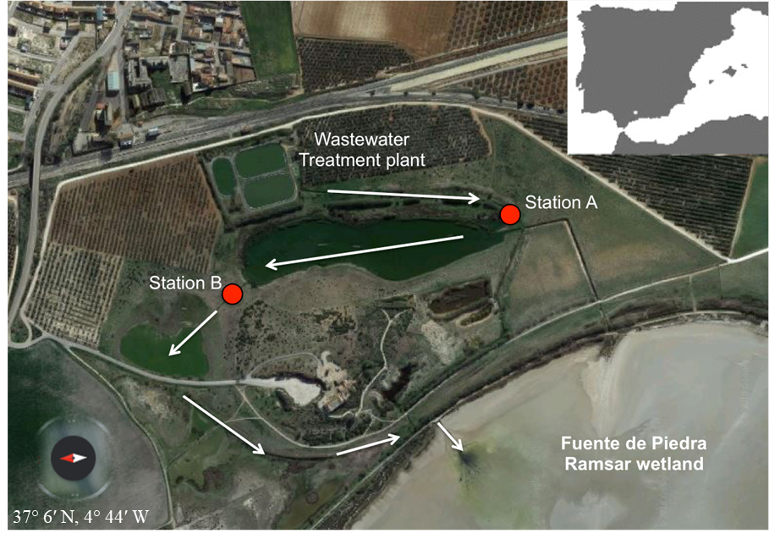

**Figure 1.** Location of the sampling sites.

The present-day lake has an average water depth of 70.5 cm (Rodríguez-Rodríguez, 2002) and several small ponds around the margin. The main fluvial supply is located in the north, with minor streams in the east and west (Höbig et al., 2016). Due to its shallow water column, the site is an ideal habitat for migrating and non-migrating birds, supporting one of the most important breeding colonies of the greater flamingo (i.e., *Phoenicopterus roseus;* Rendón et al., 2014). Despite its protection, one of the major problems of this ecosystem is the discharge of treated wastewater from the nearby towns of Fuente de Piedra and Humilladero, even though it fulfills the standards for the treatment of urban wastewater (RD 509) (de los Ríos-Mérida et al., 2017). Since 1999, secondary municipal effluents of the town of Fuente de Piedra go through several small semi-natural ponds: Laguneto (27,801 m2 and a maximum depth of 1.42 m), Laguna de los Juncares (9,222 m2 and a maximum depth of 0.39 m), and Los Juncares (19,828 m2 and a maximum depth of 0.20 m) (de-los-Ríos-Mérida et al., 2017). A recent study has quantified a notable reduction in nutrient (N and P) concentrations in the water along its flow through the semi-natural pond system (de los Ríos-Mérida et al., 2017).

* 1. ***Materials and reagents***

All the chemicals used in this study were analytical reagents of high purity. The MPs (HQ grade, BASF, Ludwigshafen am Rhein, Germany) were micron-sized magnetic spherical particles (average particle diameter: 805±10 nm; de Vicente et al. 2010) with a negligible coercive field and remanent magnetization (i.e., zero magnetization upon removal of the magnetic field). According to the manufacturer, their composition is 97.5% Fe, 0.9% C, 0.5% O and 0.9% N. Further details on these particles have been reported by de Vicente et al. (2010) and Merino-Martos et al. (2011).

* 1. ***Experimental setup***

On May 2018, water samples were collected from the Laguneto pond inlet (station A) and outlet (station B) (Figure 1). Once in the laboratory, an initial characterization of the water samples was carried out. Firstly, pH and conductivity were measured with a pH meter (pH 196, WTW, Xylem Analytics Germany Sales GmbH & Co., Weilheim, Germany) and a conductivity meter (InoLab Con Level 1, WTW, Xylem Analytics Germany Sales GmbH & Co., Weilheim, Germany), respectively. Then, the water samples were filtered through glass microfiber filters (Whatmann GF/F, Maidstone, UK; 0.7 mm) and dissolved inorganic P (DIP (Murphy and Riley, 1962)) and total dissolved Fe (Tot-Fedis;Gibbs, 1979) concentrations were spectrophotometrically quantified (BiochromLibra S50, Biochrom Ltd., Cambridge, UK).

For the experimental setup, a standard suspension (50 g L-1) of MPs was prepared with 5 g of magnetic adsorbent mixed with distilled water in a polypropylene container (100 mL). To ensure the homogeneity of the sample, the suspension was sonicated for 5 min prior to its use in the adsorption experiments.

For the batch adsorption experiments, five different treatments (with four replicates) were considered: X/2, X, 2X, 3X and 5X, where X was the estimated MP concentration as a function of both the initial DIP concentration in the sample and the maximum P adsorption capacity of the MPs (18.83 mg P g-1 MPs; de Vicente et al., 2010). Thus, the following MP concentrations were obtained: 0.08, 0.16, 0.32, 0.48 and 0.8 g L-1 for sample A, and 0.045, 0.09, 0.18, 0.27 and 0.45 g L-1 for sample B. Briefly, the adsorption experiment consisted in adding the different adsorbent concentrations to 50 mL of treated wastewater. The samples were then agitated for 24 h in a horizontal shaker (150 rpm). After this time, the supernatant was separated from the adsorbents by using a variable gap magnet for 5 min (PASCO scientific; EM-8641). Lastly, the supernatant was filtered for DIP analysis. The equilibrium adsorption capacity (q, mg g-1) was calculated as follows:

(1)

where C0 is the initial DIP concentration (mg L-1), C*e* is the equilibrium DIP concentration (mg L-1), M*a* is the mass of the adsorbent (g) and V is the total volume of the suspension (L).

Then, a new adsorption experiment was performed to identify the number of possible adsorption cycles required to achieve a high P removal efficiency by MPs. To this end, once the 1st adsorption experiment (1st adsorption cycle) was carried out, following the methodology described above, the MPs were separated from the supernatant and washed twice (each time for 24 h) with 0.1M NH3. The resulting particles were then reused for a 2nd adsorption experiment (2nd adsorption cycle) following the abovementioned adsorption procedure. The same scheme (adsorption and desorption) was again repeated to finally obtain a total of four adsorption cycles. The P removal efficiency (%) was calculated according to the following equation:

(2)

Where Cf is the final DIP concentration (mg L-1) for each adsorption cycle.

For samples A and B, DIP and Tot-Fedis concentrations were quantified in all adsorption cycles. Additionally, for sample A, major cations [calcium (Ca2+), magnesium (Mg2+), sodium (Na+) and potassium (K+)] and major anions [chloride (Cl-), bromide (Br-), fluoride (F-), sulphate (SO42-) and silica (Si)] were measured in the supernatants from the 1st and 4rd adsorption cycles. The major cations and Si were measured in filtered lake waters (Millipore 0.22 mm filters) by ion chromatography (IC; 940 Professional IC Vario, Metrohm) and the rest of the ions were analyzed by inductively coupled plasma-mass spectroscopy (ICP-MS; Perkin Elmer NexION300D). Although Al3+, Cr2+, Cu2+, Mn2+, Ni2+, Zn2+, NO3- and NO2- were also measured, their concentrations were lower than the detection limits (< 0.01 mg L-1) and, thus, the results for these are not shown.

* 1. ***Data analysis***

Differences in water chemical parameters between sample A and sample B were tested by using Student’s T-test (for pH) or Mann–Whitney U-test (for conductivity and DIP), according to the satisfaction of the normality assumption (Shapiro-Wilk test). The effect of MP addition on pH and conductivity (for all adsorption cycles) and on the concentration of the major cations and anions, during the 1st and 4th adsorption cycles, were also tested by using Repeated Measures ANOVA (RM-ANOVA) with Fisher's least significance difference (LSD) post-hoc test. Differences in Tot-Fedis concentrations and equilibrium adsorption capacity (q) for the different MP concentrations (treatments) and adsorption cycles (time) were tested by using non-parametric analysis of variance, since our data did not satisfy homoscedasticity assumptions (Levene test, p < 0.05). Therefore, a Kruskal-Wallis test was carried out to determine the differences among treatments and a Friedman ANOVA by ranks was performed to analyse the significant differences between adsorption cycles. To determine the existence of significant differences in these response variables (Tot-Fedis and q), a paired sample t-test analysis between adsorption cycles was performed after the normality was checked by the Shapiro-Wilk test. Statistica 7.1 software (StatSoft Inc., Tulsa, USA) was used for the statistical analyses.

1. **Results and Discussion**
   1. ***Efficiency of the semi-natural pond for the treatment of wastewater***

Table 1 shows changes in physicochemical parameters at the inlet (station A) and outlet (station B) of the semi-natural Laguneto pond. In general, an improvement was observed in water quality along its flow through the Laguneto pond. More specifically, pH did not significantly change between station A and B (t-test; p > 0.05), showing a slight decrease (1.32%). Although the pH values were in the range of those measured by de los Ríos-Mérida et al. (2017) in the same study site, the tendency was the opposite of that observed by these authors, found a general increase in pH from station A to station B. As was expected, a significant reduction in conductivity values was detected noticed along the water flow through the Laguneto pond (Mann-Whitney U test; p < 0.001). Similarly, a notable reduction in conductivity values was also measured by de los Ríos-Mérida et al. (2017), reporting an even higher reduction (21%) in this parameter.

**Table 1.** Changes in some of the selected chemical features of water at the inlet (station A) and outlet (station B) of the semi-natural pond (Laguneto).

|  |  |  |  |
| --- | --- | --- | --- |
|  | **Station A** | **Station B** | **Reduction (%)** |
| **pH** | 7.98 ± 0.06 | 7.88 ± 0.26 | 1.2 |
| **Conductivity (mS cm-1)** | 5.89 ± 0.04 | 5.55 ± 0.03 | 5.8 |
| **DIP (mg L-1)** | 1.86 ± 0.04 | 0.75 ± 0.01 | 59.7 |

As was expected, when comparing the DIP concentrations at the inlet and outlet of Laguneto, a significant (Mann-Whitney U-test; p < 0.05) reduction (59.5%) is detected. These results are in agreement with previous studies evidencing the efficiency of constructed wetlands for nutrient removal (Rao et al., 2013; Lu et al., 2015; Guo et al., 2016). Moreover, it has been demonstrated that the presence of aquatic vegetation in ponds drastically enhances the P removal rate (Breen, 1990; Busnardo et al., 1992; Quan et al., 2016). In the case of Laguneto, de los Ríos-Mérida et al. (2017) described up to six different helophytic species, including *Phragmites australis*, which has been recently proved to have the maximum DIP removal efficiency in a mesocosm experiment (Afrous et al., 2013). Therefore, the obtained results confirm that there exists a marked improvement in treated wastewater quality along its flow through the semi-natural Laguneto pond, which supports the convenience of constructed wetlands to improve the water quality of the final effluent.

* 1. ***Effects of magnetic particle addition on wastewater physicochemical and chemical composition***

The effects on pH and conductivity of adding different MPs concentration at different adsorption cycles are shown in Figure 2.

**(a)**

**(b)**

**(c)**

**(d)**



**Figure 2.** Changes in pH and conductivity values among treatments and among adsorption cycles in station A (figures a and c) and station B (figures b and d).Vertical bars represent standard deviation.

For station A (Fig. 2a), and similarly to previous studies carried out with the same MPs (Funes et al., 2017), no significant effect of MPs addition was observed on pH, while a significant increase with increasing adsorption cycles was found (MR ANOVA; p < 0.005). As an example, for 0.8 g MPs L-1, pH changed from 7.79 (1st adsorption cycle) to 8.37 (4th adsorption cycle). For sample B (Fig. 2b), the pH change was significantly and positively related to the increasing adsorption cycles (MR ANOVA; p < 0.005), although it was also significantly related to MP concentration (MR ANOVA; p < 0.05). Regarding the conductivity values, a significant difference when adding MPs was only observed for sample A (Fig. 2c), with a general decrease in conductivity values with MP increase. For both water samples, conductivity showed a significant increase with subsequent adsorption cycles.

Next, and based on the fact that wastewaters always contain lots of coexisting ions that could potentially compete with DIP for adsorption sites, we determined whether MP addition causes changes in major cation and anion concentrations (Figure 3; Table 2). Additionally, the equilibrium adsorption capacities and removal efficiency for major cations and anions were also estimated for station A (Table 1 in *Supplementary material*).

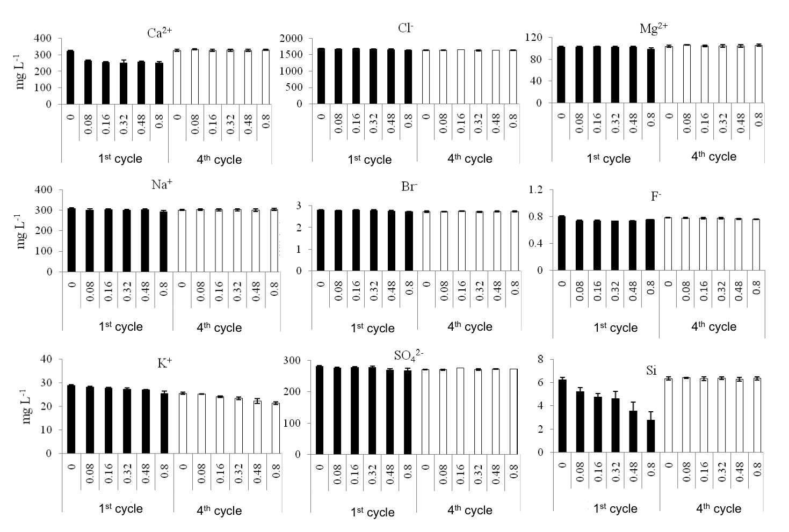

**(a)**

**(b)**

**(c)**

**(d)**

**(e)**

**(f)**

**(g)**

**(h)**

**(i)**

**Figure 3.** Mean concentrations of major cations and anions recorded in the 1st and 4th adsorption cycles for station A.

Vertical bars represent standard deviation.

Significant differences among treatments (MPs concentration) were found for Ca2+, K+, Cl-, F-, SO42- and Si (Table 2). Among these, it is important to highlight the sharp reduction in Ca2+ (22%) and Si (55%) concentrations when adding the highest MP concentration in the 1st adsorption cycle (Fig. 3a and i). Regarding Ca2+, Stachowicz et al. (2008) studied the interaction between Ca2+ and DIP on goethite. Specifically, they found that DIP adsorption occurred, as well as Ca2+ adsorption in the pH range of 3-11, despite the fact that Ca2+ had a much lower affinity for goethite than DIP. This result is explained by electrostatic interactions, as the negative charges of the adsorbed P ions on goethite stimulate the binding of the positively charged Ca2+ ion. However, in contrast to these observations, Merino-Martos et al. (2015), using single-ion solutions and the same adsorbents (MPs), did not found any Ca2+ removal by MPs in the presence of P, while a notable Ca2+ removal was observed when DIP was not present. For Si, the results are consistent with previous findings stating that Si and DIP have the same specific adsorption behavior, and competition for adsorption sites should thus occur (Sigg and Stumm, 1981; Hartikainen et al., 1996; Cornell and Schwertmann, 2004). Briefly, Si concentrations have also been notable reduced when adding DIP adsorbents such as MPs (Merino-Martos et al., 2015), Al(OH)3 (de Vicente et al., 2008; Egemose et al., 2011) or goethite (Sigg and Stumm, 1981). Similarly, Hartikainen et al. (1996), analyzing sediment samples from Lake Vesijärvi (southern Finland), found that P oxyanions competed directly with Si compounds for sorption sites, although their results indicated that Si retention on the oxide surface was less effective than that of P. The obtained results are consistent with these statements as Si concentrations were drastically reduced in the 1st adsorption cycle.

**Table 2.** Results of the repeated-measures ANOVA for major cations and anions in sample A. df= degrees of freedom; ns (no significant differences); * (p < 0.05); ** (p < 0.005); *** (p < 0.0005).

|  |  |  |  |  |  |  |  |  |  |  |  |  |  |
| --- | --- | --- | --- | --- | --- | --- | --- | --- | --- | --- | --- | --- | --- |
|  | **Treatment** | | | | **Time** | | | | **Treatment*Time** | | | | |
|  | **df1** | **df2** | **F** | ***p value*** | **df1** | **df2** | **F** | ***p value*** | | **df1** | **df2** | **F** | ***p value*** | |
| **Ca2+** | 5 | 12 | 13.53 | *** | 1 | 12 | 974.21 | *** | | 5 | 12 | 34.37 | *** | |
| **Mg2+** | 5 | 12 | 0.6 | ns | 1 | 12 | 19.5 | ** | | 5 | 12 | 2.2 | ns | |
| **Na+** | 5 | 12 | 1 | ns | 1 | 12 | 0.2 | ns | | 5 | 12 | 1.7 | ns | |
| **K+** | 5 | 12 | 29.10 | *** | 1 | 12 | 508.62 | *** | | 5 | 12 | 2.37 | ns | |
| **Cl-** | 5 | 12 | 4.4 | * | 1 | 12 | 95.9 | *** | | 5 | 12 | 10.3 | ** | |
| **Br-** | 5 | 12 | 2.8 | ns | 1 | 12 | 33.6 | *** | | 5 | 12 | 2.8 | ns | |
| **F-** | 5 | 12 | 38.8 | *** | 1 | 12 | 46.6 | *** | | 5 | 12 | 6.1 | ** | |
| **SO42-** | 5 | 12 | 3.1 | * | 1 | 12 | 4.8 | * | | 5 | 12 | 5.4 | * | |
| **Si** | 5 | 12 | 30.63 | *** | 1 | 12 | 86.70 | *** | | 5 | 12 | 6.45 | ** | |

Regarding the Tot-Fedis concentrations, notable differences were found between sample A and B (see Table 2 in *Supplementary material*). In station A, much higher values were measured (even in the control sample) and the addition of MPs caused a significant increase in Tot-Fedis during the 1st adsorption cycle. Surprisingly, for the other adsorption cycles, in general, no effect of MP addition was found.In station B, the Tot-Fedis concentrations were very similar among treatments and adsorption cycles, reaching the highest value, as expected, when adding the highest MP concentration (0.45 g L-1). It is worth noting that the results obtained for station A are the opposite of those found by previous studies using the same adsorbents, where no changes in Tot-Fedis concentrations were detected, even in anoxic conditions (Funes et al., 2017). In fact, these authors found that, after adding much higher MP concentrations (1.4 g L-1) than those used in the present study (0.8 g L-1), Tot-Fedis concentrations were always lower than the detection limit of the analytical method. In any case, and as Funes et al. (2017) suggested, there is no evidence of negative effects of increasing Fe concentrations on the maximum achievable ecological quality for fish, macrophyte and diatom communities, although a decrease of macroinvertebrate populations in contact with high total Fe concentrations has been reported (WFD-UKTAG, 2011). In fact, some thresholds have been proposed to guarantee the good state of these communities, such as 1 mg L-1 total Fe (USEPA, 1976), which is actually in the range of the highest values measured in the present study.

* 1. ***Changes in the equilibrium adsorption capacity along subsequent adsorption cycles***

In general, significant differences between treatments were found in the equilibrium adsorption capacity (q) for all adsorption cycles, although these differences were smaller along the subsequent adsorption cycles (Figure 4 and Table 3 in *Supplementary material*).

**(a)**

**(b)**

**(c)**

**(d)**

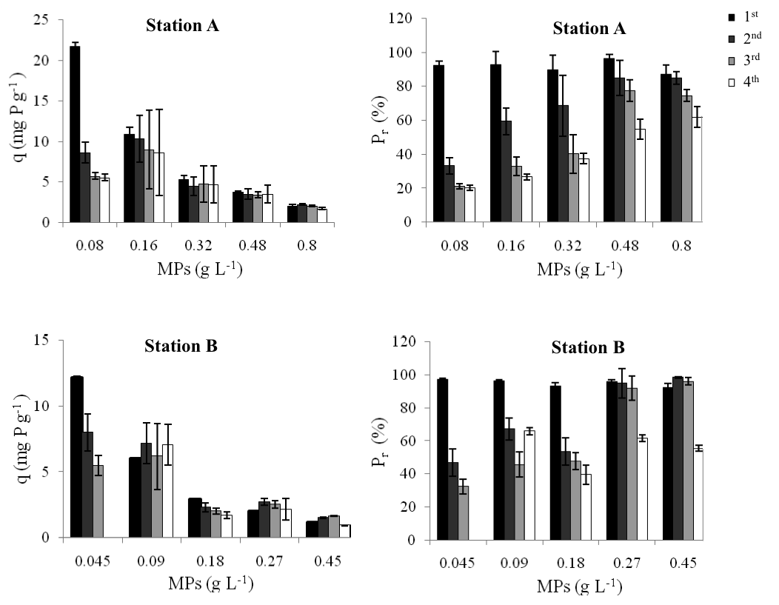

**Figure 4.** Equilibrium adsorption capacities (q) and phosphorus removal efficiency (Pr; %) for each MP concentration in station A (figures a and b) and station B (figures c and d). Vertical bars represent standard deviation.

In fact, as was expected, the equilibrium adsorption capacity (q) strongly decreased with increasing MP concentrations. Regarding the changes in q values along the different adsorption cycles, there was a significant reduction for the lowest MP concentration in both sampling sites (Table 4 in *Supplementary material; Fig. 4a and 4c*). However, no significant patter was found for the subsequent adsorption cycles.

Concerning changes in P removal efficiency along the different adsorption cycles, as was expected, maximum values were reported for the 1st adsorption cycle for all treatments and for both water samples. More specifically, the average value for P removal efficiency decreased from 93% (sample A; Fig. 4b) and 95% (sample B; Fig. 4d) during the 1st adsorption cycles to 35% (sample A) and 44% (sample B) during the 4th adsorption cycle. In general, our results show that, in both water samples (i.e., station A and B), significant differences in P removal efficiency were recorded as a function of MP concentration, except for the first adsorption cycle (Table 3 in *Supplementary material*), and as a function of the adsorption cycle (Table 4 in *Supplementary material*). Furthermore, it is relevant to notice that, for MP concentrations ≥0.48 g L-1 for sample A and ≥0.27 g L-1 for sample B, which correspond to a ratio of 0.16 g MPs mg-1 P, MPs can be reused up to 4 times and they still exhibit a P removal efficiency higher than 50%.

When comparing our results with those reported in the literature, it is striking that q values found in the present study are in the range of previous studies carried out with the same MPs but using synthetic solutions (18.83 mg P g-1;de Vicente et al., 2010) instead of wastewaters, which thus confirms the suitability of using MPs for trapping P even in wastewaters. Considering other magnetic particles, contrasting results have been reported. While several authors have found much lower adsorption capacities and P removal efficiencies for magnetite than those measured in the present study (Xiao et al., 2017; Augusto et al., 2019), other authors have shown high P removal efficiency (> 90%) when using zirconium ferrite and magnetic Fe oxide nanoparticles (7-10 nm) in treated wastewaters (Ishiwata et al., 2010; Lakshmanan et al., 2014).

We compared our results with those of other P adsorbents frequently used for lake restoration. Recently, Kasprzyk et al. (2018) found a much lower adsorption capacity when using Phoslock© (a lanthanum-modified bentonite) for removing P from wastewaters. These authors also found that q values were, as expected, higher in synthetic wastewaters (4.31 mg P g-1) than in real effluents from wastewater treatment plants (2.09 mg P g-1). Regarding P removal efficiency, a variety of lanthanum-based adsorbents have shown efficiencies higher than 95% in experiments with wastewaters (Zhang and Tian, 2015; Zuo et al., 2016). For aluminum based adsorbents, a much higher q value has been found for Al2(SO4)3 (23 mg P g-1 (Urano and Tachikawa, 1992)) than for activated Al2O3 (7-10 mg P g-1 (Brattebø and Ødegaard, 1986)) in synthetic wastewaters. Despite the fact that other authors have obtained P removal efficiencies even higher than ours (Jiang and Ashekuzaman, 2013), it is essential to point out that these adsorbents have exhibited marked changes in their efficiencies as a function of pH (Brattebø and Ødegaard, 1986; Zhang et al., 2012; Jiang and Ashekuzaman, 2013; Li et al., 2014). Similarly, it is worth highlighting that other new promising adsorbents such as zeolites have also shown a high P adsorption capacity in wastewaters (Kalló et al., 2001; Ning et al., 2008), although the maximum adsorption capacity was measured at a short pH range (4-6; Ning et al., 2008).

* 1. ***Identifying the optimum dose of magnetic particles: an economic approach***

From a practical point of view, it is essential to identify the optimum dose of MPs to be added to treated wastewaters, which will eventually depend on the initial DIP concentration (g MPs mg-1 P). To identify this, both advantages (P removal efficiency, %) and disadvantages (economic price, € L-1) of using MPs have been considered as a function of MP dose (Figure 5). For both stations, in figure 5 (a and c), the initial cost was estimated considering only the real price of MPs. On the other hand, the final cost was estimated by dividing the initial cost by the number of adsorption cycles that can be conducted with a P removal efficiency higher than 50%.

1st

2nd

3rd

4th

**(a)**

**(b)**

**(c)**

**(d)**

**Figure 5.** Cost (€ L-1) and benefits (Pr; %) of MP application in station A (figures a and b) and station B (figures c and d). Horizontal lines indicate a P removal efficiency of 50% while vertical lines denote the optimum ratio (0.16 g MPs mg-1 P).

In this approach, we have considered that MPs can be reused as many times as they can cause a reduction of the initial DIP concentration higher than 50%. This statement is based on the fact that a reduction of 50% of the initial DIP concentrations will cause a proportional reduction in lake water P concentration that will notably improve the water quality. More specifically, according to data from Batanero et al. (2017) and based on OCDE (1982) classification, regarding the trophic state, Fuente de Piedra is hypertrophic and, therefore, a 50% reduction of inlet DIP concentration may cause a change from hypertrophy to eutrophy. Based on this consideration, the optimum ratio was graphically identified, from figure 5 (b and d) and for both water samples (A and B), as 0.16 g MPs mg-1 P. This optimum ratio was selected as the one that achieves the maximum benefit (P removal efficiency higher than 50%) and the lowest economic cost, as MPs can be reused up to 4 times.

As was expected, given the chemical composition of wastewaters, this ratio (0.16 g MPs mg-1 P) is much higher (3 times) than the maximum P adsorption capacity estimated for the same adsorbent by previous studies (18.83 mg P g-1 MPs; de Vicente et al., 2010). However, this optimum ratio (0.16 g MPs mg-1 P) is in the range of that proposed for using Phoslock® in natural waters (100 kg product kg-1 P).

Finally, and despite of the inherent limitations of comparing our results with those obtained with other P sorbents that have been only used in eutrophicated waters but not in wastewaters, we compared the final cost of adding four different adsorbents (MPs, Phoslock®, AlCl6 and an Fe oxide, CFH-12®) for trapping DIP in the Laguneto pond. Furthermore, there exists another limitation for such comparisons, as we only considered the product price, disregarding the logistic cost of a real whole-lake application. For such comparison, firstly, we quantified the total mass of P-DIP present in lake water considering mean DIP concentration and morphometric features (de-los-Ríos-Mérida et al., 2017). Then, the final cost was estimated based on the reported maximum P adsorption capacity of all P adsorbents, except for MPs, where the optimum ratio identified in this study was used (0.16 g MPs mg-1 P). Additionally, the price of each productwas obtained fromFunes (2016). The results show the highest cost when using AlCl6 (7,419 €), while the lowest cost was found for CFH-12® (3963 €). Similar and intermediate costs (6,601 €) were estimated when adding Phoslock® and MPs (reused four times). Again, it is important to reflect the difficulties in making such comparisons, as real P adsorption capacities in wastewaters are likely to be much lower than maximum P adsorption capacities estimated in laboratory conditions with artificial solutions.

Thus, this study represents an outstanding starting point for further research focused on using MPs in a real scenario with treated wastewaters. Under flow conditions, the recovery of P loaded MPs could be based on the use of subsequent magnetic rakes, which will allow recovering magnetic material, as well as improving water quality downstream.

1. **Conclusions**

Firstly, it is worth noting that, when treated wastewaters flow along the Laguneto semi-natural pond, there is a notable improvement in water quality. Therefore, this semi-natural pond poses a reliable countermeasure to reduce the impact of wastewater effluents in the Fuente de Piedra Ramsar site. Secondly, the high equilibrium adsorption capacity (q) and the high P removal efficiency of MPs evidenced the suitability of using MPs for removing P in treated wastewaters. Moreover, it is relevant to note that the optimum ratio was 0.16 g MPs mg-1 P, which was identified based on both advantages (P removal efficiency) and disadvantages (economic price). Our results confirm the convenience of using MPs for removing P from treated wastewaters, as they can be recovered from the aqueous solutions and reused up to 4 times, which ultimately reduces the economic cost.

**References**

Afrous, A., Kupaei, A.A., Jalilzadeh, R., Derikvand, E., Kumar, M., 2013. Reduction of phosphorus concentration from artificial wastewater in constructed wetland. Bull. Environ. Pharmacol. Life Sci. 2, 128–129.

Álvarez-Cobelas, M., Rojo, C., Angeler, D.G., 2005. Mediterranean limnology: current status, gaps and the future. J. Limnol. 64, 13–29. https://doi.org/10.4081/jlimnol.2005.13

Augusto, P.A., Castelo-Grande, T., Merchan, L., Estevez, A.M., Quintero, X., Barbosa, D., 2019. Landfill leachate treatment by sorption in magnetic particles: preliminary study. Sci. Total Environ. 648, 636–668. https://doi.org/10.1016/j.scitotenv.2018.08.056

Batanero, G.L., León-Palmero, E., Li, L., Green, A.J., Rendón-Martos, M., Suttler, C.A., Reche, I., 2017. Flamingos and drought as drivers of nutrients and microbial dynamics in a saline lake. Sci Rep. 7, 12173. https://doi.org/10.1038/s41598-017-12462-9

Berny, P., Sadoul, N., Dol, S., Videman, B., Kayser, Y., Hafner, H., 2002. Impact of local agricultural and industrial practices on organic contamination of little egret (*Egretta garzetta*) eggs in the Rhône delta, Southern France. Environ. Toxicol. Chem. 21, 520–526. https://doi.org/10.1002/etc.5620210308

Brattebø, H., Ødegaard, H., 1986. Phosphorus removal by granular activated alumina. Water Res. 20, 977–986. https://doi.org/10.1016/0043-1354(86)90039-4

Breen, P.F., 1990. A mass balance method for assessing the potential of artificial wetlands for wastewater treatment. Water Res. 24, 689–697. https://doi.org/10.1016/0043-1354(90)90024-Z

Busnardo, M.J., Gersberg, R.M., Langis, R., 2002. Nitrogen and phosphorus removal by wetland mesocosms subjected to different hydroperiods. Ecol. Eng. 1, 287–307. https://doi.org/10.1016/0925-8574(92)90012-Q

Clarkson, B.R., Ausseil, A.E., Gerbeux, P., 2013. Wetland ecosystem services, in: Dymond, J.R. (Ed.), Ecosystem Services in New Zealand – Conditions and Trends. Lincoln, pp. 192–202. https://doi.org/10.1007/978-90-481-9659-3_66

Conde-Álvarez, R. M., Bañares-España, E., Nieto-Caldera, J. M., Flores-Moya, A., Figueroa, F. L., 2012. Submerged macrophyte biomass distribution in the shallow saline lake Fuente de Piedra (Spain) as function of environmental variables. An. del Jardín Botánico Madrid 67, 41–47. https://doi.org/10.3989/ajbm.

Cooke, D.G, Welch, E.B., Peterson, S.A., Nicholas, S.A., 2005. Restoration and Management of Lakes and Reservoirs. CRC Press, Boca Raton, pp. 3–8.

Cordell, D., Rosemarin, A., Schröder, J.J., Smit, A.L., 2011. Towards global phosphorus security: a systems framework for phosphorus recovery and reuse options. Chemosphere 84, 747–758. https://doi.org/10.1016/j.chemosphere.2011.02.032.

Cornell, R.M., Schwertmann, U., 2004. The iron oxides: structure, properties, reactions, occurrences and uses. Wiley-VCH Verlag GmbH & Co. KGaA - Weinheim, Germany. https://doi.org/10.1002/3527602097

Correll, D.L., 1998. The Role of Phosphorus in the Eutrophication of Receiving Waters: A Review. J. Environ. Qual. 27, 261–266. https://doi.org/ 10.2134/jeq1998.00472425002700020004x

de-Bashan, L.E., Bashan, Y., 2004. Recent advances in removing phosphorus from wastewater and its future use as fertilizer (1997-2003). Water Res. 38, 4222–4246. https://doi.org/10.1016/j.watres.2004.07.014

de Groot, R., Brander, L., van der Ploeg, S., Costanza, R., Bernard, F., Braat, L., Christie, M., Crossman, N., Ghermandi, A., Hein, L., Hussain, S., Kumar, P., McVittie, A., Portela, R., Rodriguez, L.C., ten Brink, P., van Beukering, P., 2012. Global estimates of the value of ecosystems and their services in monetary units. Ecosyst. Serv. 1, 50–61. https://doi.org/10.1016/j.ecoser.2012.07.005

de-los-Ríos-Mérida, J., Reul, A., Muñoz, M., Arijo, S., Tapia-Paniagua, S., Rendón-Martos, M., Guerrero, F., 2017. How efficient are semi-natural ponds in assimilating wastewater effluents? Application to Fuente de Piedra Ramsar, Mediterranean Salt Lake (South of Spain). Water 9, 1–11. https://doi.org/10.3390/w9080600

de Vicente, I., Serrano, L., Amores, V., Clavero, V., Cruz-Pizarro, L., 2003. Sediment phosphate fractionation and interstitial water phosphate concentration in two coastal lagoons (Albuferas de Adra, SE Spain). Hydrobiologia 492, 95–105. https://doi.org/10.1023/A:1024813811763

de Vicente, I., Jensen, H.S., Andersen, F., 2008. Factors affecting phosphate adsorption to aluminum in lake water: Implications for lake restoration. Sci. Total Environ. 389, 29–36. https://doi.org/10.1016/j.scitotenv.2007.08.040

de Vicente, I., Merino-Martos, A., Cruz-Pizarro, L., de Vicente, J., 2010. On the use of magnetic nano and microparticles for lake restoration. J. Hazard. Mater. 181, 375–381. https://doi.org/10.1016/j.jhazmat.2010.05.020

de Vicente, I., Merino-Martos, A., Guerrero, F., Amores, V., de Vicente, J., 2011. Chemical interferences when using high gradient magnetic separation for phosphate removal: Consequences for lake restoration. J. Hazard. Mater. 192, 995–1001. https://doi.org/10.1016/j.jhazmat.2011.05.090

Egemose, S., de Vicente, I., Reitzel, K., Flindt, M.R., Andersen, F.Ø., Lauridsen, T.L., Søndergaard, M., Jeppesen, E., Jensen, H.S., Prairie, Y., 2011. Changed cycling of P, N, Si, and DOC in Danish Lake Nordborg after aluminum treatment. Can. J. Fish. Aquat. Sci. 68, 842–856. https://doi.org/10.1139/f2011-016

Egle, L., Rechberger, H., Krampe, J., Zessner, M., 2016. Phosphorus recovery from municipal wastewater: An integrated comparative technological, environmental and economic assessment of P recovery technologies. Sci. Total Environ. 571, 522–542. https://doi.org/10.1016/j.scitotenv.2016.07.019

Funes, A., 2016. On the use of iron oxide colloidal suspensions for improving water quality. Granada.

Funes, A., de Vicente, J., Cruz-Pizarro, L., Álvarez-Manzaneda, I., de Vicente, I., 2016. Magnetic microparticles as a new tool for lake restoration: A microcosm experiment for evaluating the impact on phosphorus fluxes and sedimentary phosphorus pools. Water Res. 89, 366–374. https://doi.org/10.1016/j.watres.2015.11.067

Funes, A., del Arco, A., Álvarez-Manzaneda, I., de Vicente, J., de Vicente, I., 2017. A microcosm experiment to determine the consequences of magnetic microparticles application on water quality and sediment phosphorus pools. Sci. Total Environ. 579, 245–253. https://doi.org/10.1016/j.scitotenv.2016.11.120

Funes, A., Martínez, F.J., Álvarez-Manzaneda, I., Conde-Porcuna, J.M., de Vicente, J., Guerrero, F., de Vicente, I., 2018. Determining major factors controlling phosphorus removal by promising adsorbents used for lake restoration: A linear mixed model approach. Water Res. 141, 377–386. https://doi.org/10.1016/j.watres.2018.05.029

Gakstatter, J.H., Bartsch, A.F., Callahan, C.A., 1978. The impact of broadly applied effluent phosphorus standards on eutrophication control. Water Resour. Res. 14, 1155–1158. https://doi.org/10.1029/WR014i006p01155

García-Muñoz, E., Gilbert, J.D., Parra, G., Guerrero, F., 2010. Wetlands classification for amphibian conservation in Mediterranean landscapes. Biodivers. Conserv. 19, 901–911. https://doi.org/10.1007/s10531-009-9747-7

García-Muñoz, E., Gilbert, J.D., Parra, G., Guerrero, F., 2016. Amphibian diversity as an implement for Mediterranean wetlands conservation. J. Nat. Conserv. 33, 68–75. https://doi.org/10.1016/j.jnc.2016.08.002

Gascón, S., Boix, D., Sala, J., 2009. Are different biodiversity metrics related to the same factors? A case study from Mediterranean wetlands. Biol. Conserv. 142, 2602–2612. https://doi.org/10.1016/j.biocon.2009.06.008

Gibbs, M.M., 1979. A simple method for the rapid determination of iron in natural waters. Water Res. 13, 295–297. https://doi.org/10.1016/0043-1354(79)90209-4

Gilbert, N., 2009. Environment: The disappearing nutrient. Nature 461, 716–718. https://doi.org/10.1038/461716a

Gilbert, J.D., de Vicente, I., Jiménez-Melero, R., Parra, G., Guerrero, F., 2014. Selecting priority conservation areas based on zooplankton diversity: The case of Mediterranean wetlands. Mar. Freshw. Res. 65, 857–871. https://doi.org/10.1071/MF13143

Gilbert, J.D., de Vicente, I., Jiménez-Melero, R., Guerrero, F., 2017a. Zooplankton body size versus taxonomy in Mediterranean wetlands: Implications for aquatic ecosystem evaluation. Freshw. Sci. 36, 774–783. https://doi.org/10.1086/694321

Gilbert, J.D., de Vicente, I., Ortega, F., García-Muñoz, E., Jiménez-Melero, R., Parra, G., Guerrero, F., 2017b. Linking watershed land uses and crustacean assemblages in Mediterranean wetlands. Hydrobiologia 799, 181–191. https://doi.org/10.1007/s10750-017-3211-6

Guo, J-X., Liu, X-Z., Liang, Y., 2016. Treatment of Lakeside Domestic Wastewater by an Artificial Horizontal Undercurrent Wetland. J. Residuals Sci. Technol. 13, 15–22. https://doi.org/10.12783/issn.1544-8053/13/S2/4

Harrison, J.A., Bouwman, A.F., Mayorga, E., Seitzinger, S., 2010. Magnitudes and sources of dissolved inorganic phosphorus inputsto surface fresh waters and the coastal zone: A new global mode. Global Biogeochem. Cycles 24, 1. https://doi.org/10.1029/2009GB003590

Hartikainen, H., Pitkänen, M., Kairesalo, T., Tuominen, L., 1996. Co-occurrence and potential chemical competition of phosphorus and silicon in lake sediment. Water Res. 30, 2472–2478. https://doi.org/10.1016/0043-1354(96)00139-X

Höbig, N., Mediavilla, R., Gibert, L., Santisteban, J.I., Cendón, D.I., Ibáñez, J., Reicherter, K., 2016. Palaeohydrological evolution and implications for palaeoclimate since the Late Glacial at Laguna de Fuente de Piedra, southern Spain. Quat. Int. 407, 29–46. https://doi.org/10.1016/j.quaint.2016.02.051

Ishiwata, T., Miura, O., Hosomi, K., Shimizu, K., Ito, D., Yoda, Y., 2010. Removal and recovery of phosphorus in wastewater by superconducting High Gradient Magnetic Separation with ferromagnetic adsorbent. Phys. C Supercond. its Appl. 470, 1818–1821. https://doi.org/10.1016/j.physc.2010.05.214

Jiang, J.Q., Ashekuzaman, S.M., 2013. Preparation and evaluation of layered double hydroxides (LDHs) for phosphate removal. Desalin. Water Treat. 55, 836–843. https://doi.org/10.1080/19443994.2014.934734

Kadlec, H.R., Knight, R.L., 1996. Treatment Wetlands. CRC Lewis, Boca Raton.

Kadlec, R.H., 2009. Wetlands for contaminant and wastewater treatment., in: Maltby, E., Barker, T. (Eds.), The Wetlands Handbook. Liverpool, pp. 440–463. https://doi.org/10.1002/9781444315813.ch20

Kalló, D., 2001. Applications of Natural Zeolites in Water and Wastewater Treatment. Rev. Mineral. Geochemistry 45, 519–550. https://doi.org/10.2138/rmg.2001.45.15

Kasprzyk, M., Obarska-Pempkowiak, H., Masi, F., Gajewska, M., 2018. Possibilities of Phoslock® application to remove phosphorus compounds from wastewater treated in hybrid wetlands. Ecol. Eng. 122, 84–90. https://doi.org/10.1016/j.ecoleng.2018.07.020

Keddy, P.A., 2000. Wetland Ecology: Principles and Conservation, Cambridge University Press, Cambridge,

Lakshmanan, R., Okoli, C., Boutonnet, M., Järås, S., Rajarao, G.K., 2014. Microemulsion prepared magnetic nanoparticles for phosphate removal: Time efficient studies. J. Environ. Chem. Eng. 2, 185–189. https://doi.org/10.1016/j.jece.2013.12.008

Le Corre, K.S. Valsami-Jones, E. Hobbs, Parsons, S.A., 2009. Phosphorus

Recovery from Wastewater by Struvite Crystallization: A Review. Crit. Rev. Env. Sci. Tec. 39, 6, 433–477. https://doi.org/10.1080/10643380701640573

Li, L., Wu, Z.X., Li, Y.X., Sha, H.L., Song, G.W., 2014. Synthesis of aluminum-substituted tobermorite and the application on the phosphorus removal from waste water. Desalin. Water Treat. 52, 4292–4297. https://doi.org/10.1080/19443994.2013.801326

Linares, L., Rendón, M., 1998. La laguna de Fuente de Piedra (Málaga), un area endorreica de interés ecológico ligada al karst yesífero-salino., in: Durán, J.J., López Martínez, J. (Eds.), Karst En Andalucía. Karst en Andalucía. Instituto Tecnológico Geominero de España, Madrid, pp. 165–172.

López-Flores, R., Quintana, X.D., Salvadó, V., Hidalgo, M., Sala, L., Moreno-Amich, R., 2003. Comparison of nutrient and contaminant fluxes in two areas with different hydrological regimes (Empordà Wetlands, NE Spain). Water Res. 37, 3034–3046. https://doi.org/10.1016/S0043-1354(03)00109-X

Lu, S., Pei, L., Bai, X., 2015. Study on method of domestic wastewater treatment through new-type multi-layer artificial wetland. Int. J. Hydrogen Energy 40, 11207–11214. https://doi.org/10.1016/j.ijhydene.2015.05.165

Merino-Martos, A., de Vicente, J., Cruz-Pizarro, L., de Vicente, I., 2011. Setting up High Gradient Magnetic Separation for combating eutrophication of inland waters. J. Hazard. Mater. 186, 2068–2074. https://doi.org/10.1016/10.1016/j.jhazmat.2010.12.118

Merino-Martos, A., de Vicente, J., Cruz-Pizarro, L., de Vicente, I., 2015. Single-ion interferences when using magnetic microparticles for phosphorus removal in aquatic ecosystems. Limnetica 34, 17–28. https://doi.org/10.1016/10.23818/limn.34.02

Mitsch, William J., Gosselink, J.G., 2015. Wetlands. John Wiley & Sons, Inc., New Jersey.

Morse, G.K., Lester, J.N., Perry, H., 1993. The economic impact of phosphorus removal from wastewater in the European community. Selper Publications, London.

Murphy, J., Riley, J.P., 1962. A modified single solution method for the determination of phosphate in natural waters. Anal. Chim. Acta 27, 31–36. https://doi.org/10.1016/S0003-2670(00)88444-5

Ning, P., Bart, H. J, Li, B., Lu, X., Zhang, Y., 2008. Phosphate removal from wastewater by model-La(III) zeolite adsorbents. J. Environ. Sci. 20, 670–674. https://doi.org/10.1016/S1001-0742(08)62111-7

OECD, 1982. Eutrophisation Des Eaux. Méthodes de Surveillance D’evaluationet de Lutte. OECD, Paris.

Ortega, F., Parra, G., Guerrero, F., 2006. Usos del suelo en las cuencas hidrográficas de los humedales del Alto Guadalquivir: Importancia de una adecuada gestión. Limnetica 25, 723–732.

Poquet, J. M., Mezquita, F., Rueda, J., Miracle, M. R., 2014. Loss of Ostracoda biodiversity in Western Mediterranean wetlands. Adv. Mil. Technol. 9, 77–89. https://doi.org/10.1002/aqc

Quan, Q., Shen, B., Zhang, Q., Ashraf, M.A., 2016. Research on phosphorus removal in artificial wetlands by plants and their photosynthesis. Brazilian Arch. Biol. Technol. 59, 1–9. https://doi.org/10.1590/1678-4324-2016160506

Rao, S.R., Prasad, S.B., Sekhar, P.S.R., Rahiman, S.A., 2013. Performance Studies on Wastewater Treatment Efficiency of an Artificial Wetland. J. Environ. Sci. Eng. Technol. 2, 40–45.

Rendón, M.A., Garrido, A., Rendón-Martos, M., Ramírez, J.M., Amat, J.A., 2014. Assessing sex-related chick provisioning in greater flamingo *Phoenicopterus roseus* parents using capture-recapture models. J. Anim. Ecol. 83, 479–490. https://doi.org/10.1111/1365-2656.12138

Richardson, C.J., Vaithiyanathan, P., 2009. Biogeochemical Dynamics II: Cycling and Storage of Phosphorus in Wetlands., in: Maltby, E., Barker, T. (Eds.), The Wetlands Handbook. Liverpool, pp. 228–249. https://doi.org/10.1002/9781444315813.ch20

Rodríguez-Rodríguez, M., 2002. Contribución hidrogeológica y limnológica a la caracterización ambiental de zonas húmedas de Andalucía oriental. Granada.

Sas, H., 1989. Lake Restoration by Reduction of Nutrient Loading: Expectations, Experiences, Extrapolations. Academia Verlag Richarz, St Agustin.

Sigg, L., Stumm, W., 1981. The interaction of anions and weak acids with the hydrous goethite (α-FeOOH) surface. Colloids and Surfaces 2, 101–117. https://doi.org/10.1016/0166-6622(81)80001-7

Stachowicz, M., Hiemstra, T., van Riemsdijk, W.H., 2008. Multi-competitive interaction of As(III) and As(V) oxyanions with Ca2+, Mg2+, PO3-4, and CO2-3 ions on goethite. J. Colloid Interface Sci. 320, 400–414. https://doi.org/10.1016/j.jcis.2008.01.007

Urano, K., Tachikawa, H., 1992. Process Development for Removal and Recovery of Phosphorus from Wastewater by a New Adsorbent. Desorption of Phosphate and Regeneration of Adsorbent. Ind. Eng. Chem. Res. 31, 1510–1513. https://doi.org/10.1021/ie00006a012

USEPA, 1976. United States Environmental Protection Agency. Quality Criteria for Water. Office of Water Planning and Standards. USEPA, Washington.

Vazquez-Roig, P., Andreu, V., Onghena, M., Blasco, C., Picó, Y., 2011. Assessment of the occurrence and distribution of pharmaceuticals in a Mediterranean wetland (L’Albufera, Valencia, Spain) by LC-MS/MS. Anal. Bioanal. Chem. 400, 1287–1301. https://doi.org/10.1007/s00216-011-4826-5

WFD-UKTAG, 2011. Proposed Quality Standards for Iron in Freshwaters Based on Field Evidence. Water Framework Directive - United Kingdom Technical Advisory Group. WFD-UKTAG, Edinburgh, 2011

Xiao, X., Liu, S., Zhang, X., Zheng, S., 2017. Phosphorus removal and recovery from secondary effluent in sewage treatment plant by magnetite mineral microparticles. Powder Technol. 306, 68–73. https://doi.org/10.1016/j.powtec.2016.10.066

Zedler, J.B., Kercher, S., 2005. Wetland resources: Status, Trends, Ecosystem Services, and Restorability. Annu. Rev. Environ. Resour. 30, 39–74. https://doi.org/10.1146/annurev.energy.30.050504.144248

Zhang, Y.Y., Wang, L.P., Du, E.D., Chen, Y.Z., 2012. The Removal of Phosphorus in Wastewater by Modified 4A Zeolite. Adv. Mater. Res. 356-360, 502–505. https://doi.org/10.4028/www.scientific.net/AMR.356-360.502

Zhang, W., Tian, Y., 2015. Phosphorous removal from wastewater by lanthanum modified Y zeolites. Front. Chem. Sci. Eng. 9, 209–215. https://doi.org/10.1007/s11705-014-1448-4

Zuo, Y., Fu, X., Chen, Y., Cui, G., Liu, M., 2016. Phosphorus removal from wastewater using a lanthanum oxide-loaded ceramic adsorbent. Adsorption 22, 1091–1098. https://doi.org/10.1007/s10450-016-9831-8

**Acknowledgements**

The authors thank Junta de Andalucía for the permission to sample in the Fuente de Piedra wetland. This work was supported by Junta de Andalucía project P10-RNM-6630 (Proyectos de Excelencia, Spain), by Spanish project MINECO CTM 2013-46951-R and by the European Regional Development Fund (ERDF).