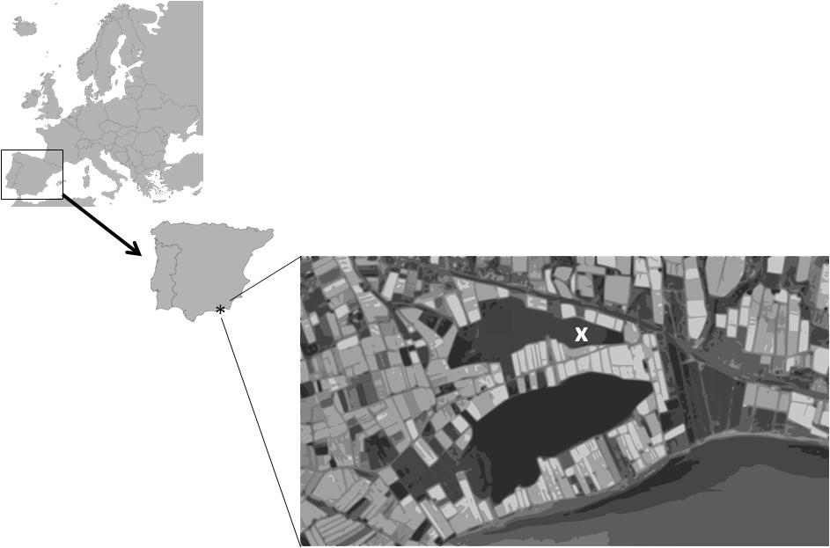

**Figure 1.** Geographic location of Honda lake.

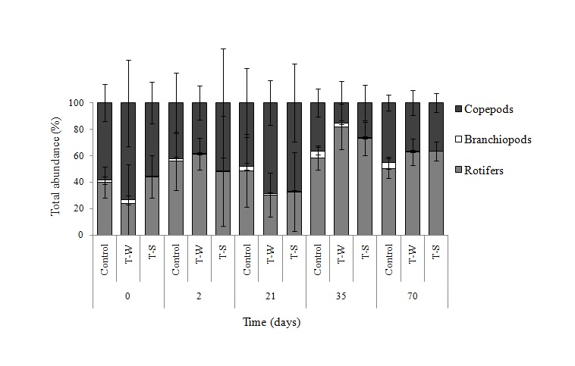

**Figure 2.** Temporal changes in the abundance of the different zooplankton groups.

*h*

*e*

*h*

*h*

*m*

*e*

*e*

*e*

*h*

TSICR2

TSICR1

TSIROT

TSIChla

TSITN

TSITP

Time (days)

Time (days)













**Figure 3.** Time evolution of trophic state indexes estimated from different chemical and biological variables. White, grey and black vertical bars represent C, T-W and T-S, respectively. Horizontal lines represent trophic states (h, e and m correspond to hypertrophy, eutrophy and mesotrophy, respectively).



**Figure 4.** Principal Responses Curves (PRC) showing the response of zooplankton community to different environmental variables. Empty circles represent Control, while asteriks and diamonds symbolize T-W and T-S, respectively.