Chirality-induced Spin Selectivity in Heterochiral Short-Peptide-Carbon Nanotube Hybrid Networks – Role of Supramolecular Chirality

Md. Wazedur Rahman,a Mari C. Mañas-Torres,b Seyedamin Firouzeh,a Sara Illescas-Lopez,b Juan M. Cuerva,b Modesto T. Lopez-Lopez,c,d Luis Álvarez de Cienfuegos*b,d and Sandipan Pramanik*a

a Department of Electrical and Computer Engineering, University of Alberta, Alberta T6G 1H9, Canada

b Universidad de Granada, Departamento de Química Orgánica, Unidad de Excelencia Química Aplicada a Biomedicina y Medioambiente, C. U. Fuentenueva, Avda. Severo Ochoa s/n, E-18071 Granada, Spain

c Universidad de Granada, Departamento de Física Aplicada, C. U. Fuentenueva, Avda. Severo Ochoa s/n, E-18071 Granada, Spain

d Instituto de Investigación Biosanitaria ibs.GRANADA, Spain

**Abstract**

Supramolecular short-peptide assemblies have been widely used for the development of biomaterials with potential biomedical applications. These peptides can self-assemble in multitude of chiral hierarchical structures triggered by the application of different stimuli, such as changes in temperature, pH, solvent, etc. The self-assembly process is very susceptible to the chemical composition of the peptides, being affected by specific amino acid sequence, type and chirality. The resulting supramolecular chirality of these materials has been explored to modulate protein and cell interactions. Recently, significant attention has been focused on the development of chiral materials with potential spintronic applications as it has been shown that transport of charge carriers through a chiral environment polarizes the carrier spins. This effect, named Chirality Induced Spin Selectivity or CISS, has been studied in different chiral organic molecules and materials, as well as carbon nanotubes functionalized with chiral molecules. Nevertheless, this effect has been only explored in homochiral systems in which the chirality of the medium, and hence the resulting spin polarization, is defined by the chirality of the molecule, with limited options for tunability. Herein, we have developed *heterochiral* carbon nanotube-short-peptide materials made by the combination of two different chiral sources, that is, homochiral peptides (L/D) + glucono-δ-lactone. We show that the presence of a small amount of glucono-δ-lactone with fixed chirality can alter the supramolecular chirality of the medium, thereby modulating the sign of the spin signal from “up” to “down” and vice versa. In addition, small amounts of glucono-δ-lactone can even induce non-zero spin polarization in an otherwise achiral and spin-inactive peptide-nanotube composite. Such “chiral doping” strategies could allow development of complimentary spintronic devices on a single material platform, opening novel design directions for CISS-based spintronic devices and circuits.

**I. Introduction.**

Short-peptide supramolecular hydrogels have turned out to be excellent materials with multiple bio- and technological applications.[1–5](https://www.zotero.org/google-docs/?H53Z6U) Some of these applications are due to the way these peptides self-assemble to form the hydrogel. In particular, aromatic short-peptides such as those containing Fmoc- (Fluorenylmethoxicarbonyl) or Nap- (2-naphthylacetic acid) dipeptides, are extremely versatile, being able to self-assemble under the influence of multiple and diverse stimuli, such as, solvent and pH switch, change in temperature, the presence of different salts, the action of enzymes, etc.[6–9](https://www.zotero.org/google-docs/?podQaR) This versatility has been very useful to develop hydrogels for different applications such as, tissue engineering,[10,11](https://www.zotero.org/google-docs/?B94pnf) drug delivery,[12,13](https://www.zotero.org/google-docs/?W0tjoO) and to control the type and morphology of the polymeric fibers and the macroscopic and physical properties of the resulting gels.[14–18](https://www.zotero.org/google-docs/?xitbKS) Furthermore, the triggering process has also been key in obtaining hybrid or composite materials.[19](https://www.zotero.org/google-docs/?LTqGhc) Composite materials have been obtained mainly by the combination of two different organic materials, such as the combination of two aromatic peptides that can be copolymerized[20](https://www.zotero.org/google-docs/?fScvly) or independently homo-polymerized[21](https://www.zotero.org/google-docs/?LoZMPf) by controlling the stimulus process. The formation of hybrid materials has also been a success since these peptides can self-assemble in the presence of multitude of inorganic, metallic and carbon-based materials.[22,23](https://www.zotero.org/google-docs/?C5sme8) A particular type of interesting hybrid hydrogels are those containing carbon nanotubes (CNTs).[24–26](https://www.zotero.org/google-docs/?NQxROs) The hydrophobic character of these peptides due to the presence of multiple aromatic groups have turned out to be ideal to solvate and disperse CNTs, being able to gel a homogeneous suspension of CNTs-peptide networks. The inclusion of CNTs inside the peptide hydrogel have shown to improve the mechanical properties of the hybrid materials as well as increase their electronic conduction. Moreover, these hybrid hydrogels have been used as a media to grow protein crystals, giving rise to catalytic and electron conduction, and novel biomaterials with potential applications in the field of bioelectronics and molecular electronics.[24](https://www.zotero.org/google-docs/?RfoxaT)

Another area of increasing interest in which these hybrid hydrogels can show novel properties and find useful applications is the area of organic or molecular spintronics.[27](https://www.zotero.org/google-docs/?uBLOrk) This area studies spin transport through organic compounds or materials and has shown that there is a connection between the chirality of the molecule and the spin polarization, named CISS effect.[28–30](https://www.zotero.org/google-docs/?R7EMGz) Organic molecules, in general, have poor electronic conductivity, which limits their potential device applications. However, as indicated above, many chiral organic molecules bind efficiently with CNTs to form hybrid structures, and can potentially imprint chirality induced spin polarization on the carriers in nanotubes. Given the immense technological importance of CNTs in the areas of electronic devices, circuits and sensors, such functionalities could open the door for a wide range of spintronic devices. Initial studies in this direction have employed single strand DNA and peptides and have shown a correlation between the nanotube-molecule interaction strength and the observed CISS effect.[27,31–34](https://www.zotero.org/google-docs/?fOGNvc) The induced spin polarization also affects carrier transport in nanotubes via spin-momentum locking, which is a signature property of CISS.[34](https://www.zotero.org/google-docs/?jNm88I)

A schematic illustration of charge transport in CNT networks functionalized with chiral molecules is shown in Figure 1(a). Spin unpolarized charge carriers are injected into the CNTs from the left and undergo phonon-assisted and electric field assisted hopping from one localized state to the other in the direction of transport. The localized states are separated by electrical barriers that arise from molecular functionalization, inter-tube junctions or tube defects.[35](https://www.zotero.org/google-docs/?5Ut5vA) In the absence of any chiral functionalization, this process does not result in any net spin polarization of the outgoing electrons. However, in the presence of chiral molecules, the barriers are “chiral”, which makes the outgoing electron population spin polarized, the spin polarization being correlated with the chirality of the molecules.[27](https://www.zotero.org/google-docs/?OWU8kU) Spin polarization originates due to spin-orbit interaction arising from spatial inversion asymmetry of the chiral barriers.[27](https://www.zotero.org/google-docs/?7YJuSJ) Spin polarization has been found to survive over length scale ~1𝜇m in these systems.[27](https://www.zotero.org/google-docs/?d8WN0X)In general, the CISS effect manifests at temperatures below ~50K, where the electron transmission is primarily via tunneling through the chiral barriers.[27](https://www.zotero.org/google-docs/?MJJxqk) At higher temperatures, electrons start to conduct via thermionic emission over the top of the barriers, a process which is intrinsically not spin-selective, and hence the CISS signal is lost.[27](https://www.zotero.org/google-docs/?8pweag)

We have recently shown that chiral Fmoc-dipeptide supramolecular aggregates are able to induce spin polarization in 2D CNT networks.[27](https://www.zotero.org/google-docs/?KkxmGv) In particular, the effect is strongest when an aromatic ring is present on the chiral side chain of the dipeptide (such as in Fmoc-diphenylalanine or Fmoc-FF, Figure 1(b)), presumably because aromatic rings bind more efficiently with CNTs via π-π interaction.[27,36](https://www.zotero.org/google-docs/?2gXzHX) Chiral side chains of Fmoc-FF (L/D) have two chiral centers with an absolute configuration of (S, S) and (R, R) respectively. These two molecules are enantiomers, meaning they are non-superimposable mirror images of each other — Fmoc-FF (L) is levorotatory ( = – 15,3) and Fmoc-FF (D) is dextrorotatory ( = 13,8), as shown in the Supporting Information. Basic aqueous solutions of these peptides form enantiomeric supramolecular fibrils that show specular images in circular dichroism (CD) spectra, as shown in Figure 1(c) (see Figure S1 for HT spectra). These chiral side chains interact strongly with the CNTs and result in chirality dependent spin signals. The incorporation of an additional chiral molecule into Fmoc-FF (L/D)-CNT hybrid hydrogels will make the resulting hydrogels diastereomeric “doped” mixtures, in the sense that they will no longer be formed exclusively by Fmoc-FF (L) or Fmoc-FF (D) enantiomeric hydrogels. The influence, if any, of such diastereomeric “doped” mixtures on CISS is unknown.

In this work, we have triggered the formation of Fmoc-FF (L/D) hybrid hydrogels by adding chiral glucono-δ-lactone (GdL), a well-known gel promoter of these type of molecules.[24](https://www.zotero.org/google-docs/?fx4qgQ) The amount of GdL in the mixture is “small”, in the sense that it does not show any detectable difference in terms of its interaction with CNTs, as evidenced from Raman studies described below. As shown in Figure 1 (d), GdL has four chiral centers – 3R,4S,5S,6R – where the number defines the position of the chiral carbon.[37](https://www.zotero.org/google-docs/?opCRrf) Presence of these additional chiral centers makes Fmoc-FF (L)+GdL and Fmoc-FF(D)+GdL heterochiral media.

In principle, due to minimal interaction of GdL with CNTs, it is not expected to directly influence CISS effect in the CNT network. However, as we report below, its presence in the chiral medium does have a significant impact on the supramolecular chirality of the peptide fibers and hence on the CISS effect. Introduction of such additional chiral molecules in the synthesis process could therefore offer a way to tune the CISS effect in 2D CNT networks.

**II. Results and Discussion.**

Fabrication of CNT networks functionalized with GdL and Fmoc-dipeptides has been described previously (see Experimental Section in Supporting Information).[24](https://www.zotero.org/google-docs/?kYKM3r) Briefly, a suspension of single wall (SW) CNTs was prepared in an aqueous basic solution of Fmoc-dipeptides. Formation of CNT suspension confirms that the CNTs are indeed interacting with Fmoc-dipeptides, otherwise they would precipitate. Interaction of CNTs and Fmoc-dipeptides in the solution occurs via π-π interactions between nanotube sidewall and the aromatic fluorenyl group of Fmoc as well as the sidechain of the peptide.[36](https://www.zotero.org/google-docs/?zaBu3c) Next, the pH of the solution is lowered by adding GdL, which makes the peptides less soluble, resulting in a collapse of the peptides into a fibrous network and formation of a hydrogel structure. The peptide nanofiber network is formed by molecular stacking mediated by hydrogen bonding and π-π interaction between the aromatic fluorenyl rings.[38](https://www.zotero.org/google-docs/?1Fn5UF) Clearly, the CNTs remain encapsulated in this fibrous network and they primarily interact with the Fmoc-dipeptides as mentioned above. Due to the presence of GdL in the media, it will also be present within the network, adding additional chiral centers, even though they do not directly interact with the CNTs.

We also prepared control samples in which gelification was induced by achiral Na2CO3, instead of GdL. In general, GdL is more effective in inducing gelification and forming peptide nanofibers than Na2CO3. Thus the nanotubes are properly encapsulated into Fmoc-dipeptides, and hence have better nanotube-peptide interaction, when GdL is used. This was clearly demonstrated by measuring the viscoelasticity under oscillatory shear of the resulting hybrid hydrogels by rheology (Figure S2). Fmoc-FF (L/D) hybrid hydrogels formed by the addition of GdL showed very similar G’ values of around 5000 Pa, as expected for enantiomeric gels. Similarly, Fmoc-FF (L/D) hybrid hydrogels formed by the addition of Na2CO3 showed G’ values similar to each other, but in this case of much lower magnitude (~ 25 Pa) than those formed by GdL. Values of tan 𝛿 = G”/G’ confirm that gels prepared with GdL were strong (tan 𝛿 < 0.1) and gels prepared with Na2CO3 were weak (tan 𝛿 > 0.1).[39](https://www.zotero.org/google-docs/?6t8JON)

A slice of the gel is placed on Ni-Au electrode pairs (~ 100 nm thick, nominal electrode gap ~ 1‒2 𝜇m) fabricated on SiO2/Si, dried at room temperature and subsequently annealed. FESEM image of the final device structure is shown in Figure 1(d). Two-dimensional nanotube network, functionalized with Fmoc-dipeptides and GdL (or Na2CO3, in case of control samples) is connected between the contacts. Both chiral (6,5) and achiral SWCNTs were tested in this work. No significant effect of CNT chirality on CISS was observed, and the data shown in this paper corresponds to (6,5) CNTs. Fmoc-FF (L/D) molecules were used to demonstrate the interplay between its chirality and that of GdL. Fmoc-GG (diglycine), which is non-aromatic and achiral, was used as a control sample to investigate the role of GdL as the sole chiral source.

Figure 2 (a) shows Raman characterization of SWCNTs functionalized with Fmoc-dipeptides and GdL. The G+ peak at ~1580 cm-1 is common in all cases, because it’s the signature of in-plane vibration of the graphitic lattice of CNTs.[40](https://www.zotero.org/google-docs/?4apWCX) The intensity of the G– peak (~1540 cm-1, which is caused by the transverse vibration of the carbon atoms) is suppressed as a result of functionalization, as shown in the *inset* of Figure 2 (a). The FF molecules strongly suppress this peak, presumably due to strong π-π interaction of its sidechain with the CNT walls, whereas GG has a lesser effect. Similar observations were made before in ref.[36](https://www.zotero.org/google-docs/?w9Ahyt), where 𝜋-stacking between aromatic groups of the amino acids and CNT have been found to have greater interaction energies. Figure 2 (b) shows the aggregate behavior (~15 samples) of G–/G+ intensity ratio for each functionalization, confirming this observation. Stronger functionalization also shifts the G– peak frequency as shown in Figure 2(a) *inset*. The G–/G+ intensity ratios with GdL and without GdL (with Na2CO3) are compared in Figure 2 (c). No statistically significant difference was observed, which is consistent with the fact that GdL does not directly bind with CNTs, rather they are trapped in the chiral medium between the CNTs and the peptides. Nevertheless, as mentioned before, the gel quality is more robust when GdL is used, indicating better nanotube-peptide interaction in this case.

We also note that the width of the G+ peak gets narrowed as a result of functionalization (Figure 2 (d)). Aside from affecting the G–/G+ intensity ratio, functionalization causes all other characteristic peaks (RBM, G+) to upshift as seen from Figure S3 (Supporting Information). This upshift indicates fractional charge transfer between molecules and nanotubes, which is more prominent in the case of Fmoc-FF.[40](https://www.zotero.org/google-docs/?p7R9i7)

We start our investigation with Fmoc-GG functionalization, because its lack of chirality will allow us to isolate the effect of GdL molecules. In this case, binding with CNTs takes place via interaction with the aromatic Fmoc group, which, like the sidechain, is achiral. Figure 3(a) shows typical current-voltage (*I-V*) characteristics of Fmoc-GG + GdL samples. Strong semiconducting behavior is observed as a function of temperature (*T*), with resistance (*R*) dropping by *more than an order of magnitude* as temperature is raised from 9K to 300K (Figure 3(a) *inset*). The *I-V* characteristics are also non-linear, especially in the low temperature range. Such behavior have been reported before in CNT networks, and is often modeled using variable range hopping (VRH) model, in which charge carriers undergo phonon-assisted tunneling from one localized state to another (Figure 1(a)).[41–44](https://www.zotero.org/google-docs/?nqaE8P) Figure 3 (b) shows fitting of temperature-dependent resistance *R*(*T*) with a two-dimensional variable range hopping (VRH) model[44](https://www.zotero.org/google-docs/?cAmwkz): *R*(*T*) ∝ exp (*T*0/*T*)1/3, where *T*0 is a parameter often referred to as the “characteristic temperature”. A linear fit has been observed over a wide temperature range. This confirms the physical carrier transport picture depicted in Figure 1(a). Figures 3(c) and (d) show similar studies performed on Fmoc-GG +Na2CO3 samples, which, unlike Figures 3(a) and (b), shows a *weak* semiconducting trend with device resistance decreasing by a meager 60% as temperature is varied from 9K to 300K, and the fitting with the VRH model is also poor.

Weak semiconducting behavior in Figures 3(c) and (d) can be understood from the poorer interaction of Fmoc-GG with CNTs when using Na2CO3. We note that the G–/G+ intensity ratios discussed above do not capture any appreciable difference in interaction strengths with and without GdL. However, as discussed earlier, Fmoc-GG samples form a proper hydrogel structure in presence of GdL, ensuring better interaction of the peptide with the CNTs. The samples without GdL are more fluid, and indicate poorer interaction between peptide and CNTs. Lack of any aromatic side chain is also responsible for the weak interaction. In this case, rheological measurements of Fmoc-GG hybrid hydrogel formed by the addition of GdL showed G’ values of 279 Pa, while those formed by the addition of Na2CO3 showed G’ values of 6 Pa. Again, the differences between both hydrogels are significant and while the gel formed with GdL can be considered weak with respect to Fmoc-FF, the gel formed with Na2CO3 can be classified as extremely weak (Figure S2). Therefore, in the context of transport measurements (Figures 3(c), (d)), the carriers are less localized due to poorer CNT-molecule interaction and hence poorer barrier formation. As a result, metallic behavior of the nanotube networks plays a strong role. This tends to offset any semiconducting behavior that originates from functionalization and carrier localization, and hence explains the weaker temperature dependence of the transport characteristics in Figures 3(c), (d), compared to Figures 3(a), (b).

To investigate the CISS effect in this system, we measured two terminal magnetoresistance (MR) with one ferromagnetic contact (Ni). The other contact is nonmagnetic Au. The basic idea is that if there are indeed chirality-induced spins in the CNT network, then their transmission through Ni should depend on the magnetization direction of Ni.[28,29](https://www.zotero.org/google-docs/?hV2DGy) One magnetization direction is supposed to offer different transmission probability of the carriers compared to the opposite magnetization. While this scheme is not effective in linear devices, CISS systems, including ours, are inherently non-linear, with conductance (d*I*/d*V*) being a strong function of bias (*V*) even at low bias range.[28](https://www.zotero.org/google-docs/?6EzMj7) As discussed above, this nonlinearity arises from energy-dependent electron transport and energy relaxation due to phonons in the VRH mode of transport. In this case there is no theoretical restriction on non-zero MR in a two-terminal setup.[45,46](https://www.zotero.org/google-docs/?pHfFxg) According to a recent model,[47](https://www.zotero.org/google-docs/?OGUJit) under true equilibrium (i.e. zero bias and zero net current) there could be local chirality-dependent spin accumulation on the non-magnetic contact, which essentially would make the device somewhat similar to a spin valve. Thus, it can exhibit differential resistance as Ni magnetization is changed.

Figures 4(a), (b) show the MR response of Fmoc-GG + GdL functionalized CNTs at different temperatures. Magnetic field, and hence Ni magnetization, is perpendicular to the sample plane (𝜃 = 90o). A background negative MR is observed, which is a common occurrence in CNT networks.[41,42,48](https://www.zotero.org/google-docs/?TBsi6v) This negative MR can arise from various sources, but in the present case, as discussed earlier,[48](https://www.zotero.org/google-docs/?g5ndnG) its origin is due to an interference effect between the forward and backward hopping paths. Most importantly, a MR asymmetry has been seen i.e. *R* (– 12 kG) ≠ *R* (+12 kG), which has been quantified by the normalized parameter Δ = [ *R* (– 12 kG) – *R* (+12 kG) ] / min [*R* (±12 kG)].

Figure 4 (c) shows MR data from Fmoc-GG+CNT samples using Na2CO3 (*without* GdL). The data is more noisy than before, presumably due to poor functionalization using Na2CO3. No Δ has been detected, above the noise level. Figure 4 (d) summarizes the evolution of Δ as a function of temperature for both cases, highlighting the difference due to GdL.

From Figures 4(a)-(d), it is clear that the presence of GdL has an impact on the chirality of the medium contributing to the non-zero Δ. This effect can be due to the chirality of GdL or due to any influence that GdL may have on the supramolecular chirality of Fmoc-GG. Although Fmoc-GG is achiral and forms supramolecular aggregates of both hands in equal proportions, the presence of a chiral molecule can promote the preferential formation of one supramolecular handedness by a “Sergeant-and-Soldier” effect.[49](https://www.zotero.org/google-docs/?Y8WRti) To investigate if this were the case, we measured the CD spectra of Fmoc-GG hydrogels formed by the addition of Na2CO3 (Figure 4 (e)) and GdL (Figure 4 (f)), since measuring the CD spectra of the hybrid hydrogels containing CNT was not possible due to the opaque media. While the value of CD was zero for the Fmoc-GG hydrogel formed with Na2CO3 showing the absence of supramolecular chiral aggregates, the CD spectrum of the mixture of Fmoc-GG with GdL showed the formation of a preferred supramolecular chirality. Since GdL does not interact with CNTs directly, and since Fmoc-GG doesn’t have any CISS effect, the non-zero CISS effect observed in the Fmoc-GG+GdL mixture must be due to the supramolecular chirality triggered by GdL. It has been reported that the CISS effect measured in supramolecular aggregates depends on the resulting supramolecular chirality of the aggregate and not on the chirality of simple molecules.[50](https://www.zotero.org/google-docs/?4OQv5R) This offers the possibility to tune the magnitude and sign of Δ by varying the supramolecular arrangement of the molecules, which can be achieved by the application of different stimuli or addition of molecules.[49](https://www.zotero.org/google-docs/?zb8OLI) Ref.[50](https://www.zotero.org/google-docs/?vVVQKw) have been able to prove this effect by obtaining chiral helical supramolecular polymers of M and P handedness using the same enantiomer but by changing the temperature at which the supramolecular aggregates form.

To further investigate the relationship between supramolecular chirality and the CISS effect in these hybrid networks, next, we consider Fmoc-FF functionalization of the nanotubes both with (Figure 5) and without (Figure S4) GdL. In this case, gel formation still occurs when Na2CO3 is used, although gel quality is better with GdL (Figure S2). Unlike Fmoc-GG, Fmoc-FF has an aromatic sidechain, which may facilitate forming gel structure even if GdL is not used. This clearly manifests in the *I*-*V* responses of these samples shown in Figures 5(a), (c), S4. Semiconducting temperature dependence has been observed in both cases with device resistance decreasing by more than an order of magnitude as sample temperature is increased from 9K to 300K. As shown in Figures 5(b), (d), S4, the data matches reasonably well with the two-dimensional VRH model, with a linear fitting over a wide temperature range. Small deviations are present in the low temperature range, which has been reported before in chirally functionalized nanotubes.[34](https://www.zotero.org/google-docs/?6CAP69)

Figures 6(a), (b), (c) show the MR response of Fmoc-FF functionalized nanotubes *in presence of* GdL. A clear MR asymmetry (non-zero Δ) has been observed, which is dependent on the chirality of the medium. For example, Δ is positive (i.e. *R* (-12 kG) > *R* (+12 kG)) for Fmoc-FF(L) whereas Δ is negative for Fmoc-FF(D). Figures 6(d), (e), (f) show the MR responses of Fmoc-FF functionalized nanotubes *without* GdL. The MR asymmetry is opposite compared to before i.e. Δ is positive for the Fmoc-FF(D) samples, and negative for Fmoc-FF(L). It is therefore clear that the presence of GdL molecules in the medium flips the sign of the CISS signal Δ. In all cases, magnetic field, and hence Ni magnetization, is perpendicular to the sample plane (𝜃 = 90o). This flip in the sign of Δ might be due to a stereoinversion of the supramolecular chirality of the peptides aggregates. To investigate if GdL was changing the supramolecular chirality of the peptide aggregates, CD spectra were performed in Fmoc-FF (L/D) hydrogels prepared with GdL and Na2CO3 (Figure 6 (g) and (h)). As it can be seen from Figures 6 (g) and (h), the addition of GdL effectively flips the sign of the peak of around 280 nm, corresponding to the π-π* transition of the Fmoc group and, similar to ref.[50](https://www.zotero.org/google-docs/?gN22kp), this results in a change of the sign of Δ compared to the results obtained using Na2CO3.

The role of GdL molecules on MR asymmetry is also apparent from the differential resistance (d*V*/d*I*) vs. bias (*V*) plots shown in Figures 7(a)-(d). It is clear that the non-zero Δ has been observed in the non-linear bias regime, thereby posing no contradiction to the reciprocity principles.[47](https://www.zotero.org/google-docs/?Ctgk02)

Irrespective of the details of the molecular functionalization, in all cases the magnitude of Δ decreases with increasing temperature, which is summarized in Figures 8(a), (b). This could be attributed to increased spin randomizing scattering as temperature is increased. As can be seen from Figure 1(a), at higher temperatures, the electrons will conduct via thermionic emission over the top of the barriers, a process which is not spin selective. We note that spin transport in carbon nanotubes is in general sensitive to temperature, and spin signals typically manifest at lower temperatures.[51](https://www.zotero.org/google-docs/?mK8udZ) Figures 8(c), (d) show the evolution of *normalized* Δ as a function of magnetic field *direction* for different functionalizations. For each molecule, normalization has been done relative to the corresponding maximum value of Δ (say Δmax), which allows direct comparison between different molecules. Role of the magnetic field is twofold – first, it determines the magnetization direction of Ni, which acts as spin detector and second, it influences the local magnetization on the Au electrode under equilibrium condition (zero bias and net zero current).[47](https://www.zotero.org/google-docs/?tpONwq) The local magnetization, as mentioned before, will also depend on molecular chirality.[47](https://www.zotero.org/google-docs/?xaP8Dz) Thus evolution of Δ is a complex function of the magnetic field angle 𝜃, but exhibits ~360o periodicity, which is expected for chiral systems in which Ni magnetization and chirality jointly select one direction along which current flow is favored. The crucial thing to note is that the sign of Δ is chirality dependent only at certain field angles (such as ~90o, 270o). Figures 8(c), (d) clearly show that at these measurement angles the sign of Δ is opposite depending on the presence of GdL molecules in the medium.

To summarize, we have demonstrated that the CISS effect is governed by the supramolecular chirality of the resulting CNT-molecule hybrid materials. This offers the possibility to tune, modulate and generate CISS effect by the application of different stimuli in the formation of the supramolecular network. Here we have shown (*a*) that by the addition of a chiral molecule (GdL), CISS effect can surge from achiral molecules (Fmoc-GG) through the formation of chiral supramolecular aggregates and (*b*) that the sign of the CISS effect can be controlled based on the stimulus used to trigger gel formation, in this case, Na2CO3 or GdL. We note that the experimentally accessible signal Δ is an “ensemble average” quantity, generated as a result of multiple spin-dependent chiral scatterings in the CNT network, and surprisingly the MR signal is still approximately in the same range of those obtained from ordered chiral molecules under comparable conditions.[30](https://www.zotero.org/google-docs/?ycnsIf) The planar geometry of these devices makes them inherently more reliable than the vertically stacked devices, where any unwanted coupling between the top and the bottom electrodes can adversely affect the MR signal. This, combined with the observation that CISS effect can be modulated by the combination of different stimuli, can lead to novel design directions for planar CISS devices, for example, enabling formation of complimentary spin devices on a single material platform. This study also highlights the importance of “global chirality” (due to supramolecular arrangements), rather than “local chirality” (due to individual molecules), which plays a dominant role in the CISS effect.

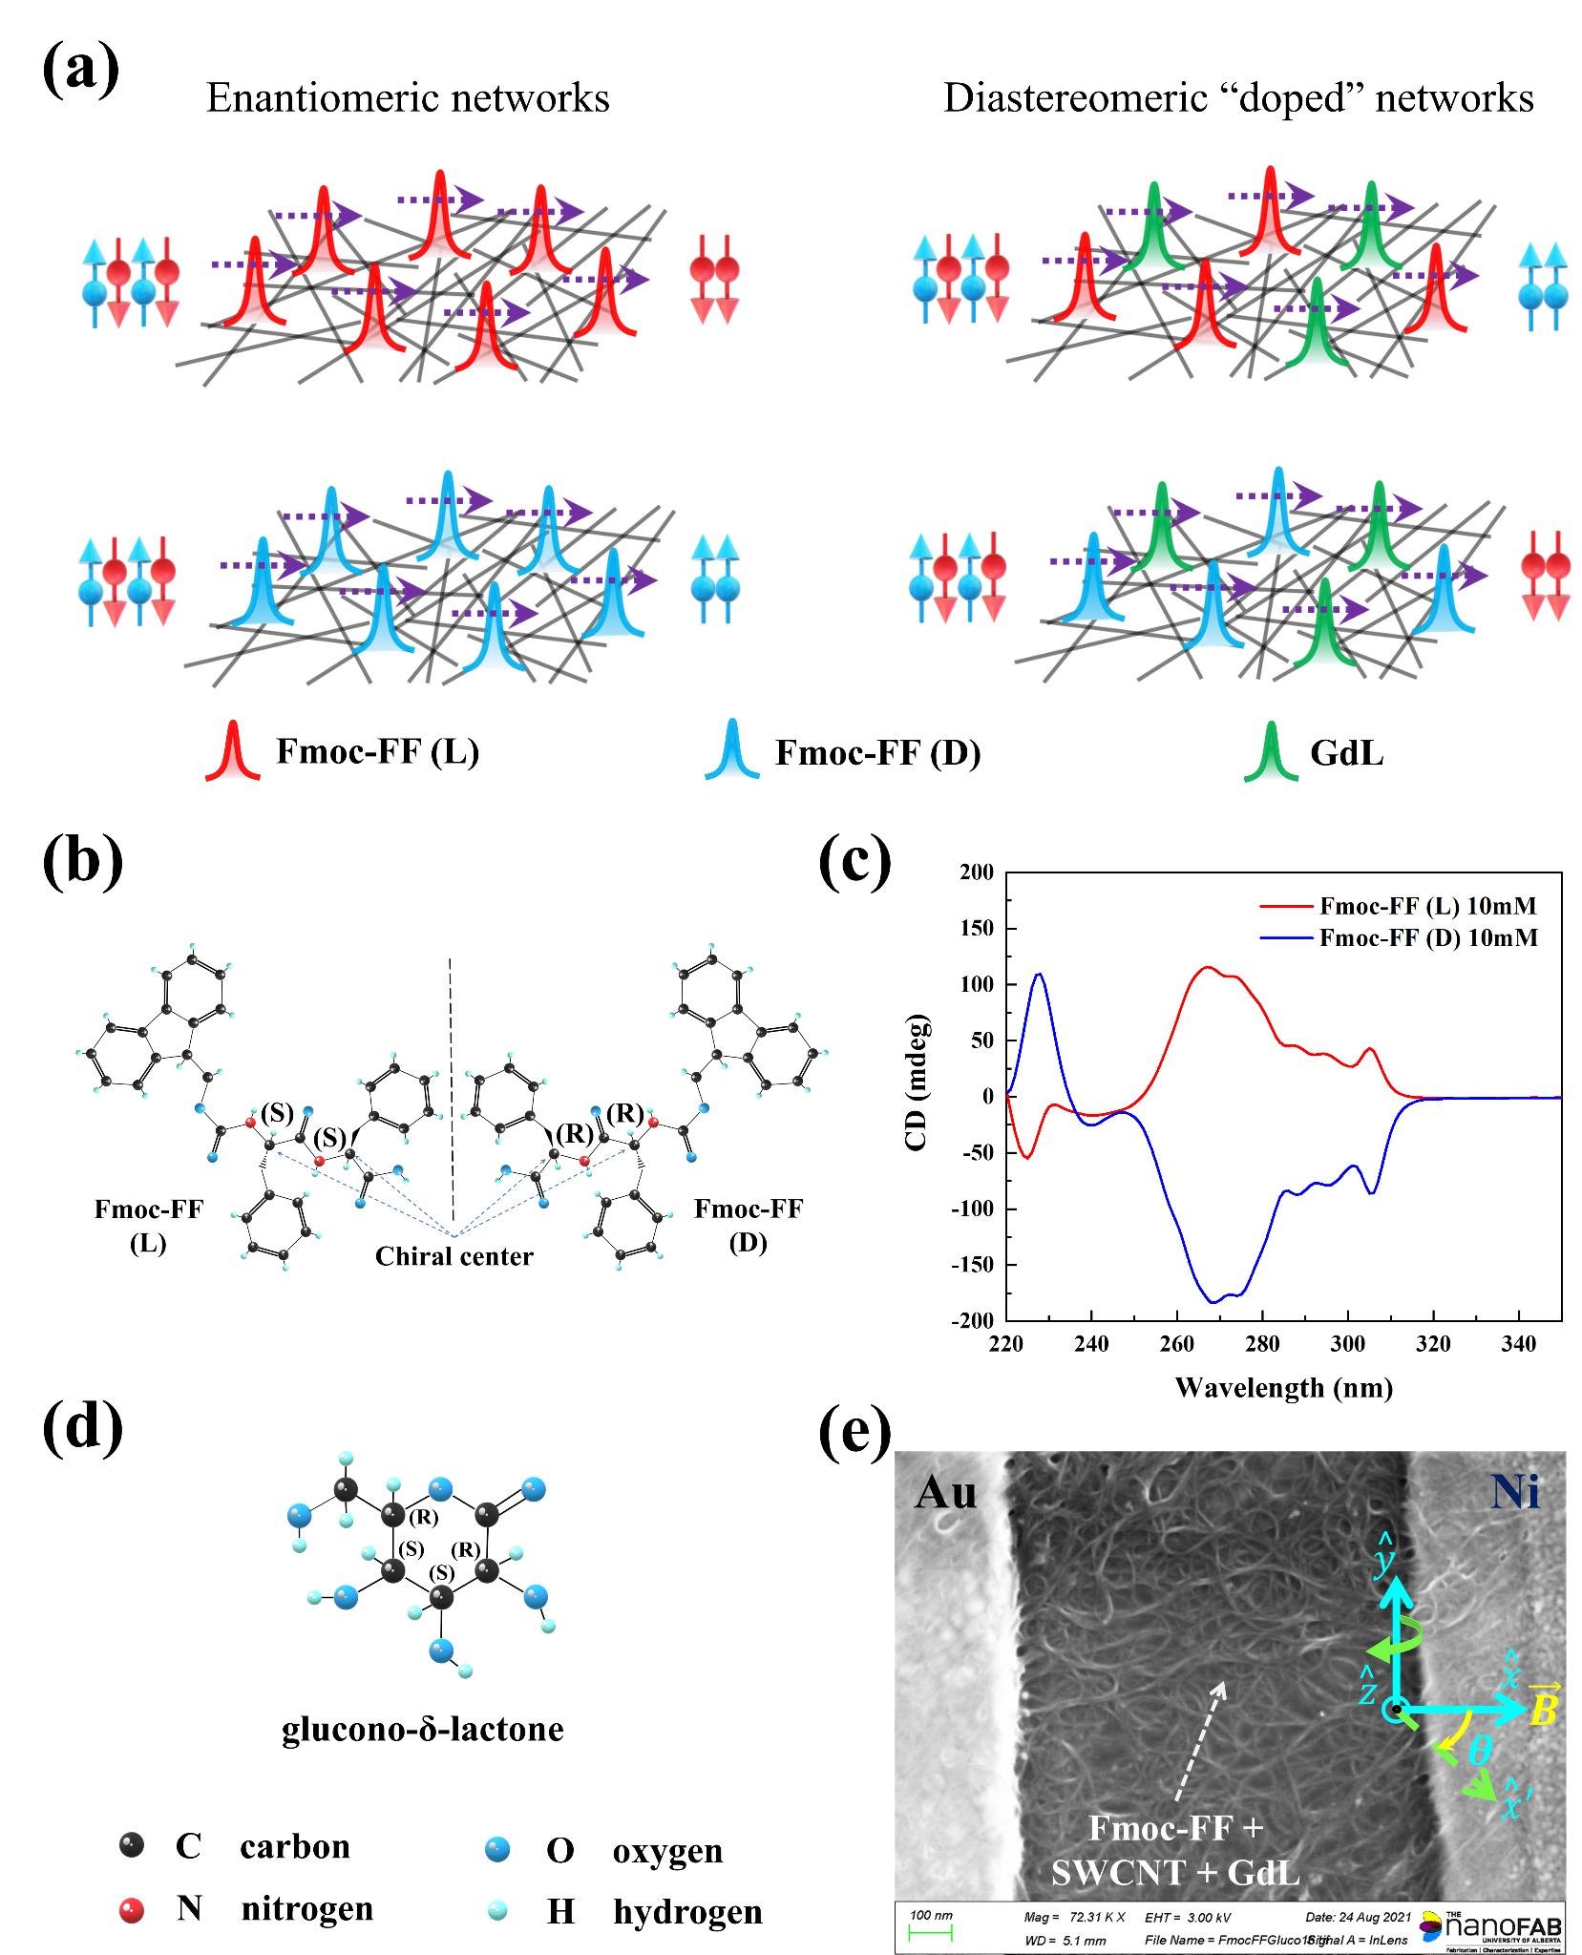

**Figure 1.** (a) Schematic depiction of charge transport through CNT networks functionalized with chiral molecules. *Left (Enantiomeric networks)* – Molecules are purely *R* or *S* chiral, transmitting “preferred” spins. *Right (Diastereomeric network)* – There is a presence of a small amount of opposite chirality molecules, which can result in opposite spin polarization of the outgoing electrons, as discussed later in this paper. (b), (c), (d) Chemical structure of chiral Fmoc-FF, CD spectra of Fmoc-FF (L/D) and chemical structure of 𝛿-gluconolactone molecule respectively. (e) FESEM image of functionalized CNT network connected between Au and Ni electrodes. Sample is in the *x*-*y* plane and 𝜃 = 0o corresponds to the case when the magnetic field ***B*** is along . For angle-dependent measurements, the sample plane is rotated as shown, while keeping the direction of ***B*** fixed.

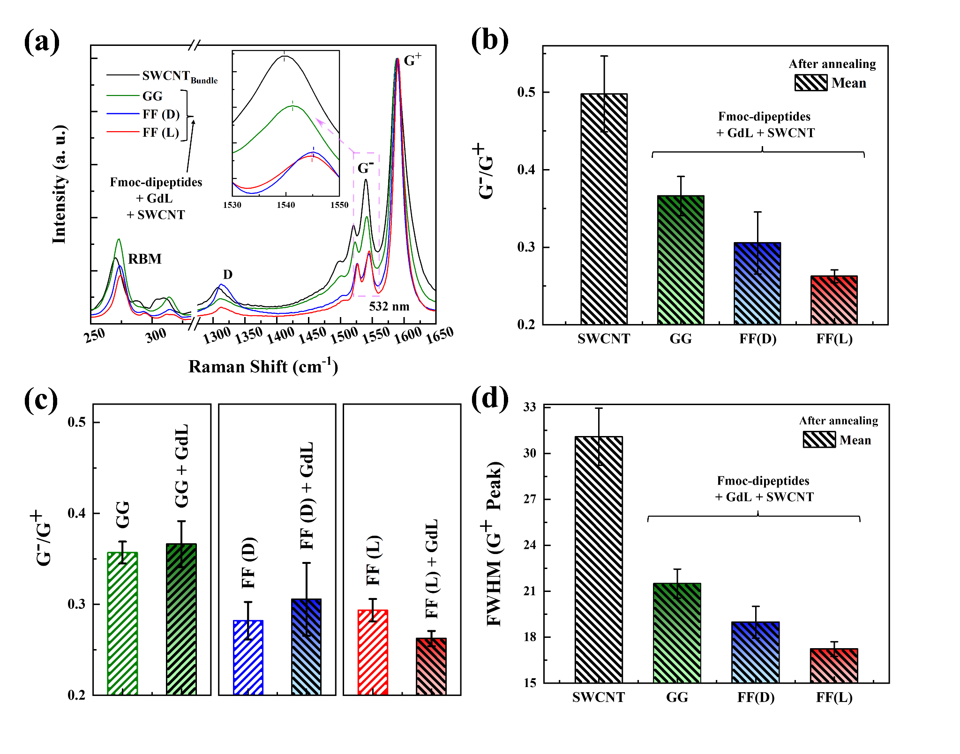

**Figure 2.** (a) Effect of molecular functionalization (Fmoc-dipeptide + GdL) on the Raman spectrum of CNTs. (b) Stronger CNT-peptide interaction in case of Fmoc-FF suppresses the G–/G+ ratio significantly more than that of Fmoc-GG. (c) Comparison of the G–/G+ ratio with and without GdL. No statistically significant difference has been observed. (d) Narrowing of the G+ peak as a result of functionalization. The effect is stronger in case of Fmoc-FF.

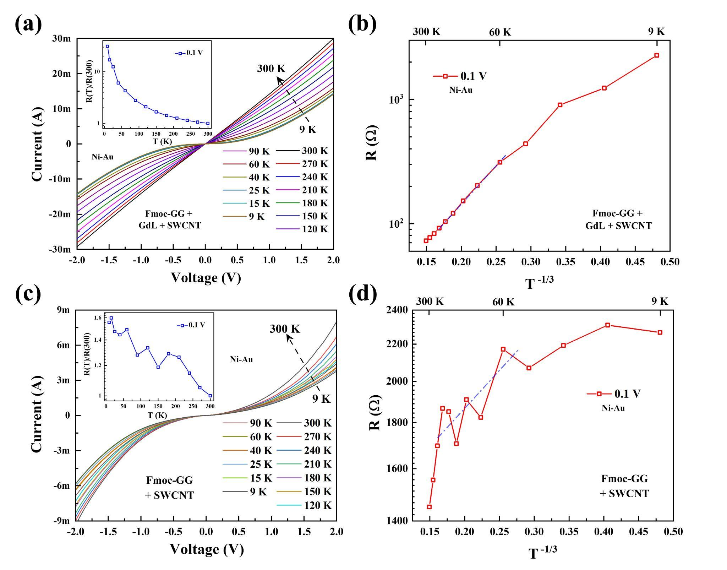

**Figure 3.** Current-voltage (*I*-*V*) characteristics and fitting with two-dimensional variable range hopping (VRH) model, with ((a), (b)) and without ((c), (d)) GdL.

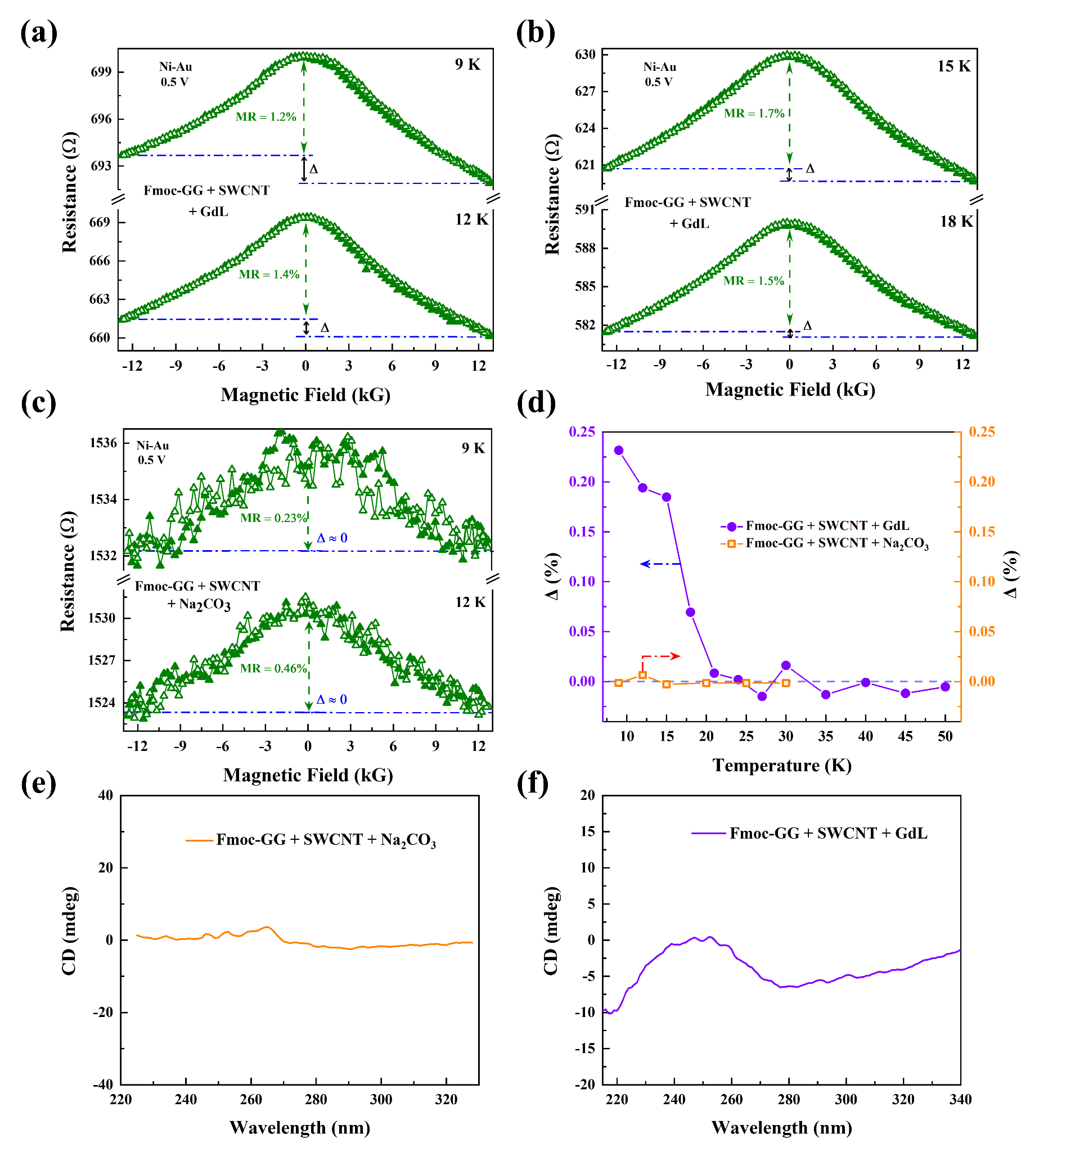

**Figure 4.** Two-terminal (Ni and Au) MR responses of Fmoc-GG functionalized CNT networks in presence ((a), (b)) and in absence ((c)) of GdL. Forward and backward magnetic field scan results are shown (open and filled markers). In case of (a) and (b), the scans are highly reproducible, with the error bar of the order of the marker size. A clear MR asymmetry Δ is present in this case. In case of (c) the error bar is larger and no Δ is detected above the noise level. (d) MR asymmetry Δ as a function of temperature in both cases. (e), (f) CD spectra of the hybrid samples without and with GdL respectively.

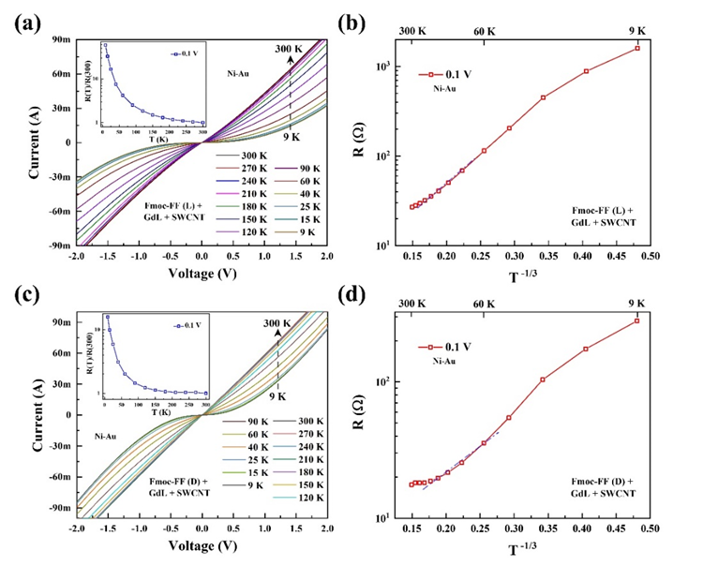

**Figure 5.** Current-voltage (*I-V*) characteristics of (a) Fmoc-FF (L) + GdL and (c) Fmoc-FF (D) + GdL functionalized SWCNTs with Ni-Au contacts. (b), (d) Fitting of device resistance *R* (= d*V*/d*I*) with the two-dimensional variable range hopping model.

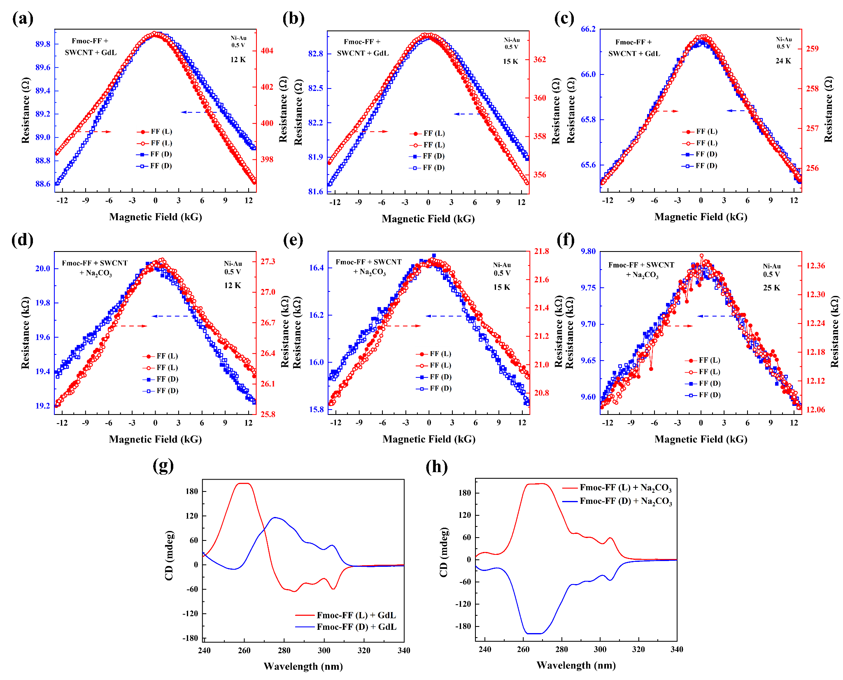

**Figure 6.** (a), (b), (c) Asymmetric MR (𝜃 = 90o) of SWCNTs functionalized with Fmoc-FF (L/D) + GdL at various temperatures. (d), (e), (f) Asymmetric MR (𝜃 = 90o) of SWCNTs functionalized with Fmoc-FF (L/D) + Na2CO3 at various temperatures. Applied bias is 0.5 V in all cases. Solid (open) symbols indicate magnetic field scan from negative (positive) to positive (negative) fields. MR asymmetry has been found to be chirality dependent, and has opposite signs for with and without GdL. (g), (h) CD spectra of the hybrid solutions with and without GdL respectively.

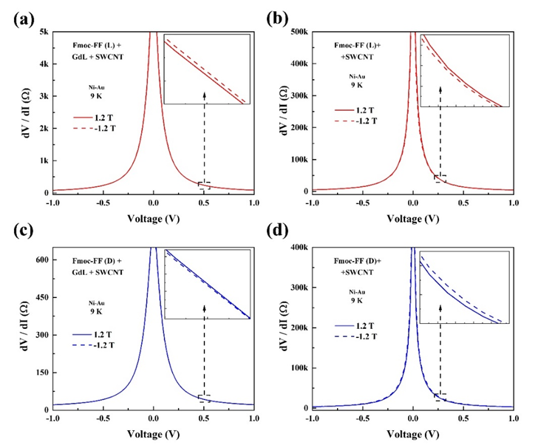

**Figure 7.** (a), (c) Differential resistance (d*V*/d*I*) vs bias (*V*) of SWCNTs functionalized with Fmoc-FF (L/D) + GdL (𝜃 = 90o). (b), (d) Differential resistance (d*V*/dI) vs bias (*V*) of SWCNTs functionalized with Fmoc-FF (L/D) + Na2CO3 (𝜃 = 90o). As seen from the *insets*, the resistance value is sensitive to the chirality of the medium as well as to the presence or absence of GdL.

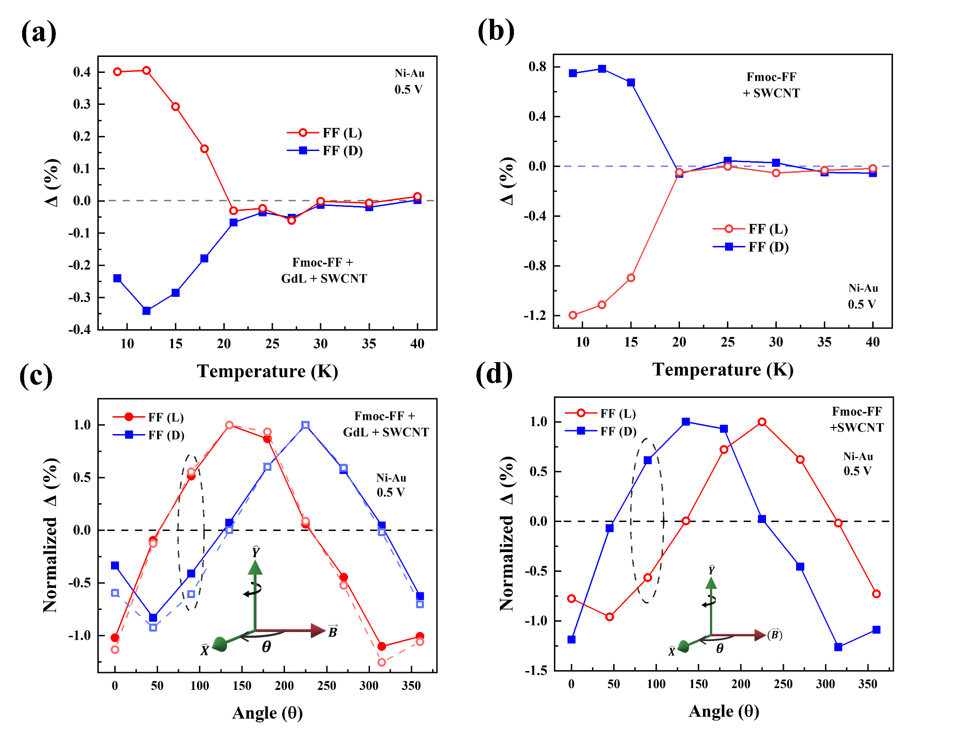

**Figure 8.** (a), (b) MR asymmetry Δ (%) as a function of temperature (measured at 𝜃 = 90o) for Fmoc-FF (L/D) + GdL functionalized and Fmoc-FF (L/D) + Na2CO3 functionalized SWCNTs respectively. (c), (d) Normalized Δ (%) at different orientations of Ni magnetization. For each sample, normalization is done relative to the corresponding maximum value of Δ. Sample is in the X-Y plane, and for 𝜃 = 0o, magnetic field coincides with the positive X axis. For angle dependent measurements, the sample plane is rotated relative to the Y axis as shown in the *insets*, while keeping the direction of the magnetic field fixed. Responses from two different samples are shown in (c), for each functionalization, demonstrating the reproducibility of the data. Applied bias is 0.5 V in all cases.

**ASSOCIATED CONTENT**

**Supporting Information**. Experimental Section and Figure S1: HT spectra of dipeptides hydrogels. Figure S2: Rheology of Fmoc-dipeptides + SWCNT hybrid hydrogels. Figure S3: Additional Raman Data. Figure S4: Current-voltage characteristics of Fmoc-FF (L/D) + CNT samples using Na2CO3. The following files are available free of charge.

**AUTHOR INFORMATION**

**Corresponding Authors:**

Luis Álvarez de Cienfuegos, *E-mail: [lac@ugr.es](mailto:lac@ugr.es)

Sandipan Pramanik, *E-mail: [spramani@ualberta.ca](mailto:spramani@ualberta.ca)

**ORCID:**

Mari C. Mañas-Torres: 0000-0003-4673-5224

Sara Illescas-Lopez: 0000-0002-8160-1435

Juan M. Cuerva: 0000-0001-8216-6511

Modesto T. Lopez-Lopez: 0000-0002-9068-7795

Luis Álvarez de Cienfuegos: 0000-0001-8910-4241

Sandipan Pramanik: 0000-0001-6761-4734

**Notes:**

The authors declare no competing financial interest

**ACKNOWLEDGMENTS**

This study was supported by project PID2020-118498GB-I00 funded by MCIN/AEI/10.13039/501100011033 and project P18-FR-3533 by FEDER/Junta de Andalucía-Consejería de Transformación Económica, Industria, Conocimiento y Universidades (Spain). MCMT acknowledge grant PRE2018-083773 funded by MCIN/AEI/10.13039/501100011033 and FSE “El FSE invierte en tu futuro”, Spain. S.P. acknowledges support from NFRFE-2019-01298 (New Frontiers in Research Fund - Exploration) and NSERC (Natural Sciences and Engineering Research Council) Canada, project RGPIN-2018-05127.

[(1) Wei, G.; Su, Z.; Reynolds, N. P.; Arosio, P.; Hamley, I. W.; Gazit, E.; Mezzenga, R. Self-Assembling Peptide and Protein Amyloids: From Structure to Tailored Function in Nanotechnology. *Chem. Soc. Rev.* **2017**, *46* (15), 4661–4708. https://doi.org/10.1039/C6CS00542J.](https://www.zotero.org/google-docs/?UHfTt6)

[(2) Yuan, C.; Ji, W.; Xing, R.; Li, J.; Gazit, E.; Yan, X. Hierarchically Oriented Organization in Supramolecular Peptide Crystals. *Nat. Rev. Chem.* **2019**, *3* (10), 567–588. https://doi.org/10.1038/s41570-019-0129-8.](https://www.zotero.org/google-docs/?UHfTt6)

[(3) Levin, A.; Hakala, T. A.; Schnaider, L.; Bernardes, G. J. L.; Gazit, E.; Knowles, T. P. J. Biomimetic Peptide Self-Assembly for Functional Materials. *Nat. Rev. Chem.* **2020**, *4* (11), 615–634. https://doi.org/10.1038/s41570-020-0215-y.](https://www.zotero.org/google-docs/?UHfTt6)

[(4) Lampel, A. Biology-Inspired Supramolecular Peptide Systems. *Chem* **2020**, *6* (6), 1222–1236. https://doi.org/10.1016/j.chempr.2020.03.005.](https://www.zotero.org/google-docs/?UHfTt6)

[(5) Mañas-Torres, M. C.; Illescas-Lopez, S.; Gavira, J. A.; de Cienfuegos, L. Á.; Marchesan, S. Interactions Between Peptide Assemblies and Proteins for Medicine. *Isr. J. Chem. n/a* (n/a), e202200018. https://doi.org/10.1002/ijch.202200018.](https://www.zotero.org/google-docs/?UHfTt6)

[(6) Tao, K.; Levin, A.; Adler-Abramovich, L.; Gazit, E. Fmoc-Modified Amino Acids and Short Peptides: Simple Bio-Inspired Building Blocks for the Fabrication of Functional Materials. *Chem. Soc. Rev.* **2016**, *45* (14), 3935–3953. https://doi.org/10.1039/C5CS00889A.](https://www.zotero.org/google-docs/?UHfTt6)

[(7) Fleming, S.; Ulijn, R. V. Design of Nanostructures Based on Aromatic Peptide Amphiphiles. *Chem. Soc. Rev.* **2014**, *43* (23), 8150–8177. https://doi.org/10.1039/C4CS00247D.](https://www.zotero.org/google-docs/?UHfTt6)

[(8) Draper, E. R.; Adams, D. J. Low-Molecular-Weight Gels: The State of the Art. *Chem* **2017**, *3* (3), 390–410. https://doi.org/10.1016/j.chempr.2017.07.012.](https://www.zotero.org/google-docs/?UHfTt6)

[(9) Adler-Abramovich, L.; Gazit, E. The Physical Properties of Supramolecular Peptide Assemblies: From Building Block Association to Technological Applications. *Chem. Soc. Rev.* **2014**, *43* (20), 6881–6893. https://doi.org/10.1039/C4CS00164H.](https://www.zotero.org/google-docs/?UHfTt6)

[(10) Panda, J. J.; Dua, R.; Mishra, A.; Mittra, B.; Chauhan, V. S. 3D Cell Growth and Proliferation on a RGD Functionalized Nanofibrillar Hydrogel Based on a Conformationally Restricted Residue Containing Dipeptide. *ACS Appl. Mater. Interfaces* **2010**, *2* (10), 2839–2848. https://doi.org/10.1021/am1005173.](https://www.zotero.org/google-docs/?UHfTt6)

[(11) Mañas-Torres, M. C.; Gila-Vilchez, C.; Vazquez-Perez, F. J.; Kuzhir, P.; Momier, D.; Scimeca, J.-C.; Borderie, A.; Goracci, M.; Burel-Vandenbos, F.; Blanco-Elices, C.; Rodriguez, I. A.; Alaminos, M.; de Cienfuegos, L. Á.; Lopez-Lopez, M. T. Injectable Magnetic-Responsive Short-Peptide Supramolecular Hydrogels: Ex Vivo and In Vivo Evaluation. *ACS Appl. Mater. Interfaces* **2021**, *13* (42), 49692–49704. https://doi.org/10.1021/acsami.1c13972.](https://www.zotero.org/google-docs/?UHfTt6)

[(12) Panda, J. J.; Mishra, A.; Basu, A.; Chauhan, V. S. Stimuli Responsive Self-Assembled Hydrogel of a Low Molecular Weight Free Dipeptide with Potential for Tunable Drug Delivery. *Biomacromolecules* **2008**, *9* (8), 2244–2250. https://doi.org/10.1021/bm800404z.](https://www.zotero.org/google-docs/?UHfTt6)

[(13) Contreras-Montoya, R.; Arredondo-Amador, M.; Escolano-Casado, G.; Mañas-Torres, M. C.; González, M.; Conejero-Muriel, M.; Bhatia, V.; Díaz-Mochón, J. J.; Martínez-Augustin, O.; de Medina, F. S.; Lopez-Lopez, M. T.; Conejero-Lara, F.; Gavira, J. A.; de Cienfuegos, L. Á. Insulin Crystals Grown in Short-Peptide Supramolecular Hydrogels Show Enhanced Thermal Stability and Slower Release Profile. *ACS Appl. Mater. Interfaces* **2021**, *13* (10), 11672–11682. https://doi.org/10.1021/acsami.1c00639.](https://www.zotero.org/google-docs/?UHfTt6)

[(14) Cardoso, A. Z.; Mears, L. L. E.; Cattoz, B. N.; Griffiths, P. C.; Schweins, R.; Adams, D. J. Linking Micellar Structures to Hydrogelation for Salt-Triggered Dipeptide Gelators. *Soft Matter* **2016**, *12* (15), 3612–3621. https://doi.org/10.1039/C5SM03072B.](https://www.zotero.org/google-docs/?UHfTt6)

[(15) McAulay, K.; Ucha, P. A.; Wang, H.; Fuentes-Caparrós, A. M.; Thomson, L.; Maklad, O.; Khunti, N.; Cowieson, N.; Wallace, M.; Cui, H.; Poole, R. J.; Seddon, A.; Adams, D. J. Controlling the Properties of the Micellar and Gel Phase by Varying the Counterion in Functionalised-Dipeptide Systems. *Chem. Commun.* **2020**, *56* (29), 4094–4097. https://doi.org/10.1039/D0CC01252A.](https://www.zotero.org/google-docs/?UHfTt6)

[(16) Levin, A.; Mason, T. O.; Adler-Abramovich, L.; Buell, A. K.; Meisl, G.; Galvagnion, C.; Bram, Y.; Stratford, S. A.; Dobson, C. M.; Knowles, T. P. J.; Gazit, E. Ostwald’s Rule of Stages Governs Structural Transitions and Morphology of Dipeptide Supramolecular Polymers. *Nat. Commun.* **2014**, *5* (1), 5219. https://doi.org/10.1038/ncomms6219.](https://www.zotero.org/google-docs/?UHfTt6)

[(17) Yuan, C.; Levin, A.; Chen, W.; Xing, R.; Zou, Q.; Herling, T. W.; Challa, P. K.; Knowles, T. P. J.; Yan, X. Nucleation and Growth of Amino Acid and Peptide Supramolecular Polymers through Liquid–Liquid Phase Separation. *Angew. Chem. Int. Ed.* **2019**, *58* (50), 18116–18123. https://doi.org/10.1002/anie.201911782.](https://www.zotero.org/google-docs/?UHfTt6)

[(18) Ji, W.; Yuan, C.; Zilberzwige-Tal, S.; Xing, R.; Chakraborty, P.; Tao, K.; Gilead, S.; Yan, X.; Gazit, E. Metal-Ion Modulated Structural Transformation of Amyloid-Like Dipeptide Supramolecular Self-Assembly. *ACS Nano* **2019**, *13* (6), 7300–7309. https://doi.org/10.1021/acsnano.9b03444.](https://www.zotero.org/google-docs/?UHfTt6)

[(19) Mañas-Torres, M. C.; Ramírez-Rodríguez, G. B.; García-Peiro, J. I.; Parra-Torrejón, B.; Cuerva, J. M.; Lopez-Lopez, M. T.; Cienfuegos, L. Á. de; Delgado-López, J. M. Organic/Inorganic Hydrogels by Simultaneous Self-Assembly and Mineralization of Aromatic Short-Peptides. *Inorg. Chem. Front.* **2022**, *9* (4), 743–752. https://doi.org/10.1039/D1QI01249E.](https://www.zotero.org/google-docs/?UHfTt6)

[(20) Gila-Vilchez, C.; Mañas-Torres, M. C.; González-Vera, J. A.; Franco-Montalban, F.; Tamayo, J. A.; Conejero-Lara, F.; Cuerva, J. M.; Lopez-Lopez, M. T.; Orte, A.; Cienfuegos, L. Á. de. Insights into the Co-Assemblies Formed by Different Aromatic Short-Peptide Amphiphiles. *Polym. Chem.* **2021**, *12* (47), 6832–6845. https://doi.org/10.1039/D1PY01366A.](https://www.zotero.org/google-docs/?UHfTt6)

[(21) Morris, K. L.; Chen, L.; Raeburn, J.; Sellick, O. R.; Cotanda, P.; Paul, A.; Griffiths, P. C.; King, S. M.; O’Reilly, R. K.; Serpell, L. C.; Adams, D. J. Chemically Programmed Self-Sorting of Gelator Networks. *Nat. Commun.* **2013**, *4*, 1480. https://doi.org/10.1038/ncomms2499.](https://www.zotero.org/google-docs/?UHfTt6)

[(22) Bellotto, O.; Cringoli, M. C.; Perathoner, S.; Fornasiero, P.; Marchesan, S. Peptide Gelators to Template Inorganic Nanoparticle Formation. *Gels* **2021**, *7* (1), 14. https://doi.org/10.3390/gels7010014.](https://www.zotero.org/google-docs/?UHfTt6)

[(23) Adorinni, S.; Rozhin, P.; Marchesan, S. Smart Hydrogels Meet Carbon Nanomaterials for New Frontiers in Medicine. *Biomedicines* **2021**, *9* (5), 570. https://doi.org/10.3390/biomedicines9050570.](https://www.zotero.org/google-docs/?UHfTt6)

[(24) Contreras‐Montoya, R.; Escolano, G.; Roy, S.; Lopez‐Lopez, M. T.; Delgado‐López, J. M.; Cuerva, J. M.; Díaz‐Mochón, J. J.; Ashkenasy, N.; Gavira, J. A.; Cienfuegos, L. Á. de. Catalytic and Electron Conducting Carbon Nanotube–Reinforced Lysozyme Crystals. *Adv. Funct. Mater.* **2019**, *29* (5), 1807351. https://doi.org/10.1002/adfm.201807351.](https://www.zotero.org/google-docs/?UHfTt6)

[(25) Roy, S.; Banerjee, A. Functionalized Single Walled Carbon Nanotube Containing Amino Acid Based Hydrogel: A Hybrid Nanomaterial. *RSC Adv.* **2012**, *2* (5), 2105–2111. https://doi.org/10.1039/C2RA00763K.](https://www.zotero.org/google-docs/?UHfTt6)

[(26) Iglesias, D.; Melle-Franco, M.; Kurbasic, M.; Melchionna, M.; Abrami, M.; Grassi, M.; Prato, M.; Marchesan, S. Oxidized Nanocarbons-Tripeptide Supramolecular Hydrogels: Shape Matters! *ACS Nano* **2018**, *12* (6), 5530–5538. https://doi.org/10.1021/acsnano.8b01182.](https://www.zotero.org/google-docs/?UHfTt6)

[(27) Rahman, Md. W.; Mañas-Torres, M. C.; Firouzeh, S.; Cuerva, J. M.; Álvarez de Cienfuegos, L.; Pramanik, S. Molecular Functionalization and Emergence of Long-Range Spin-Dependent Phenomena in Two-Dimensional Carbon Nanotube Networks. *ACS Nano* **2021**, *15* (12), 20056–20066. https://doi.org/10.1021/acsnano.1c07739.](https://www.zotero.org/google-docs/?UHfTt6)

[(28) Aiello, C. D.; Abendroth, J. M.; Abbas, M.; Afanasev, A.; Agarwal, S.; Banerjee, A. S.; Beratan, D. N.; Belling, J. N.; Berche, B.; Botana, A.; Caram, J. R.; Celardo, G. L.; Cuniberti, G.; Garcia-Etxarri, A.; Dianat, A.; Diez-Perez, I.; Guo, Y.; Gutierrez, R.; Herrmann, C.; Hihath, J.; Kale, S.; Kurian, P.; Lai, Y.-C.; Liu, T.; Lopez, A.; Medina, E.; Mujica, V.; Naaman, R.; Noormandipour, M.; Palma, J. L.; Paltiel, Y.; Petuskey, W.; Ribeiro-Silva, J. C.; Saenz, J. J.; Santos, E. J. G.; Solyanik-Gorgone, M.; Sorger, V. J.; Stemer, D. M.; Ugalde, J. M.; Valdes-Curiel, A.; Varela, S.; Waldeck, D. H.; Wasielewski, M. R.; Weiss, P. S.; Zacharias, H.; Wang, Q. H. A Chirality-Based Quantum Leap. *ACS Nano* **2022**, *16* (4), 4989–5035. https://doi.org/10.1021/acsnano.1c01347.](https://www.zotero.org/google-docs/?UHfTt6)

[(29) Evers, F.; Aharony, A.; Bar-Gill, N.; Entin-Wohlman, O.; Hedegård, P.; Hod, O.; Jelinek, P.; Kamieniarz, G.; Lemeshko, M.; Michaeli, K.; Mujica, V.; Naaman, R.; Paltiel, Y.; Refaely-Abramson, S.; Tal, O.; Thijssen, J.; Thoss, M.; van Ruitenbeek, J. M.; Venkataraman, L.; Waldeck, D. H.; Yan, B.; Kronik, L. Theory of Chirality Induced Spin Selectivity: Progress and Challenges. *Adv. Mater.* **2022**, *34* (13), 2106629. https://doi.org/10.1002/adma.202106629.](https://www.zotero.org/google-docs/?UHfTt6)

[(30) Waldeck, D. H.; Naaman, R.; Paltiel, Y. The Spin Selectivity Effect in Chiral Materials. *APL Mater.* **2021**, *9* (4), 040902. https://doi.org/10.1063/5.0049150.](https://www.zotero.org/google-docs/?UHfTt6)

[(31) Alam, K. M.; Pramanik, S. Spin Filtering through Single-Wall Carbon Nanotubes Functionalized with Single-Stranded DNA. *Adv. Funct. Mater.* **2015**, *25* (21), 3210–3218. https://doi.org/10.1002/adfm.201500494.](https://www.zotero.org/google-docs/?UHfTt6)

[(32) Alam, K. M.; Pramanik, S. Spin Filtering with Poly-T Wrapped Single Wall Carbon Nanotubes. *Nanoscale* **2017**, *9* (16), 5155–5163. https://doi.org/10.1039/C6NR09395G.](https://www.zotero.org/google-docs/?UHfTt6)

[(33) Rahman, Md. W.; Alam, K. M.; Pramanik, S. Long Carbon Nanotubes Functionalized with DNA and Implications for Spintronics. *ACS Omega* **2018**, *3* (12), 17108–17115. https://doi.org/10.1021/acsomega.8b02237.](https://www.zotero.org/google-docs/?UHfTt6)

[(34) Rahman, Md. W.; Firouzeh, S.; Mujica, V.; Pramanik, S. Carrier Transport Engineering in Carbon Nanotubes by Chirality-Induced Spin Polarization. *ACS Nano* **2020**, *14* (3), 3389–3396. https://doi.org/10.1021/acsnano.9b09267.](https://www.zotero.org/google-docs/?UHfTt6)

[(35) Kaiser, A. B.; Düsberg, G.; Roth, S. Heterogeneous Model for Conduction in Carbon Nanotubes. *Phys. Rev. B* **1998**, *57* (3), 1418–1421. https://doi.org/10.1103/PhysRevB.57.1418.](https://www.zotero.org/google-docs/?UHfTt6)

[(36) Cousins, B. G.; Das, A. K.; Sharma, R.; Li, Y.; McNamara, J. P.; Hillier, I. H.; Kinloch, I. A.; Ulijn, R. V. Enzyme-Activated Surfactants for Dispersion of Carbon Nanotubes. *Small* **2009**, *5* (5), 587–590. https://doi.org/10.1002/smll.200801184.](https://www.zotero.org/google-docs/?UHfTt6)

[(37) PubChem. *Gluconolactone*. https://pubchem.ncbi.nlm.nih.gov/compound/7027 (accessed 2022-05-21).](https://www.zotero.org/google-docs/?UHfTt6)

[(38) Jayawarna, V.; Ali, M.; Jowitt, T. A.; Miller, A. F.; Saiani, A.; Gough, J. E.; Ulijn, R. V. Nanostructured Hydrogels for Three-Dimensional Cell Culture Through Self-Assembly of Fluorenylmethoxycarbonyl–Dipeptides. *Adv. Mater.* **2006**, *18* (5), 611–614. https://doi.org/10.1002/adma.200501522.](https://www.zotero.org/google-docs/?UHfTt6)

[(39) Borzacchiello, A.; Sala, F. D.; Ambrosio, L. A. 10 - Rheometry of Polymeric Biomaterials. In *Characterization of Polymeric Biomaterials*; Tanzi, M. C., Farè, S., Eds.; Woodhead Publishing, 2017; pp 233–253. https://doi.org/10.1016/B978-0-08-100737-2.00010-8.](https://www.zotero.org/google-docs/?UHfTt6)

[(40) Dresselhaus, M. S.; Dresselhaus, G.; Saito, R.; Jorio, A. Raman Spectroscopy of Carbon Nanotubes. *Phys. Rep.* **2005**, *409* (2), 47–99. https://doi.org/10.1016/j.physrep.2004.10.006.](https://www.zotero.org/google-docs/?UHfTt6)

[(41) Kim, G. T.; Choi, E. S.; Kim, D. C.; Suh, D. S.; Park, Y. W.; Liu, K.; Duesberg, G.; Roth, S. Magnetoresistance of an Entangled Single-Wall Carbon-Nanotube Network. *Phys. Rev. B* **1998**, *58* (24), 16064–16069. https://doi.org/10.1103/PhysRevB.58.16064.](https://www.zotero.org/google-docs/?UHfTt6)

[(42) Jaiswal, M.; Wang, W.; Fernando, K. A. S.; Sun, Y.-P.; Menon, R. Magnetotransport in Transparent Single-Wall Carbon Nanotube Networks. *Phys. Rev. B* **2007**, *76* (11), 113401. https://doi.org/10.1103/PhysRevB.76.113401.](https://www.zotero.org/google-docs/?UHfTt6)

[(43) Yanagi, K.; Udoguchi, H.; Sagitani, S.; Oshima, Y.; Takenobu, T.; Kataura, H.; Ishida, T.; Matsuda, K.; Maniwa, Y. Transport Mechanisms in Metallic and Semiconducting Single-Wall Carbon Nanotube Networks. *ACS Nano* **2010**, *4* (7), 4027–4032. https://doi.org/10.1021/nn101177n.](https://www.zotero.org/google-docs/?UHfTt6)

[(44) Ioffe, L. B.; Spivak, B. Z. Giant Magnetoresistance in the Variable-Range Hopping Regime. *J. Exp. Theor. Phys.* **2013**, *117* (3), 551–569. https://doi.org/10.1134/S1063776113110101.](https://www.zotero.org/google-docs/?UHfTt6)

[(45) Yang, X.; van der Wal, C. H.; van Wees, B. J. Spin-Dependent Electron Transmission Model for Chiral Molecules in Mesoscopic Devices. *Phys. Rev. B* **2019**, *99* (2), 024418. https://doi.org/10.1103/PhysRevB.99.024418.](https://www.zotero.org/google-docs/?UHfTt6)

[(46) Yang, X.; van der Wal, C. H.; van Wees, B. J. Detecting Chirality in Two-Terminal Electronic Nanodevices. *Nano Lett.* **2020**, *20* (8), 6148–6154. https://doi.org/10.1021/acs.nanolett.0c02417.](https://www.zotero.org/google-docs/?UHfTt6)

[(47) Dalum, S.; Hedegård, P. Theory of Chiral Induced Spin Selectivity. *Nano Lett.* **2019**, *19* (8), 5253–5259. https://doi.org/10.1021/acs.nanolett.9b01707.](https://www.zotero.org/google-docs/?UHfTt6)

[(48) Rahman, M. W.; Firouzeh, S.; Pramanik, S. Carrier Localization and Magnetoresistance in DNA-Functionalized Carbon Nanotubes. *Nanotechnology* **2021**, *32* (45), 455001. https://doi.org/10.1088/1361-6528/ac18d9.](https://www.zotero.org/google-docs/?UHfTt6)

[(49) Sang, Y.; Liu, M. Hierarchical Self-Assembly into Chiral Nanostructures. *Chem. Sci.* **2022**, *13* (3), 633–656. https://doi.org/10.1039/D1SC03561D.](https://www.zotero.org/google-docs/?UHfTt6)

[(50) Kulkarni, C.; Mondal, A. K.; Das, T. K.; Grinbom, G.; Tassinari, F.; Mabesoone, M. F. J.; Meijer, E. W.; Naaman, R. Highly Efficient and Tunable Filtering of Electrons’ Spin by Supramolecular Chirality of Nanofiber-Based Materials. *Adv. Mater.* **2020**, *32* (7), 1904965. https://doi.org/10.1002/adma.201904965.](https://www.zotero.org/google-docs/?UHfTt6)

[(51) Hueso, L. E.; Pruneda, J. M.; Ferrari, V.; Burnell, G.; Valdés-Herrera, J. P.; Simons, B. D.; Littlewood, P. B.; Artacho, E.; Fert, A.; Mathur, N. D. Transformation of Spin Information into Large Electrical Signals Using Carbon Nanotubes. *Nature* **2007**, *445* (7126), 410–413. https://doi.org/10.1038/nature05507.](https://www.zotero.org/google-docs/?UHfTt6)