INTRODUCING FUNCTIONS AT PRIMARY LEVEL

Antonio Moreno, Rafael Ramírez, Aurora del Río, María C. Cañadas, Marta Molina
Universidad de Granada (España)

Contact authors:
Antonio Moreno (amorenoverdejo@gmail.com) and Aurora del Río (adelrio@ugr.es)

Abstract
The aim of this workshop is to provide ideas and teaching strategies for primary school teachers in order to enable and help them to select and design tasks. Eventually, they will be able to analyze students’ answers. Both objectives expect have an effect on primary students’ functional thinking. In the first part, we summarize some research contributions about functional thinking and we will show the main elements that characterized the several definitions of functional thinking. For the second part of the workshop, we will present a task example and then we will analyze their characteristics to develop functional thinking.

Keywords: functional thinking, functions, task design.

Introduction

The aim of this workshop is to provide ideas and teaching strategies for primary school teachers in order to enable and help them to select and design tasks. Eventually, they will be able to analyze students’ answers. Both objectives expect have an effect on primary students’ functional thinking.
Functional thinking is focused on relationships between quantities that covaries together. These relationships can be expressed through different representation systems (verbal, pictorial, tabular, graphic and symbolic) and its generalization (Cañadas, Brizuela, Blanton, 2016; Cañadas and Molina, 2016). Several authors (e.g., Blanton, Levi, Crites, & Dougherty, 2011; Kaput, 2000) recommend introducing functional thinking in the early years of elementary school, because it is consider a powerful approach in order to develop and promote algebraic thinking in later years. Ellis (2011) argued that reasoning with quantities and their relationships constitutes a solid way to initiate the learning of the concept of function, and to avoid or soften students’ difficulties evidenced at the secondary school.
Confrey and Smith (1991) propose working with functions through two kinds of relationships between variables at high school: covariation and correspondence. This framework can be tackled with elementary students as well. The covariation is based on the analysis of how two quantities vary simultaneously and how changes in one of them induce changes in the other. To identify this kind of relationship is to be able to recognize the change produced between the two quantities (e.g. for the function f(x)=x, “as x increase by three, y increases by 3”). The correspondence relationship is based on identifying a correlation between variables; that is the rule established between correspondent pairs of quantities of both variables. It allows to compute values for the dependent variable by using values of the independent variable (e.g. for the function f(x)=x+5, “ y is x plus 5”). These relationships can be established right from both, particular values or the general rule of the function.
A task that promote functional thinking can be characterized as an opportunity for the student to establish relationships between quantities that vary, to represent, to justify and to generalize this relationship (Soares, Blanton, & Kaput, 2005). In order to do that, there should be a function involved in the problem. In particular, in primary school, this function should be linear. For example, we could pose a problem involving the quantity of ears and the quantity of rabbits in a farm. We could promote students’ functional thinking by beginning with some particular cases of increasing magnitude (e.g., if there is one, there are two ears; with 2 rabbits, 4 ears; etc,), leading students towards a generalization of the involved relationship.
Various authors researching on functional thinking present different definitions of this kind of thinking (e.g., Blanton & Kaput, 2011; Cañadas, Brizuela, & Blanton, 2016; Cañadas & Molina, 2016). These definitions are used on the analysis of primary students’ productions in tasks designed to evidence functional thinking or to describe different aspects of it. From the studies of these authors, we deduce how difficult can be to distinguish some specific aspects of the functional thinking on student’s answers.
In curricular documents from different countries around the world functional thinking is included in primary education (e.g., Merino, Cañadas and Molina, 2013 Cai, Lew, Morris, Moyer, Ng and Schmittau, 2005). This fact makes relevant to address functional thinking with teachers of this educative level.

Workshop method
The workshop will begin with an initial whole group discussion to reflect on the participants´ different conceptions about the use of functions on primary school and about what functional thinking is. Afterwards, we organized two different but complementary parts, which are called: (a) “answers analysis” and (b) “tasks design”. In the first part, we summarize some research contributions about functional thinking and we will show the main elements that characterized the several definitions of functional thinking. We have named this first part of the workshop “answers analysis” (figure 1).
This workshop is framed in a more general research project whose main objective is to deep in the cognitive construct functional thinking for early grades students.
We will center on the aspects that can be useful to select, to adapt or to design tasks (see focal points in right part of Figure 1). These focal points are centered on the functional thinking elements defined by Cañadas and Molina (2016) and are based on Leinhardt et al.’s (1990) and Ayalon, Watson and Lerman (2016)’s papers.
For the second part of the workshop, we will present a task example, we will analyze their characteristics to develop functional thinking, and we will work in small groups in the design of new tasks, with the same purpose, but with changes depending on these aspects.
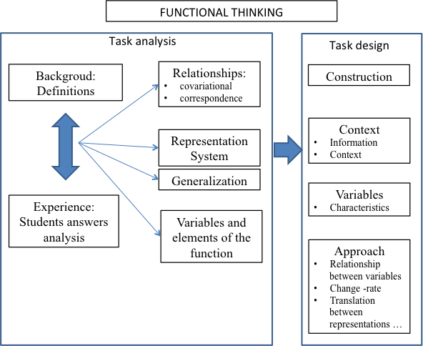

Figure 1. Focal points to task design

References
Ayalon, M., Watson, A., & Lerman, S. (2016). Progression towards functions: Students’ Performance on three tasks about variables from grades 7 to 12. International Journal of Science and Mathematics Education, 14 (6), 1-21.
Blanton, M. L., & Kaput, J. J. (2011). Functional thinking as a route into algebra in the elementary grades. In J. Cai and E. Knuth (Eds.), Early algebraization (pp. 5-23). Berlin, Germany: Springer.
Blanton, M., Levi, L., Crites, T. y Dougherty, B. (2011). Developing essential understanding of algebraic thinking for teaching mathematics in grades 3–5. Reston, VA: National Council of Teachers of Mathematics.
Cai, J., Lew, H.C, Morris, A., Moyer, J.C., Ng, S. F., Schmittau, J. (2005). The development of students’ algebraic thinking in earlier grades: a cross- cultural comparative perpective. ZDM—International Reviews on Mathematical Education, 37(1), 5-14.
Cañadas, M. C., Brizuela, B. M., & Blanton, M. (2016). Second graders articulating ideas about linear functional relationships. The Journal of Mathematical Behavior, 41, 87-103.
Cañadas, M. C., & Molina, M. (2016). Una aproximación al marco conceptual y principales antecedentes del pensamiento funcional en las primeras edades. En E. Castro, E. Castro, J. L. Lupiáñez, J. F. Ruíz and M. Torralbo (Eds.), Investigación en Educación Matemática. Homenaje a Luis Rico (pp. 209-218). Granada, España: Comares.
Confrey, J., & Smith, E. (1991). A framework for functions: Prototypes, multiple representations and transformations. In R. Underhill (Ed.), Proceedings of the 13th annual meeting of the North American Chapter of The International Group for the Psychology of Mathematics Education (pp. 57-63). Blacksburg, VA
Ellis, A. (2011). Algebra in the middle school: Developing functional relationships through quantitative reasoning. In J. Cai and E. Knuth (Eds.), Early algebraization (pp. 215-238). Springer, Berlin: Heidelberg.
Gómez, B. (2016). Sobre el análisis didáctico de la razón. En E. Castro, E. Castro, J. L. Lupiáñez, J. F. Ruíz y M. Torralbo (Eds.), Investigación en Educación Matemática. Homenaje a Luis Rico (pp. 165-174). Granada, España: Comares.
Kaput, J. (2000). Transforming algebra from an engine of inequity to an engine of mathematical power by “algebrafying” the K-12 curriculum. Dartmouth, MA: National Center for Improving Student Learning and Achievement in Mathematics and Science.
Leinhardt, G., Zaslavsky, O. & Stein, M. (1990). Functions, graphs and graphing: Tasks, learning and teaching. Review of Educational Research, 60(1), 1-64.
Soares, J., Blanton, M. L., & Kaput, J. (2005). Thinking algebraically across the elementary school curriculum. Teaching Children Mathematics, 2(5), 228-235.

