Enhanced Stability Against Radiation Damage of Lysozyme Crystals Grown in Fmoc-CF Hydrogels
Rafael Contreras-Montoya† # Albert Castellví, ‡# Guillermo Escolano-Casado,§ Judith Juanhuix,‡ Mayte Conejero-Muriel, § Modesto T. Lopez-Lopez,$ Juan M. Cuerva, † Luis Álvarez de Cienfuegos,* † and José A. Gavira* §
† Departamento de Química Orgánica, Facultad de Ciencias, Universidad de Granada, Campus de Fuentenueva, 18002-Granada, Spain
‡ ALBA Synchrotron, Carrera de la Llum 2-26, 08290 Cerdanyola del Vallé, Barcelona, Spain
§ Laboratorio de Estudios Cristalográﬁcos, IACT (Consejo Superior de Investigaciones Cientíﬁcas-Universidad de Granada), Avenida de las Palmeras 4, 18100 Armilla, Granada, Spain
$ Departamento de Física Aplicada, Facultad de Ciencias, Universidad de Granada, Campus de Fuentenueva, 18002-Granada, Spain
Supporting Information Placeholder
ABSTRACT: Lysozyme crystals grown in Fmoc-CF (Cys-Phe) hydrogels, unlike those grown in agarose, give rise to composite crystals that have an enhanced resistance against degradation caused by an intense exposure to X-ray irradiation. Fmoc-CF dipeptide shows a clear protection of the most sensitive groups (disulfide bonds and methionines) of the protein. The protection mediated by cysteine is exerted only in its gel state since cysteine in solution has an adverse effect. Probably the reactive thiols groups of cysteine being locked within the rigid peptide fibers minimize cross-reactions with the proteins favoring the formation of protein crystals. Once located inside the protein crystal the long peptide fibers are able to protect the protein against radiation damage.
Dipeptides derivatives have been the focus of an extensive research due to their capacity to self-assemble under different stimuli presenting remarkable physicochemical properties.¹⁻⁵ In particular, Fmoc (Fluorenylmethyloxicarbonyl)-peptide (abbreviated in 1 letter amino acid code from now on) hydrogels have found applications in diverse fields such as, tissue engineering, biomineralization, catalysis and drug delivery.⁶ Most of these applications have been possible thanks to the excellent macroscopic hydrogel properties and the modular chemical composition of the peptide fibers. Highlighted examples are the use of Fmoc-RGD (Arg-Gly-Asp) in tissue engineering to promote cell adhesion and increase cell proliferation and survival,⁷ and the use of Fmoc-DOPA-DOPA (DOPA = 3,4-dihydroxy-phenylalanine) as a template to chelate and precipitate cationic silver into silver nanoparticles.⁸ The application of dipeptide hydrogels as a media in protein crystallization^{9, 10} has allowed us to study the interaction between the peptide fibers and the protein and to evaluate the physicochemical properties of the resulting composite crystals since the gel fibers are occluded inside the protein crystals.^{11, 12} Using L and D-homochiral enantiomeric dipeptides we studied the influence of the peptide-chirality in the polymorphism of the resulting crystals.⁹ Later, we could observed that the peptide fibers were able to modify the thermal stability and dissolution rate of the crystals,^{10, 13} even in the case of therapeutic proteins such as insulin.¹³ Recently, we have shown that lysozyme crystals grown in Fmoc-FF hybrid hydrogels containing carbon nanotubes give rise to composite crystals filled with carbon nanotubes that have novel properties such as electron conduction and thermally enhanced catalytic activity.¹⁴
Based on these precedents, herein we wondered if novel composite crystals having a technological advantage over existing ones could be obtained using peptide hydrogels as a media for protein crystallization. At this respect, we focused our attention to the degradation that protein crystals suffer upon exposure to X-ray irradiation. Macromolecular Crystallography (MX) experiments at synchrotron light sources are commonly limited by the structural damage produced by the intense X-ray beam.¹⁵ Data quality and also quantity can be compromised by radiation damage¹⁶ but, perhaps most importantly, it may also induce wrong conclusions in the resulting macromolecular models.¹⁷ Radiation damage is an inherent consequence of the interaction between matter and ionizing radiation. Depending on where photons deposit their energy, radiation damage in protein crystals can be classified as direct or indirect. Direct damage arises from the ionizing events directly produced in the protein atoms whereas indirect damage results from the reactive species ($O_{2}^{•-}, { H}_{2}O_{2}, {}_{}^{•}{OH, { e}_{aq }^{-}}$, among others)^{18, 19} generated during the radiolysis of the solvent molecules. Both types of damage manifest themselves as both, a reduction of crystalline order (global damage), and specific structural modifications (local damage).^{15, 18, 20}
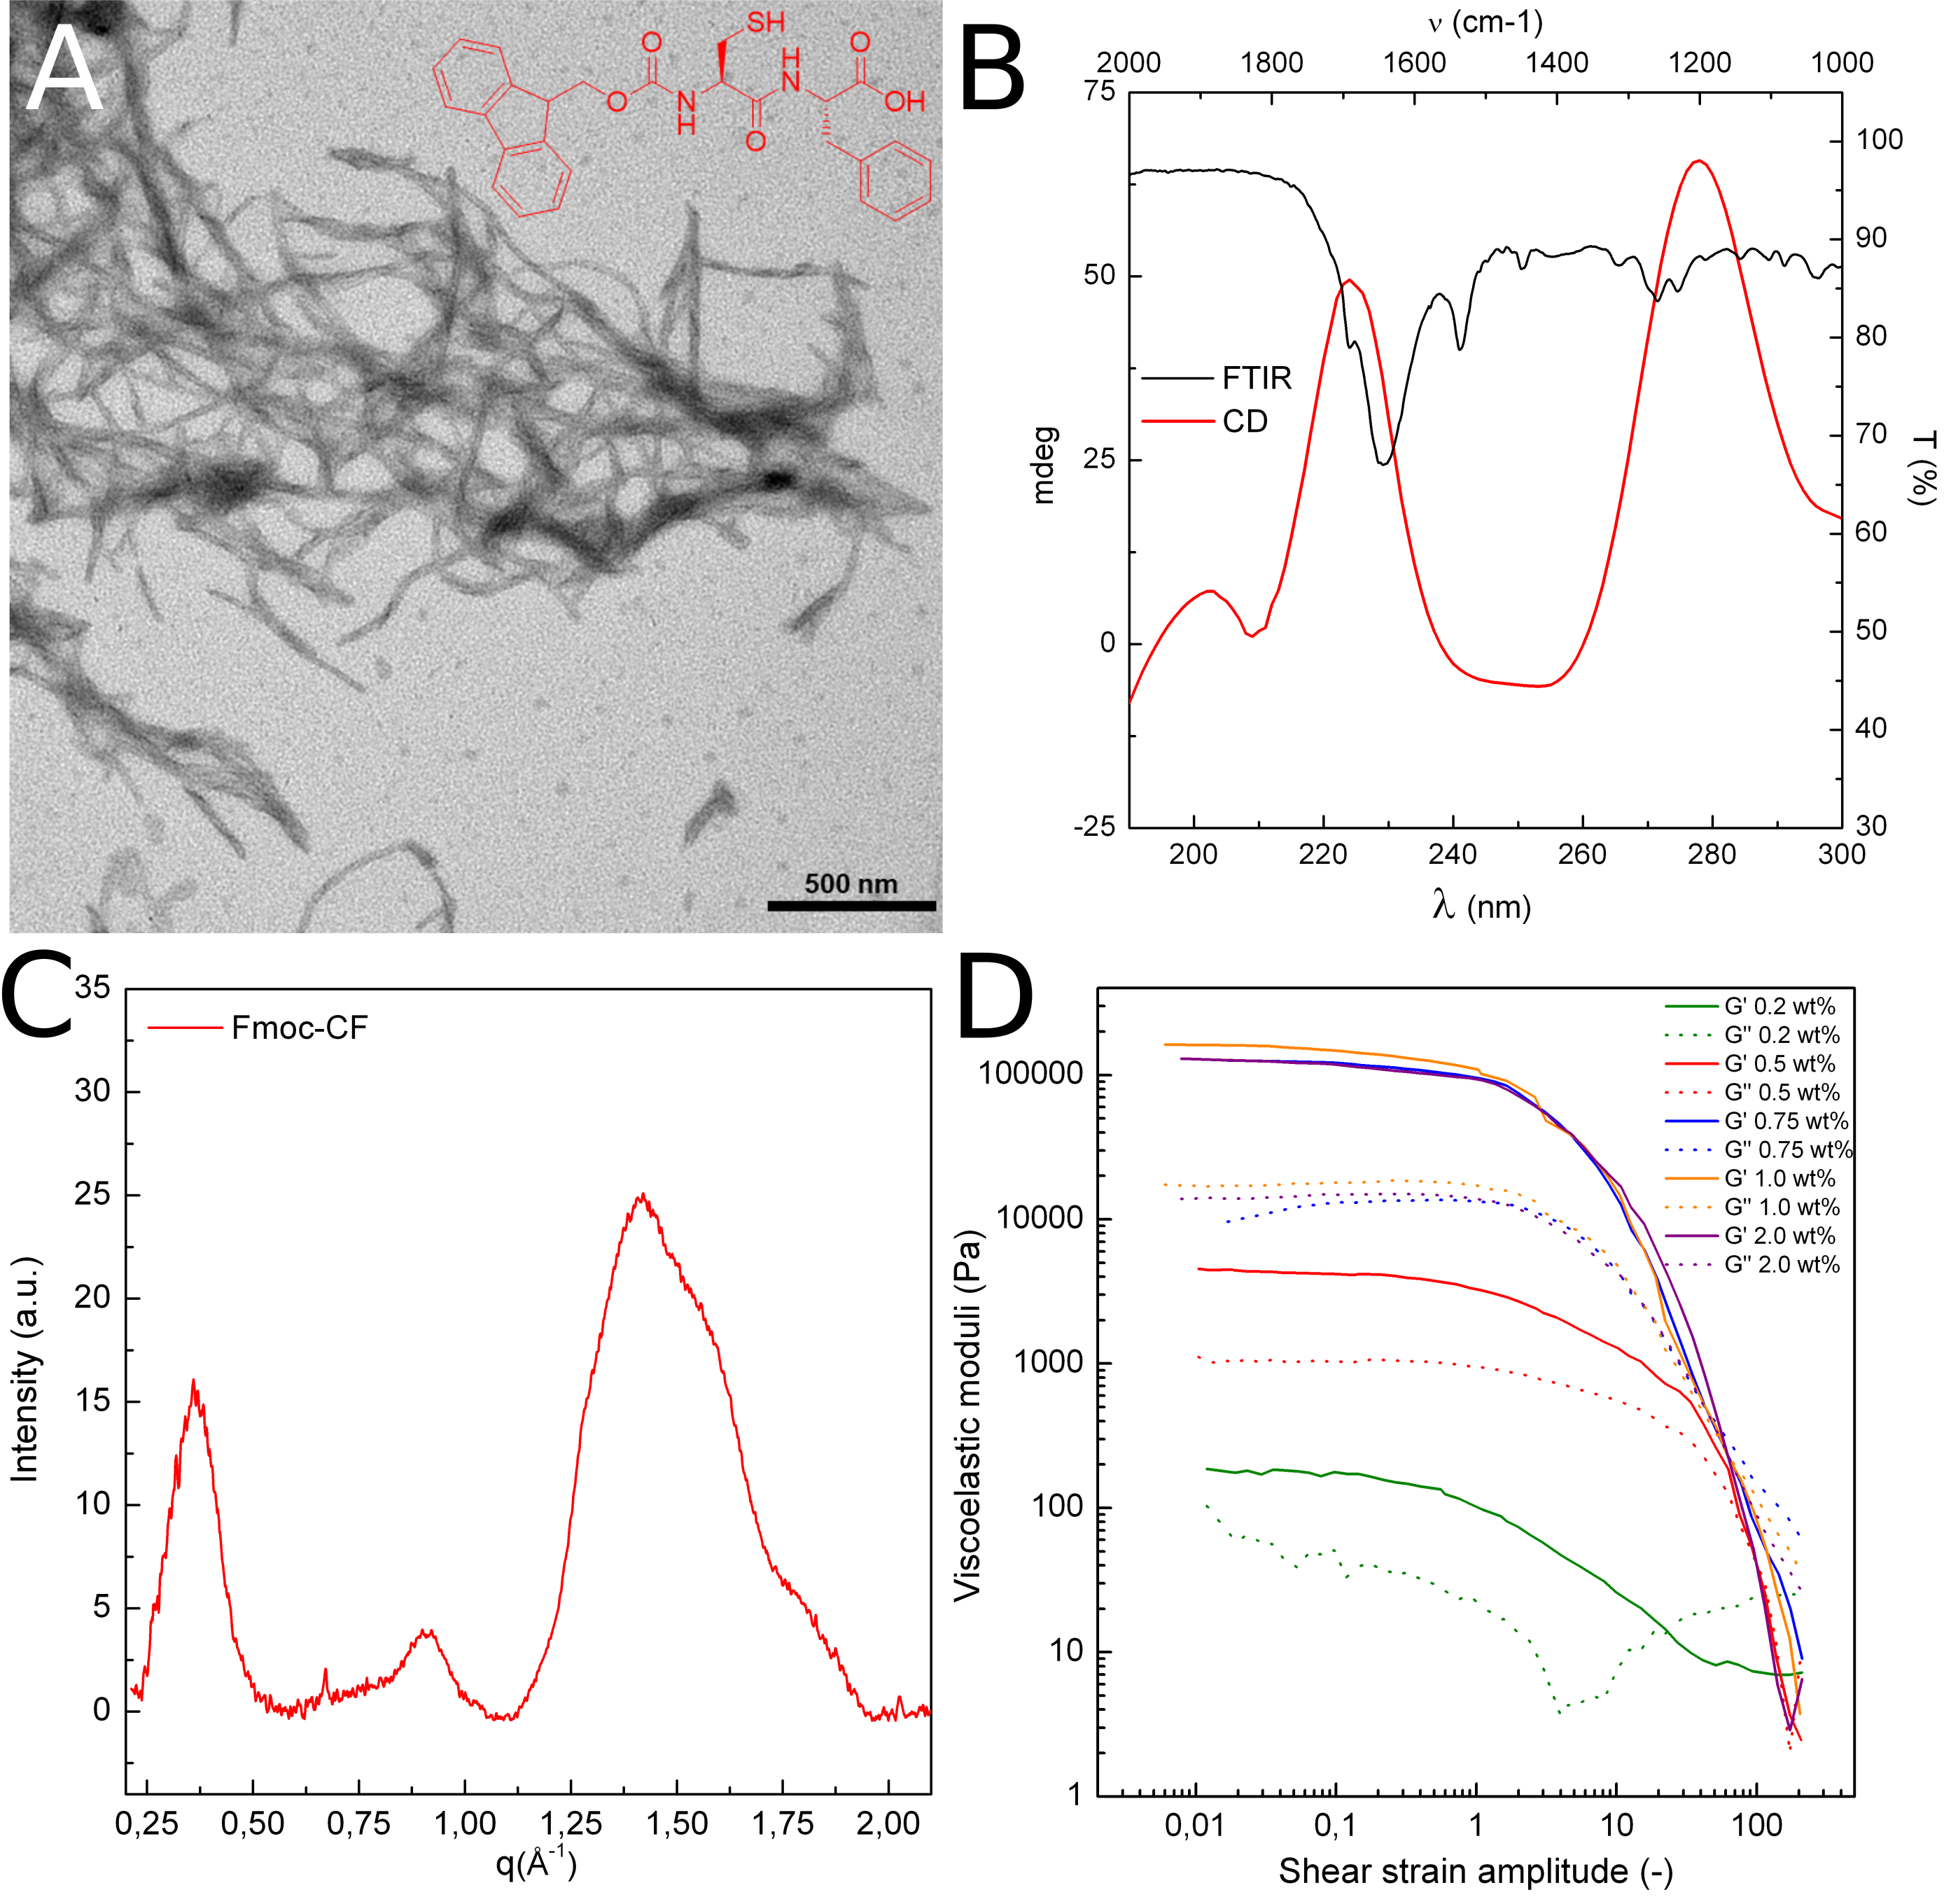
Diffraction experiments are typically performed at 100K in order to decrease the diffusion of reactive species (with the exception of electrons) and thus to minimize the indirect damage effects. Data collection at 100K gives an increase of around 70-fold in dose tolerance when compared with crystals irradiated at room temperature (RT).²¹ The drawback of this methodology is the required sample preparation to overcome cryo-cooling treatment, including the screening for cryo-protectant, and unexpected differences between the structural model obtained at 100K and at RT.²²
Fig. 1 A) TEM images of Fmoc-CF xerogel; B) CD and FTIR of Fmoc-CF hydrogel at 0.5% (w/v); C) XRD of Fmoc-CF xerogel; D) Viscoelastic moduli (G’ and G’’) versus shear strain amplitude at a constant frequency of 1 Hz for Fmoc-CF hydrogels as a function of concentration.
In this context, the use of scavenger molecules is therefore a suitable strategy to minimize radiation damage on protein crystals at room temperature. It has been shown that the most effective scavenger group against hydroxyl and solvated electrons is the thiol group.²³ Therefore, crystals permanently containing thiols groups could be more resistant to oxidation favoring protein storage for long periods in which oxidation is a serious drawback.²⁴ Nevertheless, the growth of crystals in the presence of scavengers is a challenge since these molecules can directly react with the protein altering its structure and, therefore, preventing crystallization. Moreover, it is not clear that these scavengers, once inside the protein crystals, could be of any help since they could also turn into harmful radicals during X-ray irradiation. In fact, the use of cysteine as a scavenger in X-ray diffraction experiments conducted in lysozyme at room temperature has shown that this aminoacid may produce a counterproductive effect sensitizing the crystals.²⁵
Taking this into account, we thought that Fmoc-CF hydrogels could be an interesting alternative to control scavenger reactivity, and decided to evaluate them as a media to obtain composite crystals. We have previously shown that Fmoc-peptides hydrogels are an excellent media for protein crystallization giving rise to composite crystals of high quality and size ideal for X-ray diffraction.¹⁰ Nevertheless, in this case, the thiol groups of Fmoc-CF could interact with the sulfur containing lysozyme moieties promoting cross-reactions such as disulfide bond breaking. Ulijn et al., have already shown that Fmoc-CF-OMe hydrogel maintains its free thiols active avoiding auto-oxidation locked in their rigid supramolecular fibrils.²⁶ We have also shown that Fmoc-CF peptide keeps its free thiols active at air/water interface promoting their interaction with gold nanoparticles.²⁷ Knowing that, we were expecting that the possible Fmoc-CF cross-reactions with the proteins were also minimized allowing crystallization. This would give rise to composite crystals containing permanently active thiols groups that being disposed in rigid fibers could, on one hand, avoid cross-reactions with the protein and, on the other hand, exert a protective effect against radiation damage.
To test this hypothesis, first the self-assembling ability of Fmoc-CF to give rise to novel homogeneous and transparent hydrogels was studied. Results showed that hydrogels comprising peptide concentrations from 0.2% (w/v) up to 2.0% (w/v) were successfully obtained. Fmoc-CF hydrogels showed characteristic TEM images of self-assembled nanofibers with a minimum diameter of around 20 nm (Figure 1.A).²⁸
The supramolecular rearrangement of the Fmoc-CF hydrogels was studied by circular dichroism (CD) and infrared spectroscopy (FTIR). The CD spectra of Fmoc-CF (Figure 1.B) showed two positive bands at ca. 225 nm and 280 nm respectively, indicating n-π* and π-π* transitions of the Fmoc group. Although the peak shifts do not match exactly with a typical characteristic β-sheet conformation, similar results have been found for other Fmoc-dipeptides.^{29, 30} The FTIR spectra of the hydrogel (Figure 1.B) showed two main peaks corresponding with the bands of the amide, the C=O stretching band (amide I) at 1645 cm⁻¹ and the N–H bending (amide II) at 1536 cm⁻¹. In agreement with previous reports,^{31, 32} the presence of two well-defined amide bands suggests a β-sheet conformation.
X-ray diffraction (XRD) of the xerogels (completely dried hydrogel) showed a series of diffraction peaks also found in other Fmoc-dipeptides fibers arranged in β-sheets.³² Fmoc-CF peptide showed an intense reflection observed at q = 1.5 Å⁻¹ corresponding to a spacing between peptides within the β-sheets of d = 4.2 Å (d = 2π/q). This reflection is in agreement with those found in bibliography which is between 4 and 5 Å for β-sheets depending on the peptide sequence.³² Another reflections were found at (1 < n < 6), confirming the formation of flat ribbons of single fibrils (Figure 1.C).
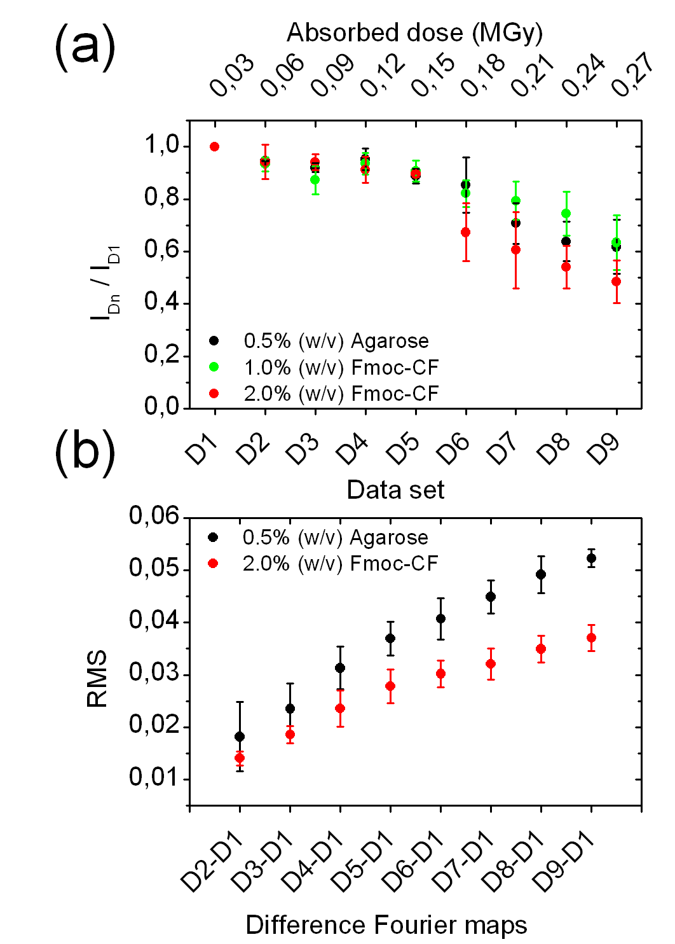
The viscoelastic properties of these hydrogels were analyzed using a regime of oscillatory shear strain. We identified the linear viscoelastic region (LVR) from tests at constant shear strain frequency (1Hz) and increasing shear strain amplitude (Figure 1.D). The LVR, characterized by approx. constant values of G’ and G’’, corresponded in all cases to shear strain amplitudes below approx. 1%. Within the LVR, samples showed G´ values considerably larger than G´´, indicating their predominant elastic behavior (Figure 1.D). The magnitude of the value of G’ for Fmoc-CF at 0.5% (w/v) (3360 Pa) indicates that this hydrogel was extremely weak.³³ Nevertheless, as the concentration of Fmoc-CF increased at 2.0% (w/v) the values of G´ increased up to 93000 Pa (Figure 1.D). Results of tests at constant shear strain amplitude and increasing frequency demonstrated approx. frequency independent values of G’ and G’’ (Figure S2).
Fig. 2 Global and specific damage on lysozyme crystals in the presence of agarose and Fmoc-CF hydrogels. (a) I_Dn/I_D1 as a function of absorbed dose/dataset in lysozyme crystals in the presence of agarose and Fmoc-CF gels. Each point was calculated by triplicate. (b) RMS values as a function of Dn – D1 maps. Each point was calculated by triplicate.
Fmoc-CF hydrogels were tested as a media for protein crystallization for the model protein lysozyme using the two layers configuration of the counter diffusion technique (see SI for details and conditions).
As already described for other dipeptide hydrogels,^{9, 10} and with hydrogels in general,^{34, 35} Fmoc-CF hydrogel grown lysozyme crystals were of the highest quality possible and compared well with those obtained in agarose as reference (Table S1-S2). Lysozyme crystals were of the same high quality independently of the hydrogel concentration in spite of the higher number of thiol groups.
The scavenging power was evaluated by analyzing the global diffracted intensity of lysozyme crystals grown in Fmoc-CF at 1.0% (w/v) and 2.0% (w/v), and agarose hydrogels measured in nine consecutive irradiation cycles (named D1 to D9) collected at room temperature (data collection statistics in the 40 – 1.7 Å resolution range are shown in the Table S1 for the first and 9th data sets). The effects of X-ray irradiation were monitored at specific and global scale. To estimate the global damage (I_{Dn} /I_{D1}) we monitored the decay of the total diffracted intensity of each cycle (I_{Dn}) by comparing it with the collected intensity of the first data set (I_{D1}).
Lysozyme crystals containing 1.0% and 2.0% (w/v) of Fmoc-CF hydrogels did not show signs of protection against global damage when compared with crystals grown in agarose (Figure 2.a), in agreement with the result of several additives tested in solution.²⁵ However, we observed a marginal improvement of the quality parameters of the crystals (R_{means} and <I/σ >) for those lysozyme crystals grown in the presence of 2.0 % (w/v) Fmoc-CF (Table S1). This result suggests that Fmoc-CF is helping to preserve the integrity of the protein molecules. In order to analyze the structure of the protein at molecular level we mapped out all the sensitive groups of lysozyme (disulfide bonds and methionines).²³
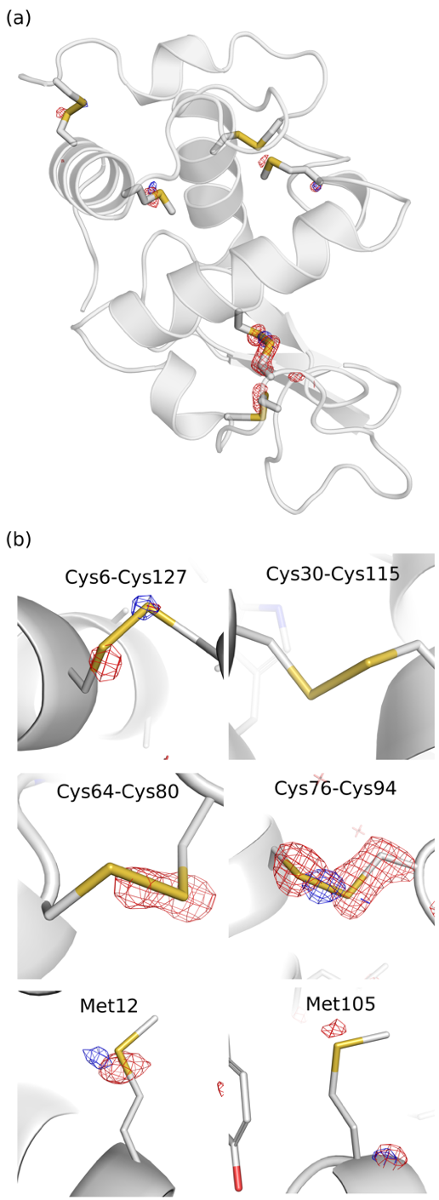
Local radiation damage in the crystal was them monitored through the inspection of the difference electron density (Fourier) maps of the Dn and D1 data sets calculated as (Dn – D1). The root mean square (RMS) value for the mean difference electron density in (Dn – D1) is an indicator of the local alteration induced by radiation damage between freshly (D1) and incremental damage (Dn) sets. From our data it is clear that the presence of 2.0% (w/v) Fmoc-CF in lysozyme crystals delays the damage as observed by the smaller increment of RMS as a function of the Dn – D1 (Figure 2.b). When compared to the reference, the RMS ratio between Fmoc-CF and agarose is maximum in the D9 – D1 and it is equal to 0.709. This local radiation damage is better observed in the most sensitive groups (disulfide and methionine) very reactive to species generated during X-ray exposure. We have calculated and represented D9 – D1 maps contoured at -0.15 e/Å³ over all disulfide bonds and methionines. Those maps showed significant specific protection of lysozyme crystals obtained in the presence of 2.0% (w/v) Fmoc-CF hydrogel (Figure 3.a).
Fig. 3 Fmoc-CF hydrogel protects disulfide bonds and methionines against radiation damage in lysozyme crystals. (a) A ribbon representation of the lysozyme structure showing the most sensitive groups to radiation damage, cysteine and methionines. The D9 – D1 maps (contoured at -0.15 e/Å³) for agarose and Fmoc-CF are shown in red and blue respectively. (b) Shows the detail of the four cysteine bridges and the two methionines followed in this study. Note that the difference electron density are obtained from the RMS x σ: RMS (Agarose-D1, D9) = 0.051 with σ (agarose-D1) = -2.95 and RMS (Fmoc-CF-D1, D9) = 0.040 with σ (Fmoc-CF-D1) = -3.76.
When analyzed one by one the target groups we have detected specific protection in Cys64-Cys80, Cys76-Cys94, Met12 and Met105 of crystals grown in Fmoc-CF, while for crystals grown in agarose, S-S and S-C bonds are broken in some degree due to the radiation effect. This damage was negligible in the case of Cys6-Cys126 (Figure 3.b and Figure S4) and not detectable at -0.15 e/Å³ contour level in the case of Cys30-Cys115 bound (Figure 3.b and Figure S4).
To sum up, for the first time, we have proven that high quality protein crystals can be obtained in Fmoc-CF hydrogels containing very reactive thiols groups. We have carried out a detailed study at molecular level of the protective effect of Fmoc-CF grown lysozyme crystals against radiation damage. The rigid and locked structure of the peptide fibers maintains the reactive groups unaltered while minimizes the direct interaction with the protein avoiding undesired side effects. Finally, we have shown that Fmoc-CF can exert a local protection of the three-dimensional structure of the protein against radiation damage not observed in agarose grown crystals or when cysteine is used as additive. Since the fibers are occluded within the crystals structure this protection is permanent and active in the protein solid state.
ASSOCIATED CONTENT
Supporting Information.
A pdf document containing the experimental section, Figures S1 to S5 and Tables S1 to S2 are also available.
AUTHOR INFORMATION
Corresponding Author
jgavira@iact.ugr-csic.es
lac@ugr.es
Author Contributions
# These authors contributed equally.
Funding Sources
The authors declared no competing financial interests.
This study was supported by projects BIO2016-74875-P (JAG) and FIS2017-85954-R (LAC) (Ministerio de Economía, Industria y Competitividad, MINECO, and Agencia Estatal de Investigación, AEI, Spain, co-funded by Fondo Europeo de Desarrollo Regional, FEDER, European Union) and by Junta de Andalucía (Spain) projects P12-FQM-2721 and P12-FQM-790.
ACKNOWLEDGMENT
We thank the “Unidad de Excelencia Química aplicada a Biomedicina y Medioambiente” (UGR) for support. We are very grateful to the staff at Xaloc (ALBA) and ID23-2 (ESRF) for support during data collection.
REFERENCES
(1) Das, T.; Haring, M.; Haldar, D.; Diaz Diaz, D., Phenylalanine and derivatives as versatile low-molecular-weight gelators: design, structure and tailored function. Biomater Sci 2017, 6, 38-59.
(2) Draper, E. R.; Adams, D. J., Low-Molecular-Weight Gels: The State of the Art. Chem 2017, 3, 390-410.
(3) Fleming, S.; Ulijn, R. V., Design of nanostructures based on aromatic peptide amphiphiles. Chem Soc Rev 2014, 43, 8150-77.
(4) Dasgupta, A.; Mondal, J. H.; Das, D., Peptide hydrogels. RSC Advances 2013, 3, 9117-9149.
(5) Adler-Abramovich, L.; Gazit, E., The physical properties of supramolecular peptide assemblies: from building block association to technological applications. Chem. Soc. Rev. 2014, 43, 6881-93.
(6) Tao, K.; Levin, A.; Adler-Abramovich, L.; Gazit, E., Fmoc-modified amino acids and short peptides: simple bio-inspired building blocks for the fabrication of functional materials. Chem Soc Rev 2016, 45, 3935-53.
(7) Zhou, M.; Smith, A. M.; Das, A. K.; Hodson, N. W.; Collins, R. F.; Ulijn, R. V.; Gough, J. E., Self-assembled peptide-based hydrogels as scaffolds for anchorage-dependent cells. Biomaterials 2009, 30, 2523-30.
(8) Fichman, G.; Adler-Abramovich, L.; Manohar, S.; Mironi-Harpaz, I.; Guterman, T.; Seliktar, D.; Messersmith, P. B.; Gazit, E., Seamless Metallic Coating and Surface Adhesion of Self-Assembled Bioinspired Nanostructures Based on Di-(3,4-dihydroxy-l-phenylalanine) Peptide Motif. ACS Nano 2014, 8, 7220-7228.
(9) Conejero-Muriel, M.; Gavira, J. A.; Pineda-Molina, E.; Belsom, A.; Bradley, M.; Moral, M.; Durán, J. d. D. G.-L.; Luque González, A.; Díaz-Mochón, J. J.; Contreras-Montoya, R.; Martínez-Peragón, Á.; Cuerva, J. M.; Álvarez de Cienfuegos, L., Influence of the chirality of short peptide supramolecular hydrogels in protein crystallogenesis. Chem. Commun. 2015, 51, 3862-3865.
(10) Conejero-Muriel, M.; Contreras-Montoya, R.; Díaz-Mochón, J. J.; Álvarez de Cienfuegos, L.; Gavira, J. A., Protein crystallization in short-peptide supramolecular hydrogels: a versatile strategy towards biotechnological composite materials. CrystEngComm 2015, 17, 8072-8078.
(11) Gavira, J. A.; García-Ruiz, J. M., Agarose as crystallisation media for proteins II: Trapping of gel fibres into the crystals. Acta Crystallogr. Sect. D 2002, 58, 1653-1656.
(12) Gavira, J. A.; Van Driessche, A. E. S.; Garcia-Ruiz, J.-M., Growth of Ultrastable Protein–Silica Composite Crystals. Crystal Growth & Design 2013, 13, 2522-2529.
(13) Alvarez de Cienfuegos, L.; Gavira, J. A.; Diaz-Mochon, J. J.; Conejero-Muriel, M. T.; Contreras-Montoya, R. Pharmaceutically active protein crystals grown in-situ within a hydrogel. WO 2017/191323 Al, 2017.
(14) Contreras-Montoya, R.; Escolano, G.; Roy, S.; Lopez-Lopez, M. T.; Delgado-López, J. M.; Cuerva, J. M.; Díaz-Mochón, J. J.; Ashkenasy, N.; Gavira, J. A.; Álvarez de Cienfuegos, L., Catalytic and Electron Conducting Carbon Nanotube–Reinforced Lysozyme Crystals. Adv. Funct. Mater. 2018, 29, 1807351.
(15) Kauffmann, B.; Weiss, M. S.; Lamzin, V. S.; Schmidt, A., How to avoid premature decay of your macromolecular crystal: a quick soak for long life. Structure 2006, 14, 1099-105.
(16) Crosas, E.; Castellvi, A.; Crespo, I.; Fulla, D.; Gil-Ortiz, F.; Fuertes, G.; Kamma-Lorger, C. S.; Malfois, M.; Aranda, M. A.; Juanhuix, J., Uridine as a new scavenger for synchrotron-based structural biology techniques. J Synchrotron Radiat 2017, 24, 53-62.
(17) Berglund, G. I.; Carlsson, G. H.; Smith, A. T.; Szöke, H.; Henriksen, A.; Hajdu, J., The catalytic pathway of horseradish peroxidase at high resolution. Nature 2002, 417, 463.
(18) Garman, E. F., Radiation damage in macromolecular crystallography: what is it and why should we care? Acta Crystallogr D Biol Crystallogr 2010, 66, 339-51.
(19) Watanabe, R.; Saito, K., Monte Carlo simulation of water radiolysis in oxygenated condition for monoenergetic electrons from 100eV to 1MeV. Radiat. Phys. Chem. 2001, 62, 217-228.
(20) Meents, A.; Gutmann, S.; Wagner, A.; Schulze-Briese, C., Origin and temperature dependence of radiation damage in biological samples at cryogenic temperatures. Proc Natl Acad Sci U S A 2010, 107, 1094-9.
(21) Nave, C.; Garman, E. F., Towards an understanding of radiation damage in cryocooled macromolecular crystals. J Synchrotron Radiat 2005, 12, 257-60.
(22) Dunlop, K. V.; Irvin, R. T.; Hazes, B., Pros and cons of cryocrystallography: should we also collect a room-temperature data set? Acta Crystallogr D Biol Crystallogr 2005, 61, 80-7.
(23) Xu, G.; Chance, M. R., Hydroxyl radical-mediated modification of proteins as probes for structural proteomics. Chem. Rev. 2007, 107, 3514-43.
(24) Daugherty, A. L.; Mrsny, R. J., Formulation and delivery issues for monoclonal antibody therapeutics. Adv Drug Deliv Rev 2006, 58, 686-706.
(25) Kmetko, J.; Warkentin, M.; Englich, U.; Thorne, R. E., Can radiation damage to protein crystals be reduced using small-molecule compounds? Acta Crystallogr D Biol Crystallogr 2011, 67, 881-93.
(26) Sadownik, J. W.; Ulijn, R. V., Locking an oxidation-sensitive dynamic peptide system in the gel state. Chemical communications 2010, 46, 3481-3.
(27) Argudo, P. G.; Contreras-Montoya, R.; Álvarez de Cienfuegos, L.; Cuerva, J. M.; Cano, M.; Alba-Molina, D.; Martín-Romero, M. T.; Camacho, L.; Giner-Casares, J. J., Unravelling the 2D self-assembly of Fmoc-dipeptides at fluid interfaces. Soft Matter 2018, 14, 9343-9350.
(28) Jayawarna, V.; Ali, M.; Jowitt, T. A.; Miller, A. F.; Saiani, A.; Gough, J. E.; Ulijn, R. V., Nanostructured Hydrogels for Three-Dimensional Cell Culture Through Self-Assembly of Fluorenylmethoxycarbonyl–Dipeptides. Adv. Mater. 2006, 18, 611-614.
(29) Muskens, O. L.; England, M. W.; Danos, L.; Li, M.; Mann, S., Plasmonic Response of Ag- and Au-Infiltrated Cross-Linked Lysozyme Crystals. Adv. Funct. Mater. 2013, 23, 281-290.
(30) Adams, D. J.; Butler, M. F.; Frith, W. J.; Kirkland, M.; Mullen, L.; Sanderson, P., A new method for maintaining homogeneity during liquid–hydrogel transitions using low molecular weight hydrogelators. Soft Matter 2009, 5, 1856-1862.
(31) Adhikari, B.; Palui, G.; Banerjee, A., Self-assembling tripeptide based hydrogels and their use in removal of dyes from waste-water. Soft Matter 2009, 5, 3452-3460.
(32) Smith, A. M.; Williams, R. J.; Tang, C.; Coppo, P.; Collins, R. F.; Turner, M. L.; Saiani, A.; Ulijn, R. V., Fmoc-Diphenylalanine Self Assembles to a Hydrogel via a Novel Architecture Based on π–π Interlocked β-Sheets. Adv. Mater. 2008, 20, 37-41.
(33) Contreras-Montoya, R.; Bonhome-Espinosa, A. B.; Orte, A.; Miguel, D.; Delgado-López, J. M.; Duran, J. D. G.; Cuerva, J. M.; Lopez-Lopez, M. T.; Álvarez de Cienfuegos, L., Iron nanoparticles-based supramolecular hydrogels to originate anisotropic hybrid materials with enhanced mechanical strength. Materials Chemistry Frontiers 2018, 2, 686-699.
(34) Lorber, B.; Sauter, C.; Theobald-Dietrich, A.; Moreno, A.; Schellenberger, P.; Robert, M.-C.; Capelle, B.; Sanglier, S.; Potier, N.; Giege, R., Crystal growth of proteins, nucleic acids, and viruses in gels. Prog. Biophys. Mol. Biol. 2009, 101, 13-25.
(35) Moreno, A.; Mendoza, M. E., Crystallization in Gels. 2015, 1277-1315.

For Table of Contents Use Only
Enhanced Stability Against Radiation Damage of Lysozyme Crystals Grown in Fmoc-CF Hydrogels
Rafael Contreras-Montoya,† # Albert Castellvi, ‡# Guillermo Escolano-Casado,§ Judith Juanhuix,‡ Mayte Conejero-Muriel, § Modesto T. Lopez-Lopez,$ Juan M. Cuerva, † Luis Álvarez de Cienfuegos,* † and José A. Gavira* §
TOC GRAPHIC
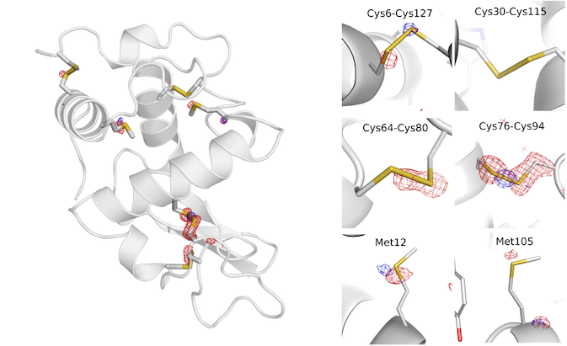

Synopsis: The most sensitive groups of the enzyme lysozyme (cysteine and methionine) have enhance resistance against radiation damage caused by an intense exposure to X-ray when crystals are grown in Fmoc-CF (Cys-Phe) hydrogels.

