Lysine as size-control additive in the biomimetic synthesis of pure superparamagnetic magnetite nanoparticles
Rafael Contreras-Montoya#,†, Ylenia Jabalera,#,‡, Víctor Blanco†, Juan Manuel Cuerva†, Concepcion Jimenez-Lopez*,‡, Luis Alvarez de Cienfuegos*,†.
†Departamento de Química Orgánica. Facultad de Ciencias. Universidad de Granada. Campus de Fuentenueva s/n 18002 Granada, Spain
‡ Departamento de Microbiología. Facultad de Ciencias. Universidad de Granada. Campus de Fuentenueva s/n 18002 Granada, Spain
*Corresponding author:
Concepción Jiménez López
Departamento de Microbiología. Facultad de Ciencias. Universidad de Granada. Campus de Fuentenueva s/n 18002 Granada, SPAIN
cjl@ugr.es
Phone: (+34) 958 249833

Luis Álvarez de Cienfuegos
Departamento de Química Orgánica. Facultad de Ciencias. Universidad de Granada. Campus de Fuentenueva s/n 18002 Granada, SPAIN
lac@ugr.es
Phone: (+34) 958 248099

Lysine as size-control additive in the biomimetic synthesis of pure superparamagnetic magnetite nanoparticles
Rafael Contreras-Montoya#,†, Ylenia Jabalera,#,‡, Víctor Blanco†, Juan Manuel Cuerva†, Concepcion Jimenez-Lopez*,‡, Luis Alvarez de Cienfuegos*,†.
†Departamento de Química Orgánica. Facultad de Ciencias. Universidad de Granada. Campus de Fuentenueva s/n 18002 Granada, Spain
‡ Departamento de Microbiología. Facultad de Ciencias. Universidad de Granada. Campus de Fuentenueva s/n 18002 Granada, Spain
Keywords: Lysine, biomimetic mineralization, magnetite, nanoparticles, green method

Abstract
Magnetite nanoparticles (MNPs) are being used in a number of nanotechnological applications, especially biomedical, both in diagnosis and therapeutics such as hyperthermia agents and as drug nanocarriers for targeted chemotherapy. However, the development of efficient methodologies to produce novel MNPs with the specific requirements needed for biomedical applications is still challenging. In this context, biomimetic approaches taking use of magnetosome proteins expressed as recombinant and/or polyaminoacids are becoming of great interest. In fact, these protocols give rise to magnetite nanoparticles of adequate size, magnetic properties and surface functionalization that make them compatible for biomedical applications. In this respect, herein we show for the first time that Lysine, unless other aminoacids like Arg, is able to exert a control over the size of MNPs produced in water and at room temperature. This control occurs through the stabilization of the magnetite nuclei by the lateral ammonium group of Lys. The strength of such stabilization allows a further release of these previously bonded nuclei to allow the further growth of the larger ones, thus resulting in larger crystals compared to those obtained by using Arg or no aminoacids at all. MNPs obtained by the mediation of this aminoacid are fairly large (30 nm) while being superparamagnetic at room temperature. They present an isoelectric point of 4, which may allow the coupling/release of these MNPs to other molecules based on electrostatic interaction, a large magnetic moment per particle and high magnetization saturation. This study highlights the effects that biological additives have in the biomimetic process of magnetite biomineralization and goes in the line of previous reports using magnetosome proteins and polyaminoacids.

Introduction
Nanoparticles have proven to be efficient multifunctional devices for targeted chemotherapy that can simultaneously carry different type of molecules such as drugs, peptides and antibodies.^{1,2} Among them, magnetic nanoparticles (MNPs), especially magnetite (Fe₃O₄) display further intrinsic properties, since they can be manipulated by external magnetic fields toward the target^{3–6} and/or they can mediate hyperthermia (through alternating magnetic field) that induces apoptosis in tumor cells.^{7,8} MNPs have been also used in many other fields besides oncology, such as in magnetic resonance imaging (MRI),⁹ tissue engineering and cell replacement therapy,¹⁰ cell tracking and bioseparation,¹¹ and DNA isolation and purification.¹²
Other than being biocompatible, certain specifications are important for the nanocarrier. One of them is size, which, for superparamagnetic pure crystalline magnetite determines the magnetic moment per particle that, in turn, reverts on how efficiently the nanoparticle responds to an external magnetic field during the guiding process and/or when trying to be concentrated at the target site.^{5,13,14} For in vivo biomedical applications, it has been shown that MNPs of sizes smaller than 150 nm are required to be able to reach the target by means of the EPR effect.¹⁵ It is also important that the MNPs are superparamagnetic at room temperature and above, i.e., at this temperature they should behave as nonmagnetic in the absence of an external magnetic field, thus preventing aggregation, but, once a magnetic field is applied, they must respond efficiently. That allows their use in clinics, as they could be injected intravenously and then guided and/or concentrated at the target site by using external magnets. Size is also important when hyperthermia treatments are in play, as the heating power generated per particle unit mass upon application of an alternating external magnetic field is directly related to the amount of iron in the nanoparticles.^{1,2,8} In this context, using MNPs with the adequate size (< 150 nm) to be able to efficiently raise the temperature is crucial because it would allow to reduce the MNPs doses.
Finally, another important requirement for biomedical MNPs is that they should provide at their surface functional groups (i.e. carboxylic acids) capable of promoting stable colloidal suspensions and favoring the electrostatic coupling/release of relevant molecules based on external stimuli, such as changes in the environmental pH.^{16,17}
MNPs are generally produced by two different strategies: i) co-precipitation of iron salts in basic aqueous media, being then stabilized by biocompatible surfactants/polymers, and ii) thermal decomposition of organometallic precursors in high-boiling nonpolar organic solvents at elevated temperatures (∼200–360 °C), which allows a great control of the size of the MNPs, their monodispersity and uniformity.¹⁷ However, thermal decomposition methods have some drawbacks, associated to the use of high temperature, organic solvents and to the generation of a significant amount of toxic by-products.^{2,18,19} Fortunately, MNPs can also be obtained by green methods, that is, water as a reaction media and at room temperature. Among the green methods, the aqueous co-precipitation is one of the most preferred for the production of MNPs, since it is cost- and time-effective, scalable for industrial applications and eco-friendly. However, the control of the size of the MNPs by this method, and thus, the magnetic properties is limited. MNPs resulting from co-precipitation at room temperature are highly polydisperse with an average crystal size ranging from 5 to 20 nm, lack functionalizable surfaces and many of them are too small to display a large magnetic moment per particle.^{1,5,17} Therefore, there is still a need for novel aqueous co-precipitation methods that allow the tuning of the particle size and magnetic properties and provide the nanoparticles with modified surfaces that allow functionalization.
In this context, a promising alternative is the biomimetic green approach, which makes use of bacterial magnetosome proteins (MAPs), or quimera containing the relevant peptides, as additives to control the size of the crystals.^{20–25} The ability of some of these MAPs, expressed as recombinant proteins, to in vitro control magnetite nucleation and/or crystal growth has been shown by several authors. In this context, much work has been done by using Mms6 (either full length expressed as recombinant protein or synthetic peptides) from Magnetospirillum magneticum AMB-1.^{22,26,27} MamC from Magnetococcus marinus MC-1^{20,25} and MmsF from Magnetospirillum magneticum AMB-1²⁸ have also been studied, although in a much less extent. The studies mentioned above, among others, have demonstrated that the C-terminal of Mms6 from AMB-1 controls the size and morphology of in vitro synthesized magnetite. Acidic aminoacids are claimed to be responsible for such a control through iron binding. Different is the case of MamC, as not only an ionotropic effect, but also a template effect have been claimed to explain the role of this protein in the nucleation and growth of magnetite in vitro.^{23, 24}
Biomimetic approaches using polyaminoacids as additives, instead of proteins, have also shown an effect in the morphology, size, aggregation and magnetic properties of the resulting MNPs.^{26,29–31} In fact, it has been proven that changing the proportion of aminoacids composition of the polyaminoacid backbones fine tunes the size and properties of the resulting MNPs.²⁹
In this scenario, we focused our attention on the possibility of using simple aminoacids as biological additives to produce MNPs under biomimetic conditions and to test if they were able to modify the size and properties of the resulting crystals. Although in the literature there are protocols that use aminoacids as additive to obtain MNPs, these protocols are based on direct aqueous co-precipitation following by a thermal treatment in which the period of incubation of the aminoacids with the iron salts is short. These protocols have shown the adsorption of the aminoacids over the MNPs but an influence on the size of the MNPs has not been reported.^{32–35} Nevertheless, in the present manuscript we have followed an approach previously developed to produce biomimetic magnetite nanoparticles mediated by MamC in which the additives and the inorganic salts are incubated for a month.²⁵ Of all known accessible aminoacids, we selected specifically Lysine (Lys) and Arginine (Arg) based on the following criteria:
(1) On one hand, these two aminoacids have a pKa2 close to pH 9 (Lys 9.04, Arg 8.95), which is the pH of our mineralization experiments. This means, that at pH 9, both aminoacids are zwitterionic having the alpha amino group neutral, the carboxylic group anionic and the amine (Lys) and guanidine (Arg) lateral groups cationic. At this pH both aminoacids could interact weekly with iron cations using both the amine, in its neutral state, and the anionic carboxylic group. This type of interaction is known as “glycine-like coordination type” and has been previously described for the formation of metal complexes of aminoacids in water.^{36–38} If this would be the case, both aminoacids could have the possibility to remove iron cations from the system modifying the supersaturation of the system with respect to magnetite, which, in turn, would affect the size of the resulting MNPs.
(2) On the other hand, these two aminoacids, at a pH value of 9, have a positively charged lateral group. The ammonium group, in the case of Lys, and the guanidinium group, in the case of Arg, could interact electrostatically with the negatively charged iron (oxyhydr)oxide crystal surface and therefore, they could also modify the properties of the resulting MNPs. The effects of the positive groups in the final properties of MNPs have already been proven and reported for the case of poly-lysine²⁹ and poly-arginine.³¹
In the present manuscript, the production of MNPs mediated by Lys and Arg is explored to provide novel magnetic nanoparticles.

experimental Section
Materials
All reagents used in the biomineralization experiments were purchased from Sigma-Aldrich including L-Lysine hydrochloride, ref: W384712 and L-Arginine monohydrochloride ref: A5131. The deoxygenated water used in these experiments was prepared by boiling nanopurified water for 1 h and then cooling in an ice bath while continuously sparging with ultrapure N₂. After that, it was immediately placed inside an anaerobic chamber (Coy Laboratory Products, Grass Lake, MI) filled with 4% H₂ in N₂, and used to prepare the stock solutions: NaHCO₃/Na₂CO₃ (0.15 M/0.15 M), NaOH (1 M), Fe(ClO₄)₂ (0.5 M) and FeCl₃ (1 M).
Precipitation of inorganic magnetite
Experiments were carried out in an anaerobic COY chamber to avoid potential oxidation of the product. Inorganic magnetite was precipitated from solutions in free-drift experiments held at 25 °C and 1 atm total pressure, following the protocol described by Perez-Gonzalez et al.³⁹ Magnetite synthesis was produced after mixing the stock solutions to a final concentration of Fe(ClO₄)₂ (2.78 mM), FeCl₃ (5.56 mM) and NaHCO₃/Na₂CO₃ (3.5 mM/3.5 mM). NaOH was used to reach a pH value of 9. This is here referred as master solution for magnetite precipitation. For comparison, experiments were also run at pH values ranging from 7 to 11 following identical precipitation protocol.
Precipitation of magnetite in the presence of aminoacids
Solid amino acids were accurately weighted, deoxygenated by blowing argon and immediately placed in the COY chamber where a stock solution for each one of the three concentrations used per aminoacid was prepared: 0.2 mM, 4 mM and 20 mM of Lys or Arg. To prepare 10 mL of reaction final volume, 5 mL of each aminoacid stock solution was mixed with the solution for magnetite precipitation to reach the final concentration of the master solution, here referred as Lys or Arg0.1-MNP, Lys or Arg2-MNP, and Lys or Arg10-MNP, respectively. In any case the concentrations of the aminoacids did not modify the pH of the medium that remained always constant at pH = 9. An inorganic (aminoacid-free) experiment was used as control (here referred as MNP-control).
The reaction was allowed to proceed for 30 days. After that, magnetic solids were magnetically concentrated and the clear supernatants were removed. The magnet was removed and the solids were re-suspended in deoxygenated water, concentrated again with the magnet and the clear supernatant discarded. Solids from each experiment were washed three times this way.
Analyses of the precipitates
Powder samples of the precipitates were analyzed with an Xpert Pro X-ray diffractometer (PANalytical; The Netherlands) using the Cu Kα radiation, with the scan range set from 20 to 60° in 2θ (0.01°/step; 3 s per step). Identification of the precipitates was performed by using the XPowder software.
The synthesized magnetic powders were dehydrated with ethanol and embedded in Embed 812 resin. Ultrathin sections (50−70 nm) were prepared using a Reichert Ultracut S microtome (Leica Microsystems GmbH, Wetzlar, Germany) after which the sections were deposited onto 300-mesh copper grids. The morphology and particle size of synthesized nanocrystals were analysed by TEM (LIBRA 120 PLUS Carl Zeiss, Germany) and by high resolution TEM (HRTEM, FEI TITAN G2, The Netherlands). The size of the crystals was measured from TEM images using ImageJ 1.47 software, and size distribution curves and statistical analyses were determined from these measurements using Origin pro 9. To ensure reproducibility of results, particle sizes were measured on multiple micrographs with an excess of 1000 nanoparticles measured for each experiment.
The surface charge of magnetite nanoparticles was evaluated by measuring the ς-potential at different pHs using a Nano Zs, Zetasizer Instrument (Malvern). For this aim, both MNP-control nanoparticles and Lys and Arg-mediated nanoparticles were suspended in 10 mM solutions of NaClO₄. Then, for each of the magnetite nanoparticles, in order to determine their isoelectric point, the pH of the suspensions was adjusted at the specific pH value (from 3 to 8) by using 0.1 M solutions of NaOH or HCl. Measurements, in triplicate for each sample, were carried out at 25 °C using disposable plastic cuvettes.
The thermograms of the magnetite nanoparticles were recorder on a METTLER-TOLEDO TGA/DSC1. Approximately 10 mg of sample were placed on a TGA cell and subject to decomposition by heating the sample to 900 ºC at a constant rate of 10 ºC/min under nitrogen atmosphere.
Zero-field cooling (ZFC-W) and field cooling (FC-C) measurements were carried out by using a superconducting quantum interference device (SQUID) 5 T magnetometer (Quantum Design MPMS XL, USA). Under gentle argon flow, a given amount of each specimen powder was placed in a double-walled polycarbonate capsule. The samples were immediately cooled in a zero applied field to 5 K to preserve randomized magnetization of the nanocrystals, after which a 500 Oe magnetic field was applied and samples were heated up to 300 K and then from 300 K without turning the field off. To allow comparison among the different complexes, the M(T) curves were normalized by the amount (g) of each sample analysed and by the magnetization value of the specific sample at 300 K. Hysteresis cycles were run at 5 K and 300 K. No distinction between the terms of “superparamagnetic” or “single magnetic domain” will be done in this work. Blocking temperature (T_{B}) was determined as that at which the maximum in magnetization occurred in ZFC curves while irreversibility temperature (T_{irr}), was such temperature below the ‘‘blocking’’ of the superparamagnetic particles which are no longer thermally equilibrated.
Adsorption of Lys and Arg on previously formed MNPs
A concentration of 0.3 mg/mL of previously synthesized MNPs were added with either Lys (10 mM) or Arg (10 mM) and the reaction was kept for 24 hours. Then after, the MNPs were magnetically concentrated and rinsed just as explained above. The solids were measured by TGA following an identical procedure as stated above.

Results and Discussion
The solids formed in all biomineralization experiments were identified as being > 95% magnetite. TEM analysis of the magnetite particles produced in the MNP-control experiments (Figure 1) were isomorphs showing an average crystal size of 17 ± 7 nm. As the concentration of Lys in the experiments increased from 0.1 mM to 10 mM, the average crystal size also increased from 21 ± 7 nm to 29 ± 7 nm (Figures 2), being these differences statistically significant according to the ANOVA tests. Moreover, not only the average size was higher, but better-defined crystal faces were also observed (Figures 2C and 2E) in magnetites collected from Lys-bearing experiments, where rhombic and hexagonal two-dimensional morphologies were displayed. On the contrary, when Arg was used as additive, no effect was observed on the size and morphology of the nanoparticles under any Arg concentration tested (MNPs of 16 ± 7, 17 ± 6 and 19 ± 6 nm for [Arg] = 0.1, 2 and 10 mM respectively), being this size not statistically different from that of the nanoparticles from the MNP-control experiment (Figure 3). This result shows that Lys is able to modify the size of MNPs while Arg is not.
Many surfaces could serve as sites for magnetite nucleation especially if electrostatic interactions between negatively charged functional groups and Fe cations and/or between positively charged functional groups and negatively charged mineral surfaces are at play. The study of Bereczk-Tompa et al.,⁴⁰ highlights this fact and goes deeper into magnetite nucleation demonstrating that iron binding by negatively charged aminoacids (in extended surfaces) is a less specific process than the binding of previously formed nuclei, suggesting that magnetite nucleation under their conditions occurs by charge accumulation (ionotropic effect). Although this seems to be the case for other protein mediated magnetite nanoparticles,²⁰ our observations suggest that in the case of Lys- and Arg-mediated magnetite nucleation the ionotropic effect by iron binding might not be the key role controlling magnetite nucleation, but nuclei stabilization by the basic lateral chain of these aminoacids.
As we have stated in the introduction, these two aminoacids could influence the process of magnetite mineralization by two different mechanisms of action. On one hand, they could sequester iron cations through the formation of iron complexes between the alpha amine and the carboxylic groups. Our calculations of ΔG for the water-ligand exchange reaction between Fe(H₂O)₆ and Lys or Arg show that both reactions are essentially isoenergetic meaning that the ΔG for the complexation of both aminoacids to iron cations is virtually identical (see ESI). This process, therefore, cannot account for the differences observed on the magnetite mediated by these aminoacids.
On the other hand, Lys and Arg could exert a stabilization effect over the magnetite nuclei mediated by their cationic lateral groups. In fact, while the hydrated surface of magnetite remain basically uncharged at physiological pH as a consequence of the dominant neutral surface species ≡Fe(II,III)OH at this pH (Equation 1), as pH value increases, Fe(II,III)OH becomes dominant, and, at even higher pH values (as occurs under the condition at which our magnetite forms), the dominant species are Fe(II,III)O⁻, being, in these conditions, the surface of magnetite negatively charged:⁴¹
≡Fe(II,III)OH²⁺ - H⁺→ ≡Fe(II,III)OH - H⁺→ ≡Fe(II,III) O⁻ pH iep ~7 (1)
In fact, TGA data of our experiments of incubation of Lys and Arg with previously formed MNPs show that Lys and Arg are adsorbed on the MNPs to a degree that is comparable to that measured in the MNPs that were synthesized in the presence of those aminoacids (see ESI; MNPs incubated with Lys and Arg showed 7.6 and 8.0 wt% loss, respectively) (Figure S2, ESI). These results suggest that Lys and Arg, in the biomineralization experiments, are not being incorporated into the magnetite crystals but rather are exerting a surface interaction with the nuclei, as previous experiments are showing.
Nevertheless, since the basicity of the ammonium group of Lys is significantly lower than that of the guanidinium group of the Arg, the electrostatic stabilization of the nuclei using these two aminoacid is expected to be different. Moreover, it is also known that the guanidinium group of Arg is also able to form stable H-bonds with oxyanions groups.^{42–44} Such a binding of previously formed nuclei may also determine the kinetics of crystal growth based on the strength of the binding, as it may allow or not, the subsequent release of the previously attached smaller nuclei to allow the growth of larger ones. Particularly, in our closed Fe-limited system, these Arg- strongly stabilized nuclei do, probably, not re-dissolve easily in the time scale of the mineralization experiment and, therefore, the resulting crystals would have a size similar (or even smaller) compared to that of the crystals already formed by a direct co-precipitation in the absence of any aminoacid, which is actually what we observe in our experiments. On the contrary, the weaker stabilization effect mediated by lysine could, probably, make it possible the re-dissolution of smaller nuclei in favor of the larger ones as the supersaturation of the system decreases during the time scale of the experiment.
To study how the pH of the media can modulate the effects of the aminoacids in the magnetite mineralization, we have performed experiments at pH of 7, 8, 10 and 11 using Lys and Arg at 10 mM concentration. At pH = 7 and 8, in both cases, we did not observe the formation of magnetite, rather, goethite was the main mineral phase of the solid. Therefore, these experiments were not further considered. On the contrary, at pH = 10 and 11, MNPs of smaller sizes than those obtained at pH 9 were formed in the presence of Lys (16 ± 4 nm and 15 ± 4 nm respectively, figure S1, ESI). This result reinforces again the key role that the lateral ammonium group is playing in stabilizing and releasing the magnetite nuclei at the specific pH = 9. At higher pH this group becomes neutral and can no longer interact with the magnetite nuclei and therefore cannot interfere in the re-dissolution-mineralization process. Moreover, as the ammonium group becomes neutral it turns into a primary amine that can also interact with iron cations favoring the formation of a greater number of nuclei that no longer are stabilized, ending up in MNPs of smaller sizes.
On the contrary, MNPs formed at higher pH values in the case of Arg were only slightly smaller (differences not significant) than those formed at pH value of 9 (Figure S1, ESI). This result also points to the key role that lateral chain plays, since, as occurs at pH = 9, at pH values of 10 and 11 the guanidinium lateral group is still positively charged, thus behaving identically within this pH interval.
Moreover, in all cases, TGA analyses show that the MNPs formed in the presence of both Lys and Arg have greater wt% losses compared to those of MNPs formed in the absence of any aminoacid (Figure 4), thus indicating their adsorption of these nanoparticles. In fact, wt% losses of Lys0.1-MNP, Lys2-MNP and Lys10-MNP, Arg2-MNP and Arg10-MNP were of 7.0, 6.3 (6.4 for Arg2-MNP) and 7.4 (7.5 for Arg10-MNP) wt% respectively at 600 ºC vs 4.7 wt% loss of MNPs control crystals, the latter due to water release (Figure 4). These results show that both aminoacids adsorbs on the surface of the MNPs at all concentrations, reaching a maximum of 2.7-2.8 wt% adsorbed on the MNPs. The small differences on the amount of Lys and Arg adsorbed on the surface of the MNPs in the whole range of concentrations tested suggest that at some point, these aminoacids saturates the surface of the MNPs and no significant further adsorption occurs, which is in agreement with a previous report.⁴⁵ These results are in line with those observed by other authors on MamC adsorption/incorporation on biomimetic magnetite nanoparticles.⁴⁶ As in this previous study, such a strong adsorption of aminoacids on MNPs surface should have changed their surface properties with respect to those of the MNPs control.
To test that, the electrophoretic mobility measurements and ς-potential determinations were performed (Figure 5). The ς-potential of all the samples from the Lys-bearing experiments showed that magnetite nanoparticles were negatively charged at pH 7.4 (-20 to -31 mV), displaying the isoelectric point (iep) at a pH value of ~ 4 (with slight differences between samples), in contrast with that of the magnetite nanoparticles from the MNP-control experiment, in which the iep occurred at a pH of 7 (Figure 5). Similarly, the ς-potential of all the Arg samples also showed that the particles were strongly negatively charged at pH 7.4 (~ -20 mV), displaying the isoelectric point (iep) at a pH value of ~ 3.5 (Figure 5). Therefore, while TGA data demonstrates that both aminoacids interact with magnetite, ζ-potential shows that such an interaction is probably trough the basic aminoacids with then expose the negatively charged groups, turning magnetite surface negatively charged. In fact, the negative values of ς-potential of the MNPs at pH values above 4 suggests that Lys and Arg are interacting with the surface of the MNPs through their cationic groups, thus exposing the carboxylic groups to the aqueous medium, which reinforces our statement of the role of the lateral group of Lys and Arg controlling the nucleation and growth of magnetite. Therefore, our results show that the nucleation of magnetite in vitro in the presence of Lys and Arg is controlled by the electrostatic interaction between the positively charged lateral group (ammonium group, in the case of Lys, and guanidinium group, in the case of Arg) and the negatively charged magnetite nuclei. Such an interaction modifies the kinetics of growth and results in the attachment of the aminoacid to the magnetite nanoparticles, as shown by TGA and ς-potential data. As the supersaturation of the system decreases, and following an Ostwald step rule, the smaller nuclei dissolve in favor of the larger ones. However, in the presence of aminoacids, these nuclei are stabilized by the aminoacids, and not free to dissolve. Only in the case of Lys, in which the interaction between its ammonium group and the surface of the nuclei is weaker than that between the guanidinium group and the surface of magnetite, the previously stabilized smaller nuclei dissolve, thus resulting in the formation of larger magnetite crystals.
By exposing the COO⁻ to the aqueous medium, the nanoparticle is strongly negatively charged at physiological pH values (-30 mV) and this is important for several reasons. On one hand, because it may improve the colloidal stability of the nanoparticles by favouring electrostatic repulsion among them.⁴⁷ On the other, it provides functional groups that might be used for further coupling of these nanoparticles with other molecules based on electrostatic interactions, as occurs with other biomimetic MNPs.^{46,48} Moreover, since Lys and Arg-bearing magnetite crystals become uncharged at acidic pH values, the release of the coupled molecules is expected to occur in response to changes in the environmental pH values toward acidic values, which occurs naturally in, for instance, tumor tissues. This opens the door for the potential applications of these nanoparticles as drug carriers for a targeted chemotherapy. The negatively charged surface is also important to minimise the potential interaction of these MNP with plasma and blood cells, also negatively charged, favouring their circulation through the bloodstream.⁴⁹
Since the size of the MNPs changed in the presence of Lys, the magnetic properties of these magnetites were determined by means of the Zero Field Cooling-Field Cooling (ZFC-FC) curves and the hysteresis cycle and compared with the results obtained for Arg10-MNP. ZFC-FC curves at 500 Oe show differences between the different magnetic nanoparticles (Figure 6A). The slowest increase in magnetization was found in Lys10-MNP while the faster increase occurred in MNP-control experiment. In fact, the blocking temperature (T_{B}) was 103 K for MNP-control, 270 K for Lys2-MNP and 280 K for Lys10-MNP and Arg10-MNP. According to Prozorov et al.,⁵ this slow magnetization increase and higher T_{B} is consistent with particles with high crystallinity and a large magnetic moment per particle in the case of Lys-bearing magnetites, particularly Lys10-MNP nanoparticles. The hysteresis loop of MNP-control and those from Lys- and Arg-bearing experiments shows a typical ferromagnetic behaviour at 5 K while, at 300 K, these nanoparticles show zero coercivity, which indicates their superparamagnetic character (Figure 6B). All these findings are important. On one hand, the higher T_{B} of Lys-bearing nanoparticles indicates larger crystals resulting from the mediation of Lys, which is in accordance with TEM observations (Figure 2). However, once an external magnetic field is applied, the MNPs respond efficiently, displaying a relatively high magnetization values (Figure 6). The magnetization saturation (M_{s}) for MNP-control and Lys-bearing MNPs at 300 K is comparable, being of 67 emu/g for Lys10-MNP and 70 emu/g for MNP-control and Lys2-MNP. The slight decrease of M_{s} for Lys10-MNP is probably due to a shielding of the magnetic core by the aminoacid coating. It is noticeable the much lower M_{s} values for Arg10-MNPs, that could be also associated to the shielding of the magnetic core and to the small sizes of the MNPs resulting from these experiments. M_{s} values reported in the literature range from 83 to 92 emu/g for MNPs of sizes ranging from 12 to 45 nm and synthesized at high temperatures and in the presence of organic solvents.^{50,51} The slightly lower magnetization of our MNPs compared to those of the literature could be due to the fact that at lower temperatures monodispersity cannot be as well controlled as it is at higher temperatures, and some aggregation of MNPs may occur.⁵²
Finally, the quality and morphology of the MNPs grown in the presence of Lys was determine by HR-TEM. These magnetite crystals displayed well-defined 2-D shapes such as hexagons and rhombs bounded by (111) crystal faces (Figure 7). In some cases, rounded corners were detected that can correspond to incipient (110) crystal faces, but, in most cases, samples contained well-faceted crystals of very homogeneous size. Fast Fourier transform (FFT) images of the samples also demonstrated that the particles were single crystals of magnetite (Figure 7 detail), in line to that determined by XRD.
Conclusions
In conclusion, in the present work we have studied the influence of Lys and Arg in the process of magnetite mineralization under biomimetic conditions. In both cases, magnetite crystals with well-defined morphologies have been obtained displaying sizes that comprise from 10 nm to 20 nm (similar to those of the inorganic control) when the MNPs were produced in the presence of Arg, while most of the magnetic nanoparticles had a larger size (20-40 nm) when the MNPs were produced in the presence of 10 mM of Lys. These aminoacids adsorbed on the MNPs significantly changing the surface properties of the MNPs. In this context, MNPs coated with Lys and Arg are negatively charged at physiological pH (7.4) having iep at pH values close to 4 vs MNPs control that have an iep close to 7. These results show that the aminoacids are interacting with the lateral positive groups to the surface of the magnetite exposing the negative carboxylic groups to the water media. Presumably, these MNPs negatively charged at physiological pH are more biocompatible, since their plasma half-life is probably increased and might also have applications as drug delivery agents in which the drug release could be pH-dependent. Remarkably, we have shown that increasing amounts of Lys, on the contrary to Arg, are able to exert a control over the size of the resulting MNPs. The different basic and structural character between the ammonium group of Lys and the guanidinium group of the Arg implies a different degree of stabilization of the preformed nuclei that, in the time scale of the mineralization experiment, could evolve differently, ending up in magnetite crystals of different sizes. Finally, Lys-bearing MNPs are superparamagnetic at room temperature, present a large magnetic moment per particle and high magnetization saturation values, properties that make them attractive for targeted-drug delivery and hyperthermia treatments.

AUTHOR INFORMATION
Corresponding Author
*E-mail: cjl@ugr.es
*E-mail: lac@ugr.es

ORCID
Rafael Contreras-Montoya: 0000-0002-0766-004X
Ylenia Jabalera: 0000-0003-1786-959X
Víctor Blanco: 0000-0002-6809-079X
Juan Manuel Cuerva: 0000-0001-6896-9617
Concepción Jiménez-López: 0000-0002-5645-2079
Luis Álvarez de Cienfuegos: 0000-0001-8910-4241
Author Contributions
RC-M, YJ, JMC, CJ-L and LAC conceived and designed the experiments. RC-M and YJ did the experiments and collected data. VB performed theoretical calculations. CJ-L, JMC and LAC discussed the data regarding magnetite characterization. All authors contributed to draft writing and revision. All authors read and approved the final manuscript.
# Both authors contributed equally to this work.
Funding Sources
Support from the Ministry of Economy and Competitiveness of Spain is acknowledged through the following projects: CGL2016-76723-P and FIS2017-85954-R (Ministerio de Economía y Competitividad from SPAIN and Agencia Estatal de Investigación, AEI, Spain, co-funded by Fondo Europeo de Desarrollo Regional, ERDF, European Union) and from Junta de Andalucía (Spain) projects P12-FQM-2721 and P12-FQM-790.
ACKNOWLEDGEMENTS
We want to thank “Unidad de Excelencia Química aplicada a Biomedicina y Medioambiente”, Ministerio de Educación, Ciencia, Deporte y Competitividad for FPU-grant (FPU16_04580) and Unidad Científica de Excelencia UCE-PP2016-05 of the University of Granada. Thanks go to the CIC personnel of the University of Granada for technical assistance. Finally, we would like to thanks the Editor and reviewers whose suggestions greatly improved the manuscript.

References

(1) Gupta, A. K.; Gupta, M. Synthesis and Surface Engineering of Iron Oxide Nanoparticles for Biomedical Applications. Biomaterials 2005, 26 (18), 3995–4021. https://doi.org/10.1016/j.biomaterials.2004.10.012.
(2) Lu, A. H.; Salabas, E. L.; Schüth, F. Magnetic Nanoparticles: Synthesis, Protection, Functionalization, and Application. Angew. Chemie - Int. Ed. 2007, 46 (8), 1222–1244. https://doi.org/10.1002/anie.200602866.
(3) Shubayev, V. I.; Pisanic, T. R.; Jin, S. Magnetic Nanoparticles for Theragnostics. Advanced Drug Delivery Reviews. 2009, pp 61, 467–477. https://doi.org/10.1016/j.addr.2009.03.007.
(4) Arakaki, A.; Yamagishi, A.; Fukuyo, A.; Tanaka, M.; Matsunaga, T. Co-Ordinated Functions of Mms Proteins Define the Surface Structure of Cubo-Octahedral Magnetite Crystals in Magnetotactic Bacteria. Mol. Microbiol. 2014, 93 (3), 554–567. https://doi.org/10.1111/mmi.12683.
(5) Prozorov, T.; Bazylinski, D. A.; Mallapragada, S. K.; Prozorov, R. Novel Magnetic Nanomaterials Inspired by Magnetotactic Bacteria: Topical Review. Mater. Sci. Eng. R Reports 2013, 74 (5), 133–172. https://doi.org/10.1016/j.mser.2013.04.002.
(6) Mody, V. V.; Cox, A.; Shah, S.; Singh, A.; Bevins, W.; Parihar, H. Magnetic Nanoparticle Drug Delivery Systems for Targeting Tumor. Appl. Nanosci. 2014, 4 (4), 385–392. https://doi.org/10.1007/s13204-013-0216-y.
(7) Pankhurst, Q. A.; Connolly, J.; Jones, S. K.; Dobson, J. Applications of Magnetic Nanoparticles in Biomedicine. J. Phys. D Appl. Phys. 2003, 36, 167–181.
(8) Alphandéry, E.; Faure, S.; Seksek, O.; Guyot, F.; Chebbi, I. Chains of Magnetosomes Extracted from AMB-1 Magnetotactic Bacteria for Application in Alternative Magnetic Field Cancer Therapy. ACS Nano 2011, 5 (8), 6279–6296. https://doi.org/10.1021/nn201290k.
(9) Lisy, M. R.; Hartung, A.; Lang, C.; Schüler, D.; Richter, W.; Reichenbach, J. R.; Kaiser, W. A.; Hilger, I. Fluorescent Bacterial Magnetic Nanoparticles as Bimodal Contrast Agents. Invest. Radiol. 2007, 42 (4), 235–241. https://doi.org/10.1097/01.rli.0000255832.44443.e7.
(10) Bulte, J. W. M.; Douglas, T.; Witwer, B.; Zhang, S.; Strable, E.; Lewis, B. K.; Zywicke, H.; Miller, B.; Moskowitz, B. M.; Duncan, I. D.; et al. Magnetodendrimers Allow Endosomal Magnetic Labeling And. Nat. Biotechnol. 2001, 19 (December), 1141–1147.
(11) Gupta, A. K.; Naregalkar, R. R.; Vaidya, V. D.; Gupta, M. Recent Advances on Surface Engineering of Magnetic Iron Oxide Nanoparticles and Their Biomedical Applications. Nanomedicine 2007, 2 (1), 23–39. https://doi.org/10.2217/17435889.2.1.23.
(12) Ota, H.; Lim, T. K.; Tanaka, T.; Yoshino, T.; Harada, M.; Matsunaga, T. Automated DNA Extraction from Genetically Modified Maize Using Aminosilane-Modified Bacterial Magnetic Particles. J. Biotechnol. 2006, 125 (3), 361–368. https://doi.org/10.1016/j.jbiotec.2006.03.007.
(13) Lenders, J. J. M.; Altan, C. L.; Bomans, P. H. H.; Arakaki, A.; Bucak, S.; De With, G.; Sommerdijk, N. A. J. M. A Bioinspired Coprecipitation Method for the Controlled Synthesis of Magnetite Nanoparticles. Cryst. Growth Des. 2014, 14 (11), 5561–5568. https://doi.org/10.1021/cg500816z.
(14) Goya, G. F.; Berquó, T. S.; Fonseca, F. C.; Morales, M. P. Static and Dynamic Magnetic Properties of Spherical Magnetite Nanoparticles. J. Appl. Phys. 2003, 94 (5), 3520–3528. https://doi.org/10.1063/1.1599959.
(15) Maeda, H. The Enhanced Permeability and Retention (EPR) Effect in Tumor Vasculature: The Key Role of Tumor-Selective Macromolecular Drug Targeting. Adv. Enzyme Regul. 2001, 41 (1), 189–207. https://doi.org/10.1016/S0065-2571(00)00013-3.
(16) Arruebo, M.; Fernández-pacheco, R.; Ibarra, M. R.; Santamaría, J. Magnetic Nanoparticles for Drug Delivery. Nanotoday 2007, 2 (3), 22–32.
(17) El-Boubbou, K. Magnetic Iron Oxide Nanoparticles as Drug Carriers: Preparation, Conjugation and Delivery. Nanomedicine 2018, 13 (8), 929–952. https://doi.org/10.2217/nnm-2017-0320.
(18) Kolhatkar, A. G.; Jamison, A. C.; Litvinov, D.; Willson, R. C.; Lee, T. R. Tuning the Magnetic Properties of Nanoparticles. Int. J. Mol. Sci. 2013, 14 (8), 15977–16009. https://doi.org/10.3390/ijms140815977.
(19) Laurent, S.; Forge, D.; Port, M.; Roch, A.; Robic, C.; Vander Elst, L.; Muller, R. N. Magnetic Iron Oxide Nanoparticles: Synthesis, Stabilization, Vectorization, Physicochemical Characterizations, and Biological Applications. Chem. Rev. 2008, 108 (6), 2064–2110. https://doi.org/10.1021/cr068445e.
(20) Nudelman, H.; Valverde-Tercedor, C.; Kolusheva, S.; Perez Gonzalez, T.; Widdrat, M.; Grimberg, N.; Levi, H.; Nelkenbaum, O.; Davidov, G.; Faivre, D.; et al. Structure-Function Studies of the Magnetite-Biomineralizing Magnetosome-Associated Protein MamC. J. Struct. Biol. 2016, 194 (3), 244–252. https://doi.org/10.1016/j.jsb.2016.03.001.
(21) Prozorov, T.; Mallapragada, S. K.; Narasimhan, B.; Wang, L.; Palo, P.; Nilsen-Hamilton, M.; Williams, T. J.; Bazylinski, D. A.; Prozorov, R.; Canfield, P. C. Protein-Mediated Synthesis of Uniform Superparamagnetic Magnetite Nanocrystals. Adv. Funct. Mater. 2007, 17 (6), 951–957. https://doi.org/10.1002/adfm.200600448.
(22) Amemiya, Y.; Arakaki, A.; Staniland, S. S.; Tanaka, T.; Matsunaga, T. Controlled Formation of Magnetite Crystal by Partial Oxidation of Ferrous Hydroxide in the Presence of Recombinant Magnetotactic Bacterial Protein Mms6. Biomaterials 2007, 28, 5381–5389. https://doi.org/10.1016/j.biomaterials.2007.07.051.
(23) Ubago-Rodríguez, A.; Casares Atienza, S.; Fernández-Vivas, A.; Peigneux, A.; Jabalera, Y.; De La Cuesta-Rivero, M.; Jimenez-Lopez, C.; Azuaga Fortes, A. I. Structure-Function of MamC Loop and Its Effect on the in Vitro Precipitation of Biomimetic Magnetite Nanoparticles. Cryst. Growth Des. 2019, 19 (5), 2927–2935. https://doi.org/10.1021/acs.cgd.9b00150.
(24) Lopez-Moreno, R.; Fernández-Vivas, A.; Valverde-Tercedor, C.; Azuaga Fortes, A. I.; Casares Atienza, S.; Rodriguez-Navarro, A. B.; Zarivach, R.; Jimenez-Lopez, C. Magnetite Nanoparticles Biomineralization in the Presence of the Magnetosome Membrane Protein MamC: Effect of Protein Aggregation and Protein Structure on Magnetite Formation. Cryst. Growth Des. 2017, 17 (4), 1620–1629. https://doi.org/10.1021/acs.cgd.6b01643.
(25) Valverde-Tercedor, C.; Montalbán-López, M.; Perez-Gonzalez, T.; Sanchez-Quesada, M. S.; Prozorov, T.; Pineda-Molina, E.; Fernandez-Vivas, M. A.; Rodriguez-Navarro, A. B.; Trubitsyn, D.; Bazylinski, D. A.; et al. Size Control of in Vitro Synthesized Magnetite Crystals by the MamC Protein of Magnetococcus Marinus Strain MC-1. Appl. Microbiol. Biotechnol. 2015, 99 (12), 5109–5121. https://doi.org/10.1007/s00253-014-6326-y.
(26) Arakaki, A.; Masuda, F.; Amemiya, Y.; Tanaka, T.; Matsunaga, T. Control of the Morphology and Size of Magnetite Particles with Peptides Mimicking the Mms6 Protein from Magnetotactic Bacteria. J. Colloid Interface Sci. 2010, 343, 65–70. https://doi.org/10.1016/j.jcis.2009.11.043.
(27) Bird, S. M.; Rawlings, A. E.; Galloway, J. M.; Staniland, S. S. Using a Biomimetic Membrane Surface Experiment to Investigate the Activity of the Magnetite Biomineralisation Protein Mms6. RSC Adv. 2016, 6 (9), 7356–7363. https://doi.org/10.1039/c5ra16469a.
(28) Rawlings, A. E.; Bramble, J. P.; Walker, R.; Bain, J.; Galloway, J. M.; Staniland, S. S. Molecular Nature of the Complement Lesion. Proc Natl Acad Sci USA 2014, 75 (11), 5655–5659. https://doi.org/10.1073/pnas.75.11.5655.
(29) Lenders, J. J. M.; Zope, H. R.; Yamagishi, A.; Bomans, P. H. H.; Arakaki, A.; Kros, A.; De With, G.; Sommerdijk, N. A. J. M. Bioinspired Magnetite Crystallization Directed by Random Copolypeptides. Adv. Funct. Mater. 2015, 25 (5), 711–719. https://doi.org/10.1002/adfm.201403585.
(30) Lenders, J. J. M.; Bawazer, L. A.; Green, D. C.; Zope, H. R.; Bomans, P. H. H.; de With, G.; Kros, A.; Meldrum, F. C.; Sommerdijk, N. A. J. M. Combinatorial Evolution of Biomimetic Magnetite Nanoparticles. Adv. Funct. Mater. 2017, 27 (10), 1–9. https://doi.org/10.1002/adfm.201604863.
(31) Baumgartner, J.; Antonietta Carillo, M.; Eckes, K. M.; Werner, P.; Faivre, D. Biomimetic Magnetite Formation: From Biocombinatorial Approaches to Mineralization Effects. Langmuir 2014, 30 (8), 2129–2136. https://doi.org/10.1021/la404290c.
(32) Nosrati, H.; Salehiabar, M.; Attari, E.; Davaran, S.; Danafar, H.; Manjili, H. K. Green and One-Pot Surface Coating of Iron Oxide Magnetic Nanoparticles with Natural Amino Acids and Biocompatibility Investigation. Appl. Organomet. Chem. 2018, 32 (2), 1–10. https://doi.org/10.1002/aoc.4069.
(33) Zhang, C.; Shan, C.; Jin, Y.; Tong, M. Enhanced Removal of Trace Arsenate by Magnetic Nanoparticles Modified with Arginine and Lysine. Chem. Eng. J. 2014, 254, 340–348. https://doi.org/10.1016/j.cej.2014.05.133.
(34) Durmus, Z.; Kavas, H.; Toprak, M. S.; Baykal, A.; Altinçekiç, T. G.; Aslan, A.; Bozkurt, A.; Coşgun, S. L-Lysine Coated Iron Oxide Nanoparticles: Synthesis, Structural and Conductivity Characterization. J. Alloys Compd. 2009, 484 (1–2), 371–376. https://doi.org/10.1016/j.jallcom.2009.04.103.
(35) Patel, D.; Chang, Y.; Lee, G. H. Amino Acid Functionalized Magnetite Nanoparticles in Saline Solution. Curr. Appl. Phys. 2009, 9 (1 SUPPL.), S32–S34. https://doi.org/10.1016/j.cap.2008.08.027.
(36) Aliyu, H. N.; Na’aliya, J. Potentiometric Studies on Transition Metal(II) Essential Amino Acid Complexes. Glob. Adv. Res. J. Microbiol. 2012, 1 (5), 72–78.
(37) Yamauchi, O.; Odani, A. Stability Constants of Metal Complexes of Amino Acids with Charged Side Chains - Part I: Positively Charged Side Chains. Pure Appl. Chem. 1996, 68 (2), 469–496. https://doi.org/10.1351/pac199668020469.
(38) Flynn, S. M.; Clydesdale, F. M.; Zajicek, O. T. Complexation, Stability and Behavior of L-Cysteine and L-Lysine with Different Iron Sources. J. Food Prot. 1984, 47 (1), 36–40. https://doi.org/10.4315/0362-028x-47.1.36.
(39) Perez-Gonzalez, T.; Rodriguez-Navarro, A.; Jimenez-Lopez, C. Inorganic Magnetite Precipitation at 25 °C: A Low-Cost Inorganic Coprecipitation Method. J. Supercond. Nov. Magn. 2011, 24 (1–2), 549–557. https://doi.org/10.1007/s10948-010-0999-y.
(40) Bereczk-Tompa, É.; Vonderviszt, F.; Horváth, B.; Szalai, I.; Pósfai, M. Biotemplated Synthesis of Magnetic Filaments. Nanoscale 2017, 9 (39), 15062–15069. https://doi.org/10.1039/c7nr04842d.
(41) Sun, Z. X.; Su, F. W.; Forsling, W.; Samskog, P. O. Surface Characteristics of Magnetite in Aqueous Suspension. J. Colloid Interface Sci. 1998, 151–159. https://doi.org/10.1006/jcis.1997.5239.
(42) Baker, H. M.; Anderson, B. F.; Baker, E. N. Bioinorganic Chemistry Special Feature. Dealing with Iron: Common Structural Principles in Proteins That Transport Iron and Heme. Proc Natl Acad Sci USA 2003, 100 (7), 3579–3583.
(43) Li, L.; Vorobyov, I.; Allen, T. W. The Different Interactions of Lysine and Arginine Side Chains with Lipid Membranes. J. Phys. Chem. B 2013, 117 (40), 11906–11920. https://doi.org/10.1021/jp405418y.
(44) Vazdar, M.; Jungwirth, P.; Mason, P. E. Aqueous Guanidinium-Carbonate Interactions by Molecular Dynamics and Neutron Scattering: Relevance to Ion-Protein Interactions. J. Phys. Chem. B 2013, 117 (6), 1844–1848. https://doi.org/10.1021/jp310719g.
(45) Schwaminger, S. P.; García, P. F.; Merck, G. K.; Bodensteiner, F. A.; Heissler, S.; Günther, S.; Berensmeier, S. Nature of Interactions of Amino Acids with Bare Magnetite Nanoparticles. J. Phys. Chem. C 2015, 119 (40), 23032–23041. https://doi.org/10.1021/acs.jpcc.5b07195.
(46) García Rubia, G.; Peigneux, A.; Jabalera, Y.; Puerma, J.; Oltolina, F.; Elert, K.; Colangelo, D.; Gómez Morales, J.; Prat, M.; Jimenez-Lopez, C. PH-Dependent Adsorption Release of Doxorubicin on MamC-Biomimetic Magnetite Nanoparticles. Langmuir 2018, 34 (45), 13713–13724. https://doi.org/10.1021/acs.langmuir.8b03109.
(47) Park, J. Y.; Choi, E. S.; Baek, M. J.; Lee, G. H. Colloidal Stability of Amino Acid Coated Magnetite Nanoparticles in Physiological Fluid. Mater. Lett. 2009, 63 (3–4), 379–381. https://doi.org/10.1016/j.matlet.2008.10.057.
(48) Kitadai, N.; Yokoyama, T.; Nakashima, S. ATR-IR Spectroscopic Study of L-Lysine Adsorption on Amorphous Silica. J. Colloid Interface Sci. 2009, 329 (1), 31–37. https://doi.org/10.1016/j.jcis.2008.09.072.
(49) Madden, V. J.; Napier, M. E.; Luft, J. C.; Ropp, P. A.; Pohlhaus, P. D.; Gratton, S. E. A.; DeSimone, J. M. The Effect of Particle Design on Cellular Internalization Pathways. Proc Natl Acad Sci USA 2008, 105 (33), 11613–11618. https://doi.org/10.1073/pnas.0801763105.
(50) Guardia, P.; Labarta, A.; Batlle, X. Tuning the Size, the Shape, and the Magnetic Properties of Iron Oxide Nanoparticles. J. Phys. Chem. C 2011, 115 (2), 390–396. https://doi.org/10.1021/jp1084982.
(51) Daniela, C.; Gabriel, C.; Charles, J. O. Magnetic Properties of Variable-Sized Fe 3 O 4 Nanoparticles Synthesized from Non-Aqueous Homogeneous Solutions of Polyols. J. Phys. D. Appl. Phys. 2007, 40 (19), 5801.
(52) Li, J.; Huang, Y.; Liu, X.; Lin, Y.; Bai, L.; Li, Q. Effect of Aggregates on the Magnetization Property of Ferrofluids: A Model of Gaslike Compression. Sci. Technol. Adv. Mater. 2007, 8 (6), 448–454. https://doi.org/10.1016/j.stam.2007.04.007.

Figure caption
Figure 1. TEM images and size distribution of A, B) MNP-control. Scale-bar corresponds with 200 nm.
Figure 2. TEM images and size distribution of A, B) Lys0.1-MNP, C, D) Lys2-MNP and E, F) Lys10-MNP. Scale-bar corresponds with 200 nm. G) Size distribution box plot. Statistical significance of alterations from Lys-bearing experiments among themselves and compared to the MNP-control was tested using the ANOVA test (P < 0.006). Dots represent the average size; box represent the average ± standard deviation and bars represent the minimum and maximum values.
Figure 3. A) Average size of magnetite in the presence of Arg at 0.1 mM, 2 mM and 10 mM. TEM images of magnetite in the presence of Arg at: A) 0.1 mM, C) 2 mM and E) 10 mM. Scale-bar corresponds with 200 nm. Size distribution of magnetite in the presence of Arg at: B) 0.1 mM, D) 2 mM and F) 10 mM. G) Size distribution box plot. Statistical significance of alterations from Arg-bearing experiments among themselves and compared to the MNP-control was tested using the ANOVA test (P < 0.006). Dots represent the average size; box represent the average ± standard deviation and bars represent the minimum and maximum values.
Figure 4. TGA analyses of the magnetites precipitated in the MNP-control experiment and Lys and Arg-bearing experiments.
Figure 5. ς-potential of the magnetites precipitated in the MNP-control experiment and Lys and Arg-bearing experiments.
Figure 6. A) ZFC-FC and B) Hysteresis cycles of MNP-control, Lys2-MNP, Lys10-MNP and Arg10-MNP.
Figure 7. HR-TEM analyses of the crystal growth in the presence of Lys (Lys0.1-MNP) and Fast Fourier transform (FFT) (detail).

Figure 1
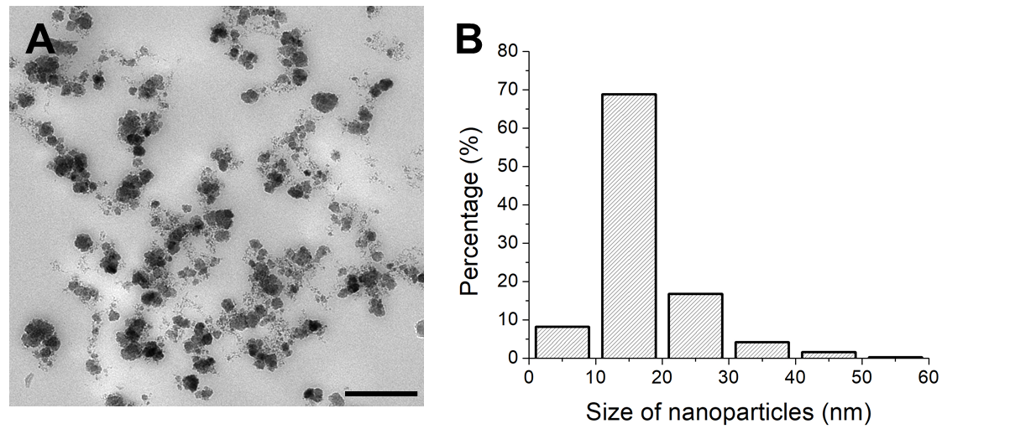

Figure 2
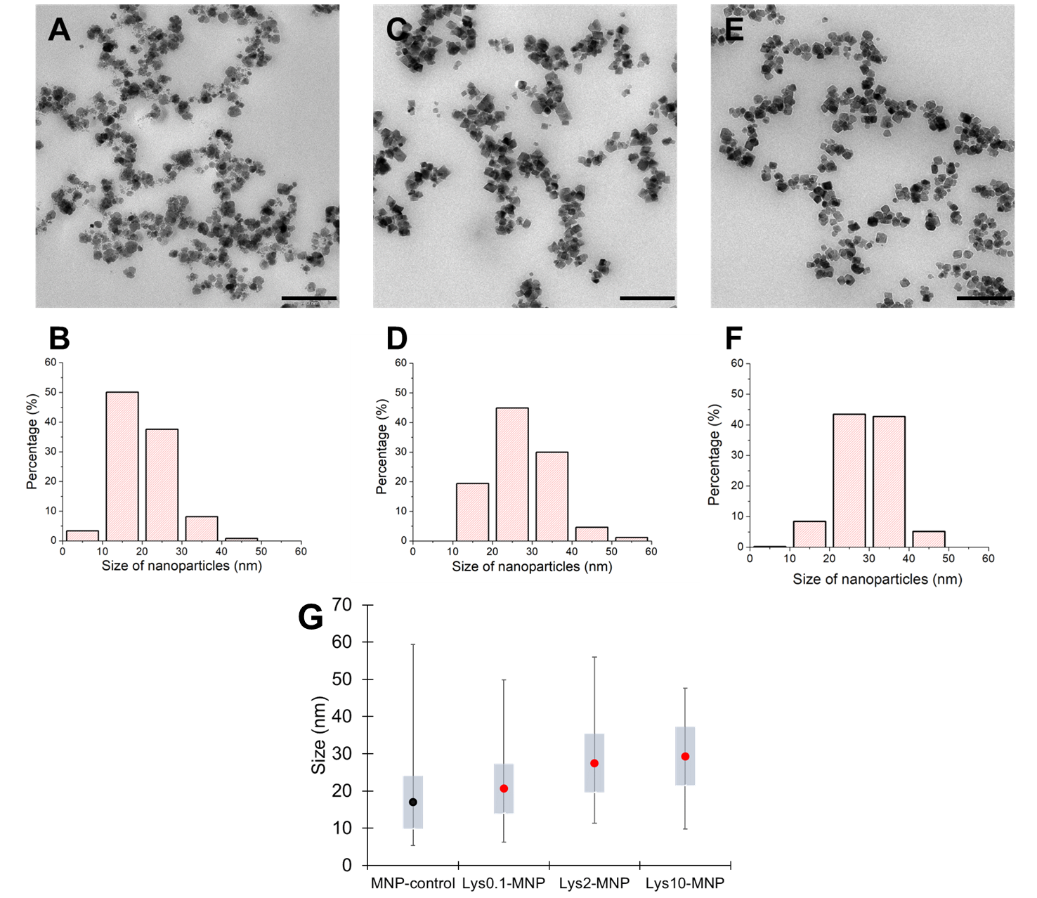

Figure 3
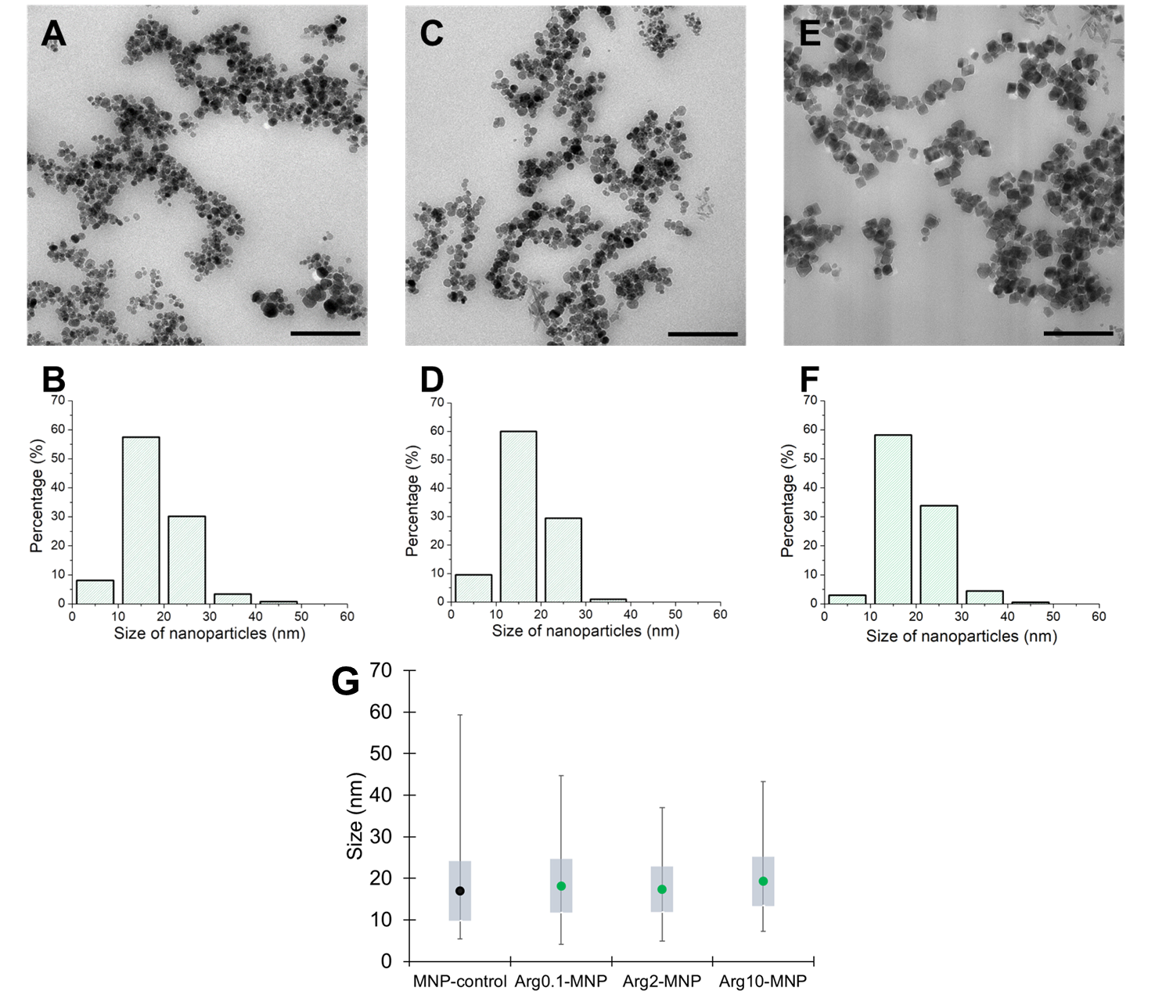

Figure 4
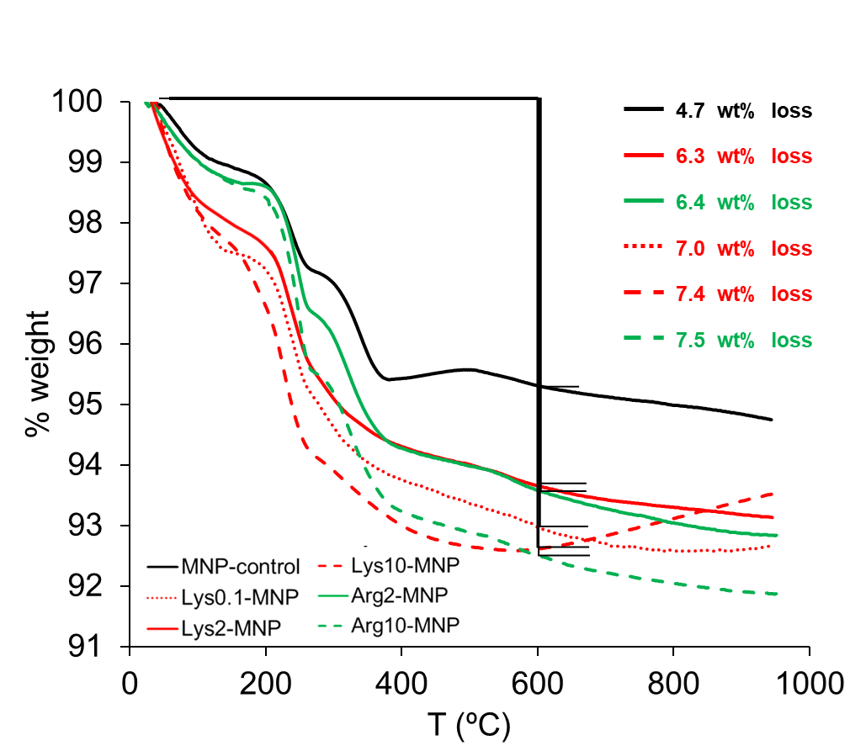
Figure 5
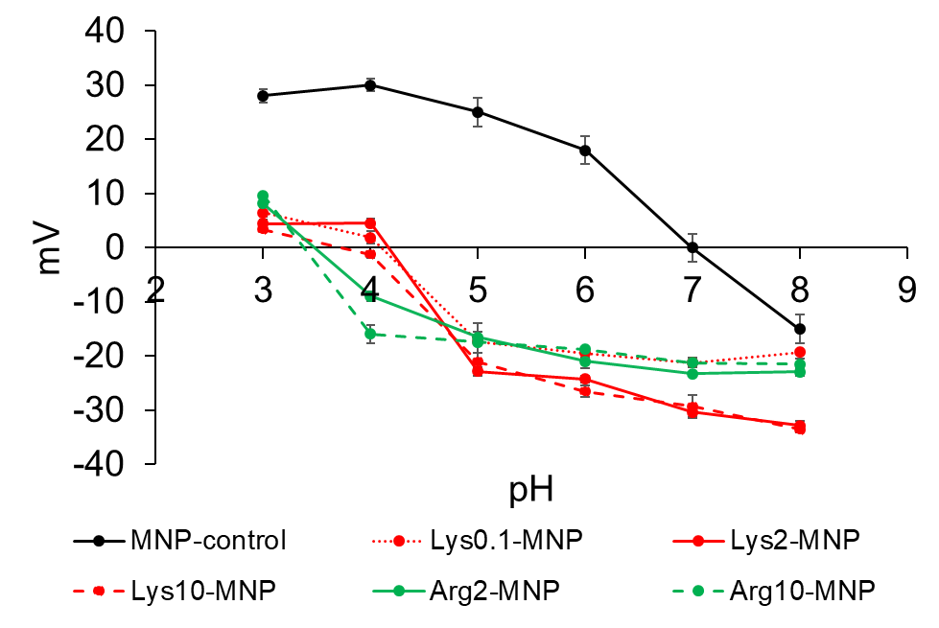

Figure 6
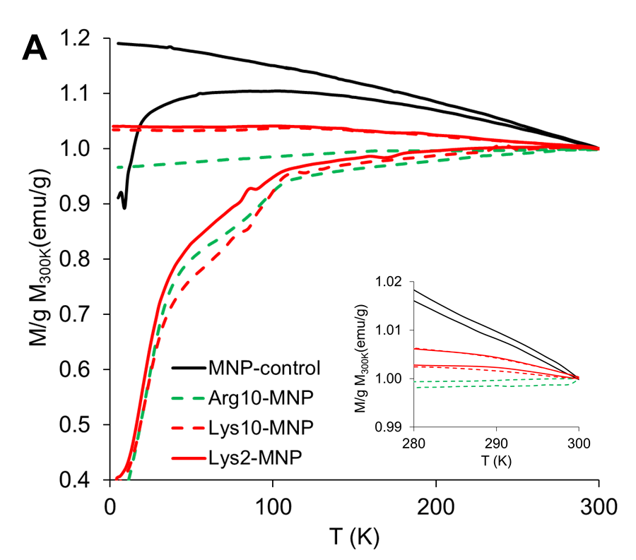
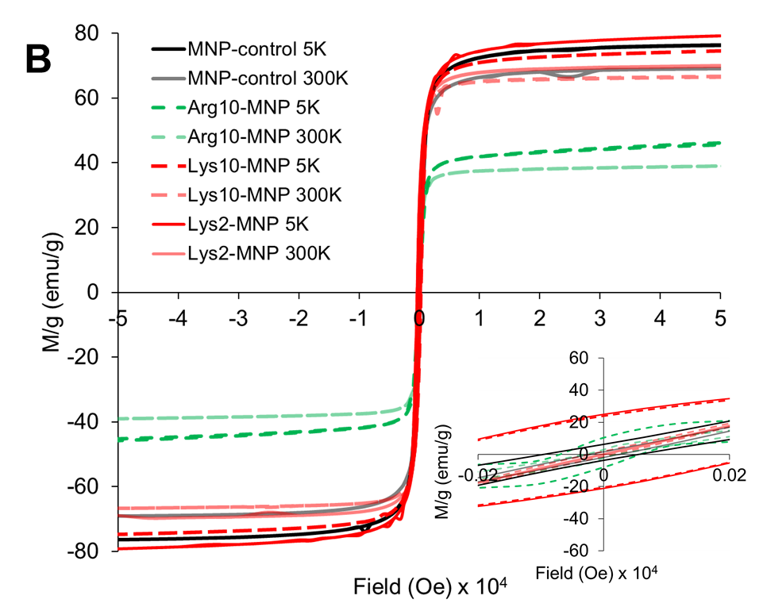

Figure 7

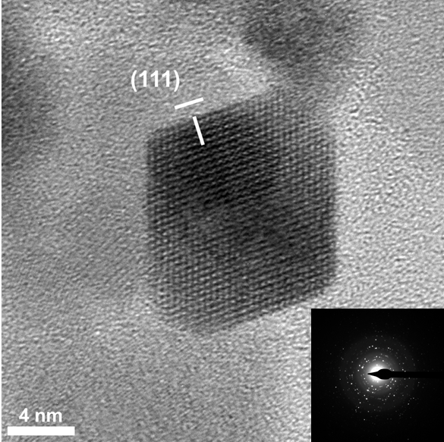

For Table of Contents Use Only

Lysine as size-control additive in the biomimetic synthesis of pure superparamagnetic magnetite nanoparticles
Rafael Contreras-Montoya#,†, Ylenia Jabalera,#,‡, Víctor Blanco†, Juan Manuel Cuerva†,Concepcion Jimenez-Lopez*,‡, Luis Alvarez de Cienfuegos*,†.
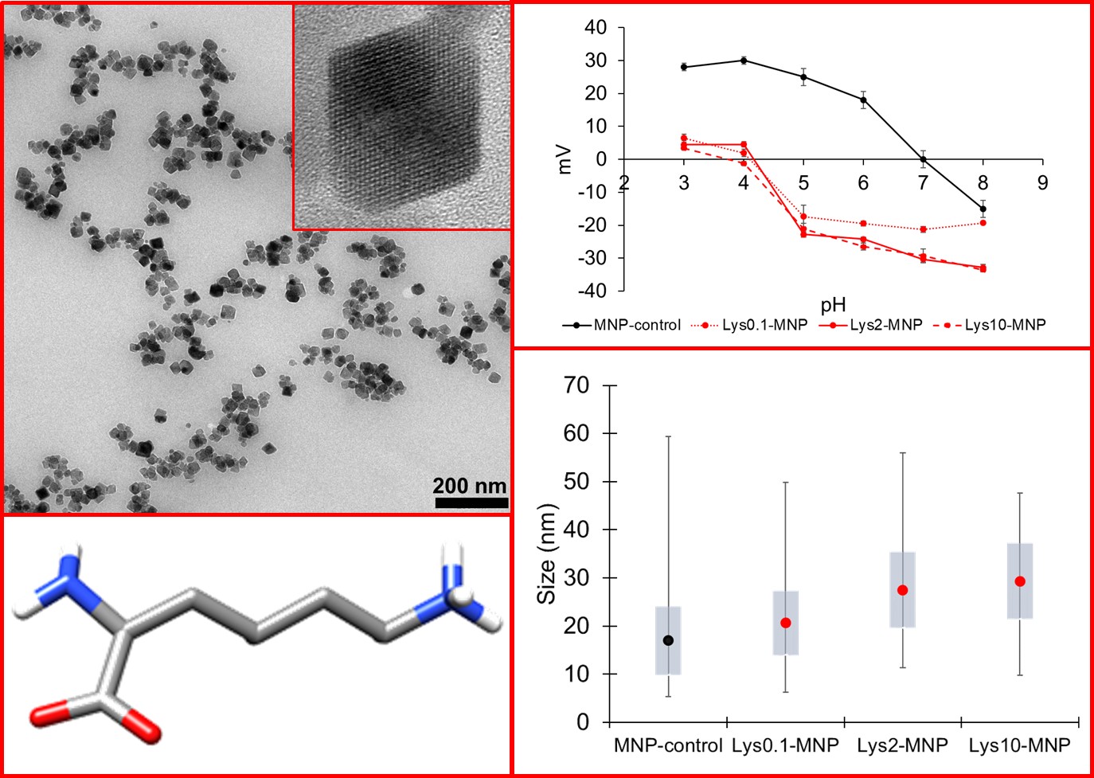
Lysine is able to exert a control over the size of magnetite nanoparticles obtained from aqueous solutions in free-drift experiments performed at room temperature. These magnetites show well-faceted faces and sizes in the range of 20-30 nm. Lysine adsorbs on the surface of the magnetites making them negatively charge at physiological pH and suitable for biotechnological applications.

